System Analysis and Design Report

of the
Combined System Development Services
for the
Enhancement of IT Systems of Repair Call Centre

for the
Architectural Services Department

Version: v1.3

Jun 2025

© The Government of the Hong Kong Special Administrative Region
Distribution
Copy No. | Holder
1 | Architectural Services Department (ArchSD)
2 | Global Technology Integrator Limited (GTI)
3 | ITApps Limited (ITApps)

Amendment History

Change Number | Revision Description | Pages Affected on Respective Version | Revision / Version Number | Date | Approval Reference
1 | Initial version |  | 1.0
2 | Revised Version Based on ArchSD’s comments |  | 1.1
3 | Revised Version Based on ArchSD’s comments |  | 1.2
4 | Revised Version Based on ArchSD’s comments |  | 1.3

Contents
1. ABBREVIATION USED IN THIS DOCUMENT 11
2. MANAGEMENT SUMMARY 12
3. CURRENT ENVIRONMENT DESCRIPTION 13
3.1. CURRENT SYSTEM DESCIPTION 13
3.1.1. Current System Overview 13
3.1.2. Current System Hardware and Software Configuration 16
3.2. CURRENT PROBLEMS AND ISSUES 17
4. REQUIREMENTS SPECIFICATION 18
4.1. USER REQUIREMENTS 18
4.1.1. Proposed System Overview 18
4.1.2. Requirements Catalogue 19
4.1.3. Business Process 20
4.1.3.1. List of Business Process 20
4.1.4. Business Model 21
4.1.4.1. BP-001 Submit e-Certificate Public Key 21
4.1.4.2. BP-002 Remove e-Certificate Public Key 22
4.1.4.3. BP-003 Upload Site check Report for High-Risk Minor Works Order (RRF) and Certificate for Minor Works Order (RRF) from MTC IT Platform 22
4.1.4.4. BP-004 Data Exchange between DA and MTC IT Platform 23
4.1.4.5. BP-005 Opt out of the RRF in the FEHD Report 24
4.1.4.6. BP-006 CyberRCC Website (B/Ds admin & General User) 24
4.1.4.7. BP-007 CyberRCC Website (DS) 27
4.1.4.8. BP-008 CCE new queue for emergency web cases and enquiries 29
4.1.4.9. BP-009 Monthly Report to B/Ds 31
4.1.4.10. BP-010 Cyber RCC Web (RCC Admin) 31
4.1.4.11. BP-011 RCC & CCE Dashboard 34
4.1.5. Functional Requirements 34
4.1.5.1. List of Functional Requirements 34
4.1.5.2. API-R1 Updating the list to synchronize and the frequency 36
4.1.5.3. API-R2 Document received and verification 36
4.1.5.4. API-R3 IC e-Certificate Management 37
4.1.5.5. API-R4 Allowing opt-out for FEHD cases 37
4.1.5.6. WEB-R1 User Registration 38
4.1.5.7. WEB-R2 User Login & Reset Password 39
4.1.5.8. WEB-R3 iAM Smart Integration 40
4.1.5.9. WEB-R4 Two Factor Authentication 41
4.1.5.10. WEB-R5 User Account Management 41
4.1.5.11. WEB-R6 User Group 43
4.1.5.12. WEB-R7 Cancel Request 44
4.1.5.13. WEB-R8 Request follow up / General Enquiry 45
4.1.5.14. WEB-R9 E-Acknowledge of Completion 46
4.1.5.15. WEB-R10 New, Copy and Save Draft Repair Request 46
4.1.5.16. WEB-R11 Assigning CyberRCC Account in DA Phonebook 48
4.1.5.17. WEB-R12 Clone Location Code 49
4.1.5.18. WEB-R13 Address lookup service 49
4.1.5.19. WEB-R14 Item suggestion 50
4.1.5.20. WEB-R15 Download repair request record 51
4.1.5.21. WEB-R16 View and search repair request 51
4.1.5.22. WEB-R17 Emergency web request 52
4.1.5.23. WEB-R18 Add appointment time to device calendar 53
4.1.5.24. WEB-R19 NetIQ integration 53
4.1.5.25. WEB-R20 DS functions in CyberRCC 54
4.1.5.26. WEB-R21 Repair tree item configuration 56
Description 56
4.1.5.27. WEB-R22 Monthly report to B/Ds 57
4.1.5.28. WEB-R23 CyberRCC Dashboard for different user role 58
4.1.5.29. WEB-R24 API Receive MTC Request convert to MWO/WO 59
4.1.5.30. WEB-R25 RCC Admin Functions in CyberRCC 60
4.1.5.31. WEB-R26 New RRF Report 62
4.1.5.32. WEB-R27 RCC & CCE Dashboard Update 62
4.1.5.33. WEB-R28 CyberRCC Notification 63
4.1.5.34. WEB-R29 Different admin roles for B/Ds 64
4.2. TECHNICAL REQUIREMENT 65
4.2.1. List of Technical Requirements 65
4.2.2. TR-WEB-001 Adopt Responsive Web Design 65
4.2.3. TR-WEB-002 Support of prevailing Internet Browsers 65
4.2.4. TR-WEB-003 Public Internet Access for DA Extranet and CyberRCC 66
4.2.5. TR-WEB-004 Hash Password in CyberRCC 66
5. SYSTEM SPECIFICATION 67
5.1. FUNCIOTNAL SPECIFICATION 67
5.1.1. Required System Overview 67
5.1.2. Function Definition 67
5.1.2.1. Data Exchange with MTC IT Platform 68
5.1.2.1.1. UF-0001 Update the list field to synchronize 68
5.1.2.1.2. UF-0002 Increase the frequency of synchronisation 69
5.1.2.1.3. UF-0003 e-signature Document Transfer from MTC MWO IT System 70
5.1.2.1.4. UF-0004 Document Verification with e-Signature and Statistics Report 71
5.1.2.1.5. UF-0005 View Document in DA 71
5.1.2.1.6. UF-0006 Update IC e-Certification information in DA 75
5.1.2.1.7. UF-0056 MTC Request Convert to MWO/WO API 77
5.1.2.2. FEHD API Enhancement 80
5.1.2.2.1. UF-0007 FEHD Opt-out API 80
5.1.2.3. CyberRCC – B/Ds user Functions and Flows 81
5.1.2.3.1. UF-0008 CyberRCC User Registration 81
5.1.2.3.2. UF-0009 CyberRCC Account Login 89
5.1.2.3.3. UF-0010 CyberRCC iAM Smart Integration 91
5.1.2.3.4. UF-0011 CyberRCC User Email Verification 93
5.1.2.3.5. UF-0012 CyberRCC Reset Password 95
5.1.2.3.6. UF-0014 CyberRCC Account Information 98
5.1.2.3.7. UF-0018 CyberRCC Submit Cancel Request 102
5.1.2.3.8. UF-0020 CyberRCC Submit General Enquiry 105
5.1.2.3.9. UF-0021 CyberRCC Request Follow Up 108
5.1.2.3.10. UF-0023 CyberRCC Repair Request Status 110
5.1.2.3.11. UF-0024 CyberRCC Location Suggestion 117
5.1.2.3.12. UF-0025 CyberRCC Copy Repair Request 118
5.1.2.3.13. UF-0026 CyberRCC Add Appointment Date Time to Device Calendar 119
5.1.2.3.14. UF-0027 CyberRCC E-acknowledgment 120
5.1.2.3.15. UF-0029 CyberRCC Create Repair Request 121
5.1.2.3.16. UF-0030 CyberRCC Save Draft Repair Request 134
5.1.2.3.17. UF-0031 CyberRCC Repair Item Suggestion 137
5.1.2.3.18. UF-0032 CyberRCC Download Plain Text Version of Repair Request 139
5.1.2.3.19. UF-0053 CyberRCC B/Ds user Dashboard 140
5.1.2.4. CyberRCC – B/Ds admin Functions and Flows 142
5.1.2.4.1. UF-0013 CyberRCC User Management by B/Ds admin 142
5.1.2.4.2. UF-0015 CyberRCC User Group Management 154
5.1.2.4.3. UF-0036 CyberRCC Reassign User to CyberRCC Cases 156
5.1.2.4.4. UF-0049 CyberRCC - Download Department Monthly RRF Report 157
5.1.2.4.5. UF-0054 CyberRCC B/Ds admin Dashboard 158
5.1.2.5. CyberRCC – DS Functions and Flows 161
5.1.2.5.1. UF-0038 DS Access CyberRCC 161
5.1.2.5.2. UF-0039 CyberRCC DS Function – Search RRF 162
5.1.2.5.3. UF-0073 Database synchronize data from ACTION 171
5.1.2.5.4. UF-0040 CyberRCC DS Function – Export Search RRF Result 171
5.1.2.5.5. UF-0041 CyberRCC DS Function – RRF Detail 174
5.1.2.5.6. UF-0042 CyberRCC DS Function – Flag Up Monitor Screen 187
5.1.2.5.7. UF-0043 CyberRCC DS Function – Form III Waiting for Acknowledgement Monitor Screen 189
5.1.2.5.8. UF-0044 CyberRCC DS Function – Inbox Request 190
5.1.2.5.9. UF-0045 CyberRCC DS Function – Alert Function 192
5.1.2.5.10. UF-0055 CyberRCC DS Home Page 194
5.1.2.5.11. UF-0063 New Dashboard & Report for DS 199
5.1.2.6. CyberRCC – RCC Admin Functions and Flows 204
5.1.2.6.1. UF-0057 CyberRCC RCC Admin – Login 204
5.1.2.6.2. UF-0058 CyberRCC RCC Admin – Announcement Setting 206
5.1.2.6.3. UF-0059 CyberRCC RCC Admin – User Maintenance 209
5.1.2.6.4. UF-0060 CyberRCC RCC Admin – System Configuration – FAQ Setting 212
5.1.2.6.5. UF-0072 CyberRCC RCC Admin – System Configuration – Upload handbook 214
5.1.2.6.6. UF-0061 CyberRCC RCC Admin – System Configuration – DS search range 214
5.1.2.6.7. UF-0062 CyberRCC RCC Admin – System Configuration – Repair Item Suggestion Management 216
5.1.2.7. CyberRCC – General Functions and Flows 218
5.1.2.7.1. UF-0016 CyberRCC Two Factor Authentication 218
5.1.2.7.2. UF-0017 CyberRCC Session Control 220
5.1.2.7.3. UF-0052 CyberRCC User Role 221
5.1.2.7.4. UF-0068 CyberRCC Notification 222
5.1.2.7.5. UF-0069 CyberRCC – FAQ 224
5.1.2.7.6. UF-0070 CyberRCC – Announcement 225
5.1.2.7.7. UF-0071 CyberRCC – Handbook on Minor Repairs to Government Properties 227
5.1.2.8. DA Enhancement for CyberRCC 228
5.1.2.8.1. UF-0019 Handle Cancel Request from CyberRCC in DA 228
5.1.2.8.2. UF-0022 RCC Supervisor End Inbox Request in DA 230
5.1.2.8.3. UF-0028 View CyberRCC Site Completion Date in DA 231
5.1.2.8.4. UF-0033 Queue Arrangement for CyberRCC Repair Request 233
5.1.2.8.5. UF-0034 Linkage CyberRCC User and DA Client Record 235
5.1.2.8.6. UF-0035 DA Display CyberRCC Account ID in repair request record 236
5.1.2.8.7. UF-0037 DS Login DA 236
5.1.2.8.8. UF-0046 DA Alert Button and Display Alert in RRF 238
5.1.2.8.9. UF-0047 Send Monthly RRF Report to B/Ds by Email 239
5.1.2.8.10. UF-0048 DA set the configuration of B/Ds monthly report 240
5.1.2.8.11. UF-0050 Configure Item Remarks of Repair Tree Item in DA 242
5.1.2.8.12. UF-0051 DA Link RRI with CyberRCC Account ID 244
5.1.2.8.13. UF-0067 New DA Role for Extranet DA Access 245
5.1.2.8.14. UF-0075 Bring up message for new batched for audit to DS 246
5.1.2.9. Reports and Dashboard 246
5.1.2.9.1. UF-0064 New Report – Monthly RRF Report 247
5.1.2.9.2. UF-0074 General RRF I & III Waiting for Acknowledge in Decision Manager 248
5.1.2.9.3. UF-0065 RCC Dashboard Update 249
5.1.2.9.4. UF-0066 CCE Dashboard Update 250
5.2. SYSYEM DESIGN 254
5.2.1. System Architecture 254
5.2.1.1. Development Tools and Software 255
5.2.1.2. System Script 256
5.2.2. Data Specification 256
5.2.2.1. Data Source 256
5.2.2.2. Logical Data Model 257
5.2.2.3. Physical Data Model 259
6. TECHNICAL SYSTEM OPTION 269
6.1. SYSTEM ARCHITECTURE 269
6.1.1. Network Architecture 269
6.1.2. Storage Architecture 270
6.1.3. Backup Schedule 270
6.2. SIZING MODEL 271
6.2.1. Data Storage 271
6.2.1.1. Raw Data Storage 271
6.2.1.2. Index Storage 272
6.2.2. File Server Sizing 273
6.2.3. Network Sizing 275
6.3. IMPACT ANALYSIS 276
6.3.1. EVALUATION OF IMPACTS ON ARCHSD DUE TO LOSS OF IT SERVICES 276
6.3.1.1. Hong Kong E-Post No Longer Issue E-Certificate 276
6.3.1.2. All E-Certificates Expired 276
6.3.1.3. Exceed File Server Storage 277
6.3.1.4. Reverse Proxy Server Down 277
6.3.1.5. CyberRCC Web Server Down 278
6.3.1.6. CyberRCC API Web Server Down 278
6.3.1.7. External DA Web Server Down 279
6.3.1.8. Internal DA Web Server Down 279
6.3.1.9. Database Service Down 280
6.4. IMPLEMENTATION PLAN 280
A. APPENDIX 284
A.1 Verified e-Signature Document Screen Capture 284
A.2 CyberRCC User Registration Flow 285
A.3 CyberRCC Session Control Flow 286
A.4 Cancel in CyberRCC Flow 287
A.5 Enquiry and Follow Up in CyberRCC Flow 288
A.6 Plain Text Version Template 289

- ABBREVIATION USED IN THIS DOCUMENT
Abbreviation | Meaning
2FA | Two Factor Authentication
ArchSD | Architectural Services Department
B/D | Bureau/ Department
BDRC | Building Defect Reporting Centre
BEO | Backend Officer
CCE | Contact Center Enterprise
CSO | Customer Services Officer
D.O. | District Officer (equal to District Staff)
DA | Desktop Application
DA user-admin | A user role in DA (e.g. SCO / CO)
DS | District Staff
FEHD | Food and Environmental Hygiene Department
IC | Independent Checker
ITApps | ITApps Limited
MTC | Maintenance Term Contractor
MWO | Minor Works Order
OTP | Onetime Passcode
RCC | Repair Call Centre
RCC Supervisor | A user role in DA (e.g. RCC/PO)
RRF | Repair Request Form
RRI | Repair Request Item
WO | Works Order

- MANAGEMENT SUMMARY
This comprehensive report evaluates the existing IT systems, including CyberRCC, DA, CCE, FEHD Web Server and MTC Data Exchange Program at ArchSD, captures user requirements, and proposes a new solution. The new system is designed to modernize CyberRCC by integrating advanced technologies and targeted enhancements while preserving existing functionalities. The CyberRCC Server and Database System will be reengineered to incorporate state-of-the-art technologies. Additionally, related IT systems, including DA, CCE, FEHD Web Server, and MTC Data Exchange Program, will be upgraded based on ArchSD’s input. This strategic approach ensures that CyberRCC is upgraded to modern technology standards for future growth while enhancing existing systems to align with ArchSD's expectations.

The above solution approach guarantees the following key benefits to ArchSD:
- Leverage existing investment. The solution re-use existing Database resources and make use of the existing components. It will minimize the procurement cost.
- Smooth and Risk-free Transition. The solution re-use existing Database schema, data migration is not needed.
- Minimal User and Customer Impact. It covers the government users, contractors, RCC and ArchSD staff. Single Day changeover will be applied.
- Easiest to support and maintain. The support mechanism and skill required remain the same.
- Future Expansion and Enhancement. The proposed solution not only meets the essential requirements of the Project Specifications but also has room for future expansion in terms of size and functionalities.

Indeed, the proposed system is anticipated to undergo significant enhancements compared to the existing system across various aspects, encompassing functionality, performance, security, capacity, user-friendliness, resilience, system monitoring, reporting, and more. These upgrades aim to elevate the overall system capabilities and user experience to meet the evolving needs and expectations within ArchSD's landscape.

- CURRENT ENVIRONMENT DESCRIPTION
  - CURRENT SYSTEM DESCIPTION
The current RCC system comprises multiple subsystem servers, including the CyberRCC Server, RCCAPP Server, RCCAPPEXT Server, and a dedicated database server. To optimize network performance and minimize latency, each server is equipped with a load balancer to efficiently distribute incoming requests.

Certain servers support connectivity across multiple domain networks, while others are limited to a single domain. The system is designed to serve both internal and external users, with robust firewall protocols securing all inter-domain network communications.
    - Current System Overview
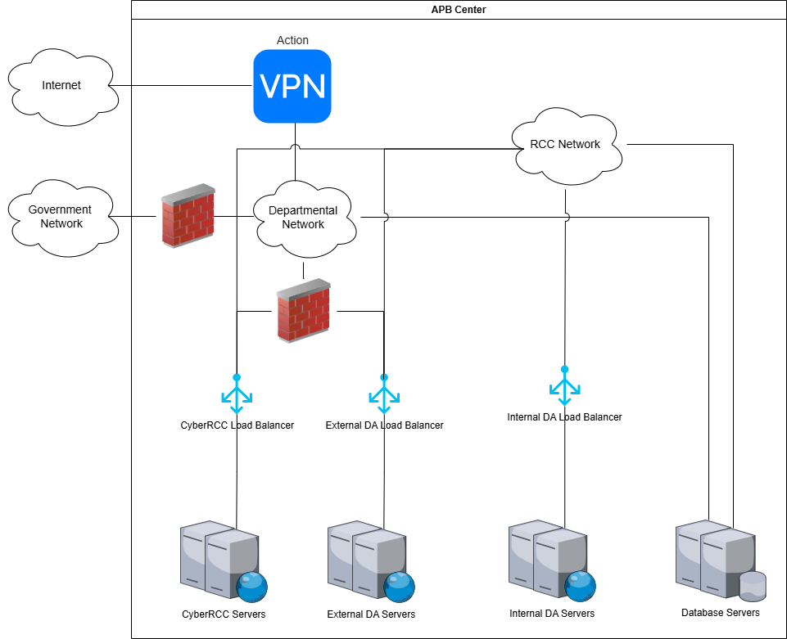

The diagram above depicts the architecture of the current RCC system, comprising subsystem components including load balancers, CyberRCC Servers, Database Servers, and Internal and External DA Servers. These systems are housed in the RCC Server Room at the APB Centre, where robust physical and logical security measures are implemented to ensure their protection. The infrastructure is organized into two network subnets: the Departmental Network and the RCC Network. Systems within the Departmental Network permit access from GNET or within the Departmental Network itself, while those in the RCC Network are restricted to internal RCC Network access only. For systems requiring internet connectivity, traffic is routed through the ASD proxy server. Access from the internet to the system necessitates the use of the ACTION VPN.

High level System Review:
Sub System | Functions
Load-Balancer | The Load-Balancer handles incoming requests to eventually distribute to the following servers:  - CyberRCC Servers  - Internal DA Servers  - External DA Servers
CyberRCC Servers | The CyberRCC Web Server hosts the following TLS-enabled websites and applications, ensuring secure and efficient operations:  - CyberRCC Website: Enables users to submit repair requests and check the status of repair requests online.  - FEHD API Web Service: Facilitates the FEHD in submitting and canceling repair requests, updating site completion dates, and issuing reminders.  - MTC Data Exchange Program: Supports data synchronization between the DA and the MTC IT Platform.  - Hostgateway Program: Allows the DA to initiate MWO or WO in the ACTION system.  - DA Dashboard Website: Provides a visual interface displaying various charts and statistics for DA operations.  Additionally, a Secure File Transfer Protocol (SFTP) Server supports the following functions:  - Enables FEHD to retrieve daily XML files exported from the database.  - Facilitates the ACTION system in uploading exported database data files.
Internal DA Servers | A Web Server hosts the following TLS-enable websites or applications:  - A website for DA which allows RCC to handle repair requests in RCC Network
External DA Servers | A Web Server hosts the following TLS-enable websites or applications:  - A website for DA which allows DS to handle repair requests in Departmental Network and allows MTC handle repair requests via VPN
Database Servers | The Database Server operates on Microsoft SQL Server, configured in a Basic Availability Group to ensure high availability and reliability. This setup synchronizes two database servers: one serves as the active node, processing all transactions, while the other functions as a standby node, providing failover support to maintain system continuity.  The Database Server acts as the central repository for the following data:  - All repair requests information in RCC  - All CCE call center log and related information  Additionally, the Database Server supports report generation for RCC operations, producing specific reports through the iReport Application.

    - Current System Hardware and Software Configuration

CyberRCC Servers:
Server Name | RCCWEB01/RCCWEB02
Operation System | Microsoft Windows Server 2019
Installed Software | - Internet Information Service 10,  - Apache Tomcat 9.0.73  - NSoftware SFTP Server 2020  - JRE 1.8.0_u192

Internal DA Servers:
Server Name | RCCAPP01/RCCAPP02
Operation System | Microsoft Windows Server 2019
Application Server Software | Apache Tomcat 9.0.73,  JRE 1.8.0_u192

External DA Servers:
Server Name | RCCAPPEXT01/RCCAPPEXT02
Operation System | Microsoft Windows Server 2019
Installed Software | - Apache Tomcat 9.0.73  - JRE 1.8.0_u192

Database Servers:
Server Name | RCCDB01, RCCDB02
Operation System | Microsoft Windows Server 2019
Installed Software | - SQL Server 2019 Standard  - Crystal Report Runtime  - iReport

  - CURRENT PROBLEMS AND ISSUES
No. | Descriptions
 | The old CyberRCC does not cater for the latest products or standards (e.g., Mobile Responsive Web Design) in information technologies.
 | The old CyberRCC is not accessible from the Internet
 | The DA system is not accessible from the public Internet
 | Current System Interface between DA and MTC’s MWO IT Platform does not support e-Signature Files Transfer
 | Current System Interface between DA and FEHD does not support the opt-out RRF in the FEHD reports

- REQUIREMENTS SPECIFICATION
  - USER REQUIREMENTS
    - Proposed System Overview

The business processes for the revamped CyberRCC System will align with the existing framework while incorporating targeted enhancements. The core functionality of the current DA system will be preserved, with adjustments to support Internet access via the DA Extranet and to meet the requirements of the revamped CyberRCC System and Data Exchange Program. Upgrades to the Data Exchange Program and FEHD API Webservice will be implemented to fulfil specified criteria. Additionally, the CyberRCC System’s interface will be comprehensively redesigned to adopt a mobile-friendly, responsive layout, enhancing accessibility and user experience.

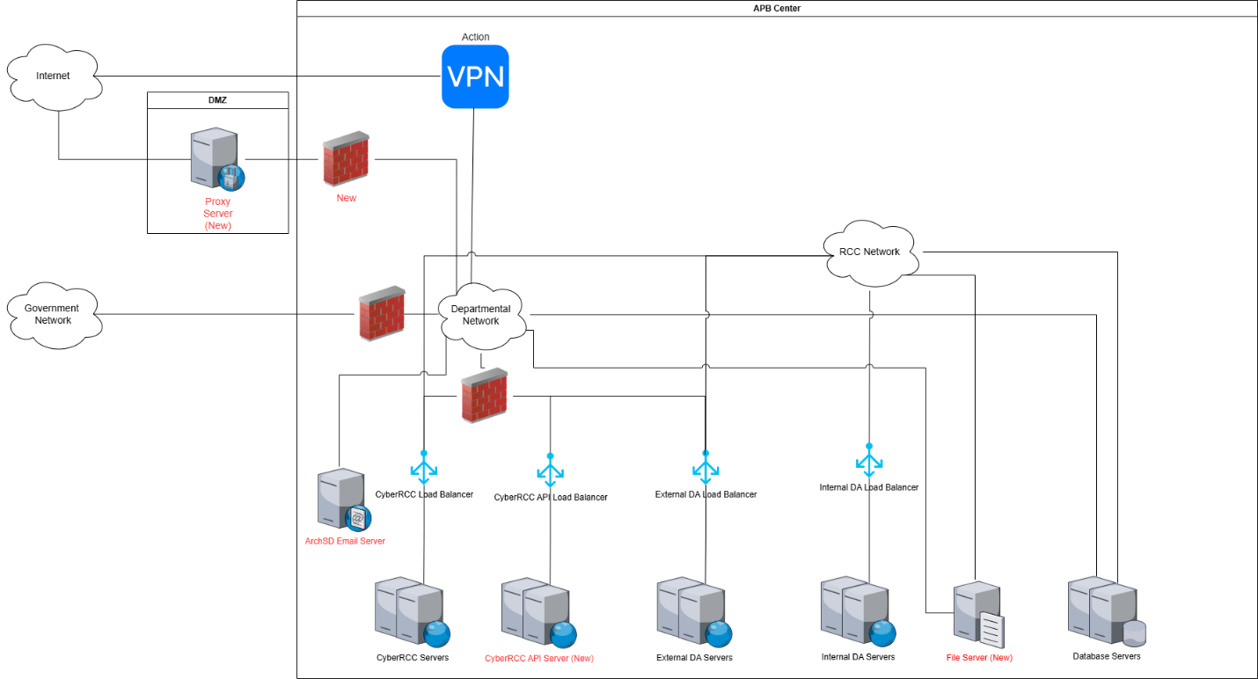

The diagram illustrates the enhanced design of the proposed RCC system, incorporating improvements while retaining core components similar to the existing architecture, including load balancers, CyberRCC Servers, Internal and External DA Servers, and Database Servers. A new Proxy Server will manage public Internet traffic for the CyberRCC and External DA Servers, optimizing connectivity. To reduce system load, new CyberRCC API Servers will separate backend components from the existing CyberRCC Servers. Additionally, a dedicated file server will be introduced to store media files from the MTC IT Platform and CyberRCC. The existing ArchSD email server will continue to facilitate email communications.

    - Requirements Catalogue
A unique ID is assigned to each requirement, and the format of a Requirement ID is as follows:

Requirement ID = [Category] + [-R] + [Sequence]
The sequence is starting from 001

    - Business Process
      - List of Business Process
Process ID | Business Process Title
BP-001 | Submit e-Certificate public key
BP-002 | Remove e-Certificate public key
BP-003 | Upload RRF document from MTC IT Platform
BP-004 | Data Exchange between DA and MTC IT Platform
BP-005 | Opt out of the RRF in the FEHD Report
BP-006 | CyberRCC Website (B/Ds admin & General User)
BP-007 | CyberRCC Website (DS)
BP-008 | CCE new queue for emergency web cases and enquiries
BP-009 | Monthly Report to B/Ds
BP-010 | Cyber RCC Web (RCC Admin)
BP-011 | DA & CCE Dashboard

    - Business Model
      - BP-001 Submit e-Certificate Public Key

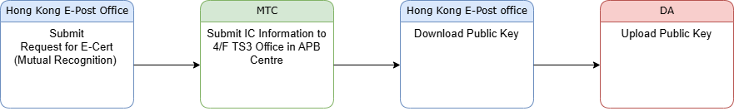

Task No. | Actor | Task Name and Description | Input | Output
 | IC | - Submits an e-Cert (Mutual Recognition) request to the Hong Kong e-Post Office. | - IC identification information | - e-Cert reference number
 | MTC | - Submits IC Information to 4/F TS3 Office at the APB Centre. | - IC full name  - e-Cert reference number | - NA
 | RCC Supervisor / DA user-admin | - Downloads the public key from the Hong Kong e-Post Office. | - IC full name  - e-Cert reference number | - Public key
 | RCC Supervisor / DA user-admin | - Uploads the public key to the DA System. | - IC full name  - e-Cert reference number  - Public key | - Public key record in DA
 | RCC Supervisor / DA user-admin | - Sends an email to notify the IC of the submission result. | - NA | - NA

      - BP-002 Remove e-Certificate Public Key

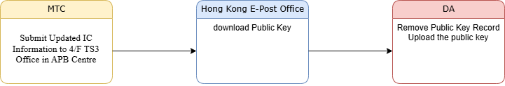

Task No. | Actor | Task Name and Description | Input | Output
 | MTC | - Submits Updated IC Information to 4/F TS3 Office at the APB Centre. | - IC full name  - e-Cert reference number | - NA
 | RCC Supervisor / DA user-admin | - Removes the public key from the DA system.  - Downloads the new public key from Hong Kong e-Post Office  - Uploads the new public key to the DA System | - NA | - NA
 | RCC Supervisor / DA user-admin | - Sends an email to inform the IC of the removal result. | - NA | - NA

      - BP-003 Upload Site check Report for High-Risk Minor Works Order (RRF) and Certificate for Minor Works Order (RRF) from MTC IT Platform

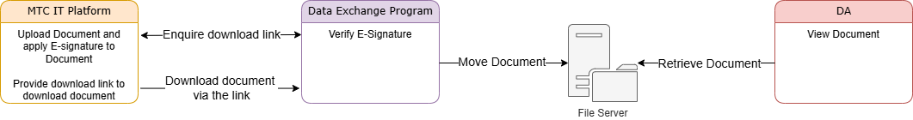

Task No. | Actor | Task Name and Description | Input | Output
 | IC | - Uploads the Site Check Report and Certificate for High-Risk Minor Works Order (RRF) to the MTC IT Platform.  - The e-signature in the document uses the IC’s private certificate to add an e-signature. | - Site check Report for High-Risk Minor Works Order(RRF)  - Certificate for Minor Works Order(RRF) | - Site check Report for High-Risk Minor Works Order(RRF) with IC’s e-signature  - Certificate for Minor Works Order(RRF) with IC’s e-signature
 | Data Exchange Program | - Retrieves the document with e-signature from the MTC IT Platform.  - Verifies the e-signature of the document. | - Site check Report for High-Risk Minor Works Order(RRF) with IC’s e-signature  - Certificate for Minor Works Order(RRF) with IC’s e-signature | - Verified e-signature documents
 | Data Exchange Program | - Transfers the verified document to the file storage server.  - Updates the RRF record with the file storage location. | - Verified e-signature documents | - RRF document location records
 | DS | - Logs into the DA and open the corresponding RRF record.  - Clicks the hyperlink of the file to view the content. | - NA | - NA
      - BP-004 Data Exchange between DA and MTC IT Platform

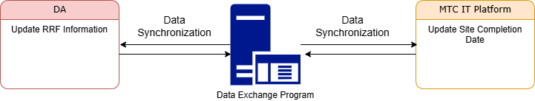

Narrative:
Task No. | Actor | Task Name and Description | Input | Output
 | RCC, DS | - Updates the RRF information in the DA. | - RRF information | - NA
 | MTC | - Updates the RRF site completion date in the MTC IT Platform. | - RRF site completion date | - NA
 | Data Exchange Program | - Synchronizes RRF information between the DA System and the MTC IT Platform. | - RRF information  - RRF site completion date | - NA

      - BP-005 Opt out of the RRF in the FEHD Report

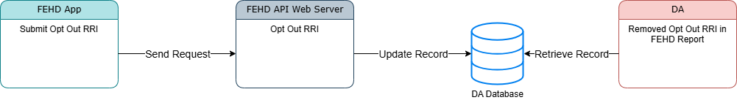
Task No. | Actor | Task Name and Description | Input | Output
 | FEHD Staff | - Submits an opt-out RRI request via the FEHD mobile application.  - FEHD API Web Service processes the opt out requests.  - FEHD API web service returns the result to the FEHD mobile application. | - RRI | - Opt-out Result
      - BP-006 CyberRCC Website (B/Ds admin & General User)
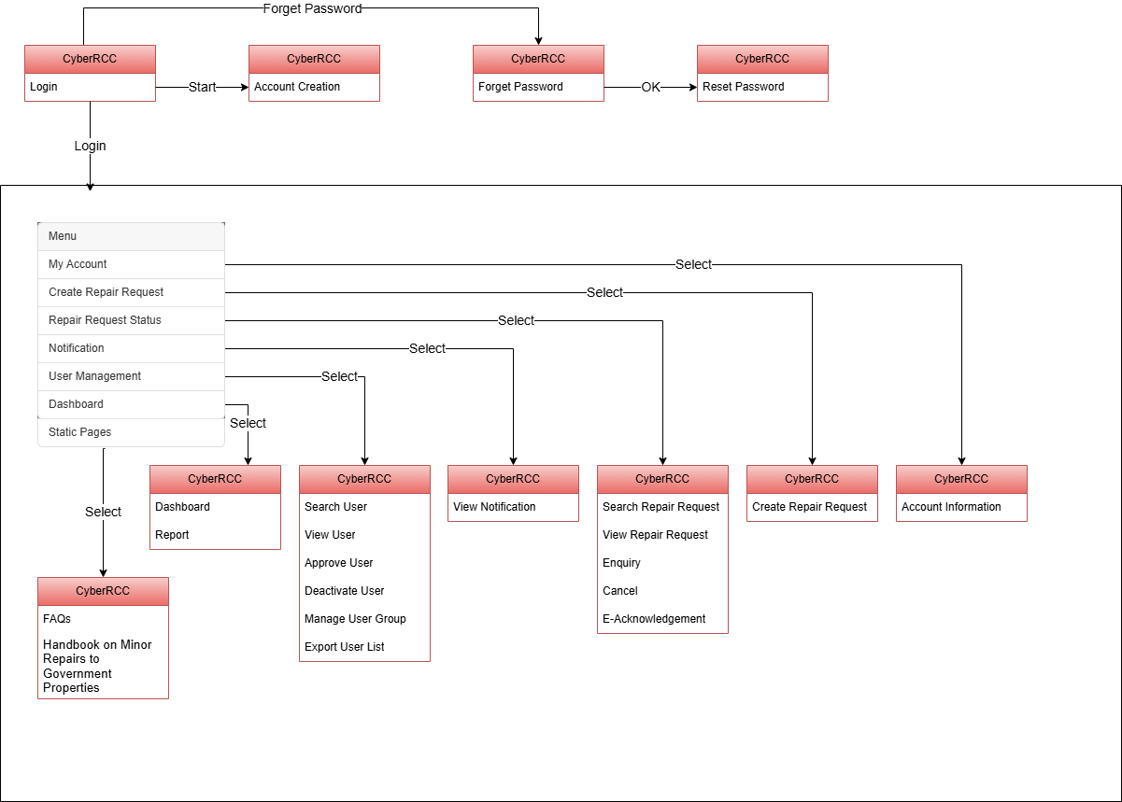

Task No. | Actor | Task Name and Description | Input | Output
 | B/Ds admin or General Users | - Log into CyberRCC Website using a login email and password or iAM Smart credentials.  - Six main functions:  - My Account  - Create Repair Request  - Repair Request Status  - Notification  - User Management  - Dashboard  - Two Static Pages:  - FAQs  - Handbook on Minor Repairs to Government Properties | - CyberRCC logon information  - Login Email  - Password  OR  - iAM Smart | - Logon the system
 | B/Ds admin or General Users | - Access CyberRCC Forget Password Page.  - Receive an email with redirect link to the Reset Password page. | - User Login Email  - Captcha | - An Email with Reset Password Page Link sent to Users
 | B/Ds admin or General Users | - CyberRCC Reset Password  - Reset password on the CyberRCC Reset Password page.  - Receive a notification email upon successful reset. | - New password | - A notification email will be sent if the password is successfully
 | B/Ds admin or B/Ds General Users | - Create New CyberRCC Account  - Self-register using a gov.com email, or  - Receive an invitation link from B/Ds admin for specific email(s), or  - B/Ds admin create account directly and sent the new account login information to users | - New account information | - The screen will display all the information filled in display-only mode for users to verify the details again.  - Various notification emails regarding account creation will be sent to users.
 | B/Ds admin or General Users | - My Account  - Update account details via the My Account page (Account ID and login email are fixed).  - Submit changes and verify on a read-only preview page.  - Link or unlink iAM Smart account with CyberRCC account. | - Account information | - Updated account information.
 | B/Ds admin or General Users | - Create Repair Request  - Report a repair request by selecting location and repair item, filling required fields.  - Submit request and verify on a read-only preview page.  - Save up to five draft requests, edit existing drafts.  - Receive a popup if draft limit is reached: “The number of draft repair requests has reached the limit; this repair request cannot be saved as a draft.” | - New Repair Request | - The screen should display all filled information and a CRK will be generated to the users as reference key.  - The popup message “The number of draft repair requests has reached the limit; this repair request cannot be saved as a draft.”
 | B/Ds admin or General Users | - Repair Request Status  - Search and view their repair request.  - Submit enquiries on repair requests.  - Cancel their repair request.  - Acknowledge completed repair requests. | - Search criteria for the repair request | - A result list of the repair requests will be shown.
 | B/Ds admin or General Users | - Notification  - View the received notification messages. | - NA | - Notification message
 | B/Ds admin | - User Management -  - View and search users within their B/Ds.  - Approve or reject application of account creation  - Approve or reject reporting addresses.  - Activate or deactivate user accounts.  - Delete user accounts  - Batch insert accounts  - Export the user lists. | - Search Criteria for B/Ds users | - A result list of B/Ds users will be shown
 | B/Ds admin or General Users | - Dashboard  - General Users: View personal repair request status  - B/Ds admin: view B/D-wide repair request status and user verification status | - Statistics of CyberRCC reported repair requests status and user verification status | - Dashboard  - Report

      - BP-007 CyberRCC Website (DS)
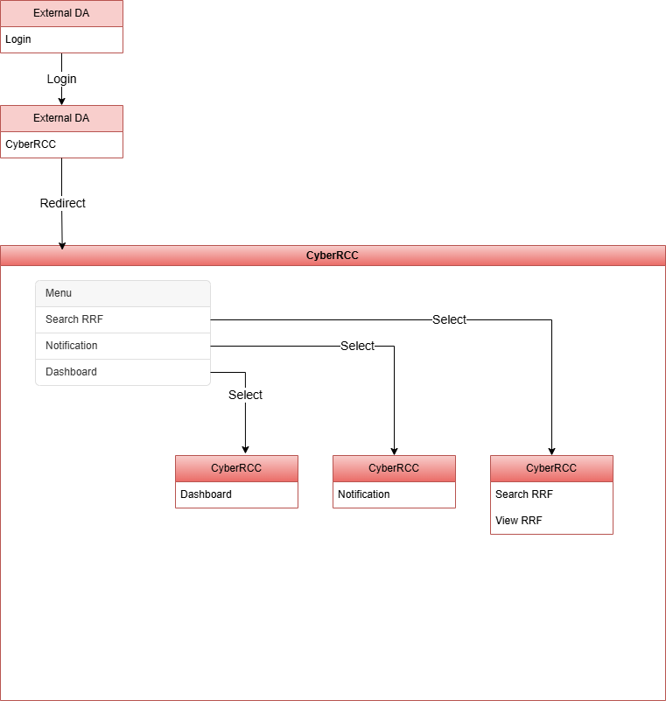

Narrative:
Task No. | Actor | Task Name and Description | Input | Output
 | DS | - Logs into External DA via:  - Public Internet with Two Factor Authentication  - ArchSD Departmental Network | - DA logon information | - Logon to DA system
 | DS | - CyberRCC  - select CyberRCC from the DA System’s menu or top banner.  - Redirect to the CyberRCC Website. | - NA | - Redirect to CyberRCC
 | DS | - Search RRF  - Search the RRF information using specified criteria.  - View a list of matching RRF records. | - Search Criteria of RRF | - A result list of RRF will be shown
 | DS | - Notification  - View the received notification messages. | - NA | - Notification messages
 | DS | - Dashboard  - View DA and RCC-related statistics on dashboards. | - NA | - RRF Statistic Dashboard

      - BP-008 CCE new queue for emergency web cases and enquiries

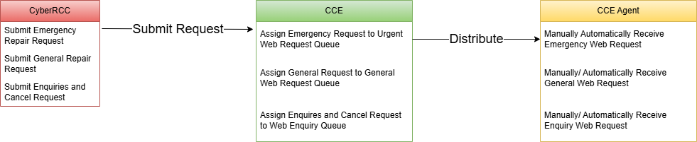

Task No. | Actor | Task Name and Description | Input | Output
 | B/Ds users | - Submit an emergency or general repair request via CyberRCC Website.  - Submit enquiries or cancel requests via CyberRCC | - Repair request information  - Enquires Information  - Cancel Information | - CRK
 | CCE System | - Assigns the submitted web repair request to the appropriate queue based on its urgency type.  - Assigns the submitted enquiries or cancel requests to the appropriate queue | - Web repair request emergency Type | - Chinese/English Emergency / General web request queue  - Chinese/English web enquiry queue
 | CCE Agent | - Retrieve emergency web request automatically or manually from emergency queue.  - Retrieve general web request automatically or manually from general web request queue.  - Retrieve enquiry or cancel requests from web enquiry queue  - Prioritize emergency requests over general ones. | - NA | - Web repair request
      - BP-009 Monthly Report to B/Ds
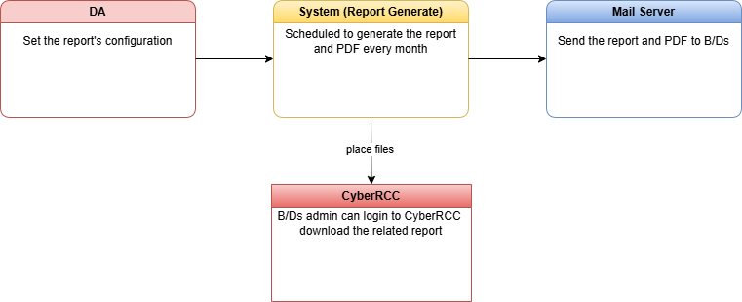
Task No. | Actor | Task Name and Description | Input | Output
 | RCC Supervisor / DA user-admin | - Configures the monthly RRF report settings in the DA System, specifying report details and recipient information to automate distribution. | - Report name  - Location Code  - Recipients  - Other mailing list  - Other recipient  - Other report name | - NA
 | System | - Automatically generates Excel and PDF reports based on the configured settings at the scheduled time.  - Copies the reports to CyberRCC system  - Initiates email delivery via the mail server. | - Scheduled time  - Report Configuration | - Excel & PDF
 | Mail Server | - Sends the Excel and PDF reports to B/Ds recipients via email. | - - | - Email

      - BP-010 Cyber RCC Web (RCC Admin)
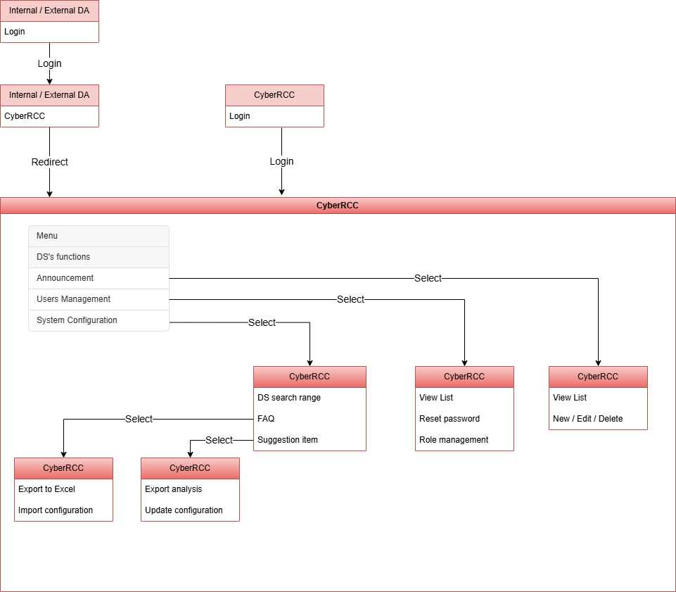
Task No. | Actor | Task Name and Description | Input | Output
 | RCC Admin | - Login Internal / External DA  - Access via public internet with Two-Factor Authentication (2FA).  - Access via ArchSD Departmental network.  - Access via ArchSD RCC network. | - DA login credentials  - (username, password, 2FA code) | - Logon to DA system
 | RCC Admin | - Access CyberRCC via DA System  - Select CyberRCC from the DA system menu. | - NA | - Redirect to CyberRCC
 | RCC Admin | - Login to CyberRCC  - Access CyberRCC directly. | - CyberRCC login credentials  - (username, password) | - Logon the system
 | RCC Admin | - Access all DS-related CyberRCC functions. | - NA | - NA
 | RCC Admin | - Announcement  - View all announcements in a list.  - Create, update or delete announcements. | - Announcement details (title, content, settings) | - The announcement shown in CyberRCC
 | RCC Admin | - User management  - View all the users on the list.  - Send the password reset link to a user’s email.  - Assign or modify user roles.  - Access all user verification and group management functions | - NA | - Reset password email to user’s email
 | RCC Admin | - System configuration  - DS search range: Set the maximum period (in month) for DS search the RRF. | - Maximum period (in month) | - DS search range Updated
 | RCC Admin | - System configuration  - FAQ:  - Export FAQs in Excel format  - Import updated FAQs from Excel to CyberRCC | - Excel with FAQs settings | - FAQs exported as Excel  - updated FAQ displayed in CyberRCC
 | RCC Admin | - System configuration  - Suggestion repair items:  - Export data analysis for suggestion repair items in Excel format  - Import updated suggestion repair item settings from Excel to CyberRCC | - Excel with suggestion repair item settings | - Data analysis exported as Excel  - updated suggestion repair items display in CyberRCC when user report repair items

      - BP-011 RCC & CCE Dashboard
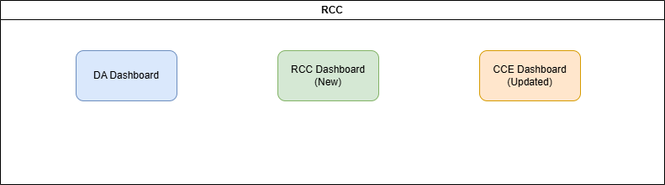
Task No. | Actor | Task Name and Description | Input | Output
 | RCC Dashboard | - New page showing the statistics for:  - Emergency and non- emergency RRI waiting MTC input appointment time  - Pending for Confirming appointment time with clients  - Created RRF III for review  - Outstanding draft complaint  - Repeated case for review | - NA | - One new page to show the statistic
 | CCE Dashboard | - Amend existing statistic page to show the statistics for CyberRCC:  - Number of general and emergency cases  - Longest waiting time in general and emergency queue  - Longest talk time  - Average talk time | - NA | - Updated page showing the statistics of CyberRCC.

    - Functional Requirements
      - List of Functional Requirements
Req. ID | Requirement Title | System
API-R1 | Updating the list to synchronize and the frequency | Data Exchange
API-R2 | Document received and verification | Data Exchange, DA
API-R3 | IC e-Certificate Management | DA
API-R4 | Allowing opt-out for FEHD cases | FEHD API, DA
WEB-R1 | User Registration | CyberRCC
WEB-R2 | User Login & Reset Password | CyberRCC
WEB-R3 | iAM Smart integration | CyberRCC
WEB-R4 | Two Factor Authentication | CyberRCC
WEB-R5 | User Account Management | CyberRCC
WEB-R6 | User Group | CyberRCC
WEB-R7 | Cancel Request | CyberRCC
WEB-R8 | Request follow up / General Enquiry | CyberRCC
WEB-R9 | E-Acknowledge of Completion | CyberRCC
WEB-R10 | New & Clone Repair Request | CyberRCC
WEB-R11 | Assigning CyberRCC Account in DA Phonebook | DA
WEB-R12 | Clone Location Code in Phonebook’s Account | DA
WEB-R13 | Address lookup service | CyberRCC
WEB-R14 | Item suggestion | CyberRCC
WEB-R15 | Download repair request record | CyberRCC
WEB-R16 | View and search repair request | CyberRCC
WEB-R17 | Emergency web request | CyberRCC, CCE
WEB-R18 | Add appointment to device calendar | CyberRCC
WEB-R19 | NetIQ integration | DA
WEB-R20 | DS functions in CyberRCC | CyberRCC, DA
WEB-R21 | Repair tree item configuration | CyberRCC, DA
WEB-R22 | Monthly report to B/Ds | DA
WEB-R23 | CyberRCC Dashboard for different user role | CyberRCC
WEB-R24 | API Receive MTC Request convert to MWO/WO | Data Exchange, DA
WEB-R25 | RCC Admin Functions in CyberRCC | CyberRCC
WEB-R26 | New RRF Report | DA
WEB-R27 | DA & CCE Dashboard Update | DA, CCE
WEB-R28 | CyberRCC Notification | CyberRCC
WEB-R29 | Different admin roles for B/Ds | CyberRCC

      - API-R1 Updating the list to synchronize and the frequency
Item | Description
Requirement ID | API-R1
Requirement Title | Updating the list to synchronize and the frequency
System | Data Exchange
Functional Requirement Description | Allow more data to synchronize (detail in UF-0001) between the DA and the MTC IT System and increase the frequency of data synchronization.
Acceptance Criteria | Successful transmission and receipt of additional data between the DA and MTC IT System, in accordance with the specified synchronization frequency.
Related Business Process | BP-004 Data Exchange between DA and MTC IT Platform

      - API-R2 Document received and verification
Item | Description
Requirement ID | API-R2
Requirement Title | Document received and verification
System | Data Exchange
Functional Requirement Description | The system receives two types of signed PDF files: Site Check Reports and Certificates for High-Risk Minor Works Orders (RRF).  Verification is conducted using Hong Kong Post e-Cert (Personal) with "Mutual Recognition" status.  Upon successful verification, the signed PDF files are uploaded to the file server and displayed on the relevant RRF page in both the Internal and External DA systems for easy access.
Acceptance Criteria | If the documents pass the verification, they are uploaded from the MTC IT Platform to the file server. Both the Internal and External DA systems have access to and display these documents on the relevant RRF page.  If verification fails, the documents will NOT be saved, and an audit log will be recorded.  If the system fails to download the documents after three attempts, an alert will be sent to the designated email address for prompt follow up.
Related Business Process | BP-003 Upload RRF document from MTC IT Platform

      - API-R3 IC e-Certificate Management
Item | Description
Requirement ID | API-R3
Requirement Title | IC e-Certificate Management
System | Data Exchange
Functional Requirement Description | Allow RCC Supervisor, DA user-admin to manage the IC e-Certification information in the DA.
Acceptance Criteria | RCC Supervisor and DA user-admin can add, update or remove the IC e-Certification information in the DA.
Related Business Process | BP-001 Submit e-Certificate Public Key  BP-002 Remove e-Certificate Public Key

      - API-R4 Allowing opt-out for FEHD cases
Item | Description
Requirement ID | API-R4
Requirement Title | Allowing opt-out for FEHD cases
System | FEHD API Web Service
Functional Requirement Description | For repair requests that are not associated with the market or public toilet group, but are issued with a FEHD-related location code reported through the hotline, the new API function enables requests from the FEHD Mobile Application to convert those cases into normal in DA System. These cases will be excluded from FEHD market or public toilet related report.  Upon successful conversion to a normal case, DA system automatically generates a bring up message to notify the MTC.
Acceptance Criteria | When the new API is invoked, the submitted FEHD cases will be updated to normal cases, and these cases will no longer be included in the FEHD Report.
Related Business Process | BP-005 Opt-out RRF in FEHD Report

      - WEB-R1 User Registration
Item | Description
Requirement ID | WEB-R1
Requirement Title | User Registration
System | CyberRCC
Functional Requirement Description | Users should have the ability to register an account through self-registration using a government email address (ending with gov.hk) or by utilizing an invitation link. During the registration process, users must provide email addresses, password, and other required information.
Acceptance Criteria | Input validation  The system must validate all required fields (e.g., email, password, address) to ensure compliance with specified criteria such as email format and password strength.  Unique Identifiers  The system will generate a unique account ID, ensuring that both email address and account ID are not already in use.  Email Verification  Users will receive email with a onetime passcode (OTP) to verify their email address.  Account Activation  After a user registers an account, the B/Ds admin must approve the registration including address before the user can create a repair request.  Error Handling  The system should deliver clear error messages for any validation failures or issues encountered during the registration process.
Related Business Process | BP-006 CyberRCC Website (B/Ds admin & General User)

      - WEB-R2 User Login & Reset Password
Item | Description
Requirement ID | WEB-R2
Requirement Title | User Login & Reset Password
System | CyberRCC, DA
Functional Requirement Description | Users can access CyberRCC through various methods, depending on whether they are on the internal network (GNET) or the external network, with Single Sign-On implemented for the DA system.  If a user fails to log in 5 times, the account will be locked for 15 minutes. After this period, the account will be automatically unlocked, or users reset their access using the “Forget password” function.
Acceptance Criteria | The system does not permit multiple logins. When a new login is detected, any existing session will be automatically logged out.  If a user remains idle for more than 30 minutes, the login session will expire, and an alert message will be prompted automatically.  Username & Password Login  Users can log in to CyberRCC via external network using their username and password. If a user enters the wrong password 5 consecutive times, their account will be locked for 15 minutes, and the user must either wait 15 minutes or reset their password to unlock the account.  Single Sign On  When a user logs into the departmental portal via the internal network (GNET), they are not required to log in again to access CyberRCC and DA.  Additionally, if a DS is already logged into the external DA, they will not need to log in again to access CyberRCC.  iAM Smart Login  Users can utilize iAM Smart to log in to CyberRCC via the external network, provided their accounts are linked between CyberRCC and iAM Smart.  Reset Password  This function requires user to input their registered email address. The system will then send a password reset link to that email. The user needs to use the link to reset their password.
Related Business Process | BP-006 CyberRCC Website (B/Ds admin & General User)  BP-007 CyberRCC Website (DS)

      - WEB-R3 iAM Smart Integration
Item | Description
Requirement ID | WEB-R3
Requirement Title | iAM Smart Integration
System | CyberRCC
Functional Requirement Description | Integrate the iAM Smart service to enable secure authentication and form filling for users accessing online services.
Acceptance Criteria | Account linking / de-linking  Users have the ability to link and de-link the account between CyberRCC and iAM Smart.  Authentication  As part of the iAM Smart functionality, the system supports OAuth 2.0 to provide secure user authentication via iAM Smart.  “e-ME” Form Filling  Another feature of iAM Smart, the system allows users to fill out forms using data from their iAM Smart profile.  Data Privacy  It is essential to ensure that user data remains secure throughout the entire process.
Related Business Process | BP-006 CyberRCC Website (B/Ds admin & General User)

      - WEB-R4 Two Factor Authentication
Item | Description
Requirement ID | WEB-R4
Requirement Title | Two Factor Authentication (2FA)
System | CyberRCC, DA
Functional Requirement Description | To access advanced features of the system, including searching B/D history and managing user, two factor authentication (2FA) is required. Consequently, 2FA is mandatory for admin roles. Logging in through iAM Smart is considered sufficient to meet the 2FA requirement.
Acceptance Criteria | 2FA only needs to be entered once and will remain active for the duration of that session.  CyberRCC  For B/Ds user, 2FA is not required.  For B/Ds admin and RCC admin, 2FA is mandatory at login. The 2FA process will utilize email to send and receive the verification code.  DA  All logins from the external network require 2FA. For DS Login, 2FA will use NETIQ to process the verification.
Related Business Process | BP-006 CyberRCC Website (B/Ds admin & General User)

      - WEB-R5 User Account Management
Item | Description
Requirement ID | WEB-R5
Requirement Title | User Account Management
System | CyberRCC
Functional Requirement Description | Different levels of access and capabilities to user(s) account based on their roles within the system.
Acceptance Criteria | B/Ds user  - Manage address  Users can add or delete the address for admin approval.  - Update password  Users have the ability to change their own account password.  - Update Basic Information  Users can modify their contact No. and set their default communication language  B/Ds admin  - Approve/Reject the user registration and address application  B/Ds admin will receive the new user registration including address after a user submit a user registration.  If B/Ds admin approve the registration including address, user can log into CyberRCC and report the case with the address. However, if the registration is rejected, user will not be permitted to log into CyberRCC.  B/Ds admin will receive the new address applications when a user registers or adds a new address.  If the B/Ds admin approves the address registration, the user can create repair requests for that address. However, if the address registration is rejected, the user will not be permitted to create any repair requests for that address.  At least one address must be approved for a B/Ds user role to remain active, with the exception for B/Ds admins.  Users will receive an email notification regarding the approval or rejection of their application.  - Activate/Deactivate/Delete Account  The B/Ds admins can deactivate a user’s account, preventing them from logging in.  B/Ds admin also have the capability to re-activate previously deactivated accounts.  B/Ds admin can delete a user’s account. which will permanently remove it from the system. However, the user can register again using the same email.  Users will receive a notification email for any changes to their account status.  - Send an invitation link to user’s email for account registration  B/Ds admin can send the email to user with account registration link.  - Batch Insert Account  B/Ds admins can upload an Excel file to batch insert account into CyberRCC.  - Department user account management  B/Ds admins can add, update, or delete users’ addresses within their respective department/bureau.
Related Business Process | BP-006 CyberRCC Website (B/Ds admin & General User)

      - WEB-R6 User Group
Item | Description
Requirement ID | WEB-R6
Requirement Title | User Group
System | CyberRCC
Functional Requirement Description | The B/Ds admin have the capability to create user groups and organize users according to the department/bureau structure. This functionality enhances the efficiency of user management.
Acceptance Criteria | User Group  The B/Ds admin and RCC Admin has the authority to create, update, and delete user groups, as well as assign users and admins to these groups.
Related Business Process | BP-006 CyberRCC Website (B/Ds admin & General User)

      - WEB-R7 Cancel Request
Item | Description
Requirement ID | WEB-R7
Requirement Title | Cancel Request
System | CyberRCC
Functional Requirement Description | After submitting a repair request, B/Ds users have the option to cancel the request if needed.
Acceptance Criteria | B/Ds user can click the button next to the RRI in the “Request Status” list to cancel the request. The action will create a new web request for CSO to handle.  The cancellation procedures vary based on the different statuses of repair requests:  - Pending (CSO not yet accepted):  The original web request will document user’s cancellation request, including the cancellation reason. The CSO will then issue a Form IV.  Status: Pending => Cancelled  - Pending (CSO accepted, BEO not yet processed):  Form I: Automatically cancels the accepted case and sends the cancelled case to a monitoring screen for acknowledgment by MTC.  Form III: Automatically cancels the original web request, adds audit logs and cancellation reason to the RRF, and provides a new button for BEO’s confirmation will be provided.  Status: Pending => Cancelled  - Arranged (Form I):  A new web enquiry request is created in the CCE queue, and the ACO will follow up on the request.  Status: Arranged => Cancelled  - Referred to D.O. (Form I converted, Form III):  A new web enquiry request is created in CCE queue, and the CSO will follow up on the request.  Status: Referred to D.O.
Related Business Process | BP-006 CyberRCC Website (B/Ds admin & General User)

      - WEB-R8 Request follow up / General Enquiry
Item | Description
Requirement ID | WEB-R8
Requirement Title | Request follow up / General Enquiry
System | CyberRCC
Functional Requirement Description | B/Ds user can submit a general inquiry about the system or request follow-up actions based on a specific repair request item (RRI) to the RCC.  (For detailed workflow, please refer to appendix A.5 ENQUIRY AND FOLLOW UP IN CYBERRCC FLOW)
Acceptance Criteria | General Inquiry  B/Ds users can submit general inquiries to RCC through CyberRCC. Once submitted, a new web enquiry request will be created in new CCE web enquiry queue for CSO to follow up.  RRI Follow-up  B/Ds users can create a follow-up request to the RCC regarding questions about the RRI. Users can choose from the following options:  - “Appointment Enquiry”  - Request of changing Appointment Time  - Miss Appointment  - “Progress Enquiry”  - “Workmanship Enquiry”  - “Cancel this Repair Request”  - “Others  If “Others” is selected, a remark must be provided; otherwise, the remark is optional.  New queues “Web Enquiry Queue – CHI / ENG” will be established in CCE to handle both general inquiries and RRI follow-ups.
Related Business Process | BP-006 CyberRCC Website (B/Ds admin & General User)

      - WEB-R9 E-Acknowledge of Completion
Item | Description
Requirement ID | WEB-R9
Requirement Title | E-Acknowledge of Completion
System | CyberRCC
Functional Requirement Description | B/Ds users can acknowledge the job completion date in CyberRCC. If the date does not align with site completion date provided by MTC, an exception report will be generated.
Acceptance Criteria | - B/Ds users are allowed to input the completion date in CyberRCC.  - If user’s completion date is later than MTC’s completion date, the user must provide a remark and upload photo/video. In this case, an exception report will be generated automatically.
Related Business Process | BP-006 CyberRCC Website (B/Ds admin & General User)

      - WEB-R10 New, Copy and Save Draft Repair Request
Item | Description
Requirement ID | WEB-R10
Requirement Title | New & Clone Repair Request
System | CyberRCC
Functional Requirement Description | Both the B/Ds user and B/Ds admin can submit repair requests to the approved addresses. They have the option to save a repair request as a draft when creating it. Additionally, they can copy cases from historical records to create new cases, which will automatically fill in certain fields for the user.
Acceptance Criteria | New repair request  Below are the steps for creating a new repair request, Fields marked with an asterisk (*) are mandatory:  - Users need to select an approved address*  - Add a new repair item*  - Select or input the position*  - Select the repair item*  - Upload photo or video  - Item remark*  - Other remark  - Select the communication language, default is Chinese  - Input the contact information (checkbox for ‘Same as reporter’)  - First name  - Last name*  - Primary contact No.*  - Secondary contact No.  - Input the remark  - Select whether a reply regarding the appointment time is required (default not required)  If the mandatory fields are not filled or do not match the related format checking (e.g. contact No. must consist of 8 digit), an error message with relevant details will be displayed on the screen.  Copy repair request  Users can create a new repair request by copying from historical cases within the past year. This action will automatically fill in the following fields:  - Record of repair item(s):  - Position  - Repair item  - Item remark  - Other remark  - Contact information  - Remark  - Require “reply the appointment time” or not  Save draft  While filling out the repair request, users can click the “Save as draft” button to preserve the inputted information.  Saved repair request can be found under the “Draft” tab in the “New repair request” function, where users can edit and delete the records.  Double-clicking a record will navigate user to the create repair request page with the saved information.  If the number of drafts has already reached the limit of 5, a warning message will be displayed to inform the user that no new repair request can be saved.
Related Business Process | BP-006 CyberRCC Website (B/Ds admin & General User)

      - WEB-R11 Assigning CyberRCC Account in DA Phonebook
Item | Description
Requirement ID | WEB-R11
Requirement Title | Assigning CyberRCC Account in DA Phonebook
System | DA
Functional Requirement Description | Allow existing DA phonebook accounts to be linked with CyberRCC account.
Acceptance Criteria | Auto Create phonebook account with CyberRCC Account  When a new CyberRCC account submits a repair request, and if the account information is not already in the DA phonebook, a new account will be automatically created in the DA phonebook.  Assign CyberRCC Account  Existing DA phonebook accounts can be linked with CyberRCC accounts using the CyberRCC Account Id. This linkage ensures cases reported by existing accounts can be displayed within CyberRCC.
Related Business Process | BP-006 CyberRCC Website (B/Ds admin & General User)

      - WEB-R12 Clone Location Code
Item | Description
Requirement ID | WEB-R12
Requirement Title | Clone Location Code
System | DA
Functional Requirement Description | Allow DA phonebook accounts to clone the location code from another account.
Acceptance Criteria | The target account will inherit all location codes from the specific source account.
Related Business Process | BP-006 CyberRCC Website (B/Ds admin & General User)

      - WEB-R13 Address lookup service
Item | Description
Requirement ID | WEB-R13
Requirement Title | Address lookup service
System | CyberRCC
Functional Requirement Description | When a B/Ds user or B/Ds admin adds or edits the reporting address, they can input a keyword, and the system will display suggested addresses through the address lookup service API.
Acceptance Criteria | The system determines the language and format of the displayed address based on the user's selected language in the CyberRCC system.  Once the user selects a suggested address, the system will automatically populate all the address fields except for the floor, block, and room fields. If the user wishes to modify the selected address, they must first clear all fields filled in by the system prior to making any amendments.
Related Business Process | BP-006 CyberRCC Website (B/Ds admin & General User)

      - WEB-R14 Item suggestion
Item | Description
Requirement ID | WEB-R14
Requirement Title | Item suggestion
System | CyberRCC
Functional Requirement Description | When the user creates a repair request, a list of suggested repair item will be displayed based on address selected by the user and department statistics.
Acceptance Criteria | The system utilizes data from the financial years 2022 to 2024 to present the most frequently reported repair items for suggestions in the following scenarios:  Quarter Address  Based on all reported repair cases for quarter addresses, repair items are categorized into kitchen/toilet types and other types:  - If the user selects a position related to the kitchen or toilet, the system will suggest the top 12 most frequently reported kitchen/toilet repair items.  - If the user selects a position other than kitchen/toilet, the system will suggest the top 12 most frequently reported repair items excluding kitchen/toilet items.  Non-Quarter Address  According to the user’s department, the system employs two algorithms to list suggested items:  - By default, the system will display the top 12 most frequently reported repair items from the past 2 years for all departments.  - In special cases, the system will present the top 12 most frequently reported repair items from the past 2 years specifically for the designated department. The admin can identify which departments are considered special and specify the associated repair items.  If users have bookmarked specific repair items, those items will replace the frequently appeared items in the suggestion list.  Admin has the capability to export system reports in CyberRCC to display more recent statistics and modify the suggestion list (Refer to WEB-R25 RCC Admin Functions in CyberRCC).
Related Business Process | BP-006 CyberRCC Website (B/Ds admin & General User)

      - WEB-R15 Download repair request record
Item | Description
Requirement ID | WEB-R15
Requirement Title | Download repair request record
System | CyberRCC
Functional Requirement Description | After a user submits a repair request, they have the option to download a text file containing the details of the repair request.
Acceptance Criteria | A text file containing the information related to the repair request can be downloaded by the user.
Related Business Process | BP-006 CyberRCC Website (B/Ds admin & General User)

      - WEB-R16 View and search repair request
Item | Description
Requirement ID | WEB-R16
Requirement Title | View and search repair request
System | CyberRCC
Functional Requirement Description | Users can view and search the reported repair cases, accessing detailed information for each case.
Acceptance Criteria | Search & Filter  Users can search for repair requests using the CRK, RRI or CRN identifiers. Additionally, they can filter the list by various statuses of the repair requests, including:  - Arranged  - Referred to D.O.  - Acknowledge  - Completed  - Cancelled  For Detail Search Criteria, please refer UF-0023 CyberRCC Repair Request Status.  For B/Ds users, they can view and search the records in past year.  For B/Ds admins, they can view and search the records specific to B/Ds, with a date range limited to a maximum of one year.  View the repair request  Users can view the completion date entered by MTC and access the follow-up history from the list. They can also click on related actions, including adding appointments to their device calendar, acknowledging the completion, making follow up enquiries, copying the case from the list.
Related Business Process | BP-006 CyberRCC Website (B/Ds admin & General User)

      - WEB-R17 Emergency web request
Item | Description
Requirement ID | WEB-R17
Requirement Title | Emergency web request
System | CyberRCC
Functional Requirement Description | Users can report an emergency repair request during the RCC office hours, and a new CCE queue will be created to manage those cases.
Acceptance Criteria | A checkbox will be provided for users to indicate the emergency of their request while reporting it. If the request is submitted during RCC office hours, it will be processed as an emergency and assigned to a new CCE web task. However, if the request is submitted outside of RCC office hours, a pop-up message will appear, informing user that they cannot select the emergency repair option.  CCE will establish new queues specifically for collecting and managing emergency web repair requests, which have a higher priority than general web queue.
Related Business Process | BP-006 CyberRCC Website (B/Ds admin & General User)  BP-008 CCE new queue for emergency web cases

      - WEB-R18 Add appointment time to device calendar
Item | Description
Requirement ID | WEB-R18
Requirement Title | Add appointment time to device calendar
System | CyberRCC
Functional Requirement Description | After the appointment time is scheduled, users have the option to add the appointment to their personal device calendar.
Acceptance Criteria | This function enables users to add the appointments to either Google Calendar or iOS Calendar. When a user clicks the 'Add Schedule' button in the mobile version, a pop up will appear with the creation details for either the iOS or Google Calendar. The user will need to confirm the addition of the appointment to their calendar.
Related Business Process | BP-006 CyberRCC Website (B/Ds admin & General User)

      - WEB-R19 NetIQ integration
Item | Description
Requirement ID | WEB-R19
Requirement Title | NetIQ integration
System | DA
Functional Requirement Description | Integrate the NetIQ service to generate the DS’s authentication code
Acceptance Criteria | When DS logs into the external DA, after validating the user ID and password, they must input the verifications code from the NetIQ application.
Related Business Process | BP-007 CyberRCC Website (DS)

      - WEB-R20 DS functions in CyberRCC
Item | Description
Requirement ID | WEB-R20
Requirement Title | DS functions in CyberRCC
System | CyberRCC
Functional Requirement Description | DS is allowed to access CyberRCC via the external DA page with functions different from B/Ds user.
Acceptance Criteria | After successfully logging into DA, DS can choose to go to DA system or CyberRCC.  After DS logging into DA, a new button for accessing CyberRCC appear in the menu and top banner. DS will not need to log in again to access CyberRCC.  Below are the functions for DS in CyberRCC:  Search RRF  An RRF search engine, allows users to conduct searches using CRN /RRI ID /MWO/WO NO. /Location Code without needing to specify a type.  Default frequently used time periods (e.g.,1 week, 1 month) are available as button for selection. Clicking a button will automatically populate the Call-in date or RRF Created Date for the search.  If the system can identify the area a DS belongs to, the DS can enable the “My RRF Only” option to search exclusively for their RRFs, using DGUS to filter the results.  Below are the searching criteria:  - CRN / RRI ID / MWO/WO No. / Location Code  - Call-in Date  - Location  - Area  - Location Code  - Position  - Phone  - Shift  - RRF Type  - RRF Status  - Cancelled RRF  - Channel  - High Risk  - Urgency  - Without Site Completion Date  - Without Site Completion Date (IC)  After performing a search, results can be exported in Excel format. The CRN in the Excel file will link to the CyberRCC RRF detail page. Clicking the record in the result list will also redirect to the RRF detail page.  Flag up  Display a list of flagged RRFs from the current user's team.  Inbox  A list of DA inbox message showing request with form type (Form I / Form III). DS can only view message in this list.  Monitor Screen (RRF III)  Display Form III wating for DS acknowledgement.  DA Statistic  - RRF 1 Status  - RRF 3 Status  - DA Monitoring  - RRF I & RRF III waiting for acknowledge  - Base Payment Claim Type pending for endorse  - No. of Default Notice pending for action  - Outstanding Exception Report  - Form I/III Pending Conversion/ Response  - Batched for audit  RCC Statistic  - Client Satisfaction Survey Result  - Statistics of Draft Complaint Received by RCC  - Statistic for certify completion of FEHD toilet / Market’ s RRF, Cyber RCC’s RRF  DA  A link back to DA system.  Alert  In DA RRF detail page, a new button allows RCC supervisor to create alert messages for DS when the post is equal to or above (up to PSM level) in DA and CyberRCC for reminders. The message will appear in the RRF detail page’s message bar and the CyberRCC Alert list.  Once the DS has read the message in DA or CyberRCC, it will no longer display in the message box of the RRF detail page. Users can find the record in request history if needed.  Additionally, when an RRF is issued with a VIP location and an emergency item, an email will be sent to SPSM as a reminder.
 | BP-007 CyberRCC Website (DS)

      - WEB-R21 Repair tree item configuration
Item | Description
Requirement ID | WEB-R21
Requirement Title | Repair tree item configuration
System | CyberRCC, DA
Functional Requirement Description | RCC supervisors can synchronize the repair tree items from DA to CyberRCC specifying different item remarks and examples.
Acceptance Criteria | Add fields below in DA for RCC supervisors to configure each repair item:  - item remark (Traditional, Simplified, English)  - item example (Traditional, Simplified, English)  - is Sync to CyberRCC  - is Required  Update the synchronize function in DA to ensure the latest repair items are synchronized to CyberRCC, including the required item remarks and examples.
Related Business Process | BP-006 CyberRCC Website (B/Ds admin & General User)

      - WEB-R22 Monthly report to B/Ds
Item | Description
Requirement ID | WEB-R22
Requirement Title | Monthly report to B/Ds
System | CyberRCC, DA
Functional Requirement Description | Create a new page for DA user-admin and RCC supervisor to configure each B/D’s location code, exclusion list and recipients. Generating the month reports in Excel and PDF format and send to each B/Ds via email.
Acceptance Criteria | Below are the settings can be configured on each report:  - Name of B/D  - Location code  - Recipients  - Other mailing list  - Other recipient  - Other report name  It allows for downloading and uploading the configuration in Excel format for review and updates.  The system will automatically generate the Excel and PDF based on configuration and sent them via email. CyberRCC B/Ds admin can log into CyberRCC system and download the Excel and PDF of their B/D.
Related Business Process | BP-009 Monthly Report to B/Ds

      - WEB-R23 CyberRCC Dashboard for different user role
Item | Description
Requirement ID | WEB-R23
Requirement Title | CyberRCC Dashboard for different user roles
System | CyberRCC
Functional Requirement Description | Provide different statistics for various user roles.
Acceptance Criteria | Below are the required dashboards for different user role:  B/Ds user  - Submitted RRI status  B/Ds admin  - Submitted RRI status by B/D  - User / address approval statistic  DS  - RRF 1 Status  - RRF 3 Status  - DA Monitoring  - RRF I & RRF III waiting for acknowledge  - Base Payment Claim Type pending for endorse  - No. of Default Notice pending for action  - Outstanding Exception Report  - Form I/III Pending Conversion/ Response  - Batched for audit  - Client Satisfaction Survey Result  - Statistics of Draft Complaint Received by RCC  - Statistic for certify completion of FEHD toilet / Market’ s RRF, Cyber RCC’s RRF  - Repair Request Status Distribution in top five bureaus/departments with most reported repair requests  - Repair Request Status Summary for all bureaus/departments
Related Business Process | BP-006 CyberRCC Website (B/Ds admin & General User)  BP-007 CyberRCC Website (DS)

      - WEB-R24 API Receive MTC Request convert to MWO/WO
Item | Description
Requirement ID | WEB-R24
Requirement Title | API Receives MTC’s Request for conversion to MWO/WO
System | Data Exchange, DA
Functional Requirement Description | Enhance Data Exchange program to receive “MTC’s request for conversion to MWO/WO” data in DA.
Acceptance Criteria | A new setting in DA to configure which areas are allowed raise requests for conversion to MWO/WO via API.  Data Exchange Program  A new endpoint will handle requests for “MTC request convert to MWO/WO”. Whether to accept the request will depend on the configuration in DA, with the default setting allowing all FEHD public toilet and public market’s requests.  Once the request is received in Data Exchange Program, the subsequent workflow will be same as original workflow in DA.
Related Business Process | BP-004 Data Exchange between DA and MTC IT Platform

      - WEB-R25 RCC Admin Functions in CyberRCC
Item | Description
Requirement ID | WEB-R25
Requirement Title | RCC Admin functions in CyberRCC
System | CyberRCC
Functional Requirement Description | RCC admin will have several system functions in CyberRCC.  - Announcement management  - User management  - Reset user password  - User role management  - System configuration  - Maximum period for searching RRF by DS  - Export and import function of FAQ excel  - Upload handbook  - Suggestion item setting  - All DS functions (refer to WEB-R20 DS functions in CyberRCC)  All RCC supervisors will act as CyberRCC’s RCC admin role automatically.
Acceptance Criteria | Announcement Management  RCC admin can create announcements with attachment and rich text formatting.  In advance, below are the setting for RCC admin posting an announcement:  - Publish date time  - Valid date time  - Show at login page / after login page  - Post category (normal / system)  - Is pop up  - Is send email needed  - Is valid  User Management  - Reset user password  RCC admin can find all the user’s profile and send the reset password links. The password must still adhere to the password policy guidelines.  - Management of user role  Upgrade or downgrade user to normal user or B/Ds admin user.  System configuration  - Maximum period for searching RRF by DS  Set limitations on DS searching period of RRF.  - Export and import function of FAQ excel  RCC admin can export the list of FAQ questions in Excel format and update the content by uploading a new Excel file. Below are the fields for RCC admin to configure the FAQ in Excel:  - Suggestion item setting  The system will generate a data analysis report by year, below are the data:  - By quarter and non-quarter  - Top 10 departments  - Top 20 repair items by top 10 departments  Based on the analysis, RCC admin can determine which repair items should be configured as suggestion items for both quarter and non-quarter cases.  All DS functions will be included in RCC admin account (refer to WEB-R20 DS functions in CyberRCC).
  Field | Description
  ID | The identity for system use only
  Question | The header of the question
  Content | The content of the question, allow text only.
  Keywords | A tag for showing in related FAQ if the question included the same keywords. Example:  login, repair request, password
  Status | Control the question is enable or disable in CyberRCC.  “A” represents enable  “D” represents disable
Related Business Process | BP-010 Cyber RCC Web (RCC Admin)

      - WEB-R26 New RRF Report
Item | Description
Requirement ID | WEB-R26
Requirement Title | New RRF Report
System | DA
Functional Requirement Description | RCC supervisor can download a new RRF Report containing all raw data, statistics and RRF by area worksheet.  The statistical layout is similar to FEHD monthly report but includes additional formula field. In the summary page, statistics will automatically update based on changes in the raw data set.
Acceptance Criteria | RCC supervisor can select the date range in DA to download the report.  The statistic of summary page can update based on changes in raw data page.
Related Business Process | BP-010 Cyber RCC Web (RCC Admin)

      - WEB-R27 RCC & CCE Dashboard Update
Item | Description
Requirement ID | WEB-R27
Requirement Title | RCC & CCE Dashboard Update
System | CyberRCC, DA
Functional Requirement Description | Create new RCC dashboard to show:  - Emergency and non-emergency RRI waiting input appointment time  - Pending for Confirming appointment time  - Created RRF III for review  - Outstanding draft complaint  - Repeated case for review  Amend the existing CCE dashboard to show CyberRCC data, ensure the layout structure align with inbound call and voice mail:  - Number of general and emergency cases  - Longest waiting time in general and emergency queue  - Longest talk time  - Average talk time
Acceptance Criteria | Both DA dashboard and CCE dashboard will display accurate data and refresh automatically based on the preset refresh rate.
Related Business Process | BP-011 DA & CCE Dashboard

      - WEB-R28 CyberRCC Notification
Item | Description
Requirement ID | WEB-R28
Requirement Title | CyberRCC Notification
System | DA
Functional Requirement Description | The system shall automatically send a notification and an email to the target user when a predefined event occurs. The notification shall be displayed within the system's user interface, and the email shall be sent to the user's registered email address. When sending the email, the system will follow user’s profile settings to determine if they are willing to receive the email, or a specific event will force the email to be sent to the user.
Acceptance Criteria | The predefined events include, but are not limited to:  - The system shall send the notification and email automatically.  - The notification and email contain predefined content.
  Address Approval
  Action | Target | Based on user setting
  New account registered | B/Ds admin | Y
  New address pending approval | B/Ds admin | Y
  Initial address approved | Owner | Override to send
  Address approved | Owner | Y
  Address rejected | Owner | Y
  Account Status
  Action | Target | Follow user setting
  Account disabled | Owner | Y
  Account enabled | Owner | Y
  Account deleted (no notification  ) | Owner | Y
  Account approved to admin role | Owner | Y
  Account downgrade to normal user role | Owner | Y
  Repair Request
  Action | Target | Follow user setting
  RRI status Pending -> Arranged | Owner | Y
  RRI status Pending -> Referred to D.O. | Owner | Y
  RRI status Arranged -> Acknowledge | Owner | Y
  RRI cancelled | Owner | Y
  New MTC re-attend time inputted | Owner | Y
  Others
  Action | Target | Follow user setting
  New monthly report released | B/Ds admin | Override not to send
  DS Alert | DS | Override to send
  Announcement | All user | Selection
Related Business Process | BP-006 CyberRCC Website (B/Ds admin & General User)  BP-007 CyberRCC Website (DS)

      - WEB-R29 Different admin roles for B/Ds
Item | Description
Requirement ID | WEB-R29
Requirement Title | Different admin roles for B/Ds
System | CyberRCC
Functional Requirement Description | Separate different roles to handle admin routine.
Acceptance Criteria | - B/Ds admin:  - The most powerful admin in B/Ds, include all admin functions and the ability to assign other admin role (excluding B/Ds admin role).  - Group admin:  - The admin can manage user accounts and search the cases that belongs to their assigned group. The admin does not have group management rights.  - Report admin  - The admin can download the monthly report but has no approval rights and group management rights.
Related Business Process | BP-006 CyberRCC Website (B/Ds admin & General User)

  - TECHNICAL REQUIREMENT
    - List of Technical Requirements
Req. ID | Requirement Table | Category | Target Users
TR-WEB-001 | Adopt Responsive Web Design | User Experience | All
TR-WEB-002 | Support of prevailing Internet Browsers | User Experience | All
TR-WEB-003 | Public Internet Access for DA Extranet and CyberRCC | User Experience | All
TR-WEB-004 | Hash Password for CyberRCC | Security | All

    - TR-WEB-001 Adopt Responsive Web Design
Item | Description
Requirement ID | TR-WEB-001
Requirement title | Adopt Responsive Web Design
Category | User Experience
Technical requirement description | The system shall implement a mobile-friendly Responsive Web Design (RWD) that automatically adjusts website content for optimal displayed on devices with varying screen sizes, resolutions and orientation, ensuring an enhanced viewing and interaction experiences.

    - TR-WEB-002 Support of prevailing Internet Browsers
Item | Description
Requirement ID | TR-WEB-002
Requirement title | Support of prevailing Internet browsers
Category | User Experience
Technical requirement description | The CyberRCC websites will feature RWD in three language versions: English, Traditional Chinese and Simplified Chinese. These sites will be accessible via common desktop and mobile Internet browsers on widely recognized operating systems such as Google Chrome, Mozilla Firefox, Microsoft Edge and Apple Safari, running on Windows, MacOS, Apple iOS and Android.

    - TR-WEB-003 Public Internet Access for DA Extranet and CyberRCC
Item | Description
Requirement ID | TR-WEB-003
Requirement title | Public Internet Access for DA Extranet and CyberRCC
Category | User Experience
Technical requirement description | The CyberRCC Website allows B/Ds users to access via the public internet. The DA Extranet enables DS to access it through the public internet as well. A proxy server will be established in the DMZ of QGO to transfer the request from the CyberRCC and DA through the public internet to the server in ArchSD.

    - TR-WEB-004 Hash Password in CyberRCC
Item | Description
Requirement ID | TR-WEB-004
Requirement title | Hash Password in CyberRCC
Category | Security
Technical requirement description | The CyberRCC Website will employ the MD5 Algorithm to hash the password combined with a unique string for secure transmission and storage in the. database.

- SYSTEM SPECIFICATION
  - FUNCIOTNAL SPECIFICATION
    - Required System Overview
Business Needs | Major Features | System Related Functions
CyberRCC | Web system for B/Ds users to view and report repair request. | UF-0008, UF-0009, UF-0010, UF-0011, UF-0012, UF-0013, UF-0014, UF-0015, UF-0016, UF-0017, UF-0018, UF-0020, UF-0021, UF-0023, UF-0024, UF-0025, UF-0026, UF-0027, UF-0029, UF-0030, UF-0031, UF-0032, UF-0036, UF-0038, UF-0039, UF-0040, UF-0041, UF-0042, UF-0043, UF-0044, UF-0045, UF-0049, UF-0052, UF-0053, UF-0054, UF-0055, UF-0056, UF-0057, UF-0058, UF-0059, UF-0060, UF-0061, UF-0062, UF-0063, UF-0068, UF-0069, UF-0070, UF-0071, UF-0072, UF-0073, UF-0074
DA System | Web system to handle and issue the repair request to the maintenance term contractor. | UF-0005, UF-0006, UF-0019, UF-0022, UF-0028, UF-0033, UF-0034, UF-0035, UF-0037, UF-0046, UF-0047, UF-0048, UF-0050, UF-0051, UF-0056, UF-0064, UF-0065, UF-0066, UF-0067, UF-0075
Data Exchange Program | Exchange data between DA System and MTC IT system. Verify the signed documents. | UF-0001, UF-0002, UF-0003, UF-0004, UF-0056
FEHD API Web Service | API Web Service for FEHD App to submit cases, cancel case, update FEHD completion date and exception report. | UF-0007

    - Function Definition
      - Data Exchange with MTC IT Platform
        - UF-0001 Update the list field to synchronize
Item | Description
Function ID | UF-0001
Function Name | Update the list field to synchronize
Category | System Interface
Related Requirements | Updating the list to synchronize and the frequency (API-R1)
Function Description | - Add additional fields to synchronize with the MTC IT System via existing Data Exchange Program.  - Images will be transmitted after being encoded using Base64.
Frequency | 3 times a day
Metadata
  Field to Be Added | Data Type
  Draft Complaint Date and Time | Datetime (YYYY-MM-DD hh:mm:ss.SSS)
  Draft Complaint Category | NVarchar (255)
  FEHD Site Completion Date | Datetime (YYYY-MM-DD hh:mm:ss.SSS)
  FEHD Certified Date | Date (YYYY-MM-DD)
  Cancelled RRF By RCC | Boolean
  IC Site Check Date | Date (YYYY-MM-DD)
  Client e-acknowledgement datetime | Datetime (YYYY-MM-DD hh:mm:ss.SSS)
  With client exception report | Boolean
  Client exception report date | Date (YYYY-MM-DD)
  FEHD repair media | varchar (Max)
  DS remark | NVarchar (255)
  MTC remark | NVarchar (255)
  MTC media upload datetime | Datetime (YYYY-MM-DD hh:mm:ss.SSS)
  WoMwoStatus | varchar (20)
  MTC apply claim type datetime | Datetime (YYYY-MM-DD hh:mm:ss.SSS)
  MTC apply claim type | varchar (50)
Interface Specification | Here is the updated Request JSON, the new fields are bold:  draftComplaints:
  Column | Type | Mandatory | Description
  crn | Integer (8) | Y | CRN of the RRF
  status | Varchar (20) |  | DA status of RRF
  mtcSiteCompletionDate | Date (YYYY-MM-DD) |  | Site completion date that is submitted by MTC
  mtcSubmitSiteCompletionDateTime | Datetime (YYYY-MM-DD hh:mm:ss.SSS) |  | The Date Time of MTC submit site completion date
  icSiteCompletionDate | Date (YYYY-MM-DD) |  | Site completion date that is submitted by IC
  icSubmitSiteCompletionDateTime | DateTime (YYYY-MM-DD hh:mm:ss.SSS) |  | The DateTime of IC submit site completion date
  orderNo | Varchar (45) |  | MWO/WO No Converted to ACTION
  claimType | Varchar (50) |  | Claim Type of the RRF
  convertDate | DateTime (YYYY-MM-DD hh:mm:ss.SSS) |  | DS convert RRF to ACTION from DA
  draftComplaints | List |  | List of Draft Complaints
  fehdSiteCompletionDate | Datetime (YYYY-MM-DD hh:mm:ss.SSS) |  | Site Completion Date from FEHD
  fehdCertifiedDate | Date (YYYY-MM-DD) |  | Certified Date from FEHD
  cancelledByRCC | Varchar(1) |  | If Cancelled RRF by RCC, then Y
  icSiteCheckDate | Date (YYYY-MM-DD) |  | Site Check Date from IC
  clientEAcknowledgementDate | Datetime (YYYY-MM-DD hh:mm:ss.SSS) |  | E-acknowledgement Datetime from CyberRCC
  withExceptionReport | Varchar(1) |  | If has Exception Report, then Y
  exceptionReportDatetime | Date (YYYY-MM-DD) |  | Client Upload Exception Report Date
  fehdRepairMedia | Base64 |  | Repair Media from FEHD
  dsRemark | NVarchar (256) |  | DS Remark
  mtcRemark | NVarchar (255) |  | MTC Remark
  mtcMediaUploadDatetime | Datetime (YYYY-MM-DD hh:mm:ss.SSS) |  | MTC Upload Media Datetime (Used Latest One)
  woMwoStatus | Varchar (20) |  | MWO/WO Status
  mtcApplyClaimTypeDatetime | Datetime (YYYY-MM-DD hh:mm:ss.SSS) |  | MTC Apply Claim Type Datetime
  mtcApplyClaimType | Varchar (50) |  | MTC Apply Claim Type
  Column | Type | Mandatory | Description
  draftComplaintCreatedDatetime | Datetime (YYYY-MM-DD hh:mm:ss.SSS) |  | Draft Complaint Created Date and Time
  draftComplaintCategory | NVarchar (255) |  | Draft Complaint Category

        - UF-0002 Increase the frequency of synchronisation
Item | Description
Function ID | UF-0002
Function Name | Increase the frequency of synchronization
Category | System Interface
Related Requirements | Updating the list to synchronize and the frequency (API-R1)
Function Description | Add an extra time slot (3 times in total) for performing the data exchange.
Frequency | Existing Timeslot  - 1st :12:30 ~ 13:00  - 2nd : 01:00 ~ 01:30  New Timeslot  - 3rd : 17:45 ~ 18:15

        - UF-0003 e-signature Document Transfer from MTC MWO IT System
Item | Description
Function ID | UF-0003
Function Name | e-signature File Transfer from MTC IT System
Category | System Interface
Related Requirements | Document received and verification (API-R2)
Function Description | - Send a request to the MTC MWO IT System to retrieve the RRF document URL  - Download documents from the URL, only PDF format is supported.  - If there is any failure during download process, an email will be sent to the designated email address
Frequency | 03:00 every day
Interface Specification | Specification of Document Retrieval Interface:  Specification of Response JSON:  Specification of documents JSON:
  Request URL | TBC by designated vendor of the MWO IT system of the MTCs
  Method | Post
  Content-Type | application/json;charset=UTF-8
  Column | Type | Description
  status | Varchar (20) | Success/ Error
  errorMessage | Varchar (200) | Error Message
  documents | Array | List of documents
  Column | Type | Description
  name | Varchar (100) | Document Name
  crn | Varchar (8) | RRF No.
  URL | Varchar (500) | Document URL

        - UF-0004 Document Verification with e-Signature and Statistics Report
Item | Description
Function ID | UF-0004
Function Name | Document Verification with e-Signature and Statistics Report
Category | Data Verification
Related Requirements | Document received and verification (API-R2)
Function Description | - Verify the e-signature of the document using the public key stored in DA.  - If the document is verified, move the file to the file server and update the corresponding RRF record with the file path  - If the document verification fails, send the failure result list to the MTC IT platform via web service and insert an audit log in the DA System.  For sample of verified document, please refer to Appendix – A1 Verified E-Signature Document Screen Capture.
E-Signature Certificate | Hong Kong e-Post Office: e-Cert (Personal) with “Mutual Recognition”
Metadata | RRF and Document Relationship:
  Field | Type | Value
  CRN | Varchar(8) | CRN number
  Document Type | Varchar(50) | Document  Report  (To Be discuss with designated vendor of the MWO IT system of the MTCs)
  Document Path | Varchar(1000) | The path in file server
Interface Specification | Specification of Fail Result Notification Interface:  Specification of failDocuments JSON:  Specification of Response JSON:
  Request URL | To Be Confirmed by designated vendor of the MWO IT system of the MTCs
  Method | Post
  Content-Type | application/json;charset=UTF-8
  Content | {failDocuments:<JSON of list of fail verification documents>}
  Column | Type | Description
  documentName | Varchar (100) | Document Name
  documentURL | Varchar (500) | URL to download the document
  Column | Type | Description
  status | Varchar (20) | Success/ Error
  errorMessage | Varchar (200) | Error Message
Document Name Format | <FileType>_<CRN>_YYYYMMDD_hhmmssSSS.pdf  File Type: ICSiteCheck  HRReport  Example: ICSiteCheck_70102030_20250101_152340435.pdf  ICSiteCheck_70102030_20250101_152430215.pdf
Document File | ICSiteCheck: MTC’s document to justify or support the work completion.  HRReport: High Risk Report
Email Server
  URL | ArchSDpsbmail.ArchSDrcc.cad.ArchSD.gov
  Sender | ITSupportRCC@archsd.gov.hk
Proxy Server
  URL | asdaproxy.cad.asd.gov
  Port | 8080
File Server Path | To Be Confirmed
Report | A report will show the received document with verification in Financial Year.
  Column | Type
  Financial Year | String
  Contract Number | String
  Number of Reports Received | Number
Housekeep Period | 6 years

        - UF-0005 View Document in DA
Item | Description
Function ID | UF-0005
Function Name | View Document in DA
Category | Presentation Layer
Related Requirements | Document received and verification (API-R2)
Function Description | - Display a hyperlink to the related document with e-signed from MTC in the RRF.  - Click on the hyperlink to view the document.  - DS can view if RRF attach IC Site Check Report or High-Risk Report in Batch for Audit Screen  - Allow to search Received IC Site Check Report in Search RRF  - Allow to search Received High Risk Report in Search RRF
Business Rule | Following Column will be added in Batch for Audit Screen and Search Batch screen:  For Search Batch screen, default past three months batch will be searched.  For Search RRF, following criterias are added:
  Column | Type | Description | Business Rule
  Site Check Reports | Hyperlink | “Y” indicate Site Check Reports Exist | Click to download the Site Check Reports
  High Risk Certificates | Hyperlink | “Y” indicate Certificates for High-Risk Minor Works Orders (RRF) | Click to download the Certificates for High-Risk Minor Works Orders (RRF)
  Column | Type | Business Rule
  Has Site Check Reports | Checkbox | Default unchecked. Check to search for RRF with site check reports.
  Has Certificates for High-Risk RRF | Checkbox | Default unchecked. Check to search for RRF with Certificates for High-Risk RRF.
Screen Capture | 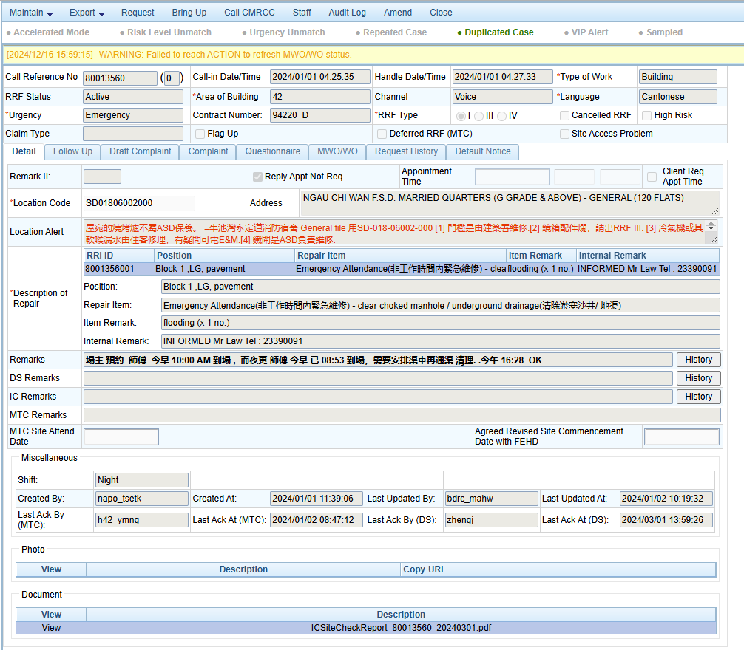  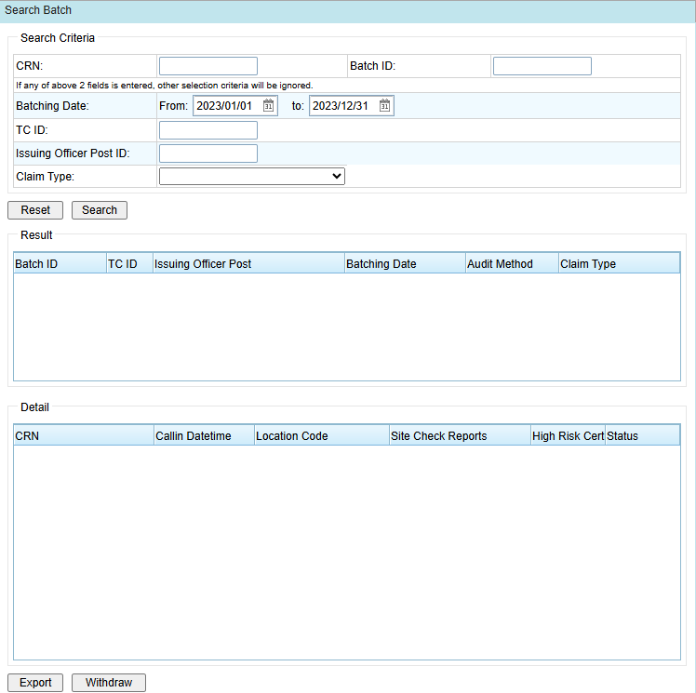  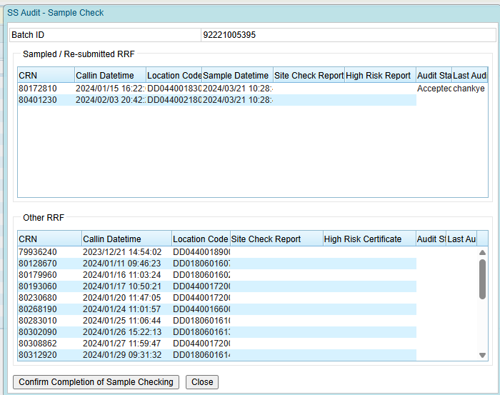  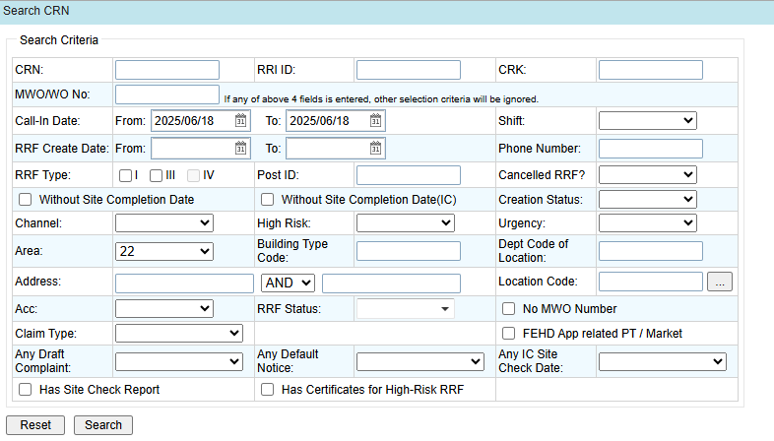

        - UF-0006 Update IC e-Certification information in DA
Item | Description
Function ID | UF-0006
Function Name | Update IC e-Certification information in DA
Category | Presentation Layer
Related Requirements | IC e-Certificate Management (API-R3)
Function Description | - A new page for the RCC Supervisor and DA user-admin to manage IC public key information  - Allow add, update or remove IC public keys
Metadata
  Fields | Type
  Contract Id | String
  IC Full Name | String
  Reference Number | String
  Public Key | String
  Search | Button
  Create | Button
  Remove | Button
Screen Capture | Menu:  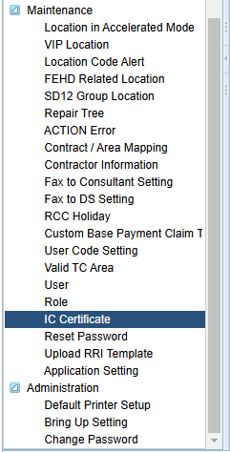  IC Certificate:  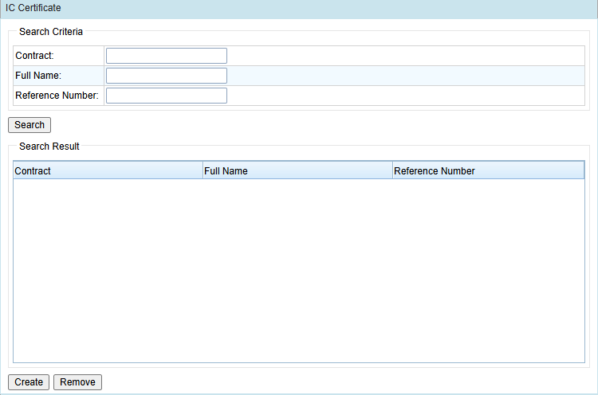  IC Certificate Detail:  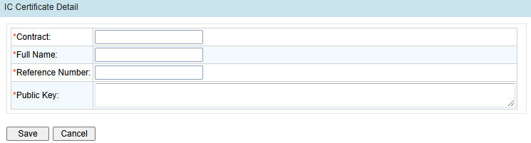

        - UF-0056 MTC Request Convert to MWO/WO API
Item | Description
Function ID | UF-0056
Function Name | MTC Request Convert to MWO/WO API
Category | System Interface
Related Requirements | API Receive MTC Request convert to MWO/WO (WEB-R24)
Function Description | - Send a request to MTC IT System to receive the MTC’s Request to Convert to MWO/WO, including remarks and supplementary documents  - Send the DS’s comment on the convert MWO/WO request to MTC IT System.  - DS can view the remarks and supplementary documents in DA
Metadata
  Field | Type
  For receiving MTC Request
  CRN | Varchar(8)
  RequestBy | Varchar(100)
  RequestDatetime | Datetime(YYYY-MM-DD hh:mm:ss.SSS)
  Remarks | NVarchar(255)
  Documents | Data File
  For returning DS’s comment
  CRN | Varchar(8)
  Comments | NVarchar(255)
Interface Specification | Specification of Retrieve MTC Request Convert to MWO/WO Interface:  Specification of Response JSON:  convertRequests:  Specification of Return DS comments on Request Conversion Interface:  Specification of Request JSON – conversionComments:  Specification of Response JSON:
  Request URL | To Be Confirmed by designated vendor of the MWO IT system of the MTCs
  Method | Post
  Content-Type | application/json;charset=UTF-8
  Column | Type | Description
  Status | Varchar(20) | Success/Error
  errorMessages | Varchar(200) | Error Message
  convertRequests | JSON Array | List of Convert Requests
  Column | Type | Description
  CRN | Varchar(8)
  SiteAccessProblem | Varchar(1)
  mtcSiteAttendDate | Datetime(YYYY-MM-DD)
  revisedSiteCommenceDateWithFehd | Datetime(YYYY-MM-DD hh:mm:ss.SSS)
  RequestBy | Varchar(100)
  RequestDatetime | Datetime(YYYY-MM-DD hh:mm:ss.SSS)
  Remarks | NVarchar(255)
  Documents | data | Supplementary Document
  Request URL | To Be Confirmed by designated vendor of the MWO IT system of the MTCs
  Method | Post
  Content-Type | application/json;charset=UTF-8
  Content | {conversionComments:<JSON of list of DS conversion comments>}
  Column | Type | Description
  crn | Varchar(8) | -
  comments | NVarchar(255) | DS Comments on the conversion MWO/WO requests
  Column | Type | Description
  Status | Varchar(20) | Success/Error
  errorMessages | Varchar(200) | Error Message
Frequency | Same as Current Data Exchange Frequency:  - 1st :12:30 ~ 13:00  - 2nd : 01:00 ~ 01:30  - 3rd : 17:45 ~ 18:15
Business Rule | After receiving the conversion request from MTC IT Platform, the Conversion to MWO/WO will be checked in the RRF in DA.  DS can view the pending conversion RRF on the original screen. By double-clicking the RRF, they can access the conversion remarks and supplementary document in RRF Detail. They can input their comments on the requests.  The logic for converting to MWO/WO will remain unchanged.
Screen Capture | RRF Detail:  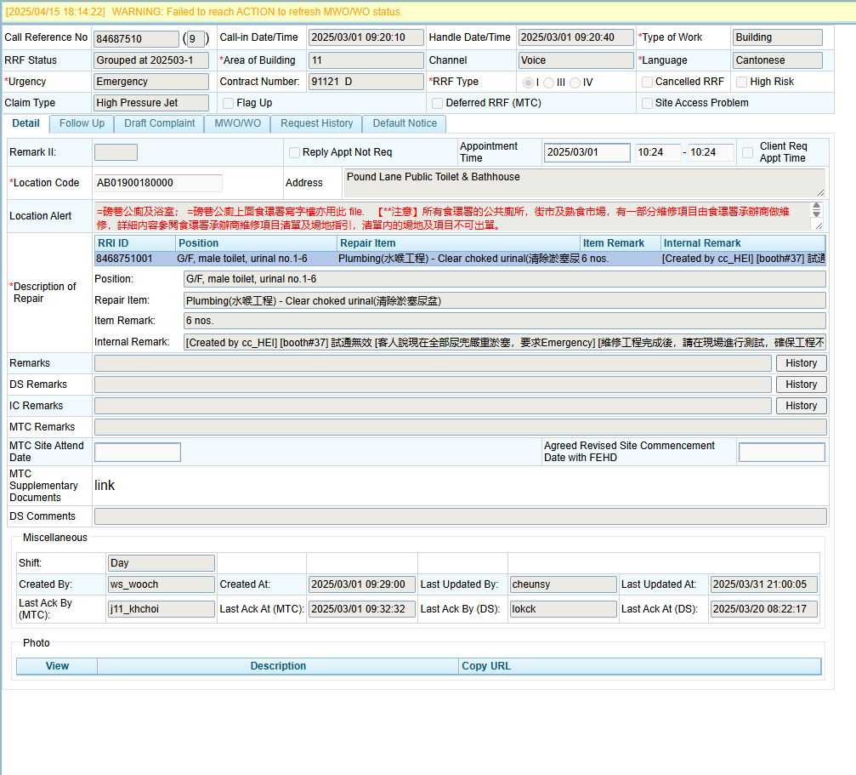

      - FEHD API Enhancement
        - UF-0007 FEHD Opt-out API
Item | Description
Function ID | UF-0007
Function Name | FEHD Opt-out API
Category | System Interface
Related Requirements | Allowing FEHD opt-out cases (API-R4)
Function Description | - A new API for FEHD App to opt out the RRF  - Update the RRF to be excluded from the FEHD related reports  - Add an audit log for the opt-out action in the RRF
Metadata
  Field | Type
  RRI | Integer
Interface Specification | Specification of Opt Out API:  Request JSON – optOutRequest:  Response JSON:
  URL | https://<IP>/rccapi/optOutRequest.json
  Method | Post
  Content-Type | application/json;charset=UTF-8
  Content | {optOutRequest:<JSON repair request encrypted by method mentioned below>}
  Encryption | Secure hash algorithm: SHA-256  Cryptographic algorithm: AES  Feedback mode: CBC  Padding scheme: PKCS5Padding  Output format: Base64
  Field | Mandatory | Type | Description
  repairDescId | Y | Varchar(10) | RRI ID
  remark | Y | NVarchar(255)
  reporterName | Y | NVarchar(40)
  reporterPost | Y | NVarchar(25)
  Column | Type | Description
  status | Varchar (20) | Success/ Error
  errorMessage | Varchar (200) | Error Message
Validation
  Validation | Error Message
  RRI Id Not Exists | The RRI Id does not exist
  RRF is FEHD cases | The RRF of RRI is not FEHD case

      - CyberRCC – B/Ds user Functions and Flows
        - UF-0008 CyberRCC User Registration
Item | Description
Function ID | UF-0008
Function Name | CyberRCC User Registration
Category | Online Update
Related Requirements | User Registration (WEB-R1)
Function Description | - B/Ds users must complete the sign-up form in CyberRCC.  - Email verification is required to proceed with the account submission (Details Refer to UF-0011).  - During the form completion, B/Ds users set their password.  - Validation will be applied to all fields, and any invalid input will trigger an immediate prompt.  - B/Ds users also have the option to use iAM Smart for filling out the form. (Details Refer to UF-0010)  - B/Ds user are required to provide at least one address for reporting repair requests.  - After clicking the “Submit” button, a review page will appear for verification.  - Once the submission is completed, a confirmation screen will be displayed.
Business Flow | Refer to Appendix A.2 CyberRCC User Registration Flow.
Metadata | User Registration Form:
  Field | Type
  Login Email | Varchar(100)
  Email Verification Code | Varchar(6)
  Password | Varchar(14)
  Confirm Password | Varchar(14)
  Title | Varchar(4)
  Last Name (Eng) | Varchar(20)
  First Name (Eng) | Varchar(20)
  Last Name (Chi) | NVarchar(20)
  First Name (Chi) | NVarchar(20)
  Primary Contact No. | Integer
  Secondary Contact No. | Integer
  Bureau/Department | Varchar(100)
  Group | Integer
  Post | NVarchar(25)
  Communication Language | Varchar(50)
  Quarter Resident | Boolean
  Area | NVarchar(100)
  District | NVarchar(100)
  Street/Estate/Village/Building | NVarchar(200)
  Block | NVarchar(100)
  Floor | Integer
  Flat | Varchar(10)
  Other Descriptions | NVarchar(250)
  Effective start date | Date
  Effective end date | Date
  Add Address | Button
  Remove Address | Button
  Edit Address | Button
  Form Filling with iAM Smart | Button
  Sign Up | Button
  Confirm | Button
  Cancel | Button
  Submit | Button
  Send Code/Resend Code | Button
  Verify | Button
Business Rule
  Field  (* mandatory) | Mode | Description | Business Rules
  Registration Page
  Form Filling with iAM Smart | Button | - | Click to fill in the form using iAM Smart.
  *Login Email | Free Text | Account Login Email for CyberRCC | - Must be in correct email format – xxx@xxx.xxx  - Email address must be verified
  Send Code/ Resend Code | Button | - | Click to send the verification code to the email.  A one-minute countdown will be enforced before clicking again after sending the code.
  Verified | Display | - | Indicates when the email is verified.
  *Verification Code | Free Text | Verification code for email | Max. length: 6
  Verify | Button | - | Click to verify the email verification code
  *Password | Free Text | Login password for CyberRCC | - Must be masked in the input field.  - Must fulfil Strong Password Policy:  - 8 to 14 Characters  - Combination of letters, capital letters, numbers and special symbols  - Spaces are not allowed
  *Title | Radio Button | User’s salutation | Default value: Mr.
  *Last Name (Eng) | Free Text | User’s last name
  *First Name (Eng) | Free Text | User’s first name
  Last Name (Chi) | Free Text | User’s last name in Chinese | Chinese characters are allowed in this field.
  First Name (Chi) | Free Text | User’s first name in Chinese | Chinese characters are allowed in this field.
  *Primary Contact No. | Free Text | User’s primary contact No. | - Max. length: 8  - Numeric only  - No space/’-‘ is allowed
  Secondary Contact No. | Free Text | User’s secondary contact No. | - Max. length: 8  - Numeric only  - No space/’-‘ is allowed
  *Department/ Bureau | Dropdown | Dropdown list of user bureau/department
  Group | Dropdown | Dropdown of user group defined by B/Ds admin
  *Post | Free Text | User’s post | - Mandatory  - Chinese characters are allowed in this field  - Max. length: 25
  Communication Language | Radio button | Selection between Chinese and English. | Default value: Chinese
  Add New Address | Button | - | Click to pop up add address screen
  Remove Address | Button | - | Click to remove an address
  Edit Address | Button | - | Click to pop up the address screen to edit address
  *Agree Term & Contract | Checkbox | User's agreement to terms and contract. | Default value: Unchecked
  *Agree Privacy Agreement | Checkbox | User's agreement to the privacy policy. | Default value: Unchecked
  Allow Receive Email & Notification | Checkbox | User's preference for receiving emails and notifications. | Default value: Unchecked
  Sign Up | Button | - | Click to redirect to Preview Page
  Add Address Page
  Is Quarter | Radio button | Indicates if the user needs to report a quarter address. | Default value: No
  Area | Free Text | - | Autofill if Street/ Estate/ Village/ Building is selected
  District | Free Text | - | Autofill if Street/ Estate/ Village/ Building is selected
  Street/Estate/Village/Building | Recommend Text box | User’s Address | - Mandatory  - Chinese characters are allowed in this field  - Maximum length: 255
  Block | Free Text | User’s Block | - Maximum length: 100  - Chinese characters are allowed in this field
  Floor | Free Text | User’s Floor | -
  Flat | Free Text | User’s Flat | - Maximum length: 10
  Other Description | Free Text | - | -
  Cancel | Button | - | - Click to cancel edit/add the address  - Address screen will be closed
  Confirm | Button | - | - Click to add/update the address  - Address screen will be closed
  Preview Page
  Back | Button | - | - Click to return to Registration Page
  Submit | Button | - | - Click to Submit Registration  - Forwards to Finish Page
  Finish Page
  Sign in | Button | - | Click to proceed to the Sign in Page
Screen Capture | Registration Form:  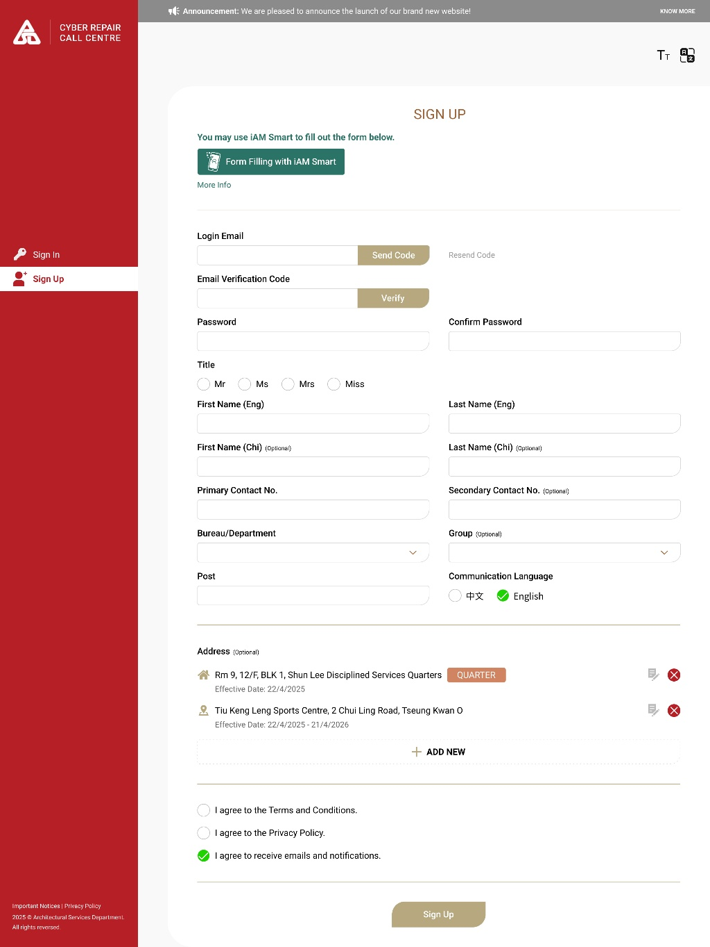  Add Address:  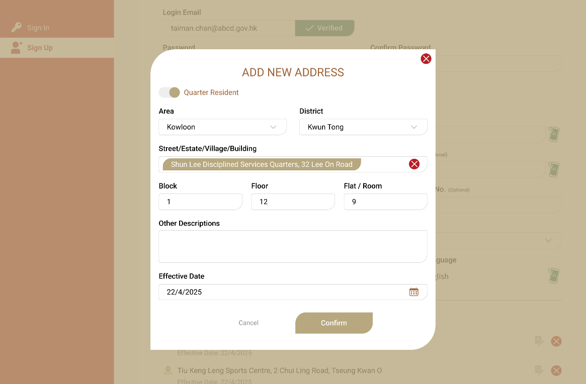  Preview Registration:  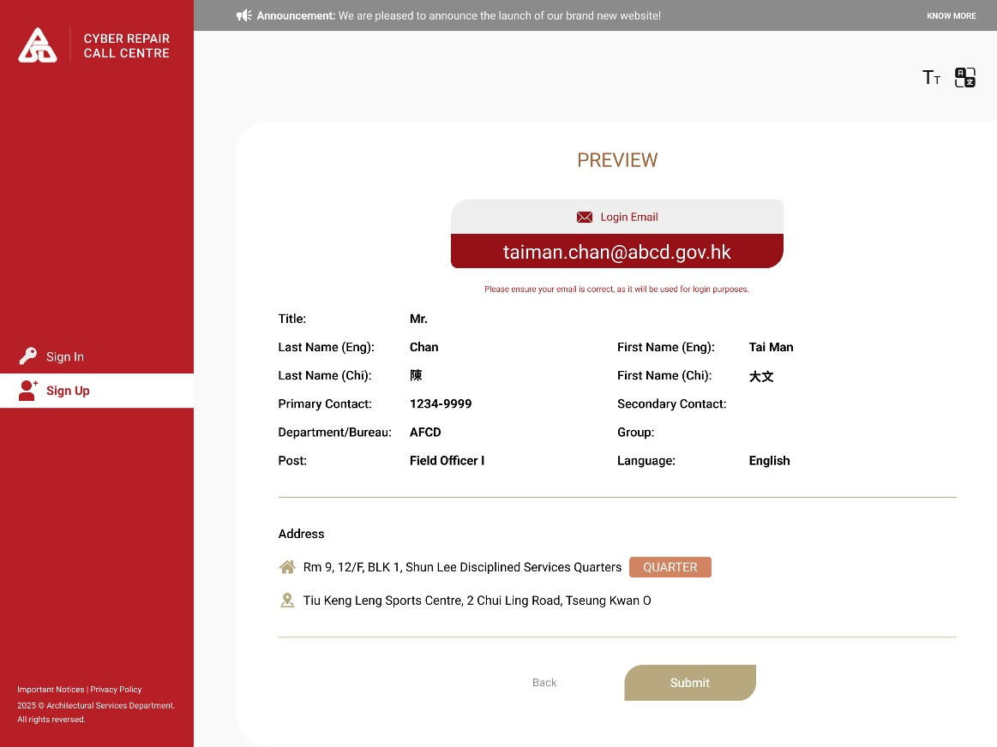  Finish Registration:  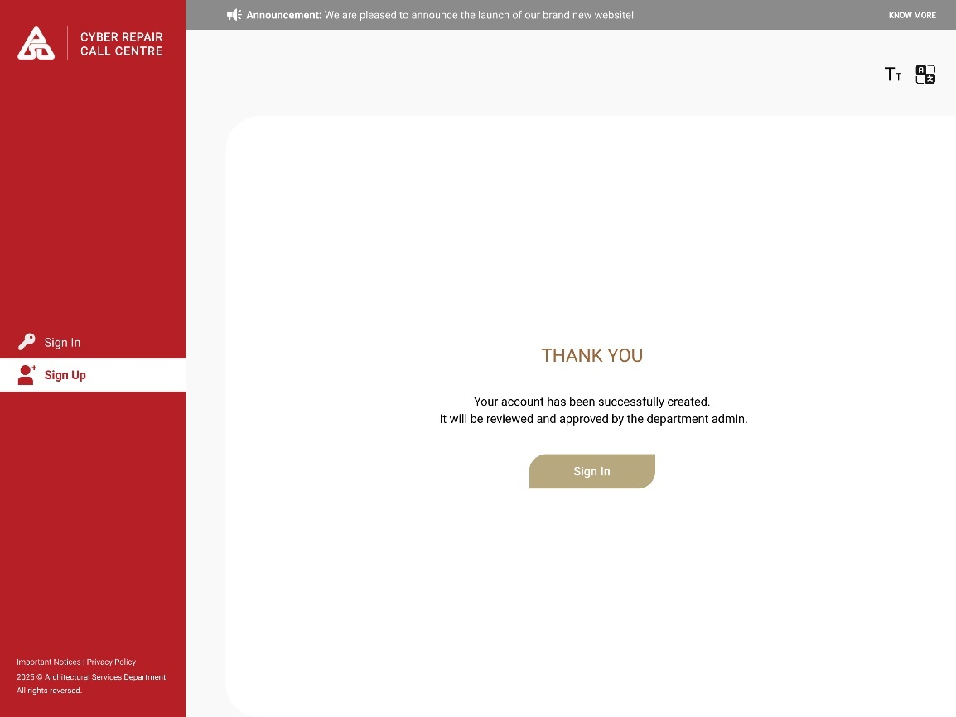

        - UF-0009 CyberRCC Account Login
Item | Description
Function ID | UF-0009
Function Name | CyberRCC Account Login
Category | Presentation Layer
Related Requirements | User Login & Reset Password (WEB-R2)
Function Description | - B/Ds admin and users can log in via the public internet using following methods  - Login using iAM Smart  - Login using login email and password  - B/Ds admin and users can also utilize single sign-on through the departmental portal  - ArchSD DS can utilize single sign-on through DA  - If users fail to log in more than 5 times, their account will be locked for 15 minutes. The account will automatically unlock after this period.
Metadata
  Field | Type
  Login through public internet
  Login Email | Varchar(100)
  Password | Varchar(14)
  Login | Button
  Sign in with iAM Smart | Button
  Sign Up | Button
  Login through department portal
  Dept_id | Varchar(50)
  U_id | Varchar(50)
  CN | Varchar(50)
  Login through DA
  LoginID | Varchar(50)
Business Rule/Validation | - Login through the public internet  - Via Login Email and Password  - Users must enter the correct login email and password.  - Via iAM Smart Authentication  - Users must have a CyberRCC Account linked to their iAM Smart Account.  - Login through departmental portal  - B/Ds users log into their departmental portal and select CyberRCC.  - Information such as Department Id, Account Id and Name will be encrypted and transmitted to CyberRCC for single sign-on.  - Login through DA  - ArchSD DS log into DA and select CyberRCC from the DA Menu or top banner.  - The login ID will be encrypted and sent to CyberRCC for a single sign-on.
Screen Capture | 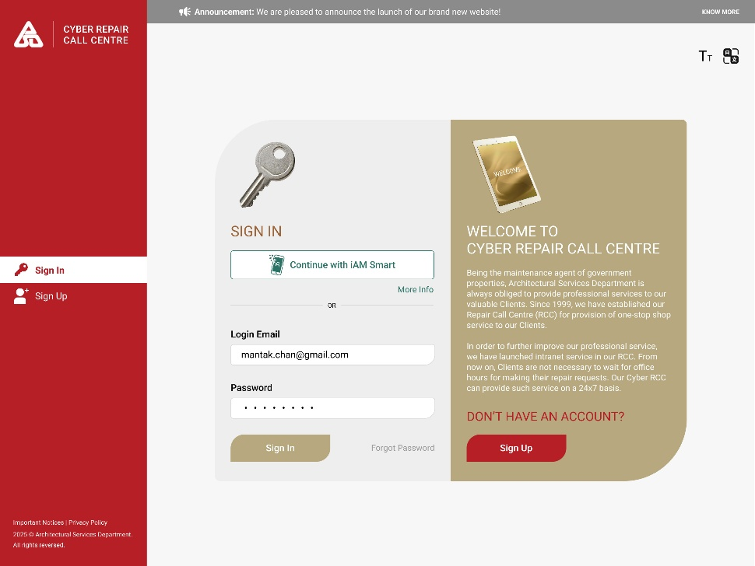

        - UF-0010 CyberRCC iAM Smart Integration
Item | Description
Function ID | UF-0010
Function Name | CyberRCC iAM Smart Integration
Category | Online Update
Related Requirements | iAM Smart Integration (WEB-R3)
Function Description | - B/Ds admin and users can log in by their iAM Smart account with Authentication function.  - B/Ds admin and users can fill in personal information by their iAM Smart account with “e-ME” form filling function.  - B/Ds admin and users can link their iAM Smart account to their CyberRCC account
Form Filling Data | User Registration and User Profile Update:
  iAM Smart Field | CyberRCC user information
  Prefix | Title
  Office Phone Number | Primary Contact No.
  Mobile Phone Number | Secondary Contact No.
  First Name | First Name
  Last Name | Last Name
Screen Capture | Sign In Page:  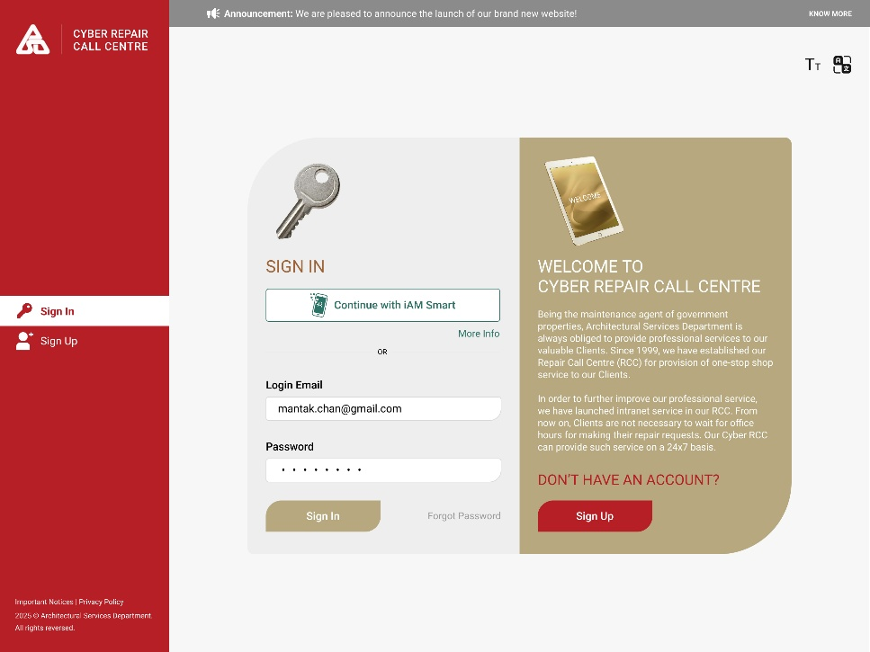  Registration Form:  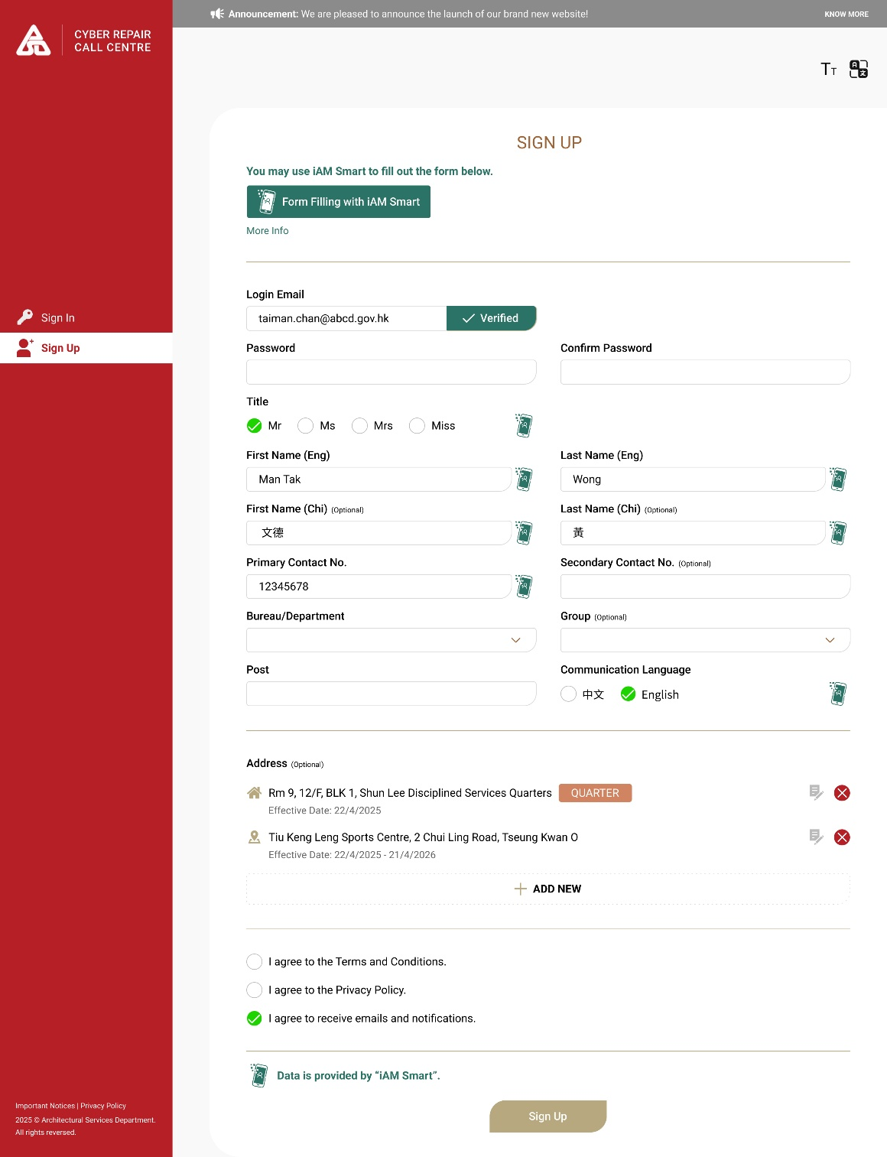

        - UF-0011 CyberRCC User Email Verification
Item | Description
Function ID | UF-0011
Function Name | CyberRCC User Email Verification
Category | Online Update
Related Requirements | User Registration (WEB-R1)
Function Description | - An email with the verification code will be sent to the B/Ds users for email verification during registration.  - B/Ds users enter the verification code from the email to verify their email address on the user registration form.  - An email with the verification code will be sent to the B/Ds users when they first login the account created by B/Ds admins.  - B/Ds users need to enter the verification code to verify the email when they first login the account created by B/Ds admins.
Metadata
  Field | Type
  User Registration
  Login Email | Varchar(100)
  Send Code/Resend Code | Button
  Verification Code | Varchar(6)
  Verify | Button
  Email
  Verification Code | Varchar(6)
Screen Capture | 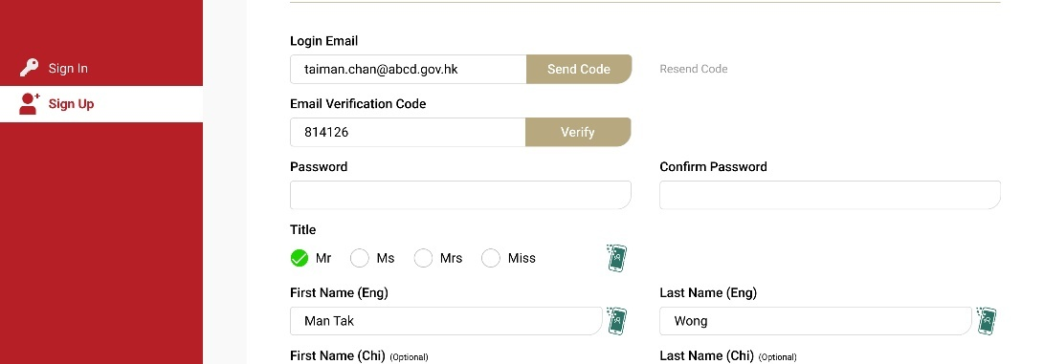  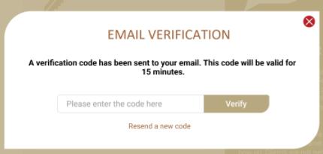
Email Template
  Sender | To be confirmed by ArchSD
  Subject | [ArchSD] Email Verification for CyberRCC
  Content | Thank you for registering for CyberRCC.  Your Email Verification Code is <<verification code>>

        - UF-0012 CyberRCC Reset Password
Item | Description
Function ID | UF-0012
Function Name | CyberRCC Reset Password
Category | Presentation Layer
Related Requirements | User Login & Reset Password (WEB-R2)
Function Description | - CyberRCC users can click Forget Password on the Sign in page.  - CyberRCC users enter the login email and the correct captcha to receive a reset email on the Forgot Password page.  - An email with a reset password page URL will be sent to the login email.  - CyberRCC users click the URL and will be redirected to the reset password page.  - CyberRCC users update their password on the reset password page.  - After successfully updating the password, the successful email will be sent.  - CyberRCC users must update their password if it has been in use for more than six months.
Metadata
  Field | Type
  Forget Password
  Login Email | Varchar(100)
  Captcha | Varchar(8)
  Reset Password | Button
  Reset Password
  New Password | Varchar(14)
  Re-Type new Password | Varchar(14)
  Reset Password | Button
  Email
  Reset Link | URL
Business Rules / Verification
  Field | Mode | Description | Validation
  Forget Password
  Login email | Free Text | Login email | - Mandatory  - Must be in the correct email forma  - Must be valid in CyberRCC
  Captcha | Free Text | Compulsory Captcha Code | - Mandatory  - Must match with generated randomized captcha
  Reset Password | Button | - | - Click to send the reset password email  - Redirect to Forget Password Email Sent Page
  Reset Password Page
  New Password | Free Text | - | - Mandatory  - Must fulfil strong password policy:  - 8 to 14 Characters  - Combination of letters, uppercase letters, numbers and special symbols  - No Spaces are allowed  - Cannot be same as previous eight passwords
  Re-Type new Password | Free Text | - | - Must match the New Password
  Reset Password | Button | - | - Click to reset the password  - Redirect to Reset Password Successful Page after a successful reset
Screen Capture | Forget Password:  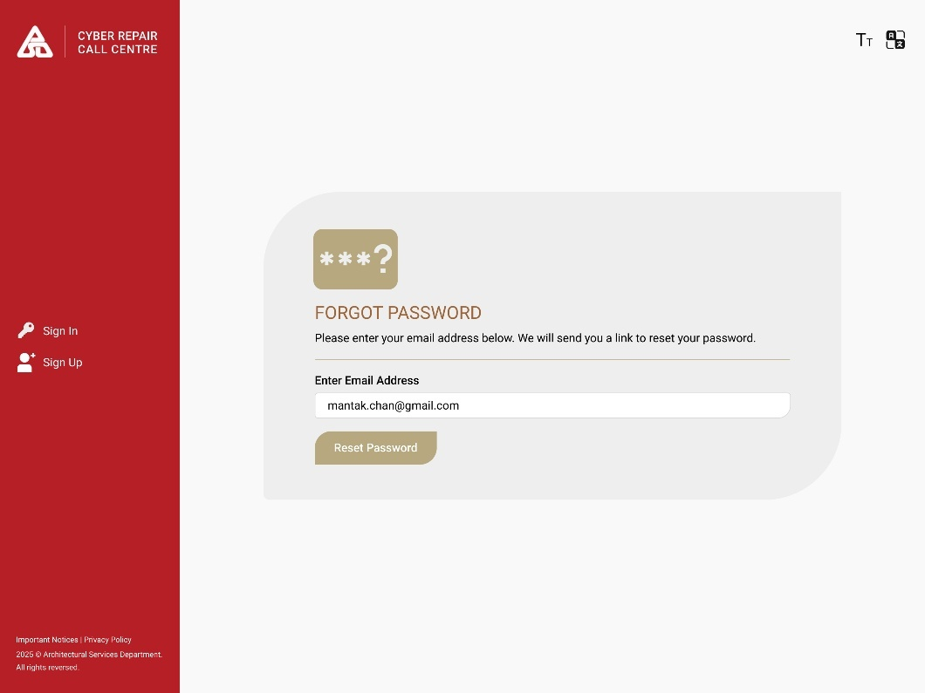  Forget Password Email Sent:  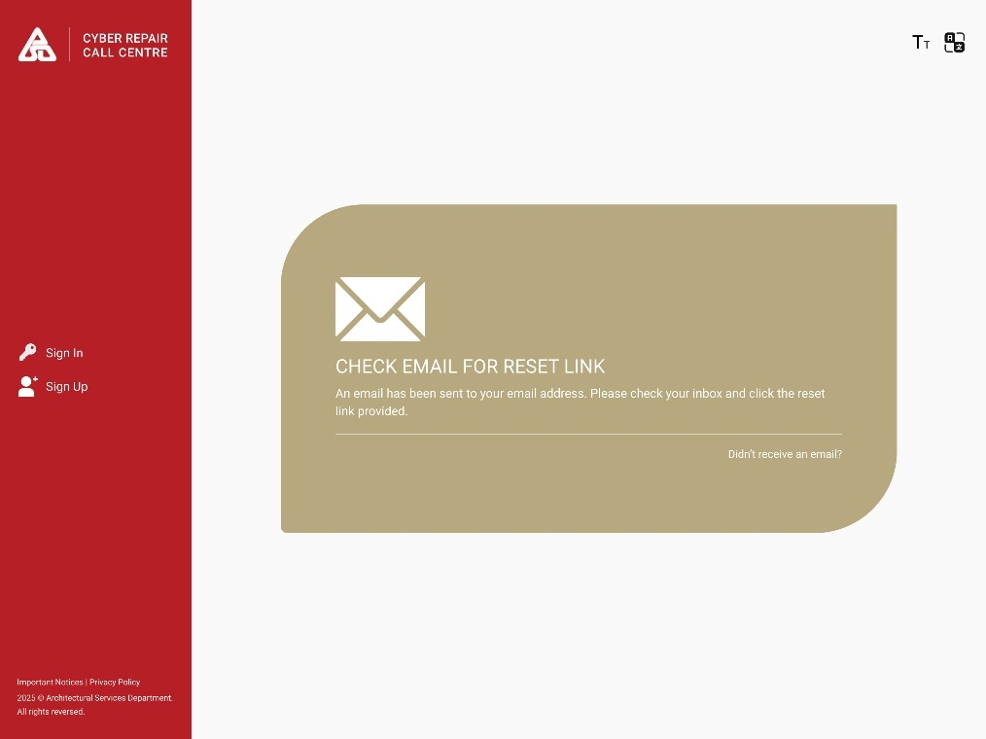  Reset Password:  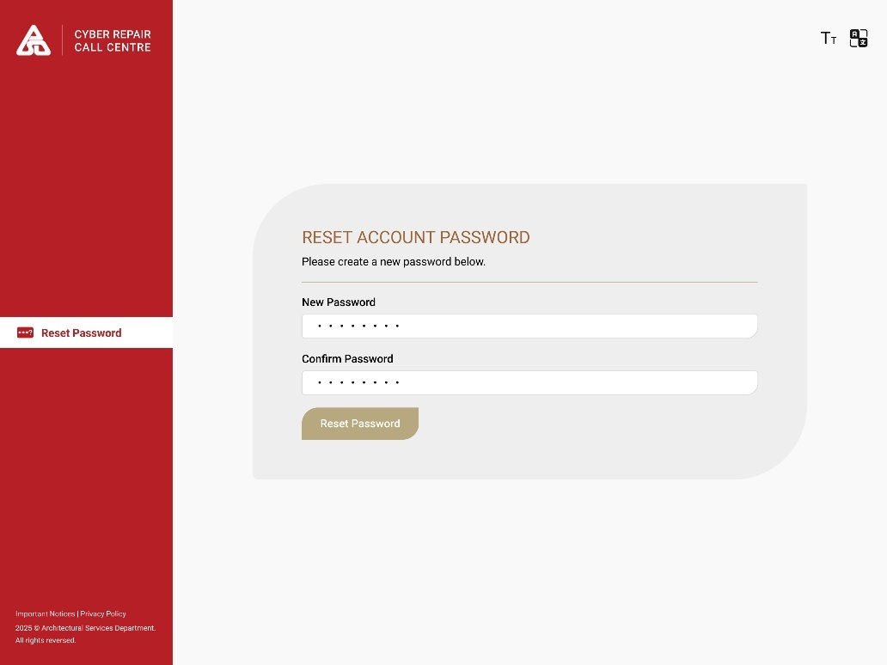  Reset Password Successfully:  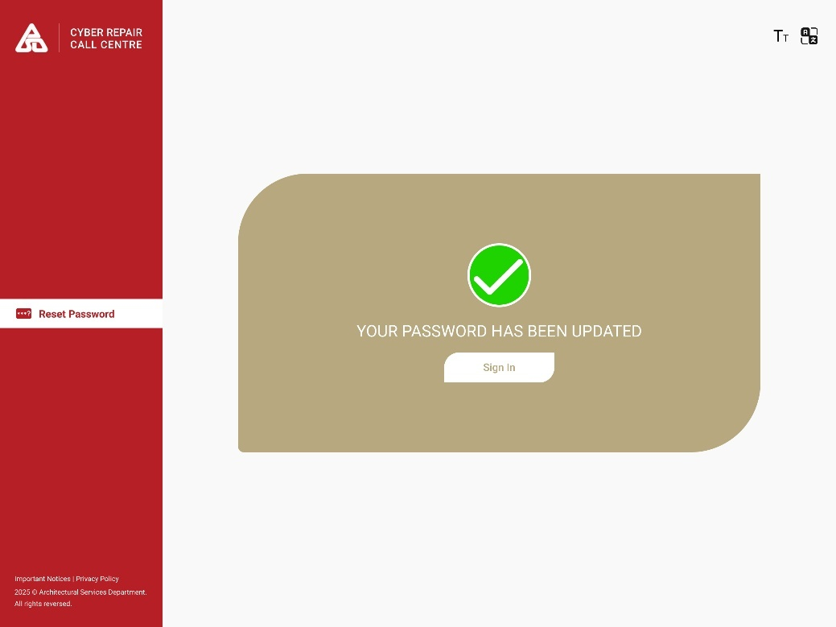
Email Template | For Password Reset Email:  For Password Update Successful Email:
  Sender | To Be Confirmed by ArchSD
  Subject | [ArchSD] Password Reset for CyberRCC
  Content | You have submitted a password reset request.  Please click the link below to update your new password for CyberRCC.  <<URL>>
  Sender | To Be Confirmed by ArchSD
  Subject | [ArchSD] Password Reset Successfully for CyberRCC
  Content | Your password has been successfully updated.

        - UF-0014 CyberRCC Account Information
Item | Description
Function ID | UF-0014
Function Name | CyberRCC Account Information
Category | Presentation Layer
Related Requirements | User Account Management (Web-R5)
Function Description | - CyberRCC users can view their account profile.  - CyberRCC users can update their account information.  - CyberRCC users can update their password.  - CyberRCC users can update their address list.  - If CyberRCC users successfully update their password, a confirmation email will be sent.
Metadata | Address Detail:
  Field | Type
  Name | NVarchar(60)
  AccountID | Varchar(5)
  Bureau/Department | Varchar(100)
  Login Email | Varchar(100)
  Primary Contact No. | Integer
  Secondary Contact No. | Integer
  Post | NVarchar(25)
  Group | Varchar(50)
  User Status | Varchar(50)
  Detail Address | NVarchar(500)
  Password | Varchar(14)
  Confirm Password | Varchar(14)
  Agree to receive email and notification | Boolean
  Form Filling with iAM Smart | Button
  Save Changes | Button
  Reset | Button
  Remove Address | Button
  Add Address | Button
  Field | Type
  Address | NVarchar(300)
  Building/Block | NVarchar(100)
  Floor | Integer
  Flat | Varchar(10)
  Is Quarter | Varchar(1)
Business Rule/ Validation
  Field | Mode | Description | Business Rule
  Login Email | Display | B/Ds user’s Login Email | -
  AccountID | Display | B/Ds user Account ID | -
  Title | Display | B/Ds user Title | -
  Last Name (Eng) | Display | B/Ds user English Last Name | -
  First Name (Eng) | Display | B/Ds user English First Name | -
  Last Name (Chi) | Display | B/Ds user Chinese Last Name | -
  First Name (Chi) | Display | B/Ds user Chinese First Name | -
  *Primary Contact No. | Free Text | B/Ds user Primary Contact | -
  Secondary Contact No. | Free Text | - | -
  Bureau/Department | Display | B/Ds user’s Bureau/ Department | -
  Group | Dropdown | - | -
  Post | Free Text | - | -
  Comm. Language | Radion Button | B/Ds user’s communication language | Option:  - Chinese  - English
  Password | Text | - | Must fulfil strong password policy:
  Re-Type Password | Text | - | Must match the Password
  Continue with iAM Smart | Button | Link Account with iAM Smart | Click to link CyberRCC Account with iAM Smart
  Receive Email Notification | Checkbox | - | -
  Address List
  Address | Display | - | Dimmed if the address is not verified
  Quarter | Display/Icon | - | Will be shown if the address is quarter.
  Remove | Button | Remove Address | - Click to delete address.  - If the address is not verified or after effective date, it will be directly deleted after clicking it.
  Edit | Button | Edit Address | - Click to edit the address  - The Address Edit Screen will be prompted
  Add New | Button | Add Address | - Click to add an address  - The Address Add Screen will be prompted
  Address Add/Edit
  Is Quarter | Radio button | Radio button: Yes/No  If user needs to report Quarter Address | Default No
  Area | Free Text | - | Autofill if Street/ Estate/ Village/ Building is selected
  District | Free Text | - | Autofill if Street/ Estate/ Village/ Building is selected
  Street / Estate / Village / Building | Recommend Text box | User’s Address | - Chinese characters are allowed in this field  - Max. length: 255
  Block | Free Text | User’s Block | - Max. length: 100  - Chinese characters are allowed in this field
  Floor | Free Text | User’s Floor | -
  Flat | Free Text | User’s Flat | Max. length: 10
  Other Description | Free Text | - | -
  Effective Date | Date picker | Effective Date of the address | With a start / end date
  Cancel | Button | - | - Click to cancel edit/add the address  - The Address add/edit screen will be closed
  Confirm | Button | - | - Click to add/update the address  - The Address add/edit screen will be closed
Screen Capture | 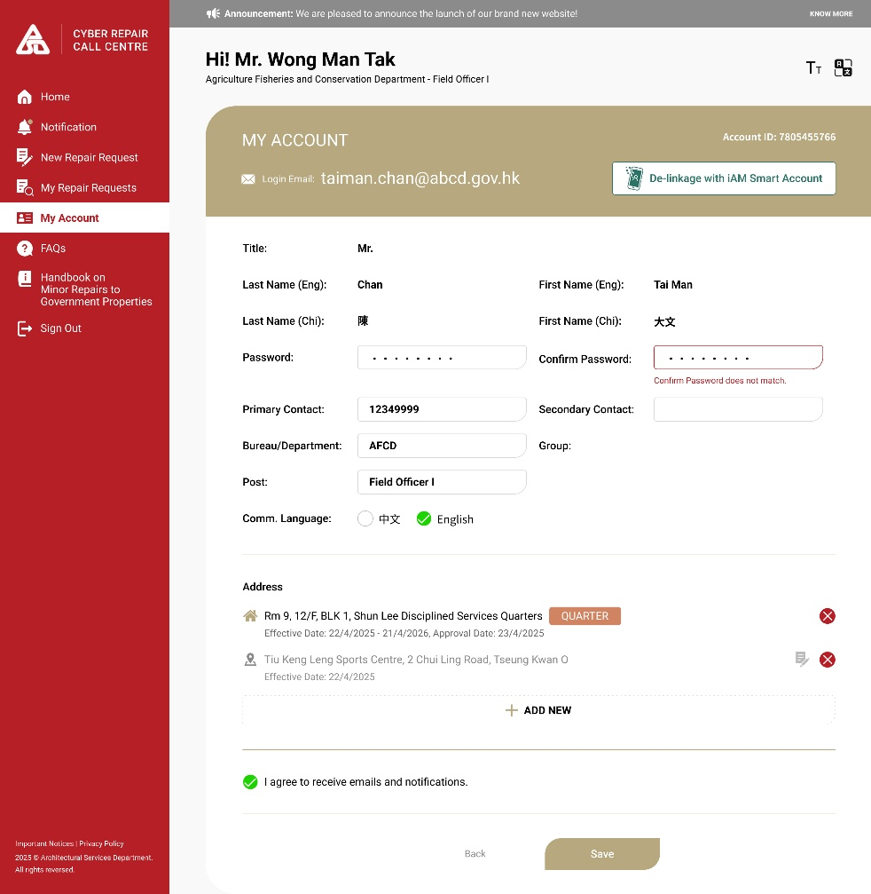
Email Template | For Password Update Successful Email:
  Sender | To Be Confirmed by ArchSD
  Subject | [ArchSD] Password Reset Successfully for CyberRCC
  Content | Your password has been successfully updated.

        - UF-0018 CyberRCC Submit Cancel Request
Item | Description
Function ID | UF-0018
Function Name | CyberRCC Submit Cancel Request
Category | Presentation Layer
Related Requirements | Cancel Request (Web-R7)
Function Description | - B/Ds user can submit a cancel request for a reported repair request.  - If the repair request has not been handled by the CSO, the DA System will update the web request with a cancellation statement.  - If the repair request is not confirmed for Form III or not grouped into Form I RRF by the BEO, the DA system will mark the request as cancelled.  - If the repair request is confirmed for Form III or grouped into Form I RRF by the BEO, a new web request will be created and distributed to the CSO. The CSO will follow up on the request and mark it cancelled once the follow up is completed.  - An audit log will be saved for the process related to the cancel request.
Metadata
  Field | Type
  RRI | Integer
  Cancel Reason | NVarchar(100)
  Submit Cancelled DateTime | DateTime
  Cancel | Button
  Follow Up | Button
Business Flow | Please refer to “Appendix A.4 Cancel in CyberRCC Flow”
Business Rule/ Validation | Pending Reported Repair Request  Submitted Repair Request
  Field  (* mandatory) | Form | Description | Business Rule
  Cancel | Button | - | - CyberRCC users can press the cancel button directly to cancel the pending repair request.  - The pending repair request will be cancelled.
  *Cancel Reason | Select Box | - | Cancel Reason Options:  - Wrong Repair Request Content  - Duplicate Repair Request  - Wrong Address  - Resume Normal  - Other
  Remarks | Text | - | Mandatory if user has selected “Others” in Cancel Reason.
  Field | Form | Description | Business Rule
  Follow Up | Button | - | - CyberRCC users can click follow-up button, which will prompt the follow-up window.  - CyberRCC users can select the “cancel request” option in the follow-up window and click “submit” to cancel the request.
Screen Capture | Cancel for Pending Repair Request:  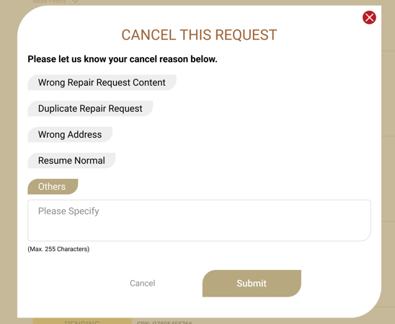  Cancel for Form I Repair Request:  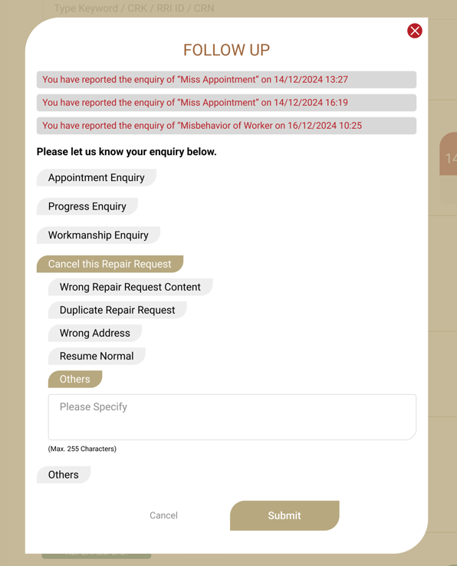  Cancel for Referred to D.O. Repair Request  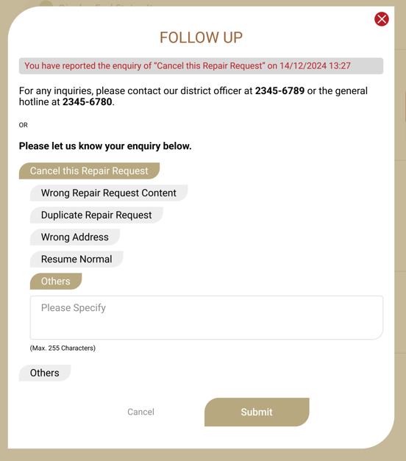

        - UF-0020 CyberRCC Submit General Enquiry
Item | Description
Function ID | UF-0020
Function Name | CyberRCC Submit Enquiry
Category | Presentation Layer
Related Requirements | Request Follow Up (Web-R8)
Function Description | - B/Ds admin and user can submit a general enquiry with type-in a free text in “Request Status” page  - A web request will be created for general enquiry and distributed to CSO  - A new repair tree item for general enquiry from CyberRCC to identity general enquiry  - CSO can flag up web request if the enquiry is complaint  - If web request is flagged up and submitted, inbox message will be sent to RCC supervisor  (Detail workflow refer to appendix A.5 ENQUIRY AND FOLLOW UP IN CYBERRCC FLOW)
Metadata
  Field | Type
  Message | NVarchar(300)
  Submit | Button
  Is Complaint | Boolean
  Accept | Button
Business Rule | Web Request Page
  Field  (* mandatory) | Mode | Description | Business Rule
  *Message | Free Text | CyberRCC User’s Enquiry Message | Max. length: 250
  Submit | Button | - | After clicking this button, a web request will be created and forwarded to CSO for follow up.
  Field | Mode | Description | Business Rule
  Is Complaint | Checkbox | CSO determine if the enquiry is complaint | Tick to send an inbox request to RCC Supervisor with the client’s message when proceed next action.
  Accept | Button |  | Click to proceed to Draft RRI.
Repair Tree Item
  Trade Name (English) | CyberRCC Requests
  Trade Name (Chinese) | CyberRCC請求
  Level 1 (English) | General Enquiry
  Level 1 (Chinese) | 查詢
  Work Type | Building
  Process Code | 33 Other
  Element Code | USER User Defined
  Urgency | Always Normal
  Category | Others
Screen Capture | General Enquiry:  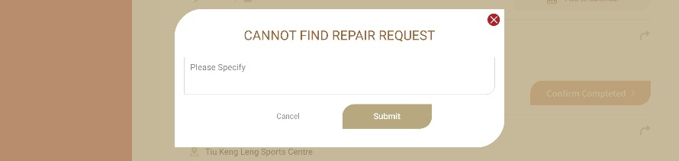  Web Request  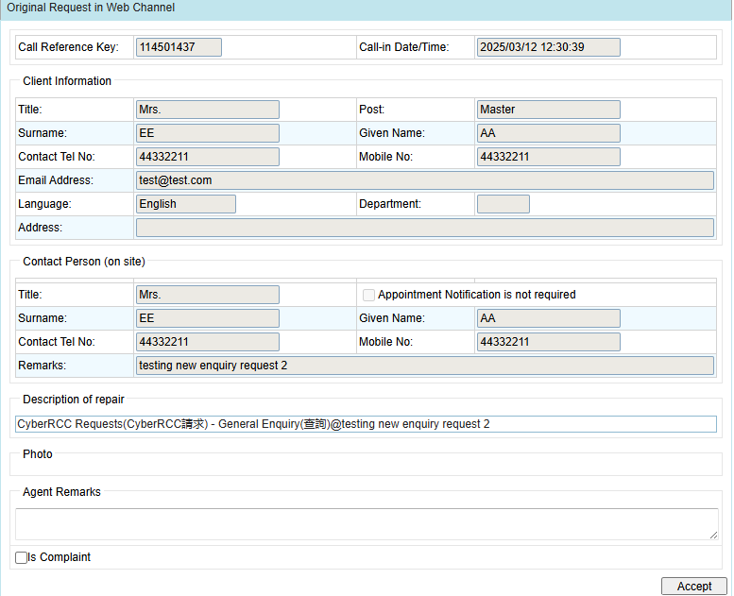

        - UF-0021 CyberRCC Request Follow Up
Item | Description
Function ID | UF-0021
Function Name | CyberRCC Request Follow Up
Category | Presentation Layer
Related Requirements | Request Follow Up (Web-R8)
Function Description | - CyberRCC users can submit a follow-up request for each RRI  - CyberRCC users can view the submitted follow-up request for each RRI  - A web request will be created for general enquiry and distributed to CSO  - For Form I RRI, CSO will create draft complaint in DA.  - For Form III RRI, CSO will send an inbox request to DS follow up in DA.  - CSO can flag up web request if the enquiry is complaint  - If web request is flagged up and submitted, inbox message will be sent to RCC supervisor  (Detail workflow refer to appendix A.5 ENQUIRY AND FOLLOW UP IN CYBERRCC FLOW)
Metadata
  Field | Type
  Follow Up Category | NVarchar(200)
  Remarks | NVarchar(500)
  Submit | Button
  Is Complaint | Boolean
  End | Button
  Accept | Button
Business Rule | Web Request Page
  Field | Mode | Description | Business Rule
  Follow Up Category | Selection Box | - | Category as follows:  - Miss Appointment  - Still Outstanding though it had been Attended  - Poor Workmanship  - Others
  Remarks | Textbox | - | This field is mandatory if ‘Others’ is selected, otherwise is optional.
  Submit | Button | - | For both Form I and Form III RRI, a web request will be generated and assigned to the web enquiry queue.
  Field | Mode | Description | Business Rule
  Is Complaint | Checkbox | CSO determine if the enquiry is complaint | Tick to send an inbox request to RCC Supervisor with the client’s message when proceed next action.
  End | Button | CSO to end the web enquiry request | Click to end the web request.
  Accept | Button |  | Click to proceed to Draft RRI.
Screen Capture | Form I:  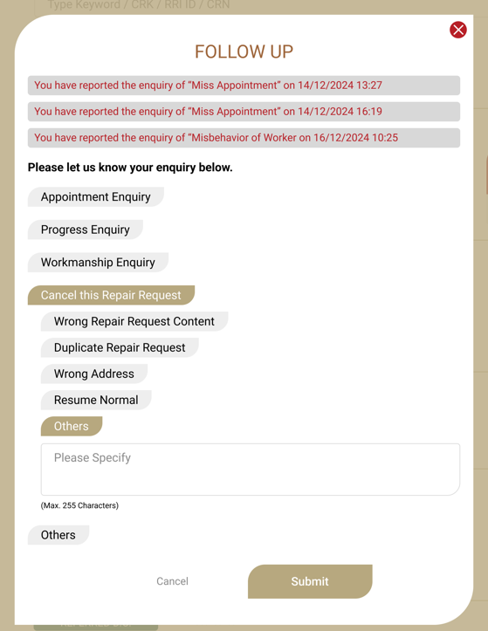  Form III:  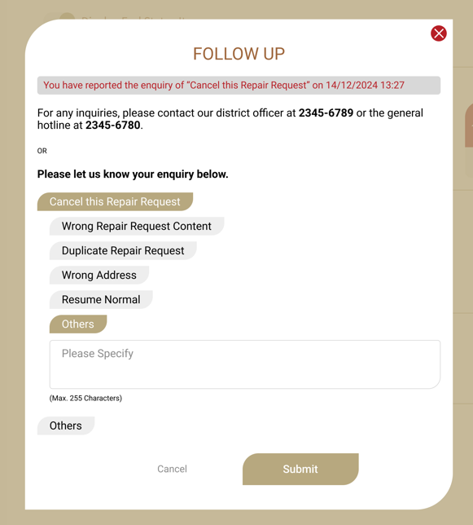  Web Request

        - UUF-0023 CyberRCC Repair Request Status
Item | Description
Function ID | UF-0023
Function Name | CyberRCC Repair Request Status
Category | Presentation Layer
Related Requirements | WEB-R16 View and search repair request
Function Description | - B/Ds users can view the list of repair request reported by them  - B/Ds users and admins can search and filter the reported repair requests list  - B/Ds admins can view the list of repair request related to the B/Ds
Metadata
  Field | Type
  Search Criteria | Varchar(50)
  Status | Varchar(50)
  CRK | Varchar(10)
  RRI ID | Varchar(10)
  Location | NVarchar(200)
  Repair Item | Varchar(100)
  Submitted Date | DateTime
  Appointment Date | DateTime
  Pending | Tab
  In Progress/End | Tab
  Search | Button
  Cannot find repair request | Button
  Follow Up | Button
  Cancel | Button
  Copy | Button
  Add to Calendar | Button
  Acknowledgement | Button
Business Rule | For Pending Repair Request Tab:  For In Progress / End Repair Request Tab:
  Field | Mode | Description | Business Rule
  Status | Label | Status of the repair request | Should be all in “Pending”
  CRK | Label | Call Reference Key | Unique key for each submission
  Submit Date | Label | Repair Case Submission Date | -
  Address | Label | Address of repair request submission | -
  Number of Repair Items | Label | Total number of repair items in the submission | -
  Cannot Find Repair Request | Button | - | After clicking, a box with free text will prompt
  Follow Up | Button | - | After clicking, a box with a selection of follow-up reasons will prompt
  Cancel Button | Button | - | After clicking, a box with cancel reasons will prompt
  Field | Mode | Description | Business Rule
  Status | Label | Status of the repair request | -
  RRI ID | Label | Repair Request Item Id | Unique Key for each repair request item
  Address | Label | Address of Repair Request Item | -
  Repair Item | Label | Repair Item | -
  Appointment Date Time | Label | Repair Request Appointment Date Time from DA | - Displayed in Form I RRI only  - Show the latest MTC Re-attend Datetime.
  Add to Calendar | Button | - | After clicking, the appointment date time will be added to the device calendar
  Cannot Find Repair Request | Button | - | After clicking, a box with free text will prompt
  Follow Up | Button | - | After clicking, a box with a selection of follow-up reasons will prompt
  E-acknowledgement | Button | - | - Displayed in Form I RRI only  - Displayed when MTC has entered the Site Completion Date in DA  - After clicking, a box will prompt for entering site completion information
  Copy | Button | - | Copies the current content of repair item into a new repair request.
Search Criteria | For Pending Repair Request Tab:  For In Progress / End Repair Request Tab:  For B/Ds users, repair requests will be displayed from the past year only.  For B/Ds admins, they can search repair request specific to B/Ds with a date range limited to a maximum of one year.
  Field | Type | Matching
  Keywords (CRK, Repair item, Location) | Free Text | Similar Match
  Advanced
  Address | Free Text | Similar Match
  Repair Item | Checkbox | Exact Match
  Submit Date | Date | Range
  Field | Type | Matching
  Keywords (CRK, RRI, CRN Repair item, Location) | Free Text | Similar Match
  Advanced
  Address | Free Text | Similar Match
  Repair Item | Checkbox | Exact Match
  Create Date | Date
  Appointment Date | Date | Range
  Status | Checkbox | Exact Match
Status Definition
  Action | Form Type | RRF Status | CyberRCC Status
  RRF Formed | Form I | Active | Arranged
  RRF Created | Form III | - | Referred To D.O.
  Converted MWO/WO | Form I | Converted/To Be Converted | Referred To D.O.
  Attach other MWO/WO but require base payment | Form I | Active | Arranged
  Attach other MWO/WO but does not require base payment | Form I | To Be Converted | Referred To D.O.
  RCC clicked Cancel | Form I | Active | Cancelled
  DS clicked Cancel but without RCC clicking cancel | Form I | Cancelled | Cancelled by D.O.
  MTC input Completion Date | Form I | Active | Acknowledge
  CyberRCC user enter Site Completion | Form I | Active | Completed
  IC submitted for Claim | Form I | Claimed | Completed
  MTC Request Conversion | Form I | Active | Referred to D.O.
Screen Capture | In Progress/End Repair Request:  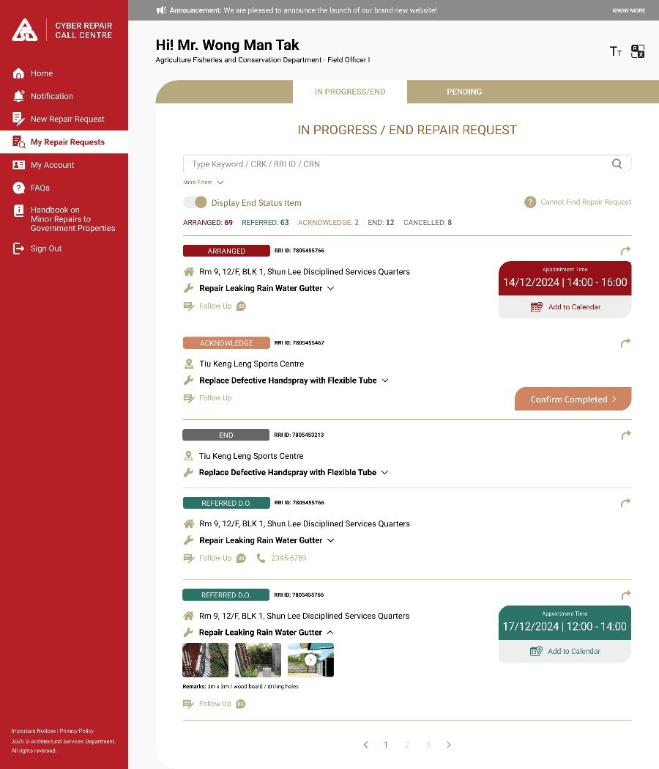  In Progress/End Repair Request Detail:  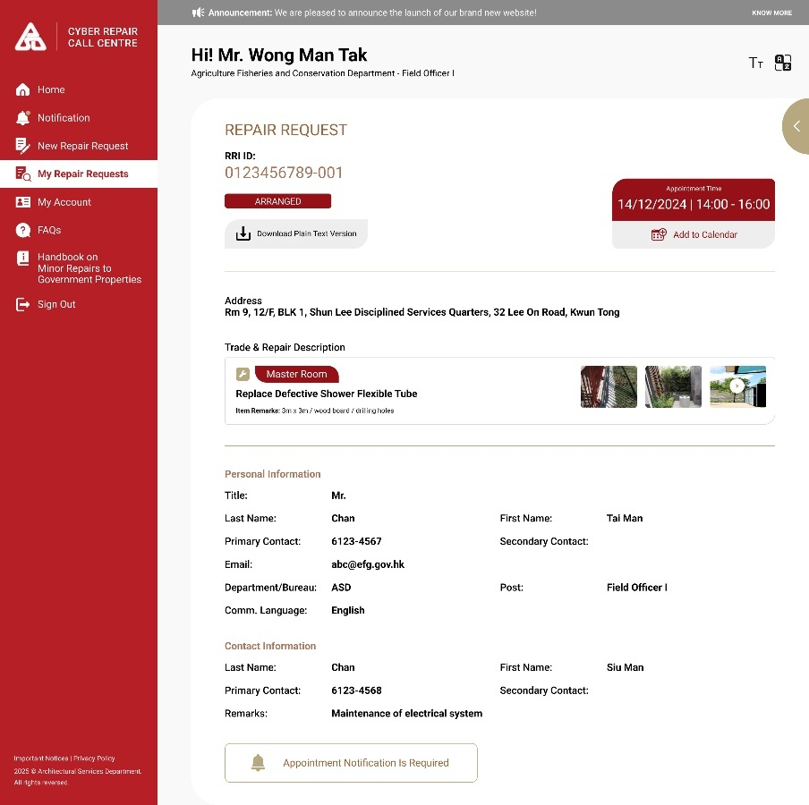  Pending:  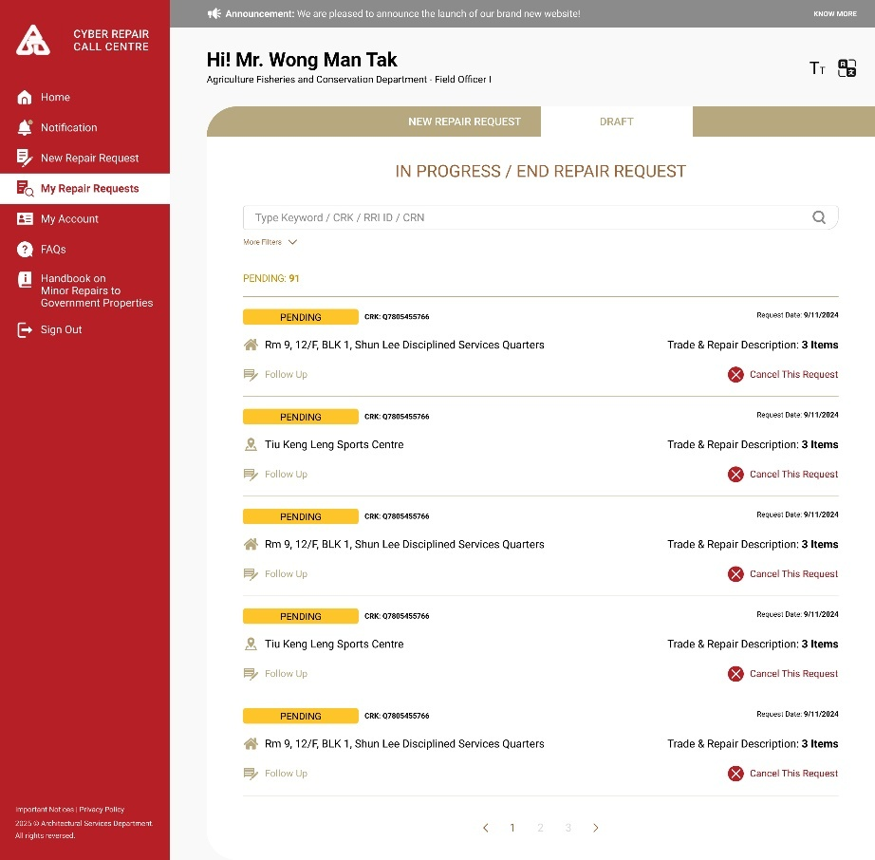  Pending Repair Request Detail:  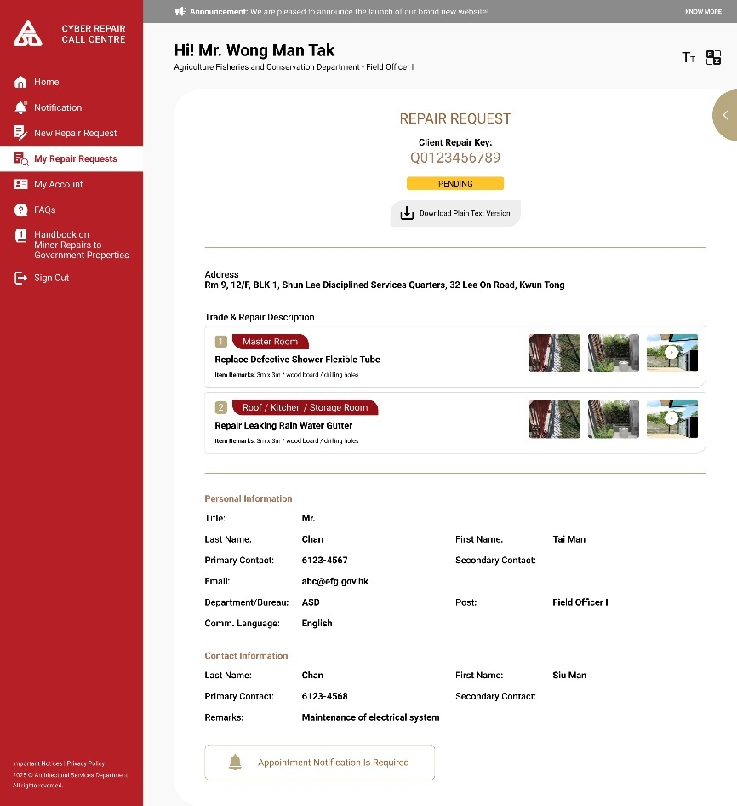

        - UF-0024 CyberRCC Location Suggestion
Item | Description
Function ID | UF-0024
Function Name | CyberRCC Location Suggestion
Category | Presentation Layer
Related Requirements | WEB-R13 Address Lookup Service
Function Description | - Location Suggestions will be based on the address entered by B/Ds users when adding a new reporting location.
Metadata
  Field | Type
  Area | NVarchar(100)
  District | NVarchar(100)
  Address | NVarchar(200)
  Block | NVarchar(100)
  Floor | Integer
  Flat / Room | Varchar(10)
Screen Capture | 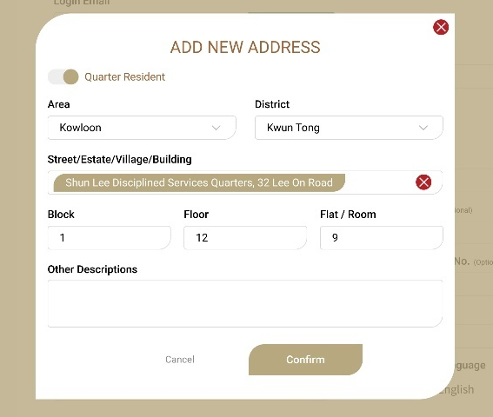
Address Data Source
  Service | Address Lookup Service
  Data Provider | Digital Policy Office
  Data Category | Housing
  Reference Link | https://data.gov.hk/en-data/dataset/hk-dpo-als_01-als

        - UF-0025 CyberRCC Copy Repair Request
Item | Description
Function ID | UF-0025
Function Name | CyberRCC Copy Repair Request
Category | Presentation Layer
Related Requirements | WEB-R10 New, Copy and Save Draft Repair Request
Function Description | B/Ds users can click the copy button in the Repair Request Status Page to copy an existing repair request item with any status to a new CyberRCC repair request
Metadata
  Field | Type
  Position | NVarchar(100)
  Repair Item Description | NVarchar(100)
  Item Remarks (Size/Quantity/Area) | NVarchar(100)
  Item Remarks (Material) | NVarchar(100)
Business Rule | The following fields will be copied to new CyberRCC Repair Item:  - Position  - Repair Item Description  - Item Remarks (Size/Quantity/Area)  - Item Remarks (Material)
Screen Capture | 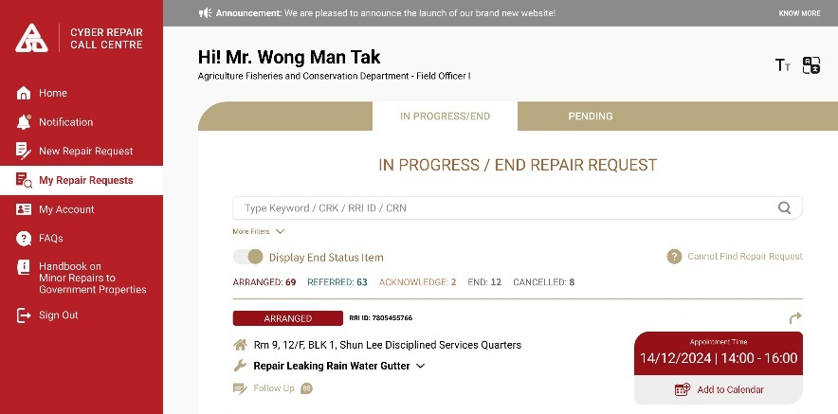

        - UF-0026 CyberRCC Add Appointment Date Time to Device Calendar
Item | Description
Function ID | UF-0026
Function Name | CyberRCC Add Appointment Date Time to Device Calendar
Category | Presentation Layer
Related Requirements | WEB-R18 Add appointment time to device calendar
Function Description | B/Ds users can add the appointment to the device calendar
Metadata
  Field | Type
  Repair Item | NVarchar(100)
  Location | NVarchar(200)
  Appointment Start Date Time | DateTime
  Appointment End Date Time | DateTime
Calendar Schedule
  Title | [ArchSD] <<Repair Item>>
  Location | <<Location>>
  Start Date | <<Appointment Start Date Time>>
  End Date | <<Appointment End Date Time>>
Screen Capture

        - UF-0027 CyberRCC E-acknowledgment
Item | Description
Function ID | UF-0027
Function Name | CyberRCC E-acknowledgement
Category | Presentation Layer
Related Requirements | WEB-R9 E-Acknowledge of Completion
Function Description | - B/Ds users can view the MTC input site completion date in CyberRCC  - B/Ds users can e-acknowledge the site completion information in CyberRCC, with the MTC’s completion date inputted by default. If users wish to change the completion date, a message box will prompt them to choose an earlier or later date. If a later completion date is selected, a remark and photo must be provided.
Metadata
  Field | Type
  RRI | Varchar(10)
  MTC Site Completion Date | Date
  CyberRCC Site Completion Date | Date
  Exception Report Remarks | NVarchar(300)
  Exception Report Photo | Binary
Business Rule
  Field | Mode | Description | Business Rule
  RRI | Label | RRI ID | -
  MTC Site Completion Date | Date Picker | MTC Input Site Completion Date | Display the MTC Site Completion Date to B/Ds users
  CyberRCC Site Completion Date | Date Picker | Site Completion Date Input by CyberRCC B/Ds users | Must be greater than and equal to RRI Creation Date
  Exception Report Remarks | Free Text | - | - Enabled when CyberRCC B/Ds users enter a date later than MTC Site Completion Date  - Mandatory if enabled
  Exception Report Photos | Upload | - | - Enabled when CyberRCC B/Ds users enter a date later than MTC Site Completion Date  - At least one photo is required if enabled
Screen Capture | Confirm Site Completion Date:  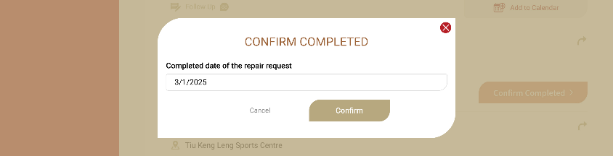  Message if amend the completed date:  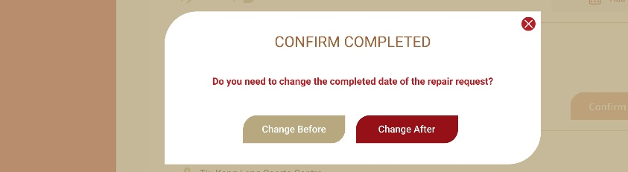  Submit Exception Report:  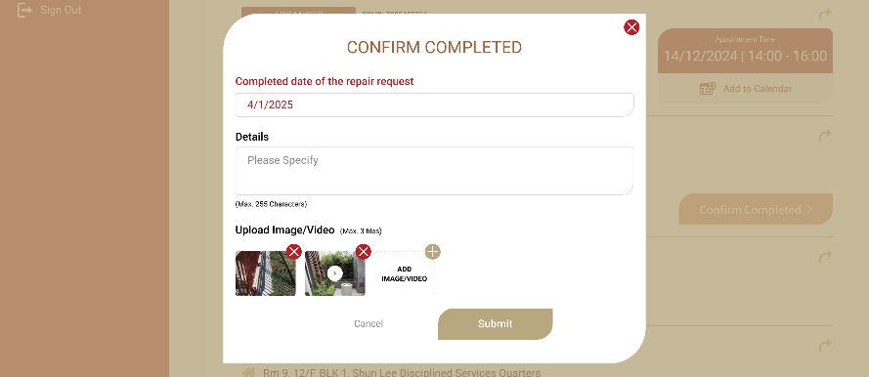

        - UF-0029 CyberRCC Create Repair Request
Item | Description
Function ID | UF-0029
Function Name | CyberRCC Create Repair Request
Category | Presentation Layer
Related Requirements | WEB-R10 New, Clone and Save Draft Repair Request,  WEB-R17 Emergency web request
Function Description | - B/Ds users can select the location for submitting repair request in CyberRCC  - B/Ds users can add repair items to a request in CyberRCC  - B/Ds users can upload photos and videos for each repair item in CyberRCC  - B/Ds users can update their contact information  - B/Ds users can preview the request before submitting it  - B/Ds users can submit repair request and receive related CRK
Metadata
  Field | Type
  Address | List
  Emergency Request | Varchar(1)
  Repair Items | List
  Position | NVarchar(100)
  Suggested Repair Item Description | List
  Repair Item Description | NVarchar(100)
  Upload Photo/Video | Data
  Item Remarks (Area/ Length/ Quantity) | NVarchar(100)
  Item Remarks (Material) | NVarchar(100)
  Other Remarks | NVarchar(100)
  Reporter Title | Varchar(3)
  Reporter Post | NVarchar(10)
  Reporter Last Name | NVarchar(10)
  Reporter First Name | NVarchar(20)
  Reporter Primary Contact | Integer
  Reporter Secondary Contact | Integer
  Reporter Email | Varchar(100)
  Reporter Bureau/Department | Varchar(3)
  Reporter Language | Varchar(3)
  Contact Person Last Name | NVarchar(10)
  Contact Person First Name | NVarchar(10)
  Contact Person Primary Contact | Integer
  Contact Person Secondary Contact | Integer
  Remarks | NVarchar(500)
  Appointment Time Required | Varchar(1)
  CRK | Varchar(10)
  New Repair Item Description | Button
  Remove Repair Item Description | Button
  Edit Repair Item Description | Button
  Same as Reporter | Button
  Upload Photo/Video Button | Button
  Add Description | Button
  Save Draft | Button
  Next | Button
  Confirm | Button
  Back | Button
Business Rule | New Repair Request Page:  New Repair Item Page:  Preview Repair Item Page:  Submitted Repair Request Page:
  Field  (* mandatory) | Mode | Description | Business Rule
  *Address | Single Selection | Approved Address List input by B/Ds user | Must Select one only address
  Emergency Request | Toggle Button | Emergency indicator | - Default is off (non-emergency)  - During RCC Office hours, B/Ds users can mark it as emergency request.  - During BDRC hours, if marked on, a message will prompt and it cannot be turned on as an emergency case.
  Repair Item Description | List | List of Item Description | Double-Clicking it overlay the New Repair Item Page with details.
  Remove | Button | - | Removes the repair item description from the list upon clicking
  Add | Button | - | Opens the New Repair Item Page when clicked
  Personal Information
  Title | Label | Title of reporter | Retrieval from User Profile
  Post | Label | Post of reporter | Retrieval from User Profile
  Last Name | Label | Last Name of reporter | Retrieval from User Profile
  First Name | Label | First Name of reporter | Retrieval from User Profile
  Primary Contact No. | Label | Primary Contact No. of reporter | Retrieval from User Profile
  Secondary Contact No. | Label | Secondary Contact No. of reporter | Retrieval from User Profile
  Email | Label | Email of reporter | Retrieval from User Profile
  Bureau/Department | Label | Bureau/Department of reporter | Retrieval from User Profile
  Contact Information
  Same as Reporter | Toggle Button | - | On click, the reporter information will be copied to Contact Person Information
  Last Name | Text | Last Name of Contact Person | -
  First Name | Text | First Name of Contact Person | -
  Primary Contact No. | Number | Primary Contact No. of Contact Person | -
  Secondary Contact No. | Number | Secondary Contact No. of Contact Person | -
  Remarks | Text | - | Max length: 500
  Appointment Time Required | Single Selection | - | Default selected with Appointment Time Required
  Next | Button | - | - Click to proceed to the next step and redirects to Preview Repair Item Page  - Checks for emergency case and within RCC Office hours. If not, prompts a message and cannot proceed.
  Save Draft | Button | - | Click to save the repair request as a draft.
  Field  (* mandatory) | Mode | Description | Business Rule
  *Position | Multiple Selection / Text | Position of the repair item | Different for Quarter and Non-Quarter Address  - Quarter: Multiple selection options:  - Living Room  - Dining Room  - Corridor  - Master Room  - Main Bathroom  - Guest Room  - Guest Bathroom  - Kitchen  - Balcony  - Laundry Room  - Storage Room  - Maid Room  - Maid Bathroom  - Other  - Non-Quarter: Free text box
  *Repair Item Description Search | Search Box | Search and display the selected item description | Similar Match for filtering repair item description
  Suggested Repair Item | Single Selection List | Repair Item Suggestion generated from system or Bookmarked items | - Click to select a single item.  - Click the bookmark icon to bookmark the repair item
  All Repair Item Lists | Single Selection List | All Repair items in DA | - Excludes items under “Emergency” Trade  - Click to expand the layer or select item  - Click the bookmark icon to bookmark the repair item
  Photo/Videos | Upload Data | - | Maximum 3 files can be uploaded for each repair item
  Add Photo/Videos | Button | - | Click to open the camera and upload the photo/videos
  Remove Photo/Videos | Button | - | Click to remove the photo/videos
  *Item Remarks 1 | Free Text | - | Item Remarks description and hint based on selected repair item will be generate.
  Item Remarks 2 | Free Text | - | - Mandatory check based on selected repair item. It will be configured by RCC Supervisor in DA.  - Item Remarks description and hint based on selected repair item will be generated.
  Other Remarks | Free Text | - | -
  Add Item | Button | - | Click to add/update the filled repair item in the repair request and returns to New Repair Request Page
  Return | Button | - | Returns to New Repair Request Page without saving.
  Field | Mode | Description | Business Rule
  Address | Label | - | -
  Repair Item Description
  Item Number | Label | The sequence number of the repair item | -
  Position | Label | - | -
  Repair Item Description | Label | - | -
  Item Remark | Label | - | -
  Photo/ Video | Display | - | -
  Reporter Information
  Title | Label | - | -
  Post | Label | - | -
  Last Name | Label | - | -
  First Name | Label | - | -
  Primary Contact No. | Label | - | -
  Secondary Contact No. | Label | - | -
  Email | Label | - | -
  Department | Label | - | -
  Language | Label | - | -
  Contact Information
  Last Name | Label | - | -
  First Name | Label | - | -
  Primary Contact No. | Label | - | -
  Secondary Contact No. | Label | - | -
  Remarks | Label | - | -
  Appointment Time Required | Display | - | -
  Back | Button | - | Returns to New Repair Request Page
  Confirm | Button | - | - Click to submit the repair request to RCC.  - The repair request will be assigned to the corresponding queue.  - Redirects to Submitted Repair Request Page.
  Field | Mode | Description | Business Rule
  CRK | Label | Reference Key for B/Ds user | -
  Status | Label | - | The repair request status should be “Pending”
  Download Plain Text Version | Button | - | Click to download the plain text version of the submitted repair request summary.
  Repair Item Description
  Item Number | Label | - | -
  Position | Label | - | -
  Repair Item Description | Label | - | -
  Item Remark | Label | - | -
  Photo/ Video | Display | - | -
  Reporter Information
  Title | Label | - | -
  Post | Label | - | -
  Last Name | Label | - | -
  First Name | Label | - | -
  Primary Contact No. | Label | - | -
  Secondary Contact No. | Label | - | -
  Email | Label | - | -
  Department | Label | - | -
  Language | Label | - | -
  Contact Information
  Last Name | Label | - | -
  First Name | Label | - | -
  Primary Contact No. | Label | - | -
  Secondary Contact No. | Label | - | -
  Remarks | Label | - | -
  Appointment Time Required | Display | - | -
  Homepage | Button | - | Click to redirect to homepage of the CyberRCC user.
Upload Media Criteria | Photo Criteria  Video Criteria  Maximum total upload data for each repair item description:  - 3 Photos or  - 2 Photos + 1 Video
  Format | *.jpg, *.png
  Maximum Size | 5MB
  Format | *.mp4
  Maximum Size | 25MB
Prompt Message | For Toggle Emergency Request During BDRC Hour:  “The Repair Call Centre is currently closed. If you need to report an emergency request, please call our hotline at 27732222.”
Screen Capture | New Repair Request for Quarter:  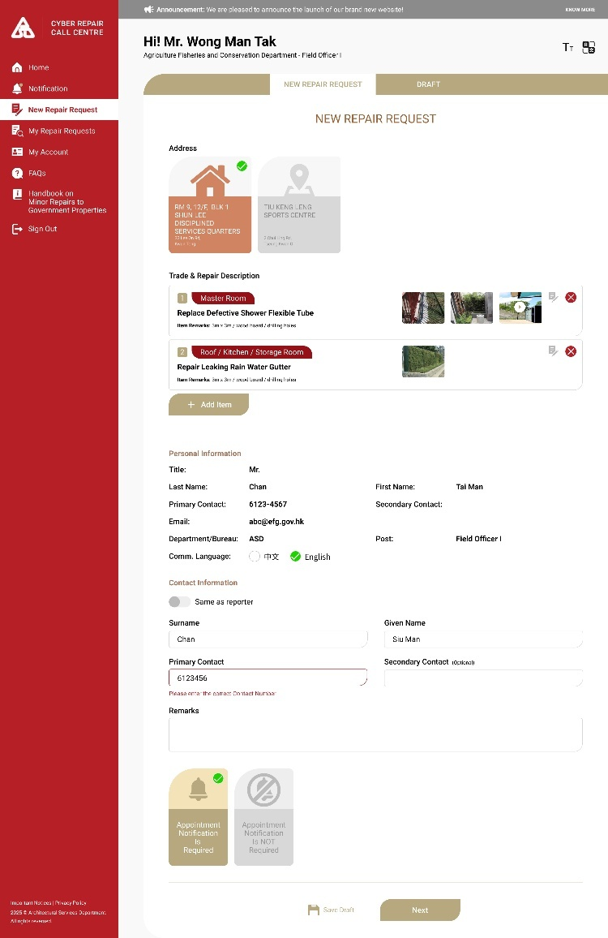  Create Repair Request for Non-Quarter:  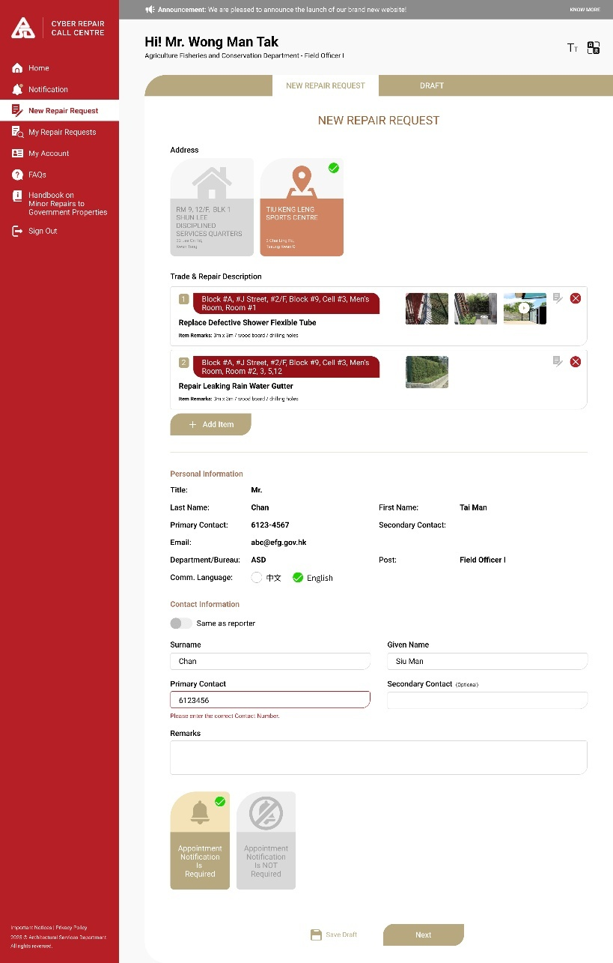  New Repair Item for Quarter:  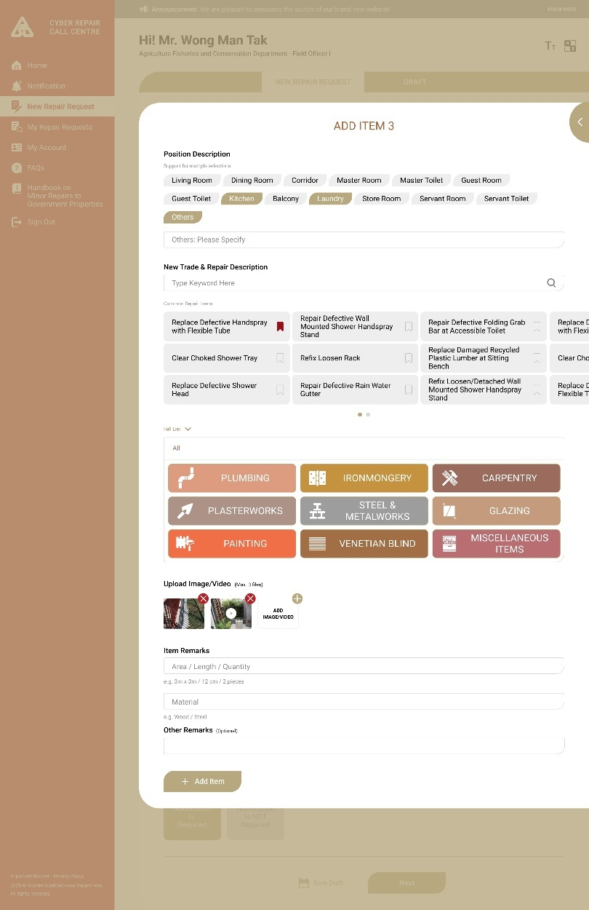  New Repair Item for non-Quarter:  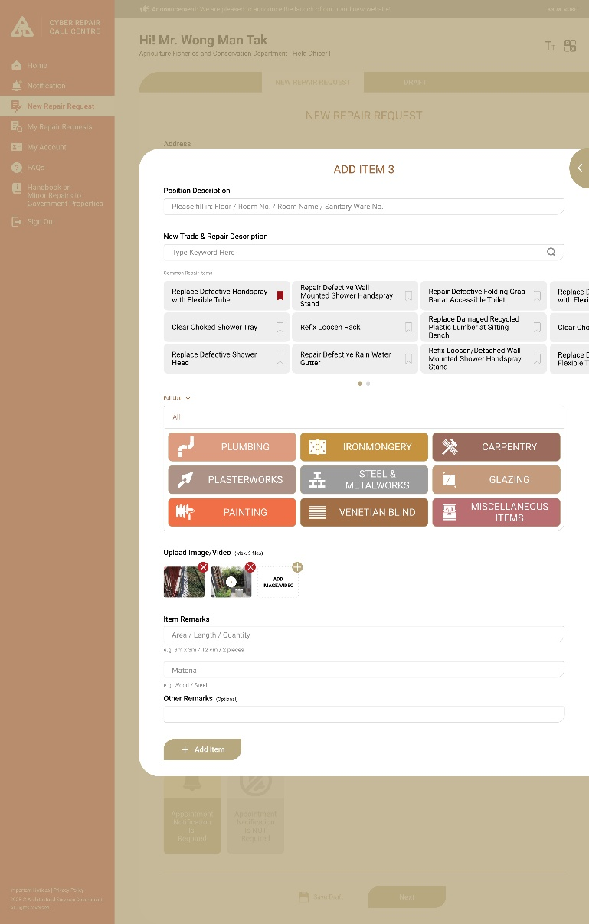  Repair Request Preview:  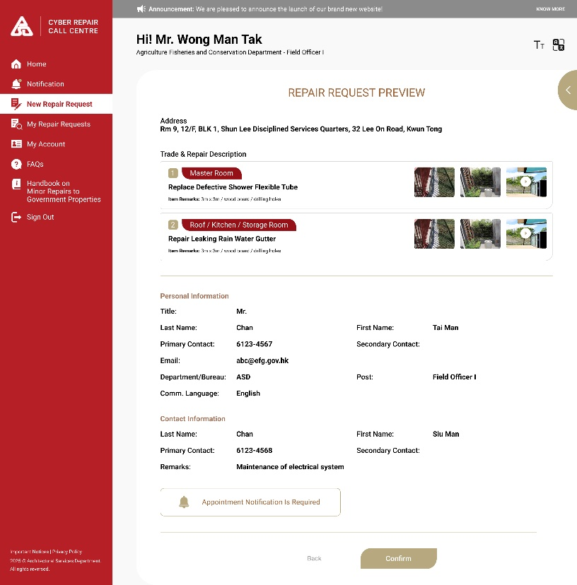  Submit Confirmation box:  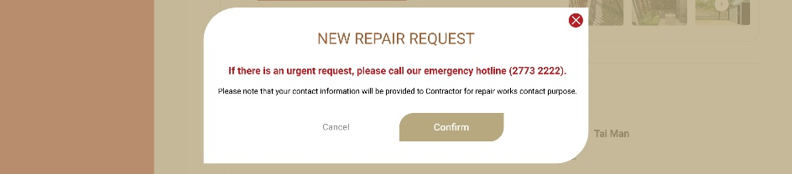  Submitted Repair Request:  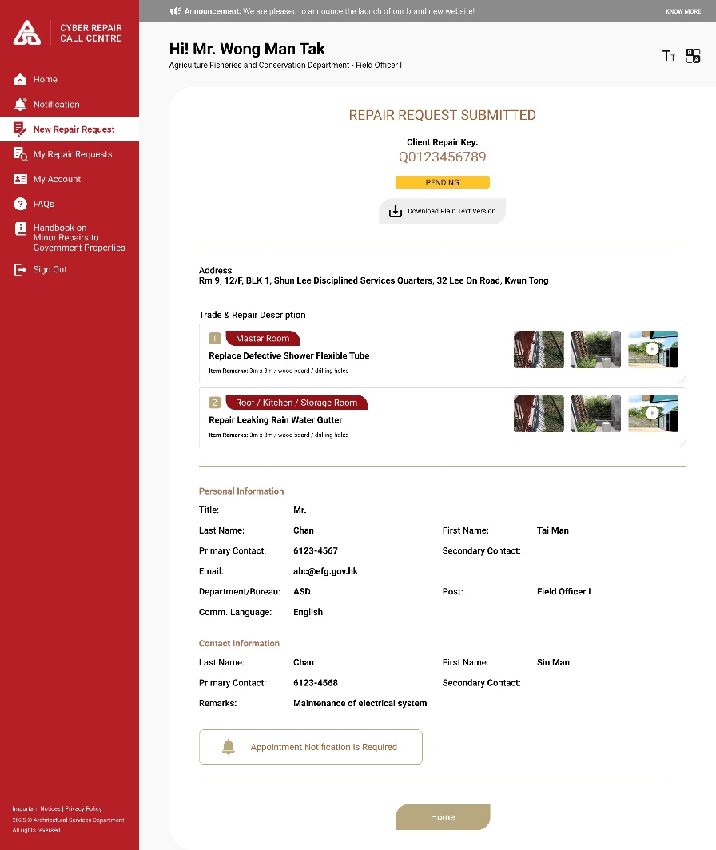

        - UF-0030 CyberRCC Save Draft Repair Request
Item | Description
Function ID | UF-0030
Function Name | CyberRCC Save Draft Repair Request
Category | Presentation Layer
Related Requirements | WEB-R10 New, Clone and Save Draft Repair Request
Function Description | - B/Ds users can save the unfinished repair requests as drafts  - B/Ds users can view and search the list of draft repair requests  - B/Ds users can continue to update draft repair requests
Metadata
  Field | Type
  Address | NVarchar(200)
  Last Modified Date | DateTime
  Repair Description | List
  Position | NVarchar(100)
  Repair Item Description | NVarchar(200)
  Upload Photo/Video | Data
  Item Remarks (Area/ Length/ Quantity) | NVarchar(100)
  Item Remarks (Material) | NVarchar(100)
  Other Remarks | NVarchar(100)
  Reporter Title | Varchar(3)
  Reporter Post | NVarchar(10)
  Reporter Last Name | NVarchar(10)
  Reporter First Name | NVarchar(20)
  Reporter Primary Contact | Integer
  Reporter Secondary Contact | Integer
  Reporter Email | Varchar(100)
  Reporter Department/Bureau | Varchar(3)
  Reporter Language | Varchar(3)
  Contact Person Last Name | NVarchar(10)
  Contact Person First Name | NVarchar(10)
  Contact Person Primary Contact | Integer
  Contact Person Secondary Contact | Integer
  Remarks | NVarchar(500)
  Appointment Time Required | Varchar(1)
  Edit | Button
  Delete | Button
Business Rule | B/Ds users can save their repair request as draft by following scenario:  - Click “Save” button when drafting the repair requests  - When leaving the create repair requests page, click “Save” in the prompt message “Are you confirm to leave the page? Your input will be saved as a draft.”  The input including the address, repair description list, and contact information will be saved.  A maximum of 5 drafts can be saved for each B/Ds user.  If the limit of 5 drafts has already reached, a warning message will appear when B/Ds user clicks “New Repair Request”, indicating that the new repair request cannot not be saved.  If B/Ds users submit a draft repair request, the draft record will be removed automatically.  For Viewing Draft Repair Request Page:
  Field | Mode | Description | Business Rule
  Total No. of Draft | Label | Total number of drafts | -
  Draft No. | Label | Draft number | A sequence number.
  Address | Label | Selected Address of the draft | -
  Number of repair description | Label | Total Numbers of repair description in the draft | -
  Last Modified Date | Label | Last Modified Date of the draft | -
  Delete | Button | - | B/Ds user clicks on the button to delete the draft.
  Edit | Button | - | B/Ds user clicks on the button to continue editing the draft.  - It will redirect to the draft repair request page.
Screen Capture | Save Draft Confirmation:  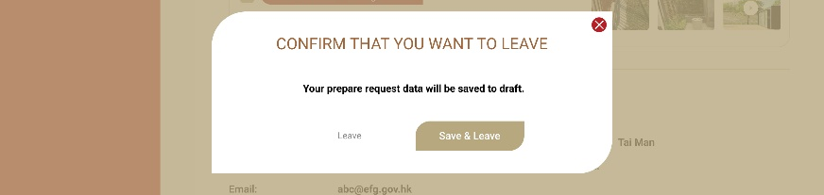  Draft Repair Request List:  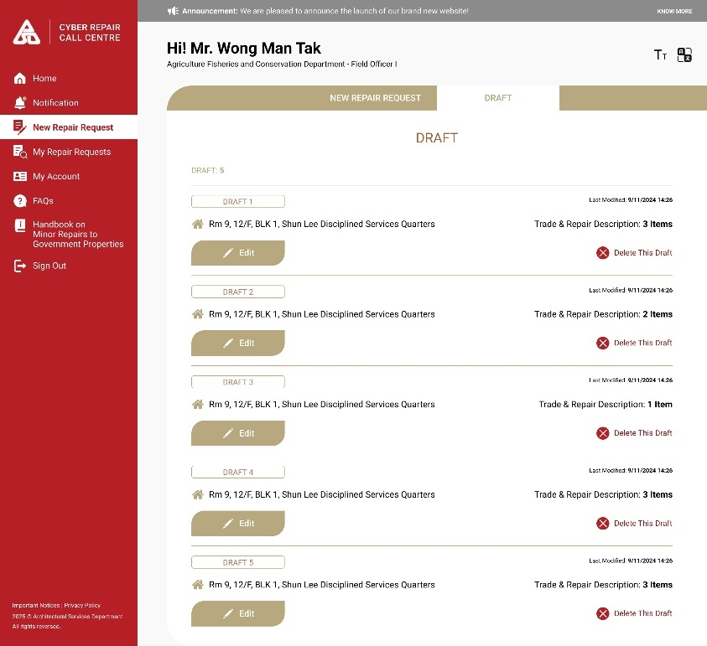  Warning message if user click new repair request and the drafts reach the limit:  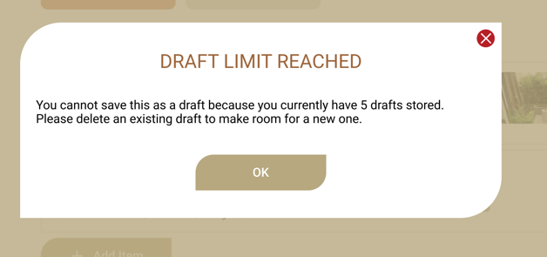

        - UF-0031 CyberRCC Repair Item Suggestion
Item | Description
Function ID | UF-0031
Function Name | CyberRCC Repair Item Suggestion
Category | Presentation Layer
Related Requirements | WEB-R14 Item suggestion
Function Description | - Repair item suggestion will be provided for B/Ds users when submitting a repair request in CyberRCC  - B/Ds users can bookmark repair items ,which will be displayed in the repair item suggestion list
Metadata
  Field | Type
  Repair Item Description | NVarchar(255)
  Favorite | Varchar(12)
Business Rule | Each suggestion list include a maximum of 12 repair, including bookmarked item.  B/Ds users can click on the bookmark icon in the repair description list.  The suggestion list will prioritize bookmarked items, followed by suggestions from the system  The suggestion list is divided into Quarter and Non-Quarter Handling.  For Quarter:  The suggestion list will be based on the position.  If toilet or kitchen is selected, the top 12 reported items related to toilets or kitchens will be displayed. For example:  - repair defective flushing cistern(修理損壞沖廁水箱)  - clear choked floor drain (清除淤塞地台去水道)  - clear choked washing basin(清除淤塞洗手盆)  - clear choked bathtub(清除淤塞浴缸)  - clear choked sink(清除淤塞星盆)  - replace defective shower flexible tube(替換損壞花洒軟喉管)  - repair defective water taps to sink(修理損壞星盆水龍頭)  - replace defective shower head(替換損壞花洒頭)  - repair defective water mixer to sink(修理損壞星盆混合水龍頭)  If other positions are selected, the top 12 reported items will be displayed. For example:  - repair defective door lock to door (修理 損壞門鎖)  - repair defective hinge to cupboard door(修理損壞櫃檯門門鉸)  - repair defective fastener to aluminium window(修理鋁窗窗扣掣)  - repair defective door lock to main entrance door(修理損壞大門鎖)  - repair defective hinge to hanging cupboard door(修理損壞吊櫃檯門門鉸)  - repair defective hinge to door(修理損壞門鉸)  - refix detached window bar(重新安裝鬆脫窗花)  - repair defective door closer to door(修理損壞門氣鼓)  For non-quarter:  The suggestion list will be based on the department or bureau of the users  For most departments and bureaus, the top 12 reported repair items among non-quarter RRF will be shown.  For the top 10 reported departments and bureaus, the top 12 reported repair items specific to those departments and bureaus among non-quarter RRF will be shown.
Screen Capture | For Quarter:  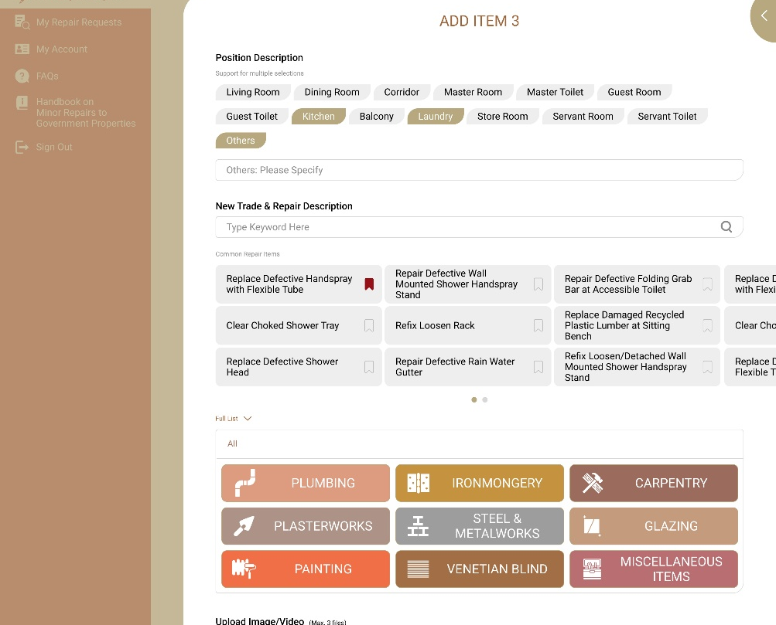  For non-quarter:  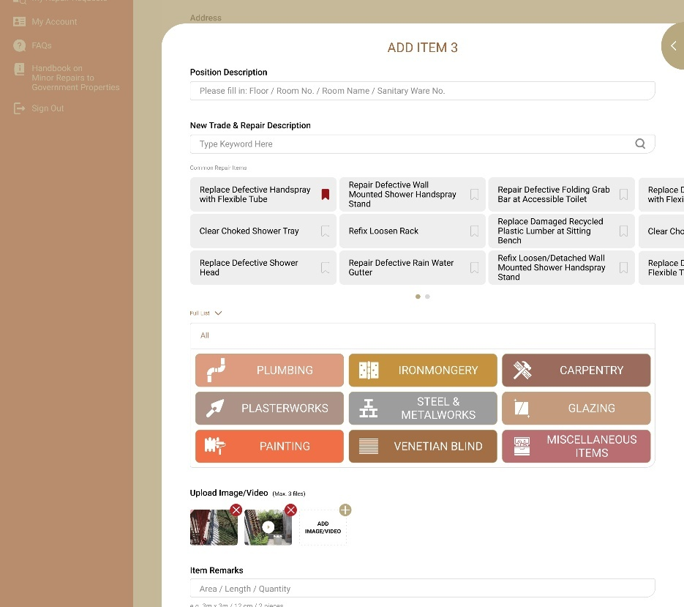

        - UF-0032 CyberRCC Download Plain Text Version of Repair Request
Item | Description
Function ID | UF-0032
Function Name | CyberRCC Download Plain Text Version of Repair Request
Category | Presentation Layer
Related Requirements | WEB-R15 Download repair request record
Function Description | B/Ds users can download a plain text version of their repair request
Metadata
  Field | Type
  CRK | Varchar(10)
  RRI | Varchar(10)
  Address | NVarchar(200)
  Repair Items | NVarchar(200)
  Download Plain Text Version | Button
Business Rule
  Field | Mode | Description | Business Rule
  CRK | Label | CRK of the repair request | -
  RRI | Label | Repair Request ID | -
  Address | Label | Address of repair request | -
  Repair Item | Label | Repair Item of repair request | -
  Download Plain Text Version | Button | - | A plain text file will be downloaded
File Type | *.TXT
Template | Refer to “Appendix A.6 Plain Text Version Template”
Screen Capture | 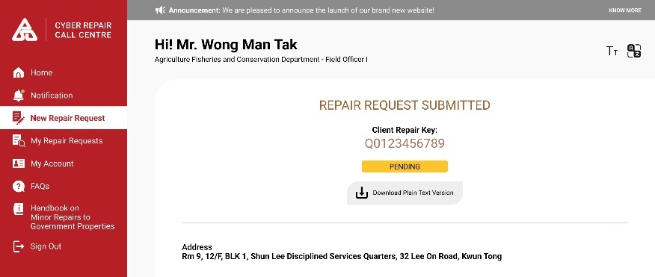

        - UF-0053 CyberRCC B/Ds user Dashboard
Item | Description
Function ID | UF-0053
Function Name | CyberRCC B/Ds user Dashboard
Category | Presentation Layer
Related Requirements
Function Description | - B/Ds user reaches the dashboard page after logging into CyberRCC  - There is a quick navigation item for B/Ds user quickly access several functions in the dashboard  - A calendar shows the appointed repair requests in the dashboard  - A chart shows B/Ds user’s repair request status in the dashboard  - B/Ds user can view the latest notifications in the dashboard
Business Rule | Site Menu:  Fast Navigation List:  Upcoming Calendar:  - Showing current month calendar  - Date with appointment for repair request are underlined.  - Selecting an underlined date shows the following repair request information:  - Date  - Appointment Time  - Address  - Repair Item Description  Notification:  - Displays the number of unread notifications  - The latest notification message includes message, address and repair item description.  - Clicking the arrow button redirects to Notification Page.  My Repair Request:  - A donut chart shows the distribution of My Repair Request status.  - A table shows the numbers and percentage of repair request status.  - Clicking a status redirects to the My Repair Request Page with the selected status.
  Menu Item | Navigation
  Home | Home Page after Login
  Notification | Notification Page
  New Repair Request | New Repair Request Page
  My Repair Request | My Repair Request Page
  My Account | My Account Information Page
  FAQs | FAQ Page
  Handbook on Minor Repairs to Government Properties | Direct Download Handbook
  Sign out | Sign Out CyberRCC
  List Item | Navigation
  New Repair Request | New Repair Request Page
  My Repair Request | My Repair Request Page
  My Account | My Account Information Page
  FAQs | FAQ Page
  Handbook on Minor Repairs to Government Properties | Direct Download Handbook
Screen Capture | Desktop:  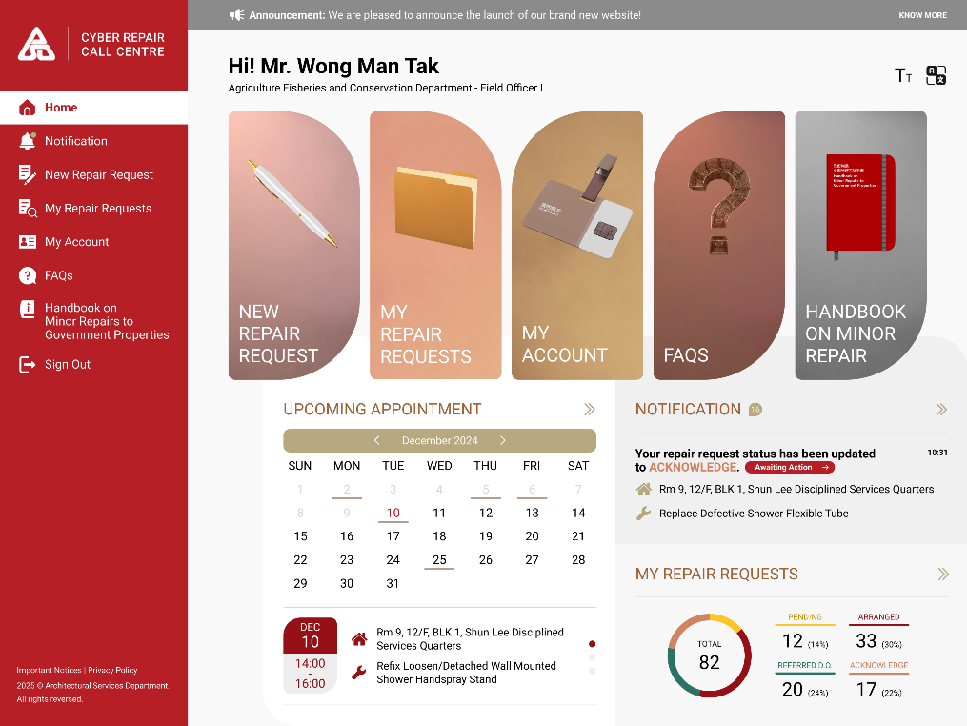

      - CyberRCC – B/Ds admin Functions and Flows
        - UF-0013 CyberRCC User Management by B/Ds admin
Item | Description
Function ID | UF-0013
Function Name | CyberRCC User Management by B/Ds admin
Category | Online Enquiry
Related Requirements | User Account Management (Web-R5)  User Group and User Management (Web-R6)
Function Description | - B/Ds admin can view all CyberRCC users under their B/D  - B/Ds admin can filter and search for CyberRCC users under their B/D  - B/Ds admin can export the list of CyberRCC users under their B/D  - B/Ds admin can activate/deactivate CyberRCC users under their B/D  - B/Ds admin can remove CyberRCC users and CyberRCC users’ address under their B/D  - B/Ds admin can verify CyberRCC users’ address under their B/D  - B/Ds admin can approve/reject CyberRCC users registration  - B/Ds admin can add and update CyberRCC users’ address list under their B/D  - B/Ds admin can multi-select CyberRCC users to perform point 4 – 7 actions  - B/Ds admin can send an invitation link to user’s email for account registration.  - B/Ds admin can upload an Excel File to batch insert accounts.  - After any update on account status, an email will be sent to the contact email to notify users.  - RCC admins will have the same functionalities for user management as B/D admins.
Metadata
  Field | Type
  Name | NVarchar(60)
  Department/Bureau | Varchar(100)
  Email | Varchar(200)
  Contact | Varchar(17)
  Group | Varchar(50)
  User Status | Varchar(50)
  Address | NVarchar(500)
  Address Status | Varchar(50)
  Verify | Button
  Download All Users | Button
  Activate | Button
  Deactivate | Button
  Delete | Button
  Batch Upload | Button
Business Rule | Search Account Panel  Searched Account:  Account Detail
  Field | Mode | Description | Business Rule
  Keywords | Text | Search Criteria | -
  Address | Text Search Dropdown | Search Criteria | -
  Group | Dropdown | Search Criteria | -
  Email | Text | Search Criteria | -
  Contact No. | Text | Search Criteria | -
  Account Status | Dropdown | Search Criteria | -
  Selected Accounts | Display | Number of Selected Accounts | -
  Download all Users | Button | Download all users’ information according to the search result | Click to export the search result of user list
  Batch Upload | Button | Upload an Excel file to batch insert accounts | Click to upload an Excel file
  Verify | Button | Verify the address under the CyberRCC Users | - Only visible when at least one user is selected  - A confirmation message will be prompted to B/Ds admin  - Only visible in Pending User Page.  - Click to verify B/Ds user and Address
  Activate | Button | Enable Multiple User Accounts | - Only visible when at least one user is selected  - A confirmation message will be prompted to B/Ds admin  - Only Visible in Verified User Page.  - Click to activate B/Ds user
  Deactivate | Button | Disable Multiple User Accounts | - Only visible when at least one user is selected  - A confirmation message will be prompted to B/Ds admin  - Only Visible in Handled User Page.  - Click to deactivate B/Ds user
  Delete | Button | Delete Users/Account | - Only visible when at least one user is selected  - A confirmation message will be prompted to B/Ds admin  - Click to delete whole user account including addresses
  Field | Mode | Description | Business Rule
  Name | Display | B/Ds user’s Full Name | -
  Government Email | Display/Icon | - | It will be shown if the email is government email
  Bureau/ Department | Display | B/Ds user’s Bureau / Department | -
  Post | Display | B/Ds user’s post | -
  Status | Display | Account Status | -
  Email | Display | B/Ds user’s Email | -
  Contact No. | Display | B/Ds user Contact | -
  Group | Display | B/Ds user’s Grouped | -
  Verified | Icon | Tick Icon Next to Address. | - It will be shown if the address is verified.  - It will be shown on the Pending User Page.
  Address | Display | B/Ds user’s address list | -
  Quarter | Display/Icon | - | It will be shown if the address is quarter.
  Pending for Delete | Display | - | It will be shown if the address is requested to be deleted from B/Ds user
  Delete | Button | - | - A confirmation message will be prompted to B/Ds admin  - Click to delete the users
  Verify | Button | - | - A confirmation message will be prompted to B/Ds admin  - It will be shown on Pending User Page  - Click to verify user’s address
  Activate | Toggle Button | - | - It will be shown on Verified User Page  - Click to activate/deactivate user
  Activate | Button | - | - It will be shown on Verified User Page  - Click to activate user
  Deactivate | Button |  | - It will be shown on Verified User Page  - Click to deactivate user
  Field | Mode | Description |  | Business Rule
  Status | Display | Account Status |  | -
  Name | Display | B/Ds user’s Full Name |  | -
  Bureau/ Department | Display | B/Ds user’s Bureau/ Department |  | -
  Delete | Button | - |  | - A confirmation message will be prompted to B/Ds admin  - Click to delete a user
  Email | Display | B/Ds user’s Email |  | -
  Contact No. | Display | B/Ds user Contact |  | -
  Group | Dropdown | - |  | -
  Address List
  Address | Display | - |  | -
  Quarter | Display/Icon | - |  | It will be shown if the address is quarter.
  Verified Address | Display/Icon | - |  | It will be shown if the address is verified
  Verify Address | Button | Verify Address |  | - It will be shown only if the address status is not verified.  - Confirmation will be prompted to confirm verification.
  Edit | Button | Edit Address |  | - Click to edit address  - Address Edit Screen Pop Up
  Remove | Button | Remove Address |  | Click to remove address
  Add New | Button | Add Address |  | - Click to add new address  - Address Edit Screen Pop Up
  Cancel | Button |  |  | Click to cancel all changes
  Save | Button | Save Changes of Account |  | Click to save all changes
  Address Add/Edit
  Is Quarter | Radio button |  | Radio button: Yes/No  If User needs to report Quarter Address | -
  *Area | Dropdown |  | - | Autofill if Street/ Estate/ Village/ Building is selected
  *District | Dropdown |  | - | Autofill if Street/ Estate/ Village/ Building is selected
  *Street/Estate/Village/Building | Recommend Text box |  | User’s Address | - Chinese characters are allowed in this field  - Maximum length: 200
  Block | Free Text |  | User’s Block | - Maximum length: 100  - Chinese characters are allowed in this field
  Floor | Free Text |  | User’s Floor | -
  Flat | Free Text |  | User’s Flat | Max length: 10
  Other Description | Free Text |  | - | Maxlength: 255
  Effective Date | Date picker |  | Effective Date of the address | -
  Cancel | Button |  | - | - Click to cancel edit/add the address  - Address add/edit screen will be closed
  Confirm | Button |  | - | - Click to add/update the address  - Address add/edit screen will be closed
Report | User List  Address List
  Field | Description
  Account ID | Unique ID for each account
  Last Name (Eng) | -
  First Name (Eng) | -
  Last Name (Chi) | -
  First Name (Chi) | -
  Email | -
  Post | -
  Primary Contact | -
  Secondary Contact | -
  Department | -
  Group | -
  Role | Account role
  Status | Account status
  CreatedAt | Account create date
  Field | Description
  Account ID | Unique ID for each account
  Area | -
  District | -
  Address | -
  AddressChi | -
  Block | -
  Floor | -
  Flat / Room | -
  Other Description | -
  Effective Start Date | -
  Effective End Date | -
  Approval Date | Admin approval date
Screen Capture | Pending Users:  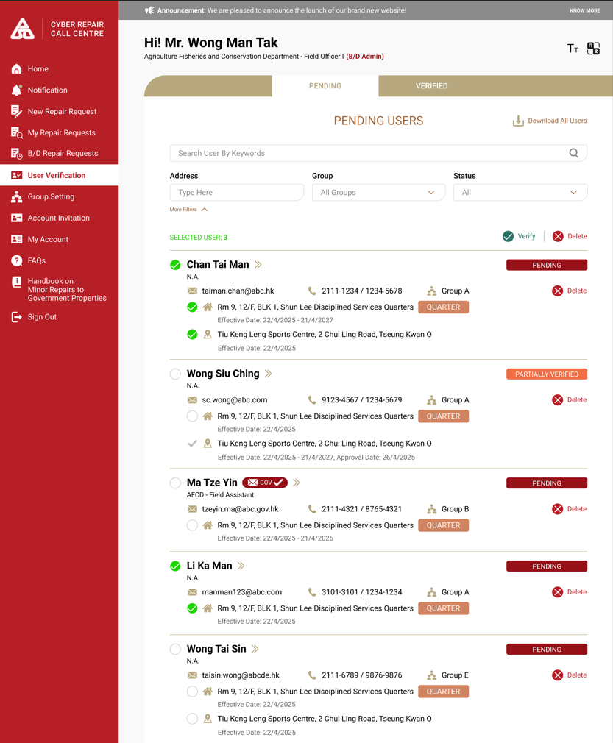  Verified Users:  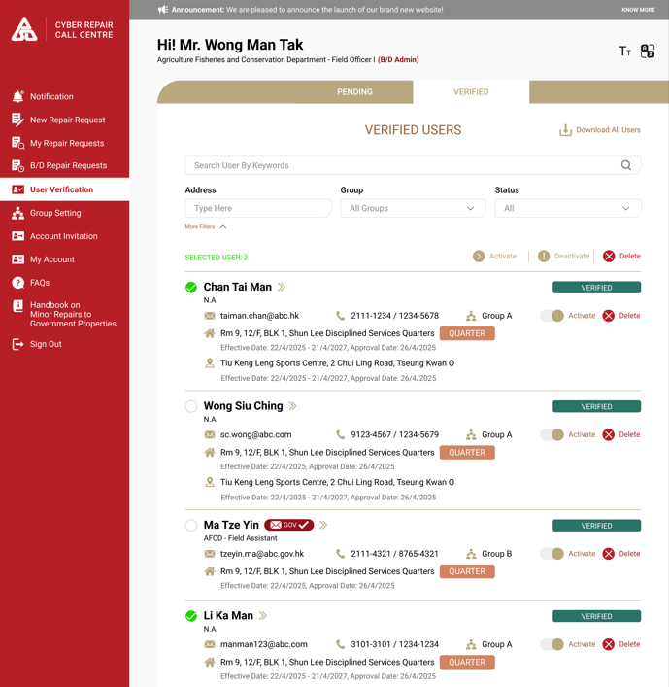  Confirm Verification:  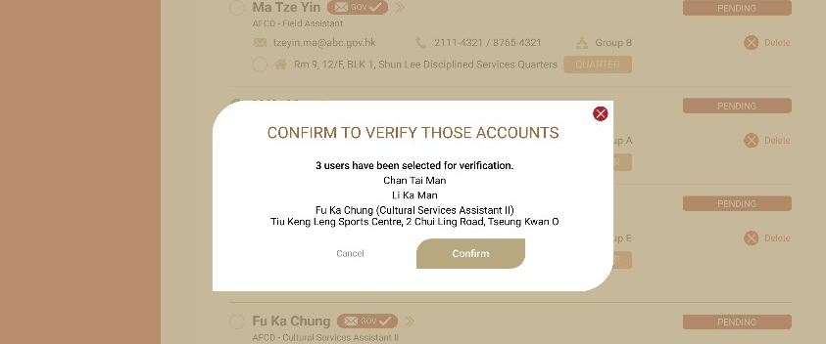  Confirm Delete:  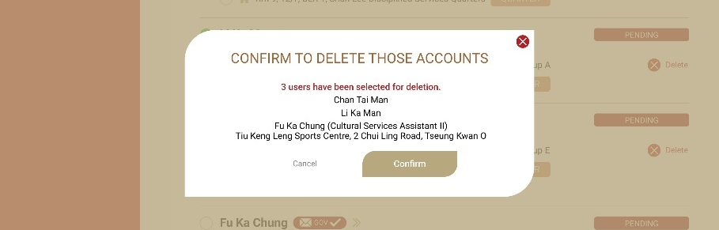  User Detail:  Pending Status  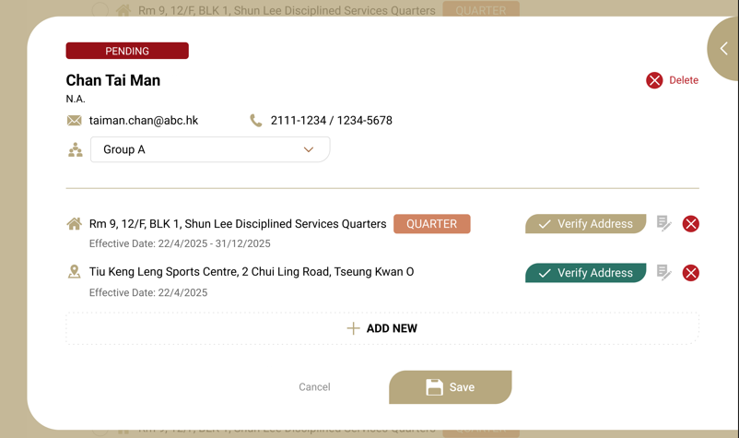  Partial Verified Status  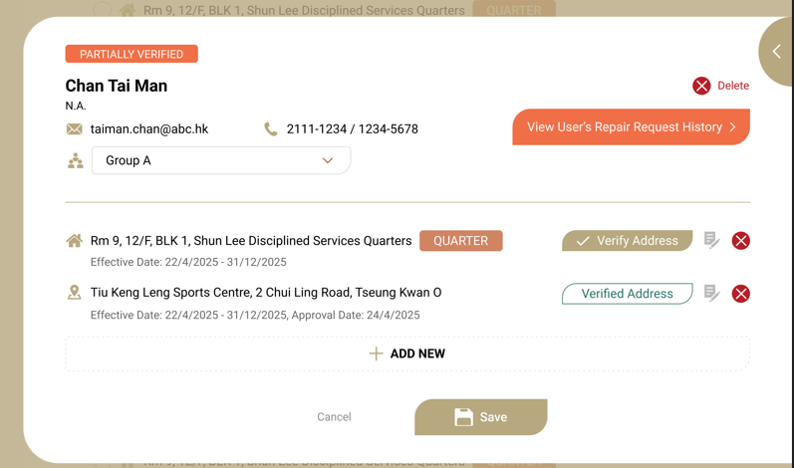  Verified Status  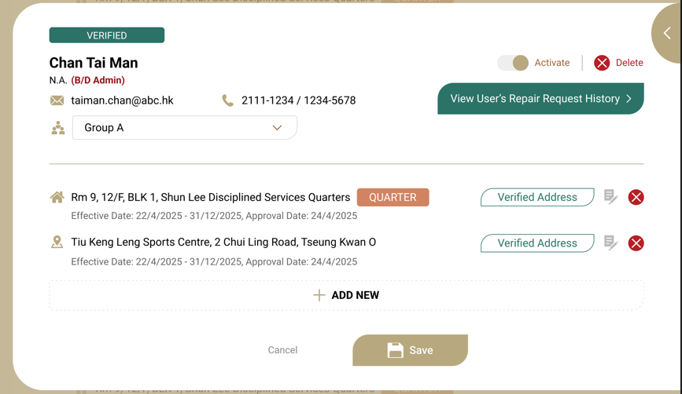  Edit Address:  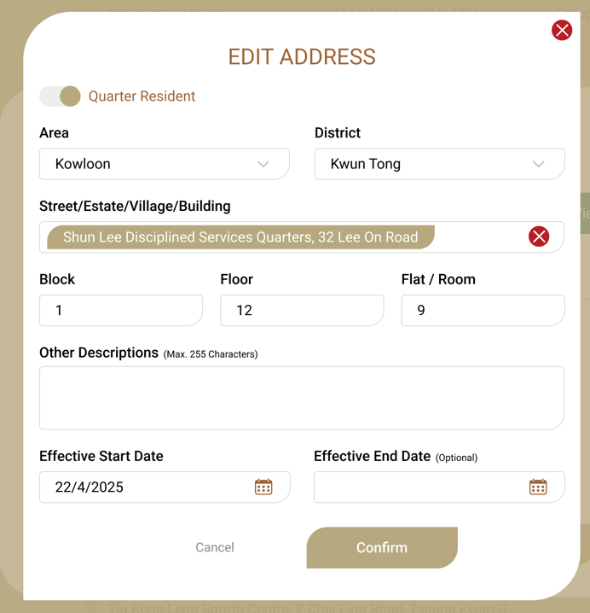  Send invitation link:  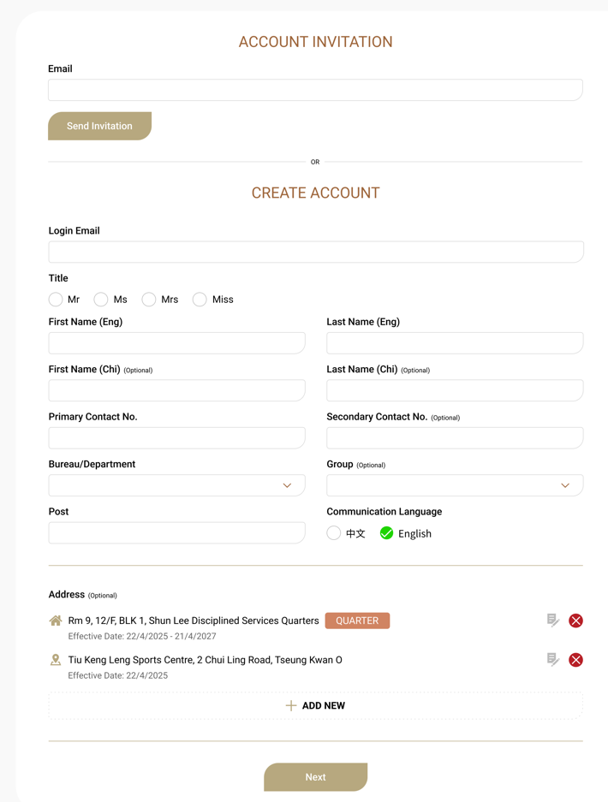
Email Template
  Sender | To Be Confirmed by ArchSD
  Subject | [ArchSD] CyberRCC User Account Status Update
  Content | Your CyberRCC User Account has <<Action>>.
Search Criteria
  Field | Type | Matching
  Name | Free Text | Similar Match
  Address | Drop Down | Exact Match
  Email | Free Text | Similar Match
  Group | Drop Down | Exact Match
  Contact No. | Drop Down | Exact Match
  Account Status | Drop Down | Exact Match
Prompt Message | Verify User:  “Are You Confirmed to verify selected users?  << Number of Selection >> Users are selected for verification.  <<Name>><<Position>><<Address>>”  Permanently Delete User:  “Are You Confirmed to remove selected users’ information?  << Number of Selection >> Users are selected for removal.  <<Name>><<Position>><<Address>>”
User Status
  Verified
  Pending
  Pending Verified

        - UF-0015 CyberRCC User Group Management
Item | Description
Function ID | UF-0015
Function Name | CyberRCC User Group Management
Category | Presentation Layer
Related Requirements | User Group (Web-R6)
Function Description | - B/Ds admins can create/update/delete user group  - B/Ds admins can assign user to different user group (Refer to UF-0013 User Management)  - B/Ds admins can assign group admin to different user groups  - User group can be up to 3 Tiers  - RCC admins will have the same functionalities for group management as B/D admins.
Metadata
  Field | Type
  Parent Group | Integer
  Group Name | Varchar(50)
  Add | Button
  Remove | Button
Business Rule/Validation
  Field  (* mandatory) | Mode | Description | Business Rule
  Group Setting
  Group Name | Display | - | -
  Tier | Display | - | At most 3 tiers
  Edit | Button | - | - Click to edit group  - A Group Edit Screen will be prompted
  Remove | Button | - | Click to remove group
  Add | Button | - | - Click to add new group  - A Group Add Screen will be prompted
  Group Add/Edit Screen
  *Parent Group | Dropdown |  | - Options:  - Top Level  - list of group  - Default: Top Level
  *Group Name | Free Text | Group Name defined for Department | Max Length: 50
  Group Admin | Multiple Selection | Selected User for Group Admin | - Options:  - User list under the B/D  - Can be Empty  - Multiple Selection
  Save | Button | - | - Click to save  - Close the Add/Edit Group Screen
  Cancel | Button | - | - Click to cancel  - Close the Add/Edit Group Screen
Screen Capture | Group Setting:  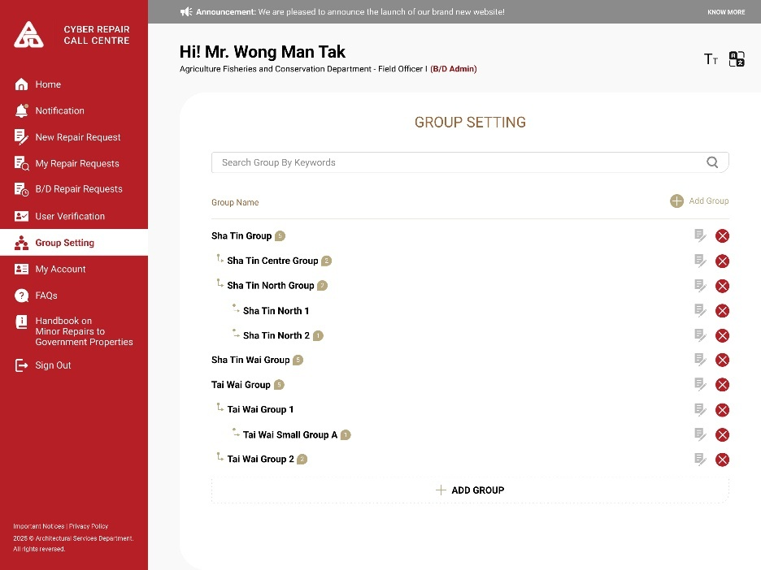  Group Setting Detail:  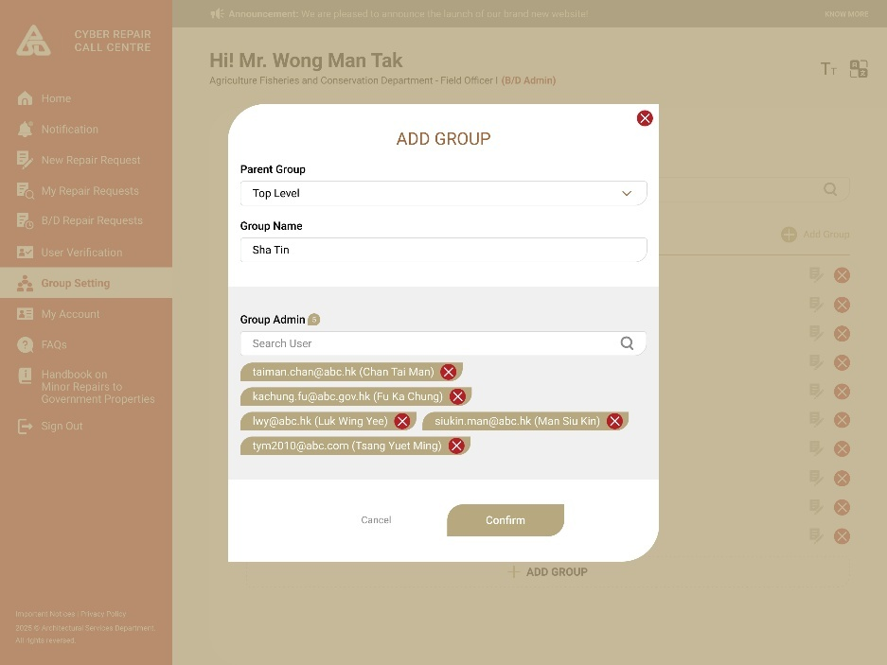

        - UF-0036 CyberRCC Reassign User to CyberRCC Cases
Item | Description
Function ID | UF-0036
Function Name | CyberRCC Reassign User to CyberRCC Cases
Category | Presentation Layer
Related Requirements
Function Description | B/Ds admin can reassign repair requests under their B/D in CyberRCC from their B/Ds user to another B/Ds user.
Metadata
  Field | Type
  CyberRCC Account ID | Varchar (5)
  CRK | Varchar (10)
  RRI | Varchar (10)
  Change PIC | Button
Business Rule | B/Ds admin can select one or more repair requests and click Change PIC button. A dialog box will be prompted, showing the list of same B/Ds users. They can select one of the B/Ds users to transfer the ownership of the non-ended or non-cancelled repair requests.
Screen Capture | 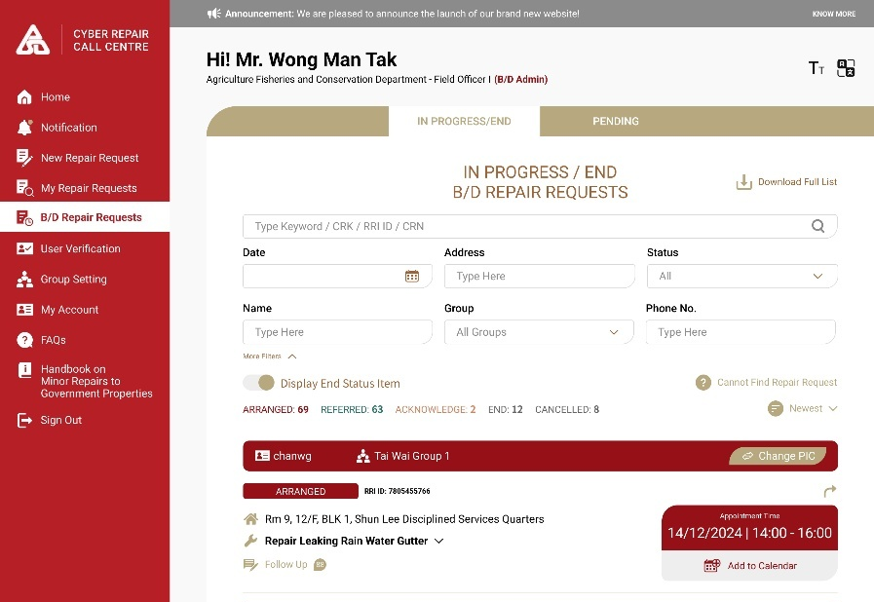  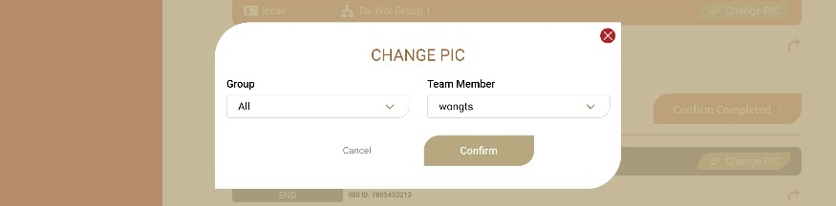

        - UF-0049 CyberRCC - Download Department Monthly RRF Report
Item | Description
Function ID | UF-0049
Function Name | CyberRCC - Download Department Monthly RRF Report
Category | Presentation Layer
Related Requirements | Monthly report to B/Ds (WEB-R22)
Function Description | - The list shows the generated report by month for corresponding B/D.  - Allow download the report by single or yearly.
Housekeep Period | 6 Years after that will move to archive server.
Screen Capture | 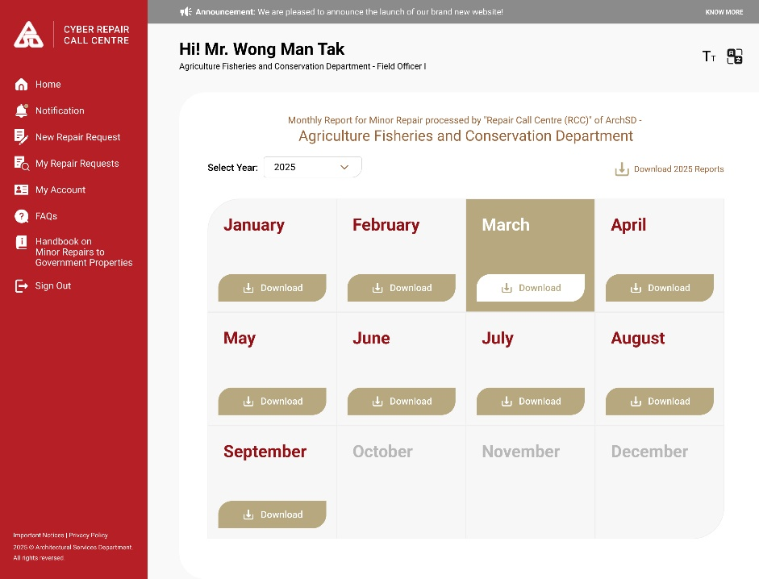

        - UF-0054 CyberRCC B/Ds admin Dashboard
Item | Description
Function ID | UF-0054
Function Name | CyberRCC B/Ds admin Dashboard
Category | Presentation Layer
Related Requirements | CyberRCC Dashboard for different user role (WEB-R23)
Function Description | - B/Ds admin reaches the page after logging into CyberRCC  - There is a quick navigation item for B/Ds admin to access several functions quickly in the dashboard  - A calendar shows the appointed repair requests in the dashboard  - A chart shows B/D’s repair request status in the dashboard  - A chart shows B/D’s account verification status in the dashboard  - B/Ds admin can view the latest notification in the dashboard
Business Rule | Site Menu:  Fast Navigation List:  User Verification:  - Three donut charts show the number and percentage of three B/Ds user verification status: Pending, Partial Verified and Verified.  - Clicking on each status chart redirects to B/Ds user Verification Page with the selected status.  B/D Repair Requests:  - A donut chart shows the distribution of B/D’s repair request status.  - A table displays numbers and percentage of repair request status.  - Clicking a status redirects B/D’s Repair Request Page with the selected status.  Upcoming Calendar:  - Showing Current Month Calendar  - If the date has appointment for repair request, it will be underlined  - Select the underlined date, following repair request information will be shown:  - Date  - Appointment Time  - Address  - Repair Item Description  Notification:  - It will show the number of unread notifications  - The latest 3 notifications will be shown, including the address and repair item description.  - Unread notifications will appear in bold.  - Clicking the arrow button will redirect to Notification Page.
  Menu Item | Navigation
  Home | Home Page after Login
  Notification | Notification Page
  New Repair Request | New Repair Request Page
  My Repair Request | My Repair Request Page
  B/D Repair Request | B/D Repair Request Page
  User Verification | B/Ds user Verification Page
  Group Setting | B/D Group Setting Page
  My Account | My Account Information Page
  Monthly Report | B/D Monthly Report Page
  FAQs | FAQ Page
  Handbook on Minor Repairs to Government Properties | Direct Download Handbook
  Sign Out | Logout CyberRCC
  List Item | Navigation
  New Repair Request | New Repair Request Page
  My Repair Request | My Repair Request Page
  My Account | My Account Information Page
  FAQs | FAQ Page
  Handbook on Minor Repairs to Government Properties | Direct Download Handbook
Screen Capture | Desktop:  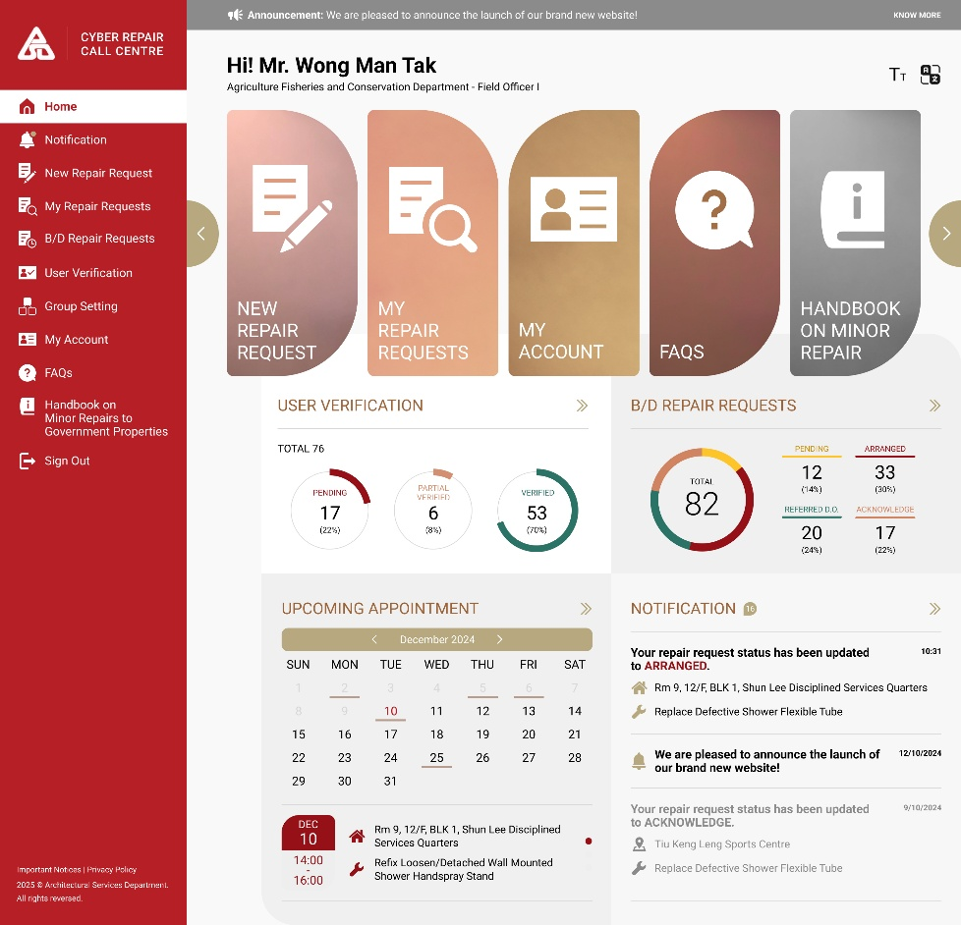
      - CyberRCC – DS Functions and Flows
        - UF-0038 DS Access CyberRCC
Item | Description
Function ID | UF-0038
Function Name | DS access CyberRCC
Category | Presentation Layer
Related Requirements | DS functions in CyberRCC (WEB-R20)
Function Description | - DS can access CyberRCC through DA
Business Rule | - When DS login into DA successfully, DS can select go to DA system or CyberRCC.  - After logging into the DA, the DS can click CyberRCC in the left menu or the top banner.  - A new page displaying the CyberRCC DS Home Page will open in the browser.
Screen Capture | 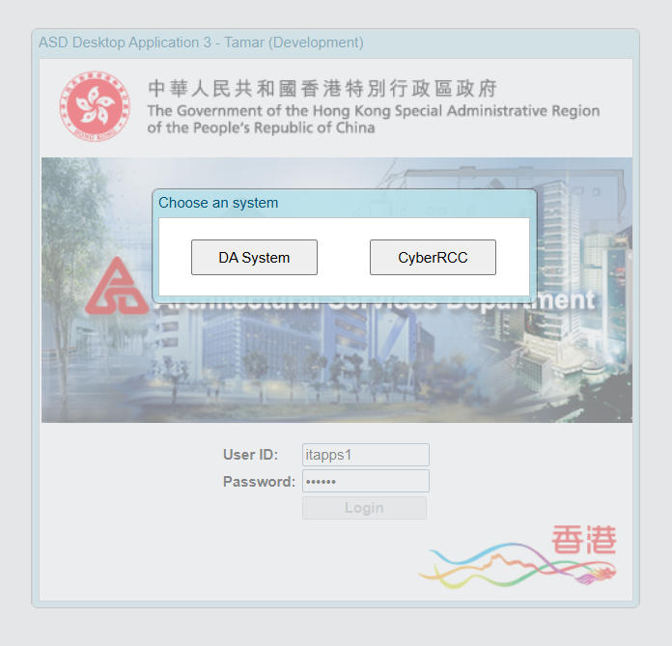  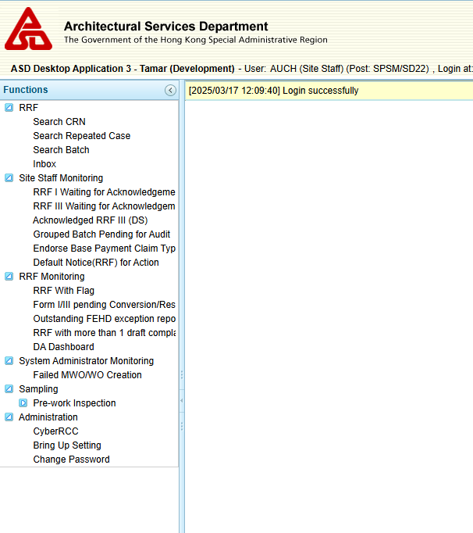

        - UF-0039 CyberRCC DS Function – Search RRF
Item | Description
Function ID | UF-0039
Function Name | CyberRCC DS Function – Search RRF
Category | Presentation Layer
Related Requirements | DS functions in CyberRCC (WEB-R20)
Function Description | The RCC Admin and DS can search for and view RRF within CyberRCC.  The field ACTION site completion date will be included as a search criteria in the DA for RRF.
Metadata
  Field | Type
  CRN | Varchar(8)
  RRI ID | Varchar(10)
  MWO/WO No. | Varchar(8)
  Call-in Date Time | DateTime
  RRF Create Date | Date
  Location | NVarchar(200)
  Area | Varchar(2)
  Location Code | Varchar(20)
  Position | NVarchar(200)
  Phone | Integer
  Shift | Varchar(5)
  RRF Type | Varchar(1)
  RRF Status | Varchar(20)
  Cancelled RRF | Varchar(1)
  Channel | Varchar(10)
  High Risk | Varchar(1)
  Urgency | Varchar(1)
  Without Site Completion Date | Varchar(1)
  Without Site Completion Date | Varchar(1)
  Have ACTION Site Completion Date | Varchar(1)
  My RRF Only | Varchar(1)
  Search | Button
  Reset | Button
  Download Full List | Button
  Number of Records Found | Integer
  Number of Inboxes | Integer
  Number of Draft Complaints | Integer
  VIP Alert | Varchar(1)
  Request Date | Date Time
  Flag Up | Varchar(1)
  Repair Item Description | NVarchar(255)
  Primary Contact Person Name | NVarchar(40)
  Primary Contact No. (Primary) | Integer
  Secondary Contact No. (Primary) | Integer
  Second Contact Person Name | NVarchar(40)
  Primary Contact No. (Second) | Integer
  Secondary Contact No. (Second) | Integer
  Detail | Button
Business Rule | Search Panel  Search RRF Result
  Field | Mode | Description | Business Rule
  CRN/RRI ID/MWO/WO No./Location Code | Text | - | - If the input starts with letter (A/B/W), it will search for MWO/WO No.  - If it starts with two English characters, it will search for Location Code.  - If it is exactly 8 digits, it will search for CRN.  - If it is exactly 10 digits, it will search for RRI ID.  - Any other input will be considered invalid.
  Call-in Date/RRF Create Date | Date Picker/ Selection | - | - Choose either Call-in Date or RRF Create Date  - Selection options:  - 7 days  - 14 days  - 1 month  - Default Option : 7 days  - The count will start today and extend back to the specified range.  - If a date range is selected, the selected option will be disregarded.
  Location | Text | - | - A dropdown for selecting “And” or “Or” condition for two location inputs  - Default is “And” condition  - “And” condition requires both inputs  - “Or” condition allows either one of the two inputs.
  Area | Dropdown | - | - Mandatory  - Option:  - 11  - 12  - 21  - 22  - 31  - 32  - 41  - 42  - 51  - 52
  Position | Text | - | -
  Phone | Text | - | -
  Shift | Dropdown | - | - Option:  - <Empty>  - Day  - Night  - Default <Empty>  - <Empty> means all shift
  RRF Type | checkbox | - | - Option:  - I  - III  - For DS in 10 Areas: Form I and III is checked by default.  - For DS not in 10 Areas: Form III is checked by default.
  RRF Status | Dropdown | - | - Option:  - <Empty>  - Active  - To Be Converted*  - To Be Converted  - Converted  - Cancelled  - Claimed  - Batched for Audit  - Accepted  - Rejected  - Re-submitted  - Grouped at  - Default <Empty>  - <Empty> means all status
  Cancelled RRF | Dropdown | RRF is Cancelled by RCC | - Option:  - <Empty>  - Yes  - No  - Default <Empty>  - <Empty> means both cancelled and non-cancelled RRF
  Channel | Dropdown | - | - Option:  - <Empty>  - Web  - Voice  - FEHD API  - Default <Empty>  - <Empty> means all Channel
  High Risk | Dropdown |  | - Option:  - <Empty>  - Yes  - No  - Default <Empty>  - <Empty> means both high-risk and non-high risk
  Urgency | Dropdown | - | - Option:  - <Empty>  - Emergency  - Urgent  - Normal  - Default <Empty>  - <Empty> means all urgency
  With ACTION Site Completion Date | Dropdown | - | - Option:  - <Empty>  - Yes  - No  - Default <Empty>  - <Empty> means both with and without ACTION Site Completion Date
  Without Site Completion Date | Checkbox | Without Site Completion Date from MTC | Default Unchecked
  Without Site Completion Date (IC) | Checkbox | Without Site Completion Date from IC | Default Unchecked
  My RRF | Radio Button | - | - Default off  - Disabled if DS not in 10 Areas  - Comparison based on DGUS. It will compare the login DS’s DGUS with the RRF’ s DGUS to check for a matched
  Search | Button | - | Search RRF based on the search criteria.
  Reset | Button | - | Reset Search Criteria
  Field | Mode | Description | Business Rule
  Number of RRF(s) Found | Display | - | -
  Download Full List | Button | - | Click to download the full search result list.
  CRN | Display | - | -
  RRF Type | Icon | - | -
  Number of Related Inbox | Display + Icon | - | -
  Number of Draft Complaints | Display + Icon | - | -
  VIP Alert | Icon | - | -
  Flag Up | Icon | - | -
  Detail | Button | - | Click to navigate to the RRF Detail Page
  Request Date | Display | - | -
  Location Code | Display | - | -
  Address | Display | - | -
  Position | Display | - | -
  Repair Item Description | Display | - | -
  RRI ID | Display | - | -
  Primary Contact Person Name | Display | - | -
  Primary Contact No. (Primary) | Display | - | Click to call the number on a mobile device.
  Secondary Contact No. (Primary) | Display | - | Click to call the number on a mobile device.
  Second Contact Person Name | Display | - | -
  Primary Contact No. (Second) | Display | - | Click to call the number on a mobile device.
  Secondary Contact No. (Second) | Display | - | Click to call the number on a mobile device.
Search Criteria
  Search Criteria | Type | Matching
  CRN/RRI ID/MWO/WO No./Location Code | Text | Exact Match
  Call-in Date/RRF Create Date | Date Range | Within selected date range
  Location | Text | Similar Match
  Area | Dropdown | Exact Match
  Position | Text | Similar Match
  Phone | Text | Exact Match
  Shift | Dropdown | Exact Match
  RRF Type | Checkbox | Exact Match
  RRF Status | Dropdown | Exact Match
  Cancelled RRF | Dropdown | Exact Match
  Channel | Dropdown | Exact Match
  Urgency | Dropdown | Exact Match
  With ACTION Site Completion Date | Dropdown | Exact Match
  Without Site Completion Date | Checkbox | Exact Match
  Without Site Completion Date (IC) | Checkbox | Exact Match
  My RRF | Radio Button | Exact Match
Screen Capture | Search RRF:  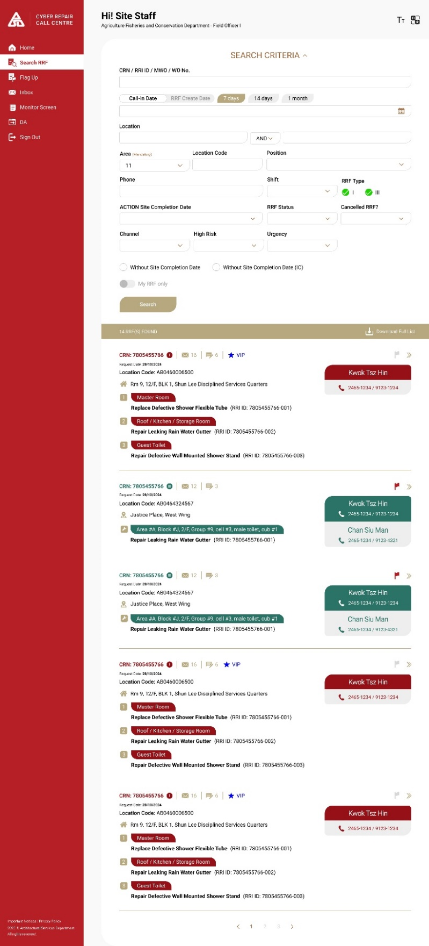
        - UF-0073 Database synchronize data from ACTION
Item | Description
Function ID | UF-0073
Function Name | Synchronize ACTION site completion date from ACTION database to DA database
Category | Presentation Layer
Related Requirements | DS functions in CyberRCC (WEB-R20)
Function Description | - A new field will be created in the DA database to store the ACTION site completion date .  - Additionally, the job synchronization process will be updated to ensure that data is accurately transferred from the ACTION database to the DA database.
Metadata | ACTION Database:  DA Database:
  Field | Type
  TBC | Datetime
  Field | Type
  ACTIONSiteCompDate | Datetime

        - UF-0040 CyberRCC DS Function – Export Search RRF Result
Item | Description
Function ID | UF-0040
Function Name | CyberRCC DS Function – Export Search RRF Result
Category | Presentation Layer
Related Requirements | DS functions in CyberRCC (WEB-R20)
Function Description | - DS have the capability to export the RRF search results to an Excel file.  - In the exported Excel file, DS can click on the URL to navigate back to the CyberRCC RRF Detail Page.
Metadata
  Field | Type
  CRN | Varchar(8)
  Issuing Officer Post | Varchar(25)
  Cancelled RRF | Varchar(1)
  MWO No. | Varchar(8)
  Location Code | Varchar(20)
  Address | NVarchar(255)
  Area | Varchar(2)
  RRF Type | Varchar(1)
  Urgency | Varchar(1)
  High Risk | Varchar(1)
  RRF Status | Varchar(50)
  Site Completion Date (From MTC) | Date
  Site Completion Date (From IC) | Date
  RRI ID | Varchar(10)
  Call-in Datetime | Datetime
  Position | NVarchar(70)
  Repair Item Description | NVarchar(255)
  Item Remark | Varchar(150)
  Complicated Repair Description | NVarchar(700)
  Client Request Appointment Time | Datetime
  Appointment Time from Contractor | Datetime
  NA | Varchar(1)
  No Appointment Time | Varchar(1)
  Channel | Varchar(10)
  Not Issue MWO/WO | Varchar(1)
  Other MWO/WO No. | Varchar(100)
  Claim Type | Varchar(50)
  RRF Creation Datetime | Datetime
  Number of Draft Complaints | Integer
  FEHD Site Completion Date | Date
  IC Site Completion Date Update Date | Datetime
  FEHD Exception Report Date | Date
  MTC Completion Media Upload Datetime | Datetime
  URL | Varchar(500)
Business Rule | Exported Excel Column  For each RRF, if there is more than one RRI associated with it, the exported Excel file will contain multiple rows for the same CRN.
  Field | Business Rule
  CRN | -
  Issuing Officer Post | -
  Cancelled RRF | -
  MWO No. | -
  Location Code | -
  Address | -
  Area | -
  RRF Type | -
  Urgency | -
  High Risk | -
  RRF Status | -
  Site Completion Date (From MTC) | -
  Site Completion Date (From IC) | -
  RRI ID | -
  Call-in Datetime | -
  Position | -
  Repair Item Description | -
  Item Remark | -
  Complicated Repair Description | -
  Client Request Appointment Time | -
  Appointment Time from Contractor | -
  NA | -
  No Appointment Time | -
  Channel | -
  Not Issue MWO/WO | -
  Other MWO/WO No. | -
  Claim Type | -
  RRF Creation Datetime | -
  Number of Draft Complaints | -
  FEHD Site Completion Date | -
  IC Site Completion Date Update Date | -
  FEHD Exception Report Date | -
  MTC Completion Media Upload Datetime | -
  URL | DS can click on the URL to return to RRF Detail Page.
Screen Capture | 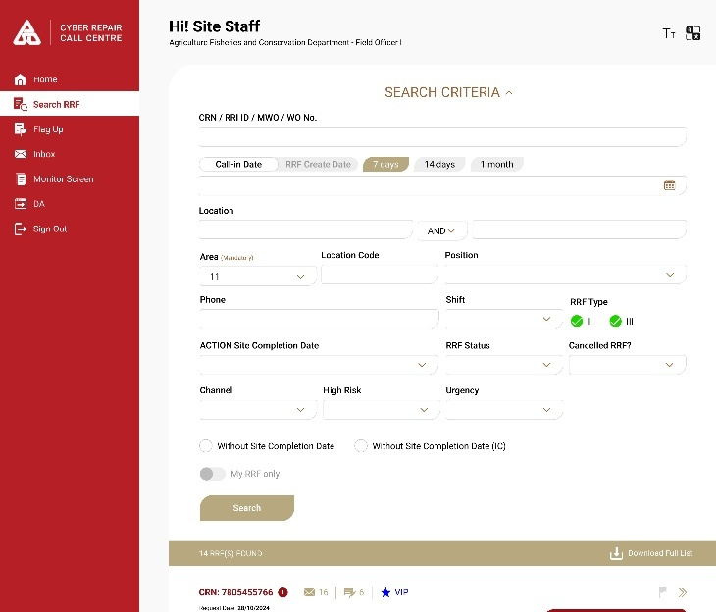

        - UF-0041 CyberRCC DS Function – RRF Detail
Item | Description
Function ID | UF-0041
Function Name | CyberRCC DS Function – RRF Detail
Category | Presentation Layer
Related Requirements | DS functions in CyberRCC (WEB-R20)
Function Description | DS can view the RRF Detail within CyberRCC
Metadata
  Field | Type
  CRN | Varchar(8)
  High Risk | Varchar(1)
  Cancelled RRF | Varchar(1)
  Flag Up | Varchar(1)
  Form Type | Varchar(1)
  Repeated Cases | Varchar(1)
  Number of Inbox Request | Integer
  Number of Draft Complaints | Integer
  VIP Alert | Varchar(1)
  To DA | Button
  Callin Datetime | Datetime
  Handle Datetime | Datetime
  RRF Status | Varchar(50)
  Area of Building | Integer
  Urgency | Varchar(1)
  Contract Number | NVarchar(8)
  Primary Contact Person Name | NVarchar(40)
  Primary Contact No. (Primary) | Integer
  Secondary Contact No. (Primary) | Integer
  Second Contact Person Name | NVarchar(40)
  Primary Contact No. (Second) | Integer
  Secondary Contact No. (Second) | Integer
  Detail | Tab
  Follow Up | Tab
  Draft Complaint | Tab
  MWO/WO | Tab
  Request History | Tab
  Location Code | Varchar(20)
  Location | NVarchar(255)
  DS Remarks | NVarchar(255)
  IC Remarks | NVarchar(255)
  MTC Remarks | NVarchar(255)
  RRI ID | Varchar(10)
  Appointment Datetime | Datetime
  Position | NVarchar(70)
  Repair Item Description | NVarchar(255)
  Item Remarks | Varchar(150)
  Internal Remarks | NVarchar(255)
  Photos | Base64
  Complicated Repair Description | NVarchar(700)
  CRK | Varchar(10)
  MWO/WO Not Required | Varchar(1)
  Follow-Up Case | Varchar(1)
  Superseded By | Varchar(10)
  Issuing Officer Post | NVarchar(25)
  Issuing Officer | Varchar(35)
  Date of Commencement | Date
  Target Completion Date/Time | Date/Datetime
  Revised Target Completion Date/Time | Date/Datetime
  Site Completion Date (from MTC) | Date
  Site Completion Date/Time (from IC) | Date/Datetime
  Site Completion Date (from client) | Date
  DC No | Integer
  Datetime of Complaint | Datetime
  Name of Caller | NVarchar(45)
  Category | NVarchar(200)
  Description of Complaint | NVarchar(500)
  FEHD App | Varchar(1)
  RRI ID | Varchar(10)
  Result | NVarchar(30)
  Created By | Varchar (30)
  Remarks | Varchar(2)
  MWO/WO Number | Varchar(8)
  MWO/WO Status | Varchar(50)
  MWO/WO Cancelled Reason | Varchar(1500)
  Creation Datetime | Datetime
  Creation Status | Varchar(1)
  MWO Manual Creation Time | Datetime
  ACTION Site Completion Date | Date
  Created By | Varchar(30)
  Other MWO/WO | List
  Request Datetime | Datetime
  Participants | Varchar(1000)
  Message | NVarchar(255)
  Request Ended By | Varchar(30)
  Request Message Datetime | Datetime
  From | Varchar(30)
  019 Follow Up Action | NVarchar(550)
  019 Follow Up Post | Varchar(30)
  Alert Message | NVarchar(255)
  Send Alert DateTime | Datetime
  Send By | Varchar(10)
  Batch ID | Varchar(11)
  DN(RRF) Status | Varchar(50)
  DN(RRF) Reason | Varchar(200)
  DN(RRF) Create Date | Date
  DN(RRF) Created By | Varchar(20)
  Appeal By MTC | Varchar(1)
  DS Remarks | Varchar(200)
  PO Update | Varchar(20)
  PO Reject DN(RRF) Reasons | Varchar(200)
  PO Update By | Varchar(100)
  PO Update Date | Date
  PSM Update | Varchar(20)
  PSM Reject DN(RRF) Reasons | Varchar(200)
  PSM Update By | Varchar(100)
  PSM Update Date | Date
  MTC Submit for Appeal Date | Date
  PO Recommend/Reject | Varchar(20)
  PSM Recommend/Reject Appeal Reasons | Varchar(200)
  PO Appeal Review By | Varchar(100)
  PO Review Appeal Date | Date
  PSM Approve/Reject | Varchar(20)
  Remarks | Varchar(200)
  PSM Appeal Review By | Varchar(100)
  PSM Review Appeal Date | Date
  Appeal Result | Varchar(20)
  Created By | Varchar(20)
  Created Date | Date
  Issued By | Varchar(20)
  Issued Date | Date
  Updated By | Varchar(20)
  Updated Date | Date
Business Data | RRF Information:  Detail Tab:  Follow Up Tab:  Draft Complaint Tab:  MWO/WO Tab:  Request History Tab:  Default Notice Tab
  Field | Mode | Description | Business Rule
  CRN | Display | - | -
  High Risk | Icon | - | -
  Cancelled RRF | Icon | - | -
  Flag Up | Icon | - | -
  Form Type | Display | - | -
  Repeated Cases | Icon | - | -
  Number of Inbox Request | Icon | - | -
  Number of Draft Complaints | Icon | - | -
  VIP Alert | Icon | - | -
  To DA | Button | - | Click to pop up the RRF Detail Page in DA
  Callin Datetime | Display | - | -
  Handle Datetime | Display | - | -
  RRF Status | Display | - | -
  Area of Building | Display | - | -
  Urgency | Display | - | -
  Contract Number | Display | - | -
  Primary Contact Person Name | Display | - | -
  Primary Contact No. (Primary) | Display | - | Click to call the number on a mobile device
  Secondary Contact No. (Primary) | Display | - | Click to call the number on a mobile device
  Second Contact Person Name | Display | - | -
  Primary Contact No. (Second) | Display | - | Click to call the number on a mobile device
  Secondary Contact No. (Second) | Display | - | Click to call the number on a mobile device
  Detail | Tab | - | Click to switch to Detail tab
  Follow Up | Tab | - | - Click to switch to Follow Up tab  - Applicable for Form I Only
  Draft Complaint | Tab | - | - Click to switch to Draft Complaint tab  - Applicable for Form I Only
  MWO/WO | Tab | - | Click to switch to MWO/WO tab
  Request History | Tab | - | Click to switch to Request History tab
  CRK | Display | - | Displayed in Form III only
  MWO/WO Not Required | Display | - | Displayed in Form III only
  Follow-Up Case | Display | - | Displayed in Form III only
  Superseded By | Display | - | Displayed in Form III only
  Field | Mode | Description | Business Rule
  Location Code | Display | - | -
  Location | Display | - | -
  DS Remarks | Display | - | -
  IC Remarks | Display | - | -
  MTC Remarks | Display | - | -
  RRI ID | Display | - | -
  Appointment Datetime | Display | - | Displayed in Form I Only
  Position | Display | - | Displayed in Form I Only
  Repair Item Description | Display | - | Displayed in Form I Only
  Item Remarks | Display | - | -
  Internal Remarks | Display | - | -
  Photos | Display | - | -
  Complicated Repair Description | Display | - | Displayed in Form III Only
  Field | Mode | Description | Business Rule
  Issuing Officer Post | Display | - | -
  Issuing Officer | Display | - | -
  Date of Commencement | Display | - | -
  Target Completion Date/Time | Display | - | -
  Revised Target Completion Date/Time | Display | - | -
  Site Completion Date (from MTC) | Display | - | -
  Site Completion Date/Time (from IC) | Display | - | -
  Site Completion Date (from client) | Display | - | -
  Field | Mode | Description | Business Rule
  DC No | Display | - | -
  Datetime of Complaint | Display | - | -
  Name of Caller | Display | - | -
  Category | Display | - | -
  Description of Complaint | Display | - | -
  FEHD App | Display | - | -
  RRI ID | Display | - | -
  Result | Display | - | -
  Created By | Display | - | -
  Remarks | Display | - | -
  Field | Mode | Description | Business Rule
  MWO/WO Number | Display | - | -
  MWO/WO Status | Display | - | -
  MWO/WO Cancelled Reason | Display | - | -
  Creation Datetime | Display | - | -
  Creation Status | Display | - | -
  MWO Manual Creation Time | Display | - | -
  ACTION Site Completion Date | Display | - | -
  Created By | Display | - | -
  Other MWO/WO
  MWO/WO Number | Display | - | -
  MWO/WO Status | Display | - | -
  ACTION Site Completion Date | Display | - | -
  019 Form
  RRI ID | Display | - | -
  Follow Up Action | Display | - | -
  Follow Up Post | Display | - | -
  Field | Mode | Description | Business Rule
  Request Datetime | Display | - | -
  Participants | Display | - | -
  Message | Display | - | -
  Request Ended By | Display | - | -
  Message History
  Request Message Datetime | Display | - | -
  From | Display | - | -
  Message | Display | - | -
  Alert Message
  Alert Message | Display | - | -
  Send Alert DateTime | Display | - | -
  Send By | Display | - | -
  Field | Mode | Description | Business Rule
  Batch ID | Display | - | -
  DN(RRF) Status | Display | - | -
  DN(RRF) Reason | Display | - | -
  DN(RRF) Create Date | Display | - | -
  DN(RRF) Created By | Display | - | -
  Appeal By MTC | Display | - | -
  Default Notice Detail
  DN(RRF) Status | Display | - | -
  DN(RRF) Reason | Display | - | -
  DS Remarks | Display | - | -
  PO Update | Display | - | -
  PO Reject DN(RRF) Reasons | Display | - | -
  PO Update By | Display | - | -
  PO Update Date | Display | - | -
  PSM Update | Display | - | -
  PSM Reject DN(RRF) Reasons | Display | - | -
  PSM Update By | Display | - | -
  PSM Update Date | Display | - | -
  Appeal By MTC | Display | - | -
  MTC Submit for Appeal Date | Display | - | -
  PO Recommend/Reject | Display | - | -
  PSM Recommend/Reject Appeal Reasons | Display | - | -
  PO Appeal Review By | Display | - | -
  PO Review Appeal Date | Display | - | -
  PSM Approve/Reject | Display | - | -
  Remarks | Display | - | -
  PSM Appeal Review By | Display | - | -
  PSM Review Appeal Date | Display | - | -
  Appeal Result | Display | - | -
  Created By | Display | - | -
  Created Date | Display | - | -
  Issued By | Display | - | -
  Issued Date | Display | - | -
  Updated By | Display | - | -
  Updated Date | Display | - | -
Screen Capture | Form I Detail Tab:  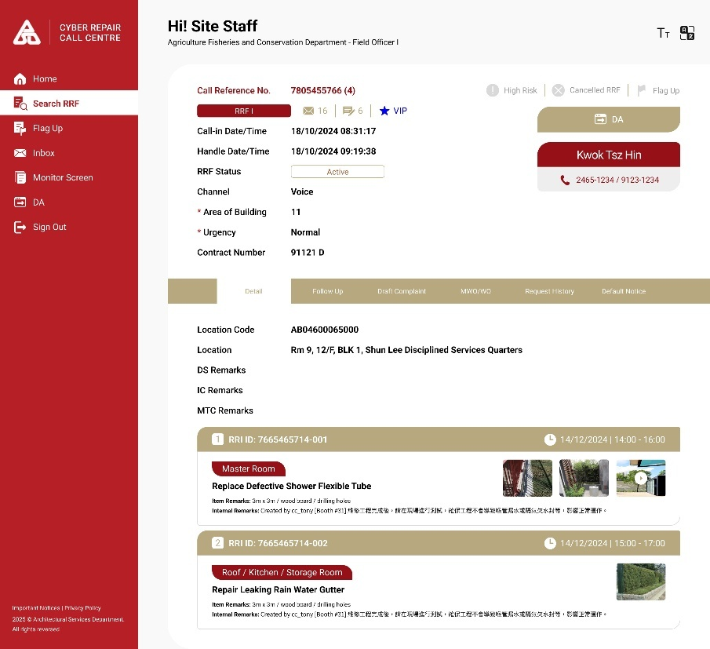  Form III Detail Tab:  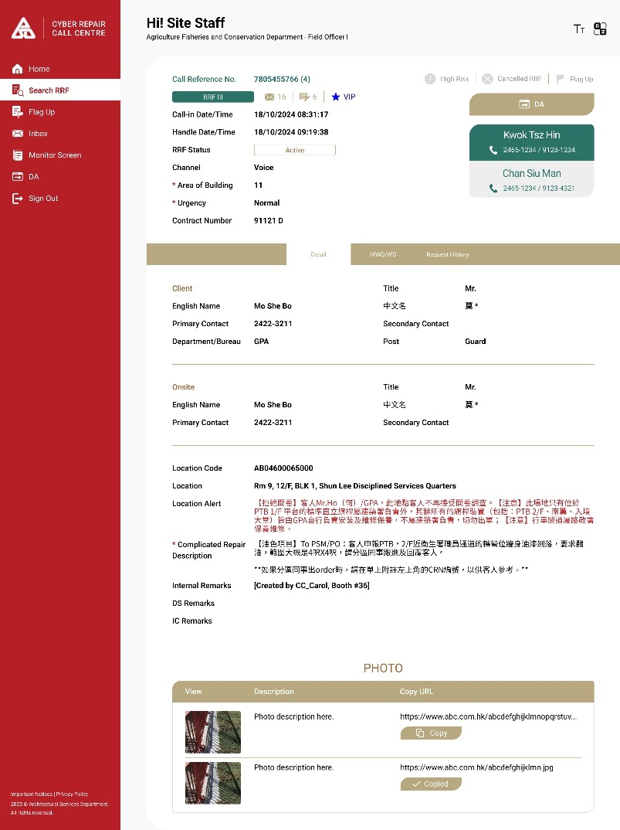  Follow Up Tab  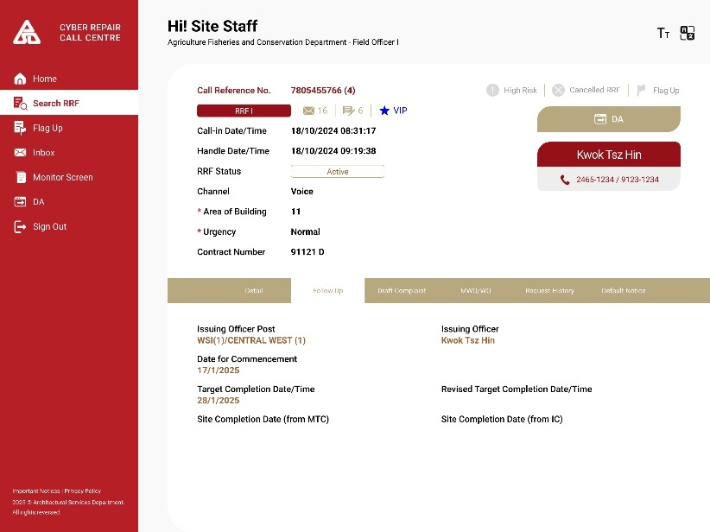  Draft Complaint Tab:  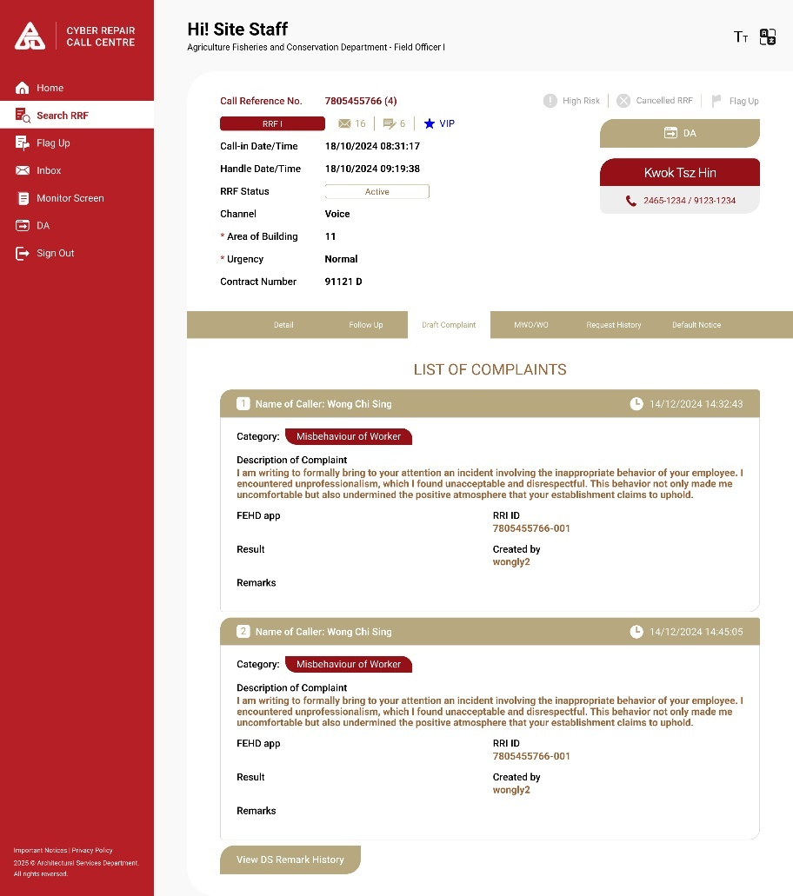  MWO/WO Tab:  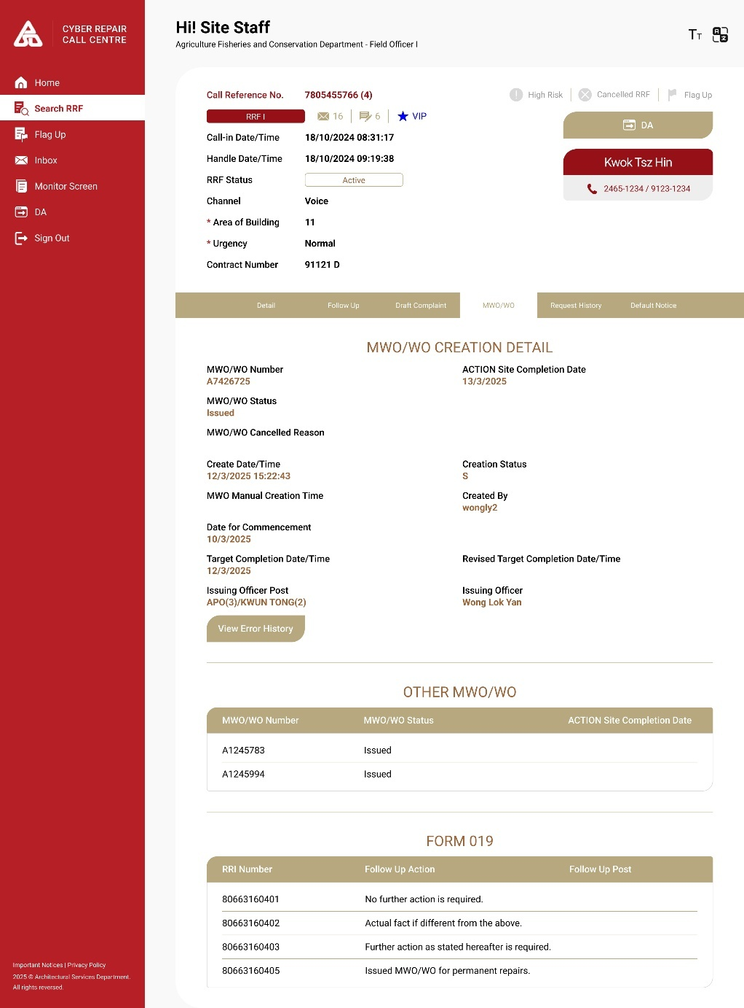  Request History:  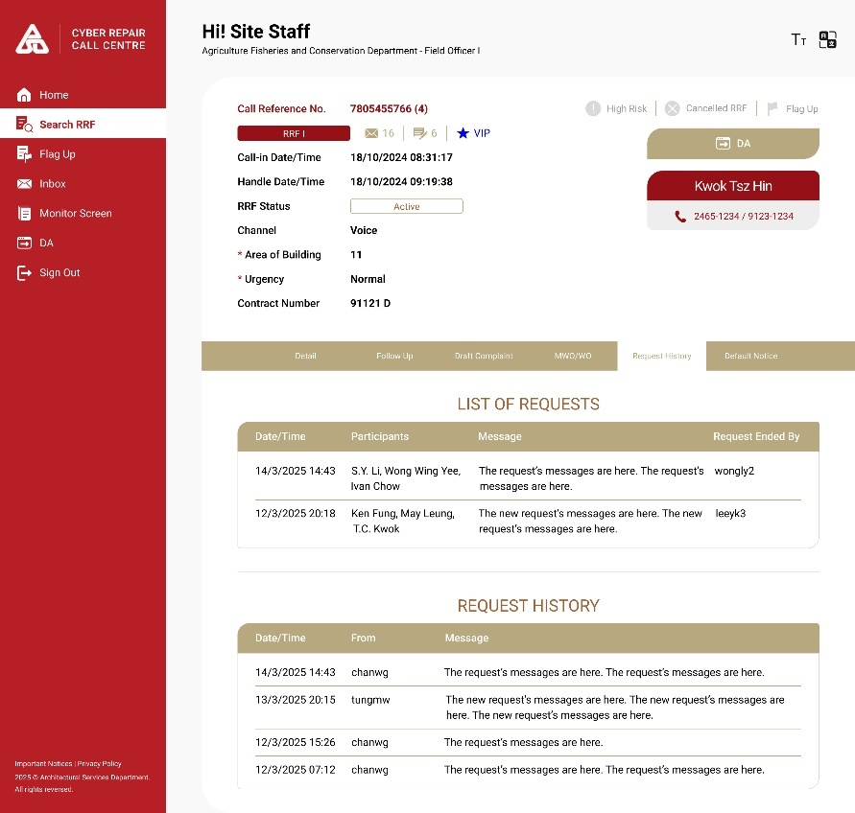  Default Notice Tab:  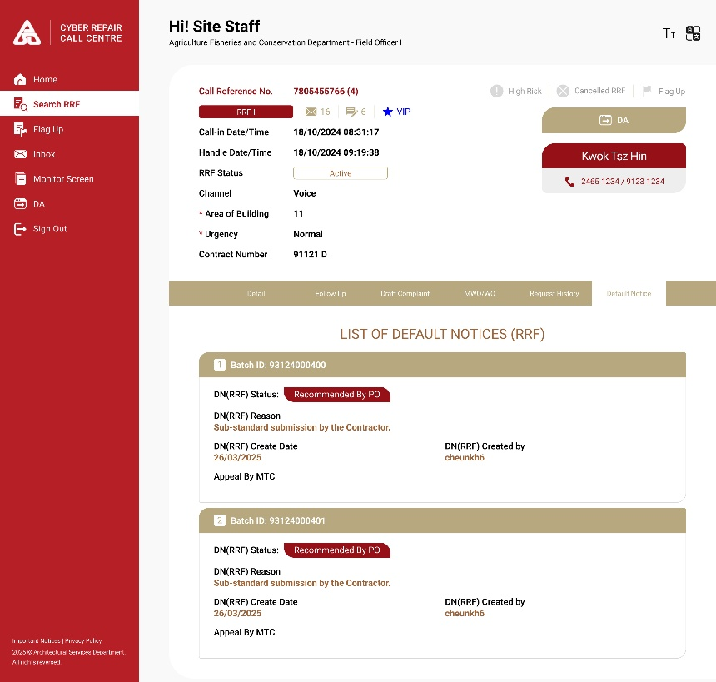  Default Notice Detail:  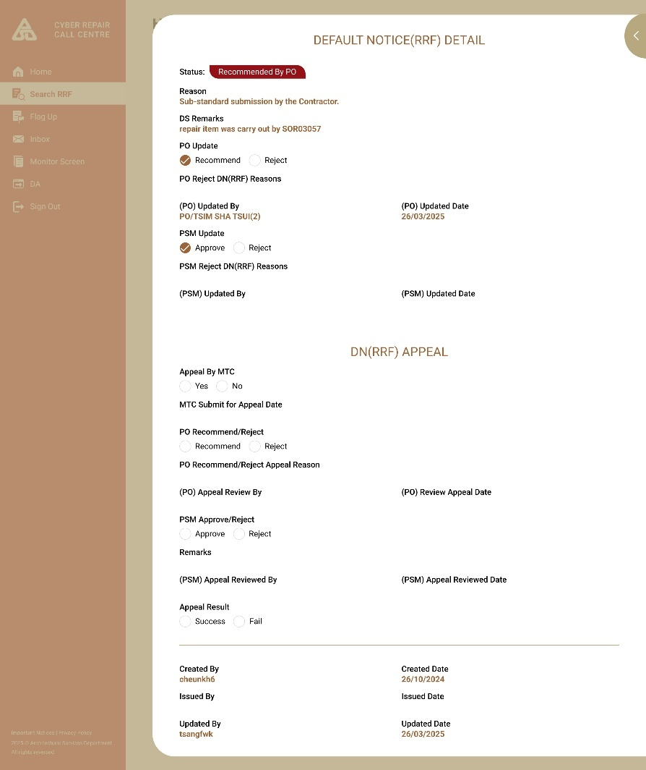

        - UF-0042 CyberRCC DS Function – Flag Up Monitor Screen
Item | Description
Function ID | UF-0042
Function Name | CyberRCC DS Function – Flag Up Monitor Screen
Category | Presentation Layer
Related Requirements | DS functions in CyberRCC (WEB-R20)
Function Description | - DS can view all Flag Up RRFs on a monitor screen within CyberRCC.  - DS can double-click an RRF to be redirected to RRF Detail Page.
Metadata
  Field | Type
  CRN | Varchar(8)
  Location Code | Varchar(20)
  Location Name | NVarchar(255)
  DS Remark | NVarchar(255)
  Flag Up By | Varchar(30)
  Flag Up Date | Datetime
  Issuing Officer Post | Varchar(25)
Business Rule | DS can double-click the RRF record to be redirected to RRF Detail Page.
  Field | Mode | Description | Business Rule
  CRN | Display | - | -
  Location Code | Display | - | -
  Location Name | Display | - | -
  DS Remark | Display | - | -
  Flag Up By | Display | - | -
  Flag Up Date | Display | - | The default sorting of the displayed items is set to ascending order.
  Issuing Officer Post | Display | -
Screen Capture | 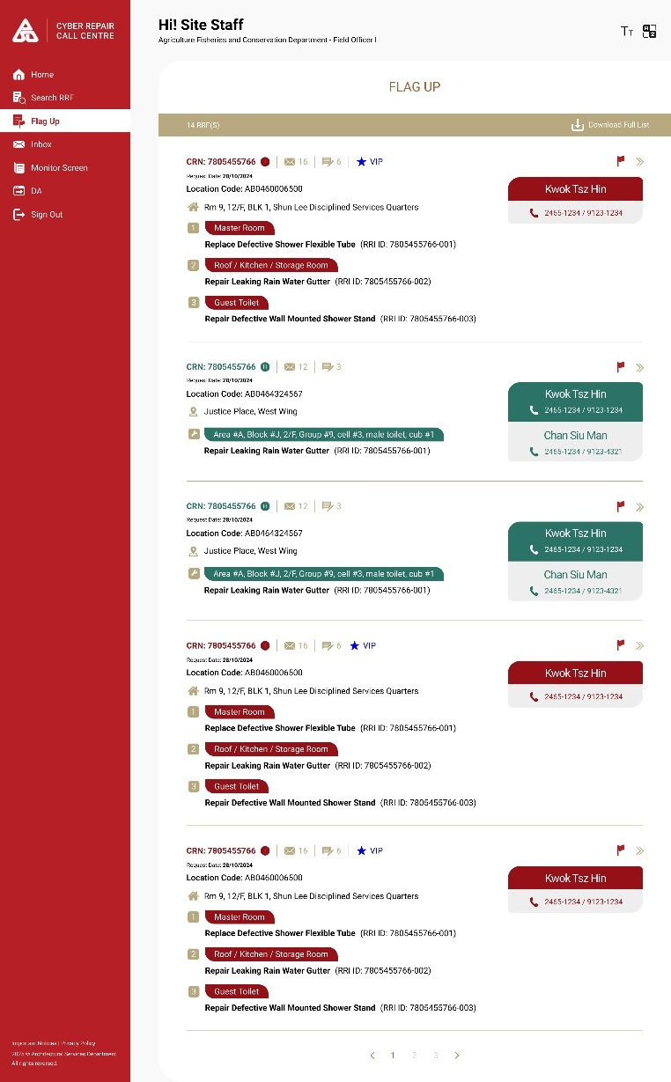

        - UF-0043 CyberRCC DS Function – Form III Waiting for Acknowledgement Monitor Screen
Item | Description
Function ID | UF-0043
Function Name | CyberRCC DS Function – Form III Waiting for Acknowledgement Monitor Screen
Category | Presentation Layer
Related Requirements | DS functions in CyberRCC (WEB-R20)
Function Description | - DS can view all Form III RRF Pending Acknowledgement on a Monitor Screen within CyberRCC.  - DS can double-click the RRF to be redirected to RRF Detail Page
Metadata
  Field | Type
  CRN | Varchar(8)
  Callin Datetime | Datetime
  Location Code | Varchar(20)
  Address | NVarchar(255)
  VIP | Varchar(1)
  Complicated Repair Description | NVarchar(700)
  Handling Officer Post | Varchar(25)
  Priority | Integer
  MWO/WO | Varchar(8)
  Other MWO/WO | Varchar(100)
Business Rule | DS can double-click the RRF record to be redirected to RRF Detail Page.
  Field | Mode | Description | Business Rule
  CRN | Display | - | -
  Callin Datetime | Display | - | The default sorting of the displayed items is set to descending order.
  Location Code | Display | - | -
  Address | Display | - | -
  VIP | Display | - | -
  Complicated Repair Description | Display | - | -
  Handling Officer Post | Display | - | -
  Priority | Display | - | -
  MWO/WO | Display | - | -
  Other MWO/WO | Display | - | -
Screen Capture | 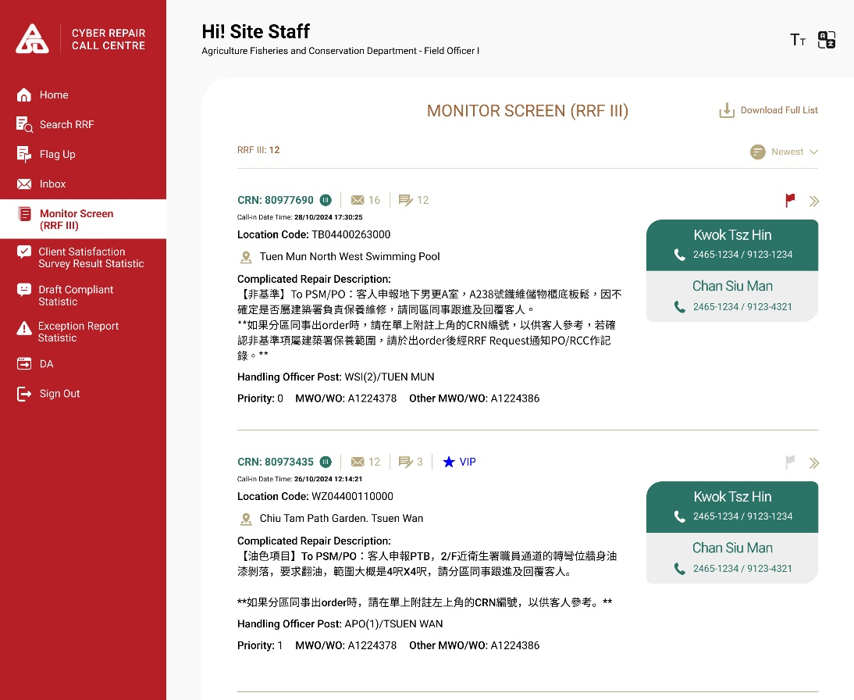

        - UF-0044 CyberRCC DS Function – Inbox Request
Item | Description
Function ID | UF-0044
Function Name | CyberRCC DS Function – Inbox Request
Category | Presentation Layer
Related Requirements | DS functions in CyberRCC (WEB-R20)
Function Description | - DS can view the list of their Inbox Request within CyberRCC  - DS can double-click on a record to display the details of the Inbox Request  - DS can view the details of their Inbox Requests in CyberRCC
Metadata
  Field | Type
  Initiate Datetime | Datetime
  CRN | Varchar(8)
  Address | NVarchar(255)
  Issuing officer Post | Varchar(25)
  Participants | Varchar(1000)
  Priority | Integer
  Responded | Varchar(1)
  Last Message By | Varchar(30)
  Message | NVarchar(255)
  Last Reply Datetime | Datetime
  Message Sent Datetime | Datetime
Business Data | Inbox Request Page  When DS double-click on the record, the Inbox Request Detail Page will pop up.  Inbox Request Detail Page
  Field | Mode | Description | Business Rule
  Initiate Datetime | Display | - | The default sorting of the displayed items is set to descending order.
  CRN | Display | - | -
  Address | Display | - | -
  Issuing officer Post | Display | - | -
  Participants | Display | - | -
  Priority | Display | - | -
  Responded | Display | - | -
  Last Message By | Display | - | -
  Message | Display | - | -
  Last Reply Datetime | Display | - | -
  Field | Mode | Description | Business Rule
  CRN | Display/Hyperlink | - | Click to pop up RRF Detail Page
  Participants | Display | - | -
  Inbox History
  Message Sent Datetime | Display | - | The default sorting of the displayed items is set to descending order.
  From | Display | - | -
  Message | Display | - | -
Screen Capture | 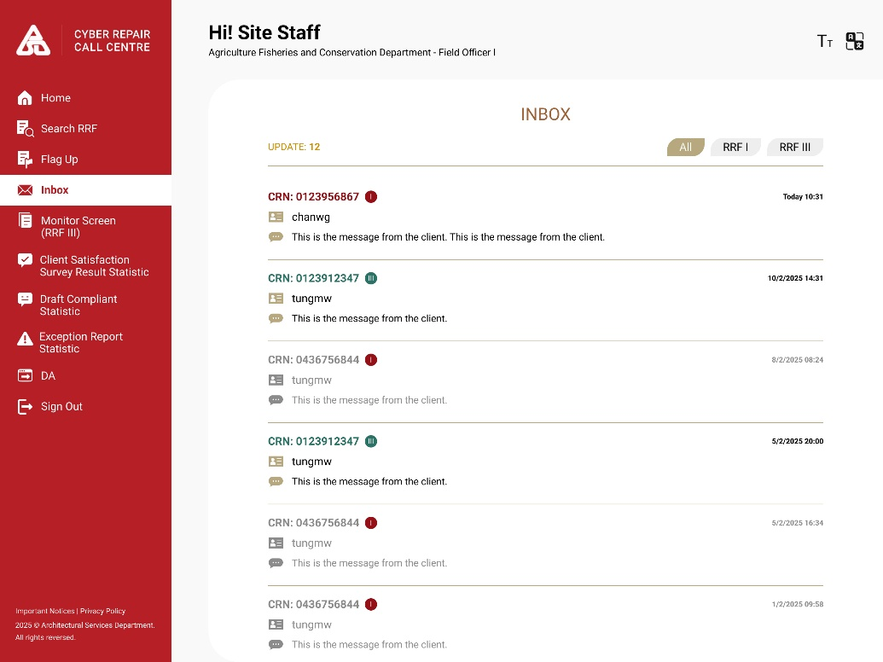

        - UF-0045 CyberRCC DS Function – Alert Function
Item | Description
Function ID | UF-0045
Function Name | CyberRCC DS Function – Alert Function
Category | Presentation Layer
Related Requirements | DS functions in CyberRCC (WEB-R20)
Function Description | - DS will receive alerts from the DA System  - DS can view the alerts within CyberRCC
Metadata
  Field | Type
  CRN | Varchar(8)
  Alert | Varchar(1)
  Alert Message | NVarchar(255)
  Read | Varchar(1)
  Recipient | Varchar(25)
  Sender | Varchar(25)
  Alert Datetime | Datetime
  Remove | Button
  Mark as Read | Button
Business Rule | The following situations will trigger an alert to DS from DA to CyberRCC:  - When issued an RRF with a VIP location and emergency repair item, an email will be sent to SPSM for reminder.  An audit log will be created in the RRF when an alert message is created. Each alert message will be sent to the corresponding DS list, including PSM, based on the RRF DGUS to identify the responsible DS.  Alert Page  To mark a message as read, users can select a single alert message or multiple messages at once.  RCC Supervisor can update the SPSM Email List to DA, if the SPSM email list is empty, notification email will not be sent.
  Form Type | Condition
  I | Alert Button is clicked by RCC in DA
  III | Alert Button is clicked by RCC in DA
  Field | Mode | Description | Business Rule
  CRN | Hyperlink | - | Click to pop up RRF Detail Page
  Alert DateTime | Display | - | The default sorting is set to ascending order.
  Sender | Display | - | -
  Alert Message | Display | - | -
  Recipient | Display | - | -
  Read | Hidden | - | Unread message will be displayed in bold
  Mark As Read | Button | - | - Click to mark the alert as read  - Multiple Selection is available to mark as read
  Field | Business Rule
  Area Code | 10 District Area Code
  SPSM Email | A notification will be sent to SPSM’s email address if there is an RRF with VIP Location and emergency repair item. If the field is empty, email will not be sent out.
Screen Capture | 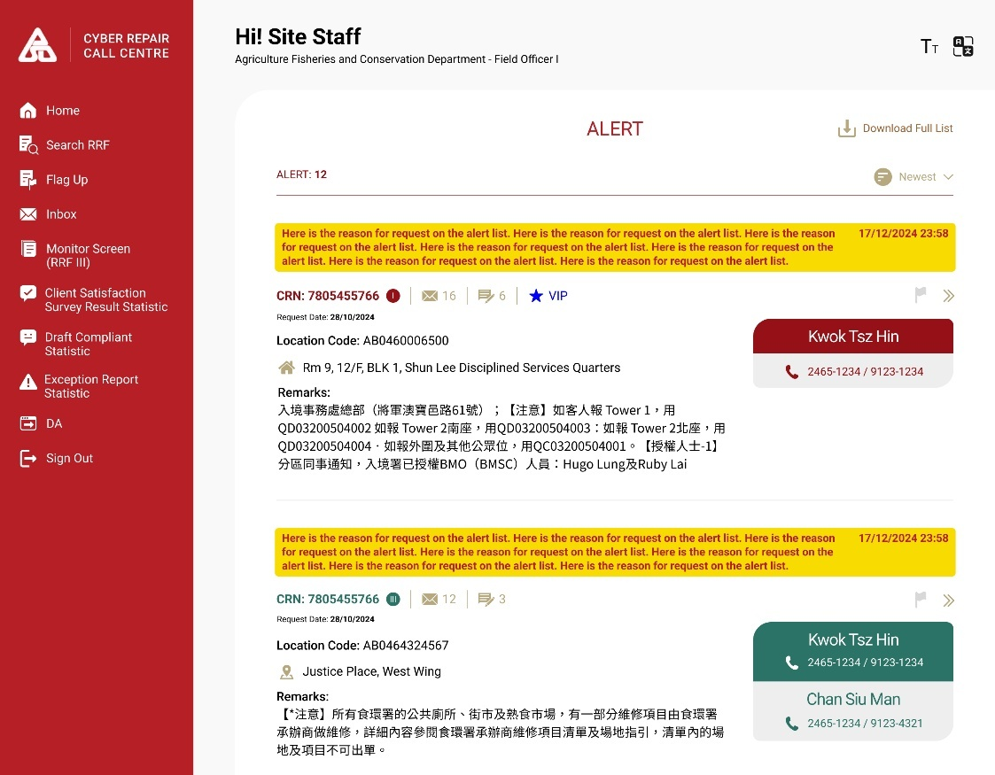  SPSM Email Configure Page  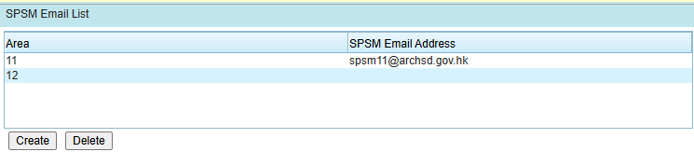

Item | Description
Function ID | UF-0055
Function Name | CyberRCC DS Home Page
Category | Presentation Layer
Related Requirements | DS functions in CyberRCC (WEB-R20)  CyberRCC Dashboard for different user role (WEB-R23)
Function Description | - DS will access this page from DA.  - A quick navigation menu enables DS to efficiently access various dashboard functions.  - A streamlined RRF Panel allows DS to perform quick searches for RRF.  - DS can view the latest Inbox Message.
Business Rule | Site Menu:  Fast Navigation List:  Quick Search RRF Panel:  Inbox:
  Menu Item | Navigation
  Home | Home Page after Login
  Alert | Alert Screen
  Search RRF | Search RRF Page
  Flag Up | Flag Up RRF Monitor Screen
  Inbox | Inbox Monitor Screen
  Monitor Screen | Form III Waiting for Acknowledgement Monitor Screen
  DA Statistic | - RRF 1 Status  - RRF 3 Status  - DA Monitoring  - RRF I & RRF III waiting for acknowledge  - Base Payment Claim Type pending for endorse  - No. of Default Notice pending for action  - Outstanding Exception Report  - Form I/III Pending Conversion/ Response  - SDS can export the detailed record on each report.  - Batched for audit
  RCC Statistic | - Client Satisfaction Survey Result  - Statistics of Draft Complaint Received by RCC  - Statistic for certify completion of FEHD toilet / Market’ s RRF, Cyber RCC’s RRF
  DA | Back to DA System.
  Sign Out | Sign out CyberRCC System
  List Item | Navigation | Business Rule
  Alert |  | Display the number of unread Alert in the top right corner
  Search RRF | Search RRF Page | -
  Flag Up | Flag Up RRF Monitor Screen | -
  Inbox | Inbox Monitor Screen | Display the number of unread Inbox in the top right corner
  Monitor Screen | Form III Waiting for Acknowledgement Monitor Screen | -
  DA | Back to DA System. | -
  Search Criteria | Type | Business Rule
  My RRF Only | Toggle Button | - Disabled when DS does not belong to 10 Contract Area  - Default is off
  CRN/RRI ID/MWO/WO No./ Location Code | Free Text | - If the input text is started with one letter (A/B/W), it will search for MWO/WO No.  - If the input text starts with two English character, it will search for Location Code.  - If the input text is exactly 8 digits, it will search for CRN.  - If the input text is exactly 10 digits, it will be search for RRI ID
  Call-in Date | Selection Or Date Picker | - Selection Option:  - 7 days  - 14 days  - 1 month  - For the selected option, the counting will commence today and extend back to the specified range.  - If date range is selected, selected option will be neglected.
  Location | Free Text | - A Dropdown for selecting “And” or “Or” Condition for two location inputs  - Default is “And” Condition  - “And” Condition must contain both inputs  - “Or” condition contains either one of the two inputs.
  Area | Dropdown | - Mandatory  - Option:  - 11  - 12  - 21  - 22  - 31  - 32  - 41  - 42  - 51  - 52
  RRF Type | Select Checkbox | - Option:  - I  - III  - For DS in 10 Contract Areas: Form I and III are default checked.  - For DS not in Contract 10 Areas: Form III is default checked.
  Search | Button | Redirect to Search RRF Page and submit the search criteria
  Advanced Search | Button | Redirect to Search RRF Page with more search criteria
  Field | Type | Description
  Number of Unread Inbox | Number | Shows the number of unread inboxes
  Form Type | Selection | - Option:  - All  - RRF I  - RRF III  - Only displays Inbox messages of the selected RRF type
  Inbox List
  CRN | Display | -
  Form Type | Icon | -
  Message Sent Datetime | Display | -
  Message From | Display | -
  Message | Display | -
Screen Capture | Desktop:  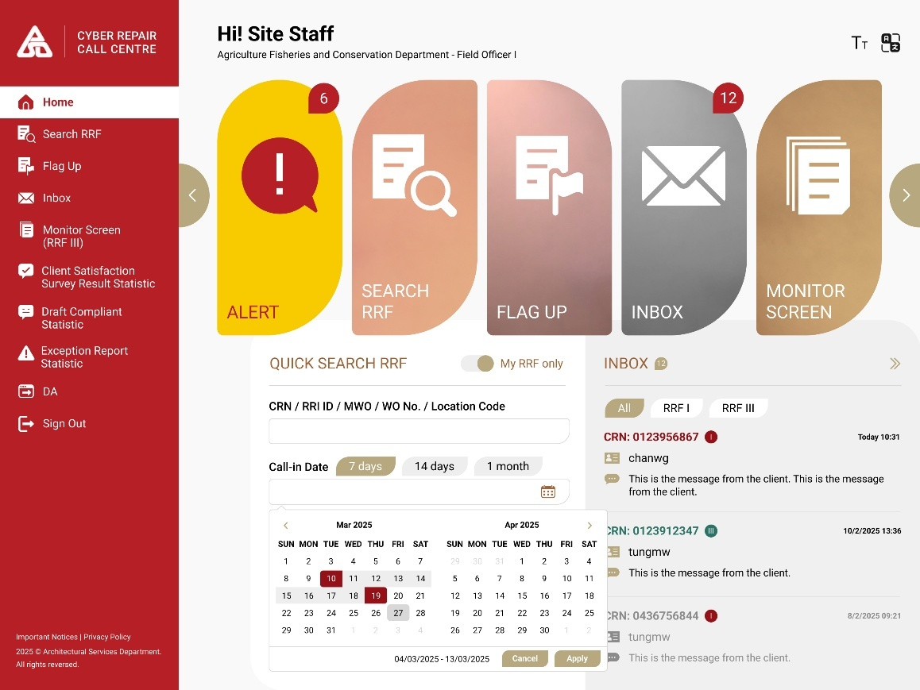

        - UF-0063 New Dashboard & Report for DS
Item | Description
Function ID | UF-0063
Function Name | New Dashboard & Report for DS
Category | Presentation Layer
Related Requirements | CyberRCC Dashboard for different user role (WEB-R23)
Function Description | A dashboard show DA statistic for DS:  DA Statistic:  - RRF 1 Status  - RRF 3 Status  - DA Monitoring  - RRF I & RRF III waiting for acknowledge  - Base Payment Claim Type pending for endorse  - No. of Default Notice pending for action  - Outstanding Exception Report  - Form I/III Pending Conversion/ Response  - Batched for audit  A new monthly statistical chart for DS, DS can export the detailed record and summary into the report as Excel format:  RCC statistic:  - Client Satisfaction Survey Result  - Statistics of Draft Complaint Received by RCC  - Statistic for certify completion of FEHD toilet / Market’ s RRF, Cyber RCC’s RRF  CyberRCC statistic:  - Repair Request Status Distribution in top five bureaus/departments with most reported repair requests  - Repair Request Status Summary for all bureaus/departments
Business Rule | Criteria to filter and search the data:  DA Statistic:  RCC Statistic:  Criteria to generate the chart and report:  Column for Client satisfaction survey report:  Column for draft complaint report:  Column for Exception report:
  Column | Description
  Period of call-in date | Specifics the period to search the data.
  Contract | Include all data within the selected contract.  (past 6 years for selection)
  High-risk | Only display high-risk RRF if selected.
  FEHD related | Only show RRF with FEHD related locations if selected.
  Area | -
  District code | Select the district code prefix; the area must be selected.
  Issuing office post | Search the data with related to the issuing officer post, up-to 5 can be input.
  Column | Description
  Date range | -
  Area | -
  Location prefix | Select the location code prefix; the area must be selected.
  Column | Type
  Period in monthly | Drop down list
  Area | Check box
  District code prefix | Drop down list
  Column | Type | Description
  crn | Number | crn
  TBC | TBC | TBC
  Column | Type | Description
  TBC | TBC | TBC
  Column | Type | Description
  TBC | TBC | TBC
Screen Capture | 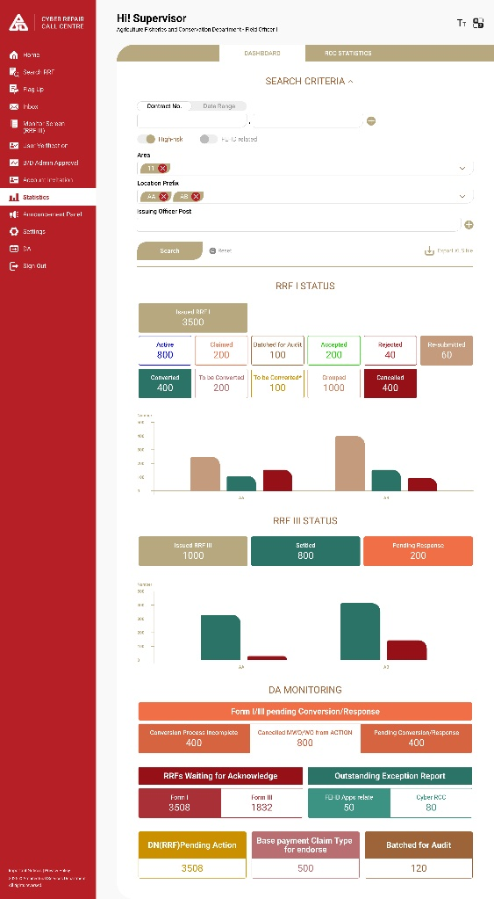  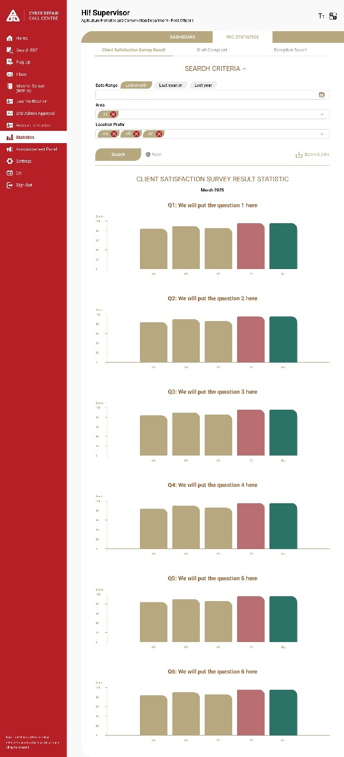  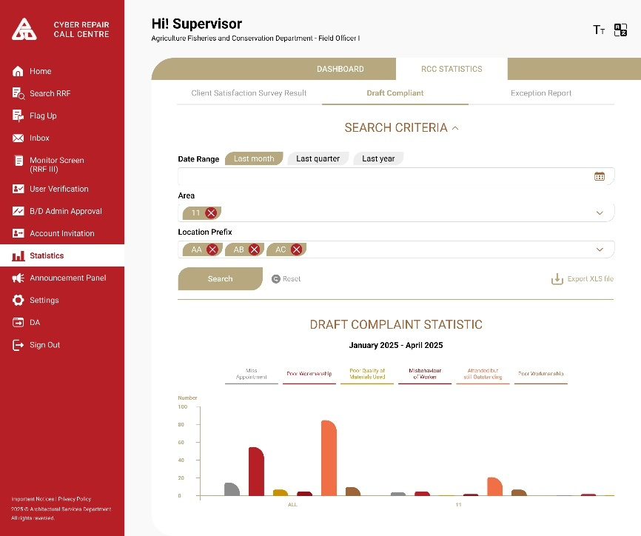  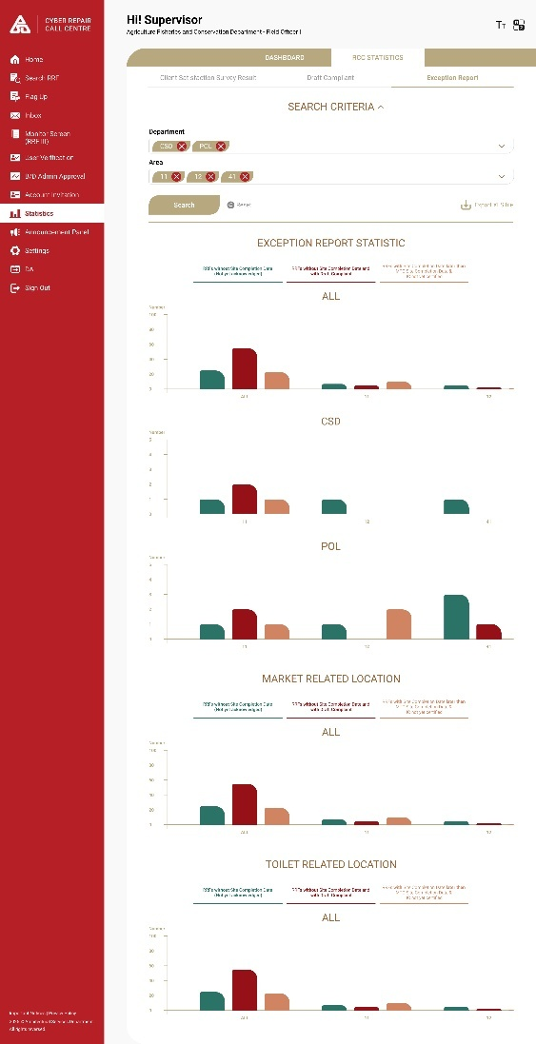  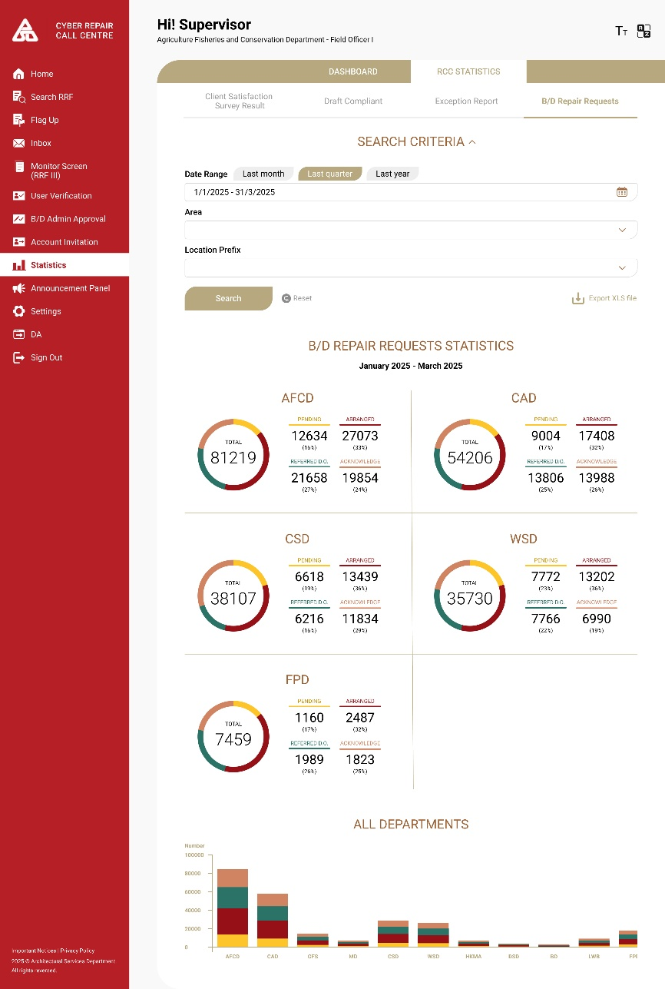

      - CyberRCC – RCC Admin Functions and Flows
        - UF-0057 CyberRCC RCC Admin – Login
Item | Description
Function ID | UF-0057
Function Name | CyberRCC RCC Admin – Login
Category | Presentation Layer
Related Requirements | RCC Admin Functions in CyberRCC (WEB-R25)
Function Description | - RCC Admin can redirect to CyberRCC Page within DA System  - RCC Admin can direct log in to CyberRCC through the login page on public internet
Metadata
  Field | Type
  DA Account | Varchar(100)
  Password | Varchar(100)
Business Rule | RCC Admin can log in to CyberRCC by following methods:  Method 1:  - Log in to DA System using the DA Account and Password  - Select the CyberRCC function item from the DA Menu  - A new page will redirect to the CyberRCC Function  Method 2:  - Log in CyberRCC in CyberRCC Login Page with DA Account and Password
Screen Capture | Method 1:  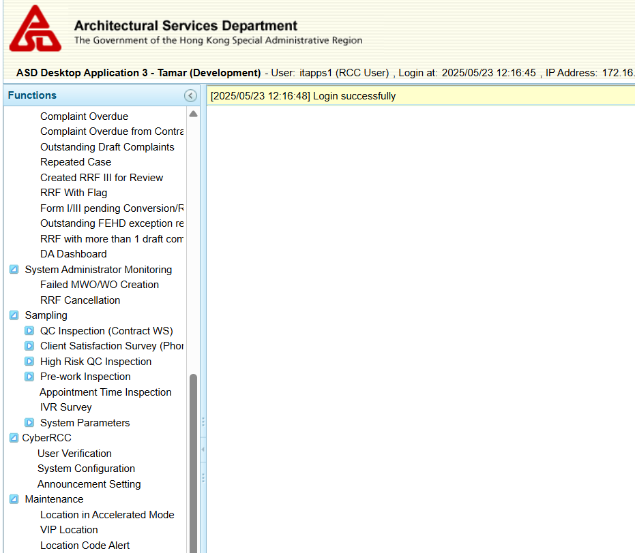  Method 2:  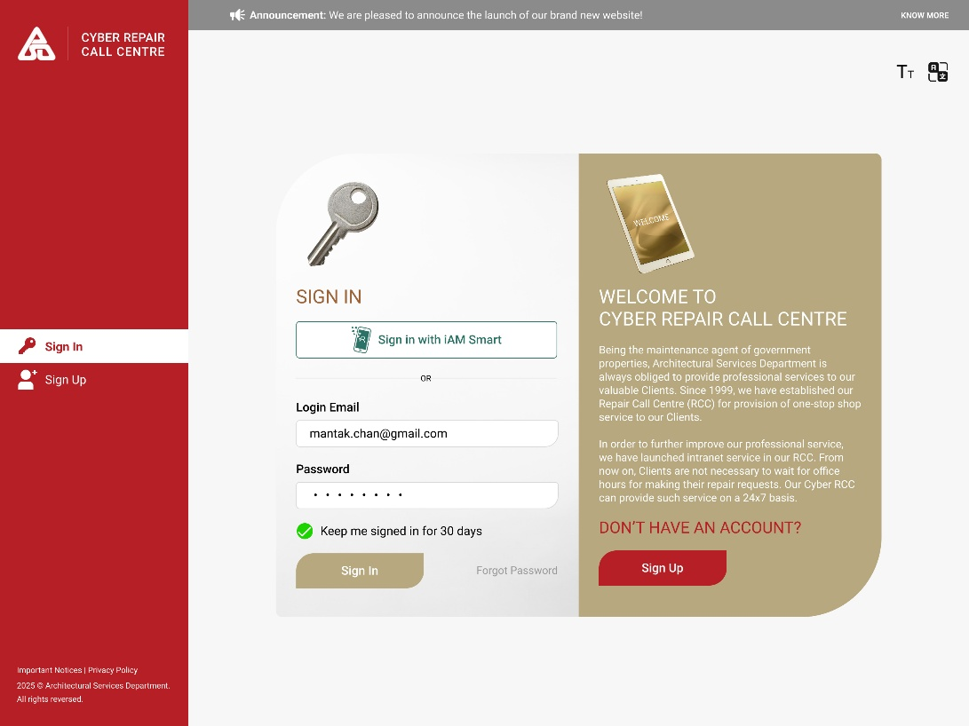

        - UF-0058 CyberRCC RCC Admin – Announcement Setting
Item | Description
Function ID | UF-0058
Function Name | CyberRCC RCC Admin – Announcement Setting
Category | Presentation Layer
Related Requirements | RCC Admin Functions in CyberRCC (WEB-R25)
Function Description | - RCC Admin can create announcements with rich text content in English, Traditional Chinese and Simplified Chinese.  - RCC Admin can upload documents as attachments within the announcement content.  - RCC Admin can set the publish date time, valid date time, specific whether the announcement is shown before or after login, select the post category, determine if it should be a popup, indicate if an email should be sent, and specify the validity of the announcement.
Metadata
  Field | Type
  Title | Varchar (255)
  Content | Text
  Start Date | Date
  End Date | Date
  Show On Page | Varchar (20)
  Category | Varchar (20)
  Is Valid | Boolean
  Is Popup | Boolean
  Is Send Email | Boolean
  Uploaded File | Data
Business Rule
  Field  (*mandatory) | Type | Business Rule
  *Title | Free Text | Max. Length: 255
  *Content | Free Text | Have format the content in html format
  * Category | Checkbox | Options:  - Announcement  - System Notice
  Announcement Valid | Toggle Button | -
  User Visibility | Multiple Selection | Options:  - All Users  - B/Ds Admins  - Report Admins  - Site Staff
  *Start Date | Date Picker | -
  End Date | Date Picker | -
  Show On Page | Dropdown | Options:  - <Empty>  - Before Login  - After Login
  Default Pop Up Screen | Checkbox | -
  Send Email Notification | Checkbox | -
  Uploaded File | Data | -
Screen Capture | Announcement Panel:  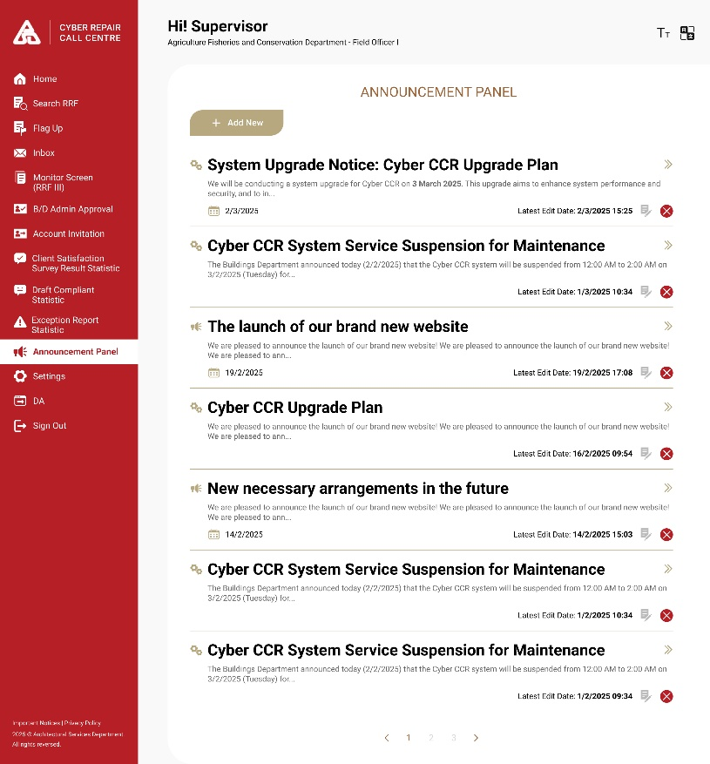  Add New Announcement:  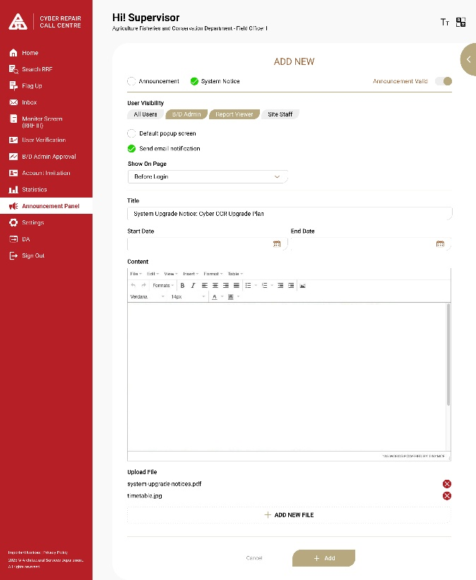

        - UF-0059 CyberRCC RCC Admin – User Maintenance
Item | Description
Function ID | UF-0059
Function Name | CyberRCC RCC Admin – User Maintenance
Category | Presentation Layer
Related Requirements | RCC Admin Functions in CyberRCC (WEB-R25)
Function Description | - RCC admin can view all user profiles.  - RCC admin can send the reset password link to user’s email address.  - RCC admin can promote the user account to admin role or demote the admin account to normal user role.  - RCC admin can change a user’s group
Metadata | -
Business Rule | User list:  Filter:
  Field | Mode | Description | Business Rule
  Name | Text | User’s full name | -
  Bureau/ Department | Text | User’s bureau/ department | -
  Post | Text | User’s post | -
  Email address | Text | User’s email | -
  Primary Contact No. | Number | User’s primary contact no. | -
  Secondary Contact No. | Number | User’s secondary contact no. | -
  Group | Drop down | User’s group | - Display list of groups created by user’s B/D.  - A confirmation message will be prompted when changed.
  Reset password | Button | - | - A confirmation message will be prompted when clicked.  - A reset password link will be sent to user’s email.
  User role | Drop down | User’s role | - List of user role for selection.  - A confirmation message will be prompted when changed.
  Field | Description
  Search User by Keywords | Keyword search the name, email, contact No., department and group.
  Bureau/Department | -
  User Role | -
  Group | -
  Status
Screen Capture | B/Ds user List:  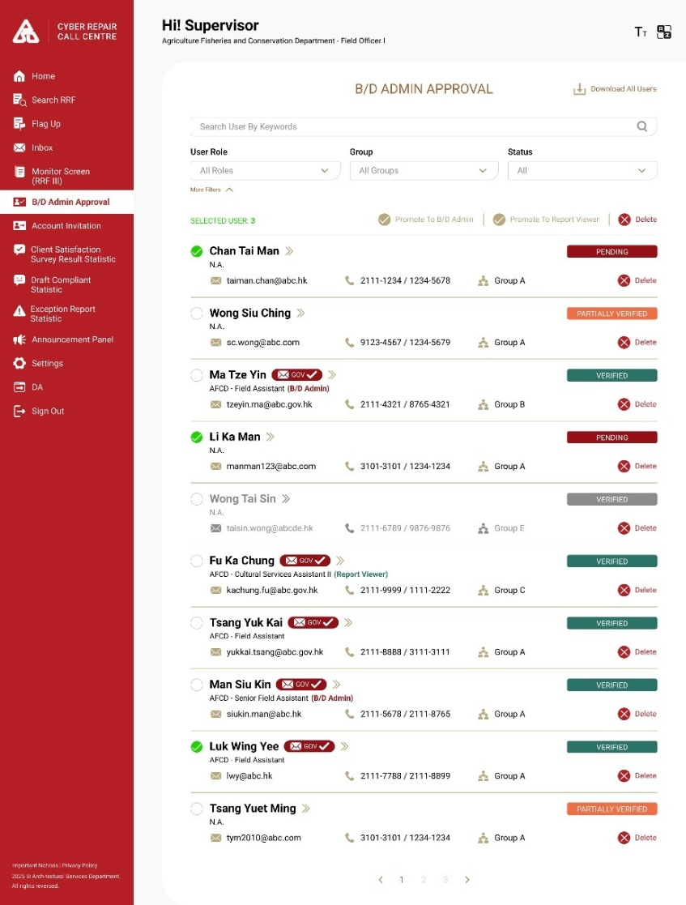  B/Ds user Detail:  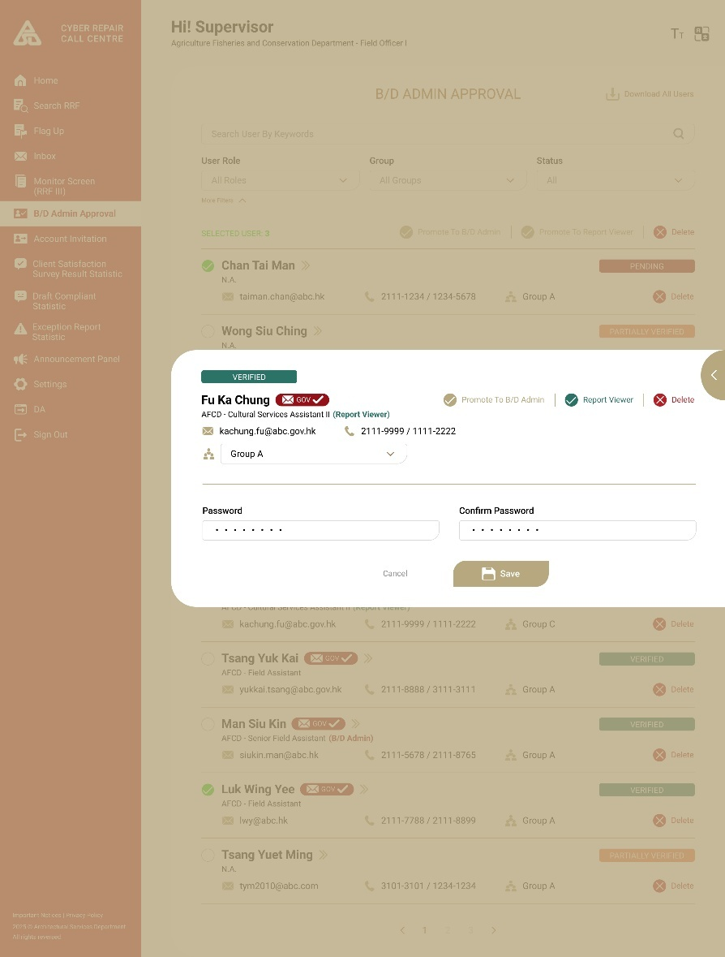  Account Invitation/Creation:  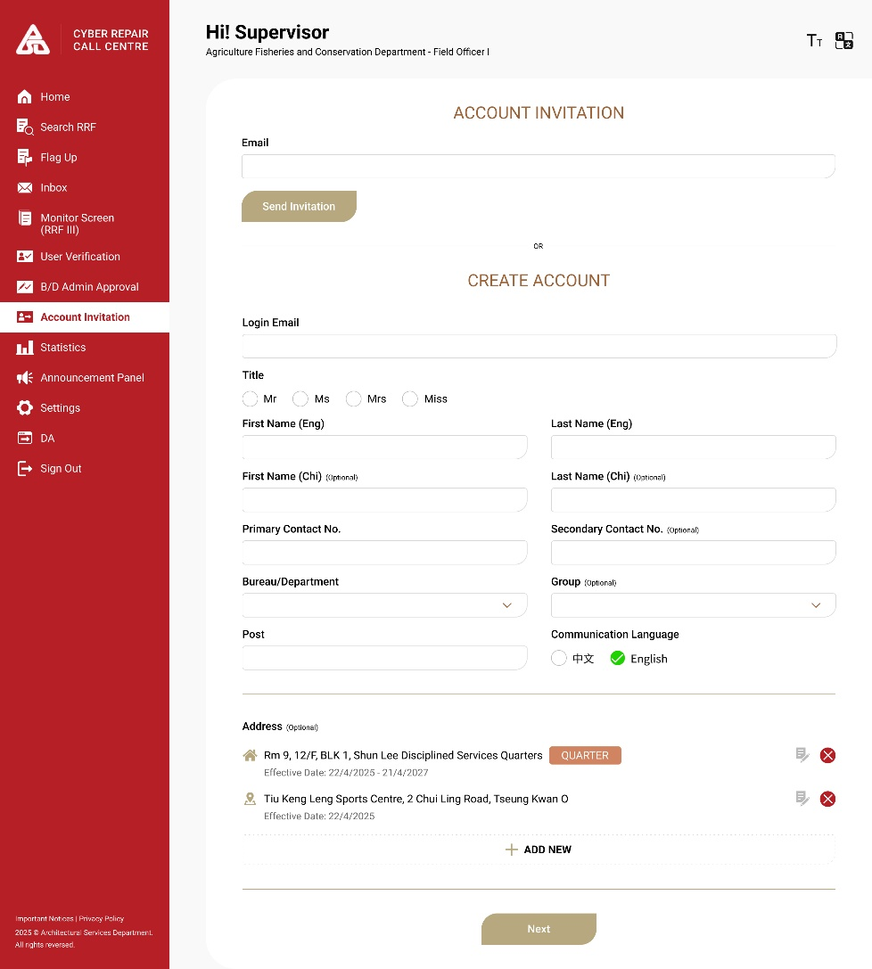

        - UF-0060 CyberRCC RCC Admin – System Configuration – FAQ Setting
Item | Description
Function ID | UF-0060
Function Name | CyberRCC RCC Admin – System Configuration - FAQ Setting
Category | Presentation Layer
Related Requirements | RCC Admin Functions in CyberRCC (WEB-R25)
Function Description | - RCC Admin can manage the FAQ questions, content and keywords using Excel.  - RCC Admin can export existing FAQ content to Excel and import any updated Excel files.
Metadata
  Field | Type
  ID | Integer
  Question | Varchar (255)
  Content | Text
  Keywords | Varchar (255)
  Is Active | Boolean
Business Rule | Export the FAQ data in Excel format for review and management.  Import an updated Excel file to refresh and update the existing FAQ content.  The column for the export and import Excel:
  Field  (*mandatory) | Description
  ID | A unique identity for system use. Automatically generated from system.
  *Question | The question title is displayed on the webpage.
  *Content | The content associated with the question.
  Keywords | Terms used to find related FAQs.
  Is Active | A setting indicating whether the record is displayed or not.
Screen Capture | Setting:  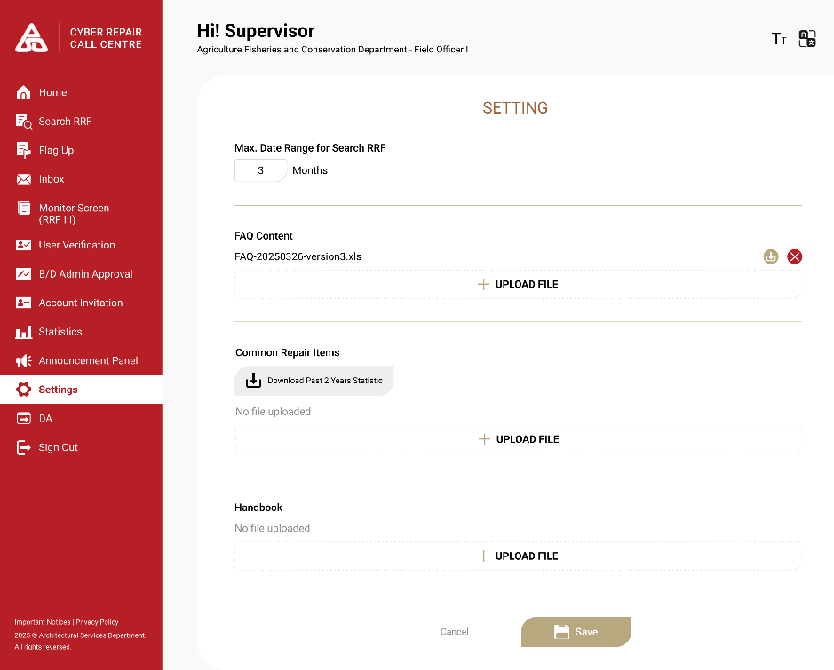

        - UF-0072 CyberRCC RCC Admin – System Configuration – Upload handbook
Item | Description
Function ID | UF-0072
Function Name | CyberRCC RCC Admin – System Configuration – Upload handbook
Category | Presentation Layer
Related Requirements | RCC Admin Functions in CyberRCC (WEB-R25)
Function Description | RCC Admin can update the new version of handbook in CyberRCC for users to download. The file must be PDF format.
Business Rule | Uploading the handbook:
  Field | Type | Description
  File | button | Select the file to upload. (Must be PDF format)
  Upload | button | Click to upload the handbook.
Screen Capture | 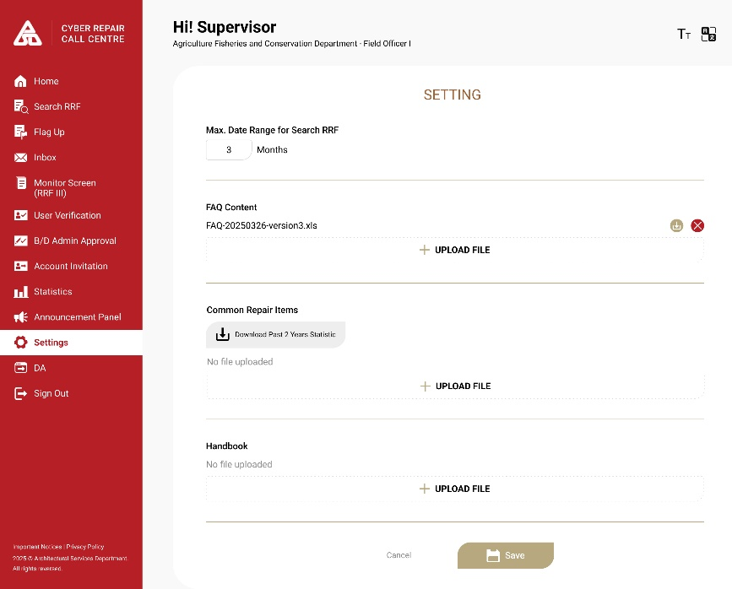

        - UF-0061 CyberRCC RCC Admin – System Configuration – DS search range
Item | Description
Function ID | UF-0061
Function Name | CyberRCC RCC Admin – System Configuration – DS search range
Category | Presentation Layer
Related Requirements | RCC Admin Functions in CyberRCC (WEB-R25)
Function Description | - RCC Admin can set the limit for the DS search range for the RRF.
Metadata
  Field | Type
  DS search limit in month(s) | Date time
Business Rule | This setting limiting DS maximum searching period of RRF.
  Field | Mode | Description | Business Rule
  Date range | Date | DS selected date range. | -
  Search | Button |  | - If the date range exceeds the configuration limit, the error message “The date range cannot be large than {x} month(s).”. In this case, the search will be cancelled.
Screen Capture | Setting:  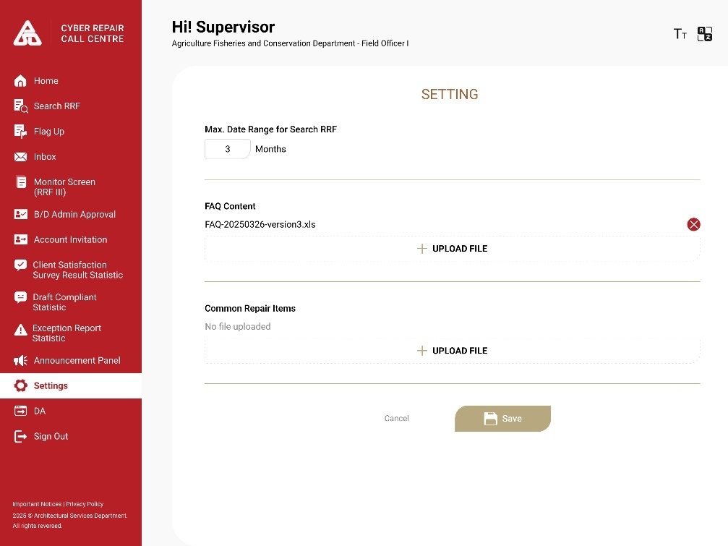

        - UF-0062 CyberRCC RCC Admin – System Configuration – Repair Item Suggestion Management
Item | Description
Function ID | UF-0062
Function Name | CyberRCC RCC Admin – System Configuration – Repair Item Suggestion Management
Category | Presentation Layer
Related Requirements | RCC Admin Functions in CyberRCC (WEB-R25)
Function Description | - RCC Admin can export the data analysis of created RRFs from the previous year in Excel format.  - RCC Admin can update the suggestion repair items by department for non-quarter address and by position for quarter address by uploading an Excel file.
Business Rule | Column of the exported Excel:  Top 10 department Form I case reported (quarter)  Top 10 department Form I case reported (non-quarter):  Top 20 reported repair item in top 10 department (quarter)  Top 20 reported repair item in top 10 department (non-quarter):  Top 20 reported repair item by top 10 department (quarter)  Top 20 reported repair item by top 10 department (non-quarter):  Column of the Excel to import:
  Column | Type
  Number of all cases reported in the period | Number
  Number of Form I cases reported in the period | Number (%)
  Number of quarter address reported cases | Number (%)
  Number of non-quarter address reported cases | Number (%)
  Column | Type
  Department name | String
  Number of cases reported | Number
  Column | Type
  Repair item | String
  Number of Repair item reported | Number
  Column | Type
  Repair item | String
  Number of Repair item reported | Number
  Field | Type
  Quarter normal | String
  Number of Repair item reported | Number
Screen Capture | Exported Excel:  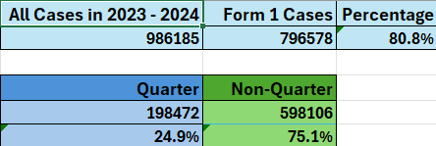  Top 10 department Form I case reported &  Top 20 reported repair item in top 10 department:  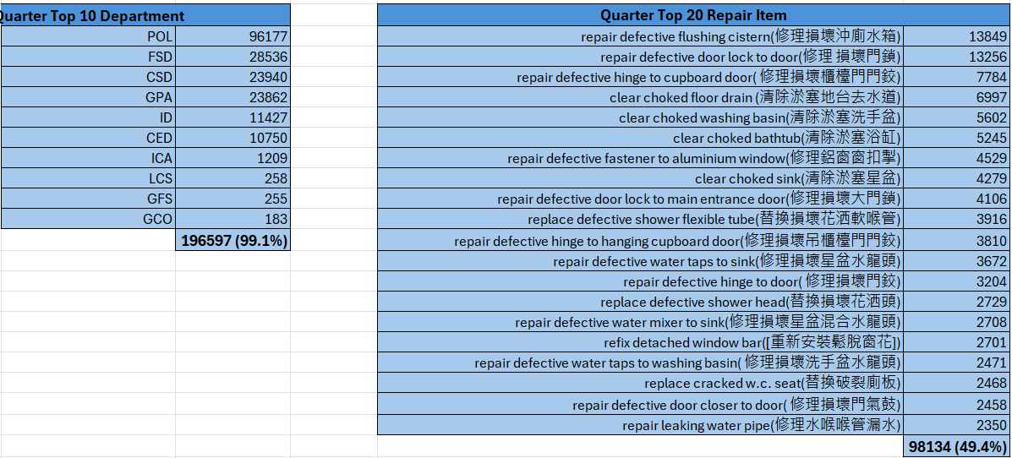  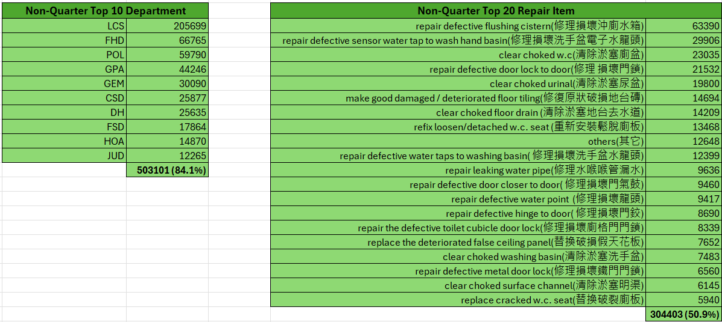  Top 20 reported repair items by top 10 departments:  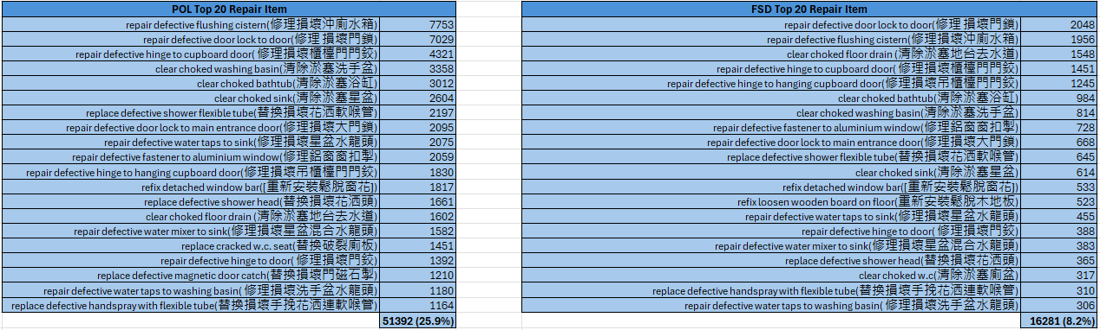  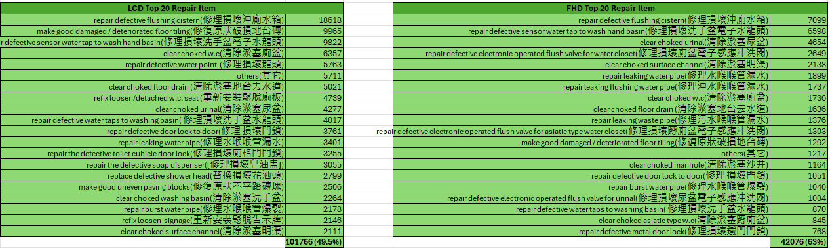  Setting:

      - CyberRCC – General Functions and Flows
        - UF-0016 CyberRCC Two Factor Authentication
Item | Description
Function ID | UF-0016
Function Name | CyberRCC Two Factor Authentication
Category | Online Update
Related Requirements | Two Factor Authentication (2FA) (Web-R4)
Function Description | - B/Ds admins must log in to CyberRCC using Two Factor Authentication over the public internet  - A random six-digit code will be sent to users’ emails.  - B/Ds admins are required to enter the code in CyberRCC for authentication  - Login via iAMsmart is considered equivalent to being authenticated with 2FA.
Metadata
  Field | Type
  Login Email | Varchar(100)
  Code | Varchar(6)
  Resend Verification Code | Button
  Submit | Button
Business Rule/Validation
  Field | Mode | Description | Business Rule
  Login Email | Display | The Email for receiving two factor authentication email | -
  Code | Input | Verification Code in the email | - 6 Digits  - Valid for 15 minutes  - Randomly Generated
  Resend Verification Code | Button | Resend a verification code email for Two Factor Authentication | - A new code will be generated in each email  - The previous code will be invalid if resend button is clicked
  Submit | Button | To submit the input code from users | Checks if the code is correct and valid
Screen Capture | 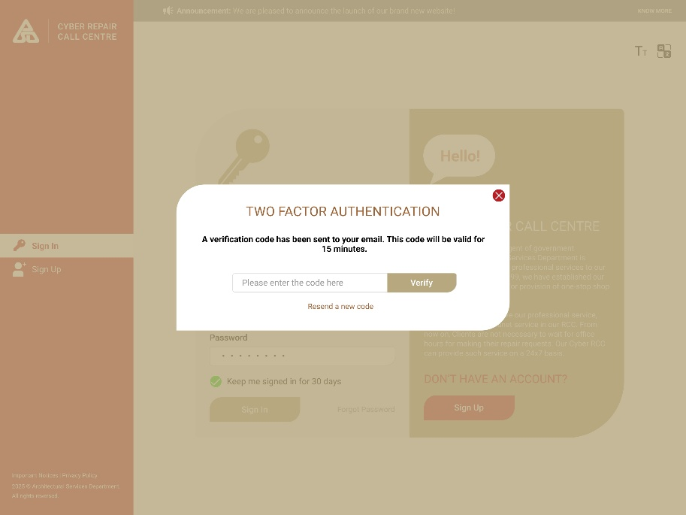
Email Template
  Sender | To Be Confirmed by ArchSD
  Subject | [ArchSD] CyberRCC Verification Code
  Content | Here is the verification code for CyberRCC:  <<Code>>  The code will expire in 15 minutes.

        - UF-0017 CyberRCC Session Control
Item | Description
Function ID | UF-0017
Function Name | CyberRCC Session Control
Category | Online Update
Related Requirements | User Login & Reset Password (WEB-R2)
Function Description | - Log in with username and password via the public internet, a session will be generated  - A countdown for the idle session will commence  - If the session times out, CyberRCC will display a message and automatically log out the user on the public internet  - If another session is initiated for a user account via the public internet, the existing session for the same user account will be invalid
Business Flow | Please refer to “Appendix – A.3 CyberRCC Session Control Flow”
Metadata
  Field | Type
  Session Timeout Time | Integer
Business Rule/Validation
  Field | Mode | Description | Business Rule
  Session Timeout Time | Database Value | Configuration Duration for Session Timeout | - In Minutes  - Value = 30 Minutes

        - UF-0052 CyberRCC User Role
Item | Description
Function ID | UF-0052
Function Name | CyberRCC User Role
Category | Data Layer
Related Requirements | RCC Admin Functions in CyberRCC (WEB-R25)  Different admin roles for B/Ds (WEB-R29)  DS functions in CyberRCC (WEB-R20)
Function Description | There are 6 user types for user roles in the CyberRCC, including B/Ds user, B/Ds Report Admin, B/Ds Group Admin, B/Ds admin, DS and RCC Admin.
Business Rule
   | B/Ds user | B/Ds Report Admin | B/Ds Group Admin | B/Ds admin | DS | RCC Admin
  Create Repair Request | Y | Y | Y | Y
  Submit Cancel | Y | Y | Y | Y
  Submit Enquiry | Y | Y | Y | Y
  E-acknowledgement | Y | Y | Y | Y
  Case Transfer |  |  | Y (Within B/D’s Group) | Y
  Update User Profile | Y | Y | Y | Y
  Notification | Y | Y | Y | Y
  Search own repair request | Y | Y | Y | Y
  Search B/Ds Repair request |  |  | Y (Within B/D’s Group) | Y
  View B/Ds Monthly Report |  | Y |  | Y |  | Y
  User Maintenance – Location Approval |  |  | Y (Within B/D’s Group) | Y |  | Y
  User Maintenance – Promote B/Ds admin |  |  |  |  |  | Y
  User Maintenance – Reset Password |  |  |  |  |  | Y
  Group Maintenance |  |  |  | Y |  | Y
  Search RRF |  |  |  |  | Y | Y
  Flag Up Monitor |  |  |  |  | Y | Y
  Form III Pending for Acknowledgement Monitor |  |  |  |  | Y | Y
  Inbox |  |  |  |  | Y | Y
  Alert |  |  |  |  | Y | Y
  RRF Dashboard |  |  |  |  | Y | Y
  Announcement Configuration |  |  |  |  |  | Y
  Repair Item Suggestion Setting |  |  |  |  |  | Y
  System Configuration |  |  |  |  |  | Y

        - UF-0068 CyberRCC Notification
Item | Description
Function ID | UF-0068
Function Name | CyberRCC Notification
Category | Presentation Layer
Related Requirements | CyberRCC Notification (WEB-R28)
Function Description | - CyberRCC users will receive notifications or emails based on their specific roles within the system.  - CyberRCC users can view all notifications in CyberRCC.  - The notifications will indicate if further action is required.
Business Rule
  Type | Action | Required Further Action | Target | Send Email
  Address Approval | New account | Y | B/Ds admin | Based on User's Preference
  Address Approval | New address pending approval | Y | B/Ds admin | Based on User's Preference
  Address Approval | Initial address approved | N | Owner | Y
  Address Approval | Address approved | N | Owner | Based on User's Preference
  Address Approval | Address rejected | N | Owner | Based on User's Preference
  Account status | Account Disabled | N | Owner | Based on User's Preference
  Account status | Account Enabled | N | Owner | Based on User's Preference
  Account status | Account Deleted | N | Owner (no notify) | Based on User's Preference
  Account status | Account change to admin role | N | Owner | Based on User's Preference
  Account status | Account change to B/D user role | N | Owner | Based on User's Preference
  Repair request | RRI status 待處理 -> 已安排 | N | Owner | Based on User's Preference
  Repair request | RRI status 待處理 -> Referred to D.O. | N | Owner | Based on User's Preference
  Repair request | RRI status 已安排 -> 待確認 | Y | Owner | Based on User's Preference
  Repair request | RRI status cancelled | N | Owner | Based on User's Preference
  Repair request | New MTC re-attend time | N | Owner | Based on User's Preference
  Others | New monthly report released | N | B/Ds admin, B/Ds report admin | N
  Others | Alert from RCC | Y | DS (up to PSM level only) | Y
  Others | Announcement | N | All users | Based on User's Preference
Screen Capture | 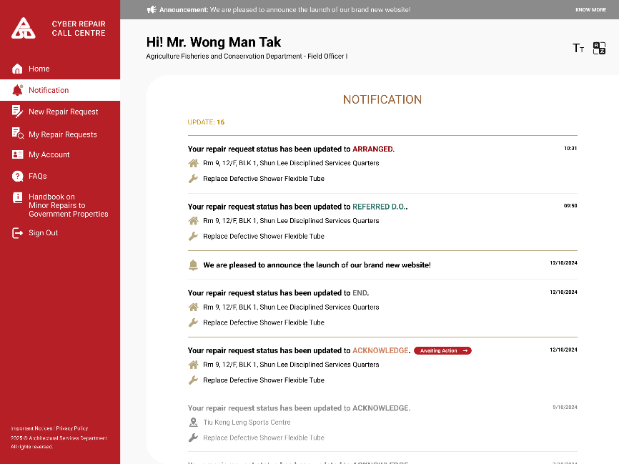

        - UF-0069 CyberRCC – FAQ
Item | Description
Function ID | UF-0069
Function Name | CyberRCC – FAQ
Category | Presentation Layer
Related Requirements | RCC Admin Functions in CyberRCC (WEB-R25)
Function Description | - A page displays the FAQ, which includes the questions, answers and a related FAQ list configured by RCC admin.  - User can search for the FAQ using keywords or the question title.
Business Rule | An Input box for searching the FAQ.
Screen Capture | 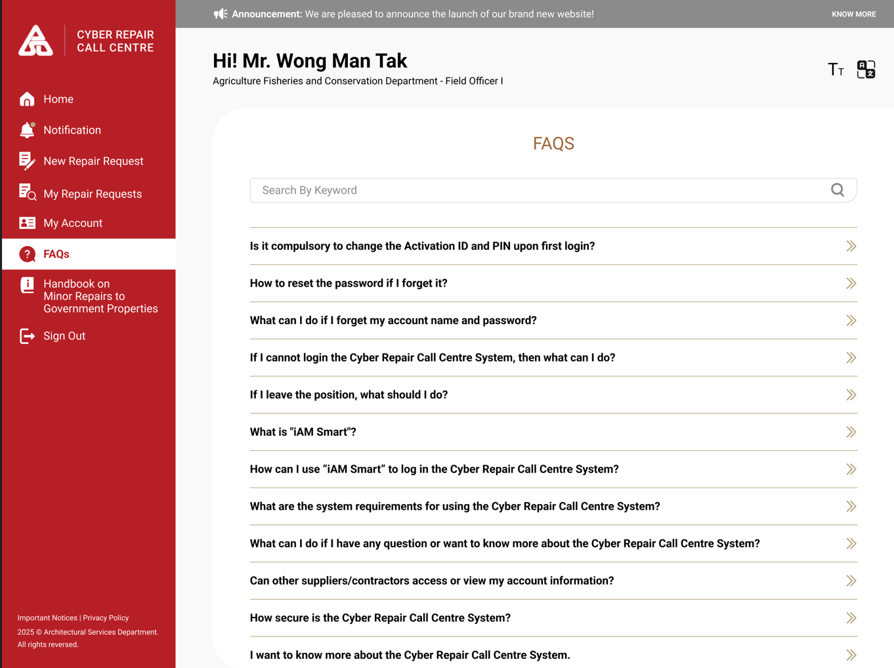  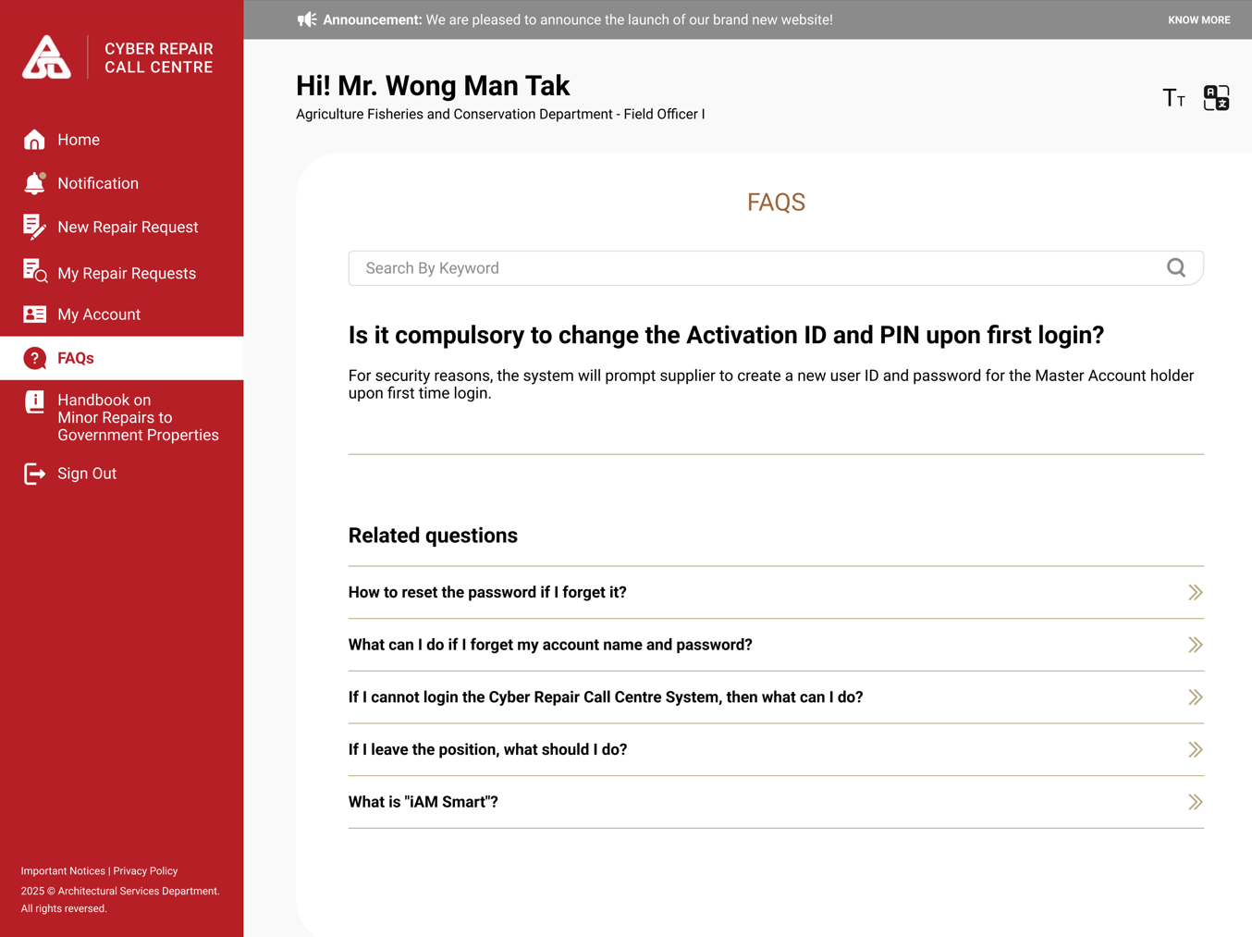

        - UF-0070 CyberRCC – Announcement
Item | Description
Function ID | UF-0070
Function Name | CyberRCC – Announcement
Category | Presentation Layer
Related Requirements | RCC Admin Functions in CyberRCC (WEB-R25)
Function Description | - A page displays all the announcements published by RCC Admin  - Users can view the latest announcement on each page.
Metadata
  Field | Type
  Announcement Type | Varchar(50)
  Announcement Title | NVarchar(200)
  Announcement Content | NVarchar(500)
  Post Date | Date
  Attachment | Base64
Business Rule | A notification bar will appear at the top of each page, displaying the latest notification.  Click “KNOW MORE” to redirect to the notification page.
  Field | Mode | Description | Business Rule
  Announcement Type | Icon | - | Two Types:  - System Notification  - System Announcement
  Announcement Title | Display | - | -
  Announcement Content | Display | - | -
  Post Date | Display | - | -
  Attachment | File | - | Click to Download.
Screen Capture | Announcement Bar:  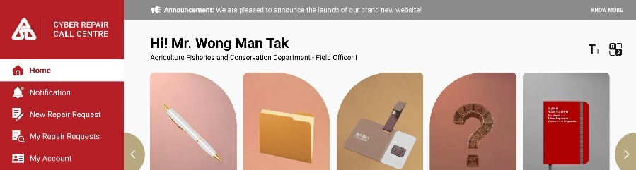  Announcement Page:  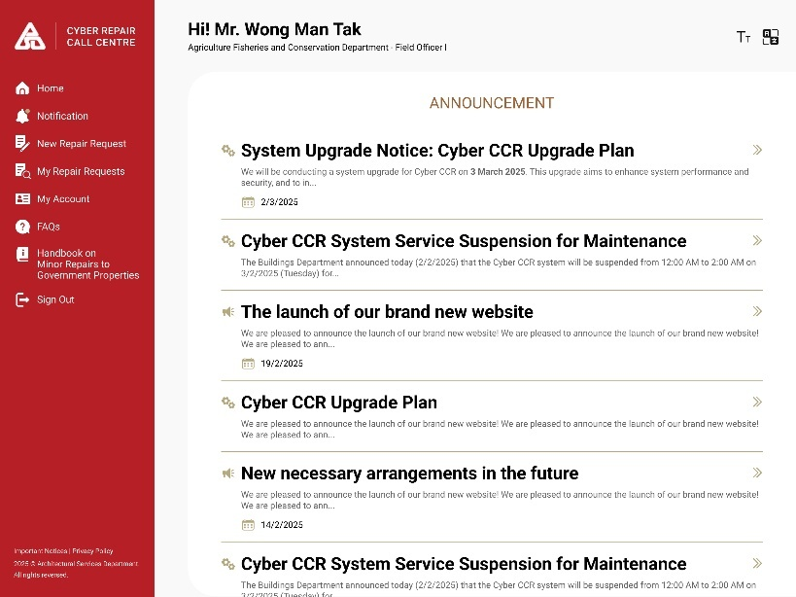  Announcement Detail:  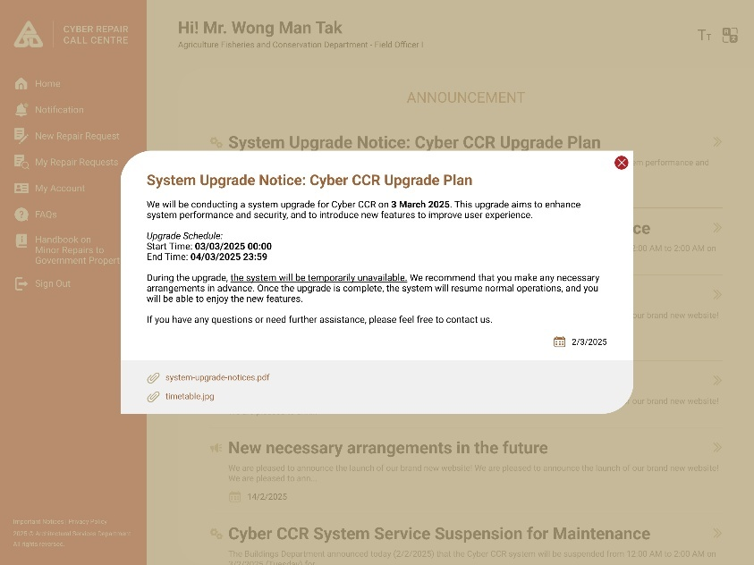

        - UF-0071 CyberRCC – Handbook on Minor Repairs to Government Properties
Item | Description
Function ID | UF-0071
Function Name | CyberRCC – Handbook on Minor Repairs to Government Properties
Category | Presentation Layer
Related Requirements | RCC Admin Functions in CyberRCC (WEB-R25)
Function Description | Users can download the Handbook on Minor Repairs to Government Properties from CyberRCC
Business Rule | -
Screen Capture | 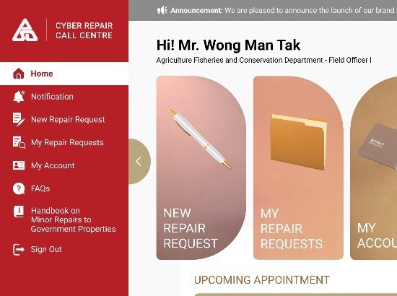

      - DA Enhancement for CyberRCC
        - UF-0019 Handle Cancel Request from CyberRCC in DA
Item | Description
Function ID | UF-0019
Function Name | Handle Cancel Request from CyberRCC in DA
Category | Presentation Layer
Related Requirements | Cancel Request (Web-R7)
Function Description | - The message “The web request was requested to be cancelled by the CyberRCC user” will be displayed on the web request if it has not been handled by a CSO.  - CSO can click the "Cancel" button on the web request to update its status to "Cancelled.".  - A new repair tree item will be created for cancellation requests from CyberRCC to identify them as web cancel requests.
Metadata
  Field | Type
  Cancelled | Boolean
  Remarks | Varchar(100)
  Cancel | Button
Business Rule
  Field | Mode | Description | Business Rule
  Cancelled | Checkbox | - | Checked if the web requested is cancelled by a CSO.
  Remarks | Display | Display the message “The web request was requested to be cancelled by the CyberRCC user” if the request has not been handled by a CSO and was submitted for cancellation by a CyberRCC user. | If there is cancellation reason, it will be shown after the message.
  Cancel | Button | For CSO to update the web request to cancelled. | Only appears for "Requested Cancel Web Request" or "Web Cancel Request".
Screen Capture | 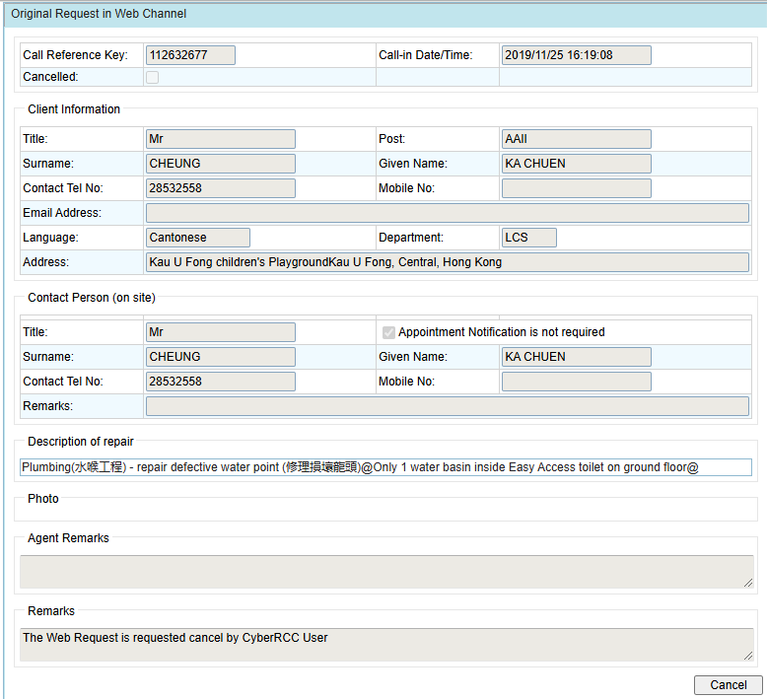
Repair Tree Item
  Trade Name (English) | CyberRCC Requests
  Trade Name (Chinese) | CyberRCC請求
  Level 1 (English) | Cancel Request
  Level 1 (Chinese) | 取消定單
  Work Type | Building
  Process Code | 33 Other
  Element Code | USER User Defined
  Urgency | Always Normal
  Category | Others

        - UF-0022 RCC Supervisor End Inbox Request in DA
Item | Description
Function ID | UF-0022
Function Name | RCC Supervisor End Inbox Request in DA
Category | Presentation Layer
Related Requirements | Request Follow Up (Web-R8)
Function Description | RCC Supervisors can end Inbox Request in the DA.
Metadata
  Field | Type
  End Request | Button
Business Rule
  Field | Form | Description | Business Rule
  End Request | Button | Button for End the Inbox Request | Button is visible under either of the following conditions:  - Inbox Request Create User  - RCC Supervisor

        - UF-0028 View CyberRCC Site Completion Date in DA
Item | Description
Function ID | UF-0028
Function Name | View CyberRCC Site Completion Date in DA
Category | Presentation Layer
Related Requirements | E-Acknowledge of Completion (WEB-R9)
Function Description | - RCC, DS and MTC can view the CyberRCC Site Completion Date and Exception Report in RRI Detail and RRF Detail in the DA.  - DS and MTC users can view the Exception Report List in Outstanding Exception Report Monitor Screen.
Metadata
  Field | Type
  RRI | Varchar(10)
  Site Completion Date (entered by Client) | Date
  Certification Date | Date
  Certifier Name | NVarchar(45)
  Certifier Post | NVarchar(25)
  Exception Report Creation Datetime | Datetime
  Exception Report | Hyperlink Button
  Justification | NVarchar(250)
  Exception Report Photo | Binary
Business Rule | RRI Detail Page:  RRF Detail Page:  Outstanding FEHD Exception Report monitor screen will be renamed to Outstanding Exception Report.  The following columns will be renamed in Outstanding Exception Report monitor screen:
  Field | Mode | Description | Business Rule
  Site Completion Date (entered by Client) | Display | - | Displays a value if the RRI record includes a site completion date provided by the client.
  Field | Mode | Description | Business Rule
  Site Completion Date (entered by Client) | Display | - | - Displays a value only if all RRI records have a site completion date provided by the client; otherwise, it remains empty.  - Display the latest site completion date (entered by client) from all RRI records.
  Original Column Name | New Column Name
  FEHD Site Completion Date | Client Site Completion Date
  FEHD Exception Report | Exception Report
  FEHD Exception Report Creation Datetime | Exception Report Creation Datetime
Screen Capture | RRI Detail:  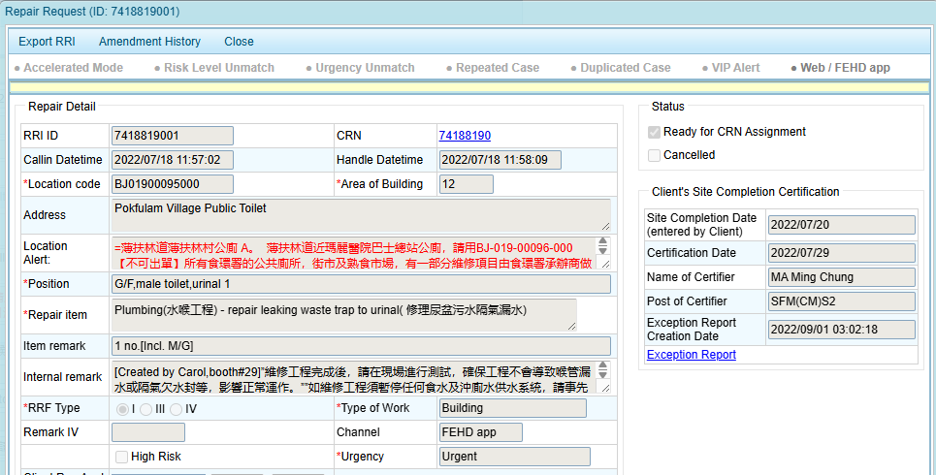  Exception Report Detail:  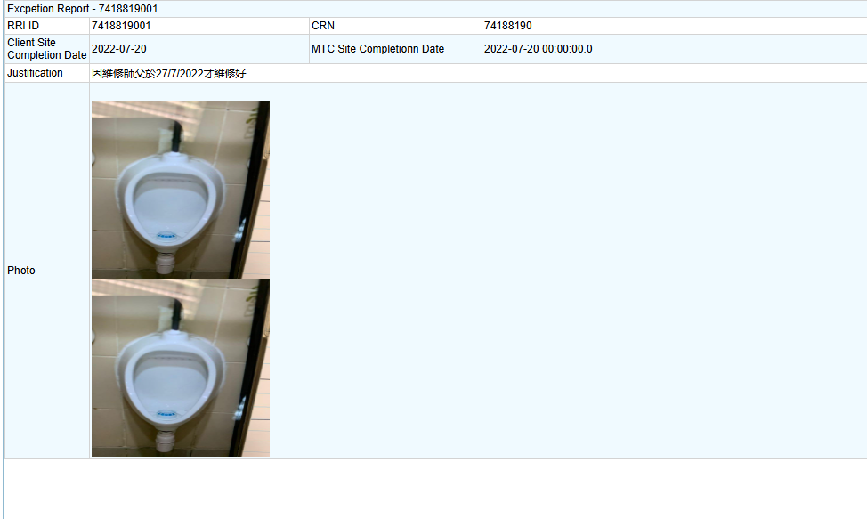  RRF Detail:  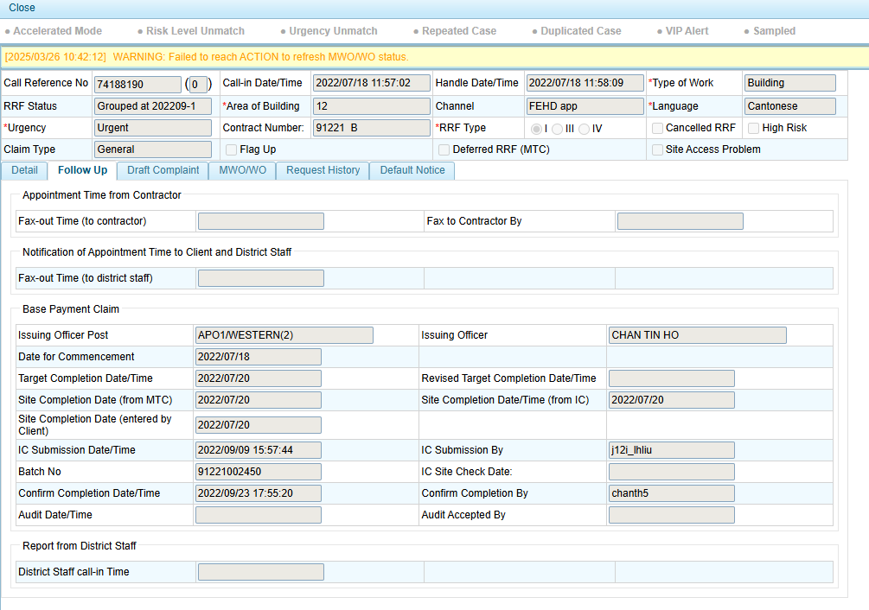  Outstanding Exception Report monitor screen  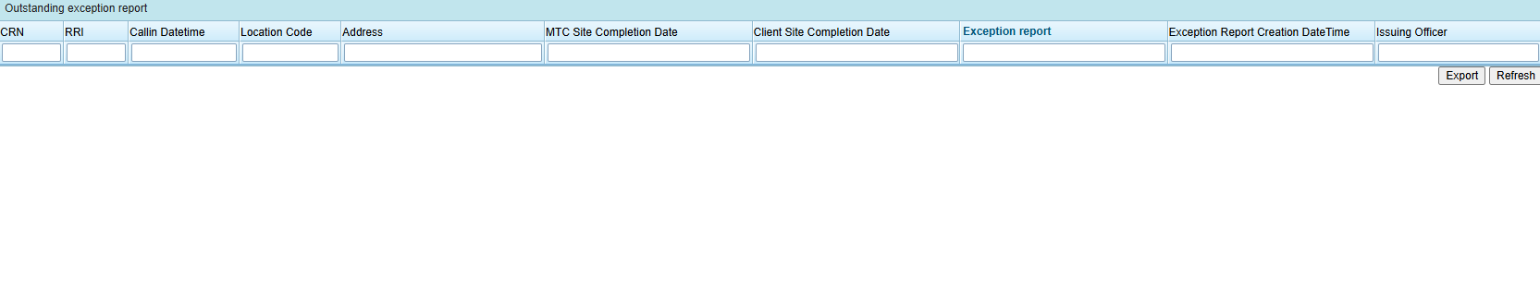

        - UF-0033 Queue Arrangement for CyberRCC Repair Request
Item | Description
Function ID | UF-0033
Function Name | Queue Arrangement for CyberRCC Repair Request
Category | Presentation Layer
Related Requirements | Request follow up / General Enquiry (WEB-R8)  Emergency web request (WEB-R17)
Function Description | - There are queues for normal for Chinese and English web request in Enghouse Contact Centre Enterprise (CCE)  - There are queues for emergency for Chinese and English web request in Enghouse Contact Centre Enterprise (CCE)  - There are queues for General Enquiry / RRI follow-up for Chinese and English web request in Enghouse Contact Centre Enterprise (CCE)  - Emergency web request queues are prioritized higher than normal web request queues.  - Enghouse CCE automatically assigns emergency web requests to available agents.
Business Rule
  Repair Request Type | General
  Language | Chinese
  Queue Name | RRF_WEB_CHI
  IType | Task
  Base priority for newly queued items | 800
  Distribution Mode | Preferred Take
  Repair Request Type | General
  Language | English
  Queue Name | RRF_WEB_ENG
  IType | Task
  Base priority for newly queued items | 800
  Distribution Mode | Preferred Take
  Repair Request Type | Emergency
  Language | Chinese
  Queue Name | Emer_RRF_WEB_CHI
  IType | Task
  Base priority for newly queued items | 550
  Distribution Mode | Preferred Force
  Repair Request Type | Emergency
  Language | English
  Queue Name | Emer_RRF_WEB_CHI
  IType | Task
  Base priority for newly queued items | 550
  Distribution Mode | Preferred Force
  Repair Request Type | General
  Language | Chinese
  Queue Name | RRF_WEB_ENQ_CHI
  IType | Task
  Base priority for newly queued items | 800
  Distribution Mode | Preferred Take
  Repair Request Type | General
  Language | English
  Queue Name | RRF_WEB_ENQ_ENG
  IType | Task
  Base priority for newly queued items | 800
  Distribution Mode | Preferred Take

        - UF-0034 Linkage CyberRCC User and DA Client Record
Item | Description
Function ID | UF-0034
Function Name | Linkage CyberRCC User and DA Client Record
Category | Presentation Layer
Related Requirements | Assigning CyberRCC Account in DA Phonebook (WEB-R11)
Function Description | - RCC CSO can link the CyberRCC user record to DA client record using the CyberRCC account ID.  - RCC CSO can associate repair requests from other channels (e.g., incoming calls, voicemail, FEHD App) with the CyberRCC user record, provided the DA client record is linked to the CyberRCC account ID.
Metadata
  Field | Type
  Client Id | Integer
  CyberRCC account Id | Varchar(5)
Business Rule | RCC CSO can input the CyberRCC account ID into the DA client record.
Screen Capture | 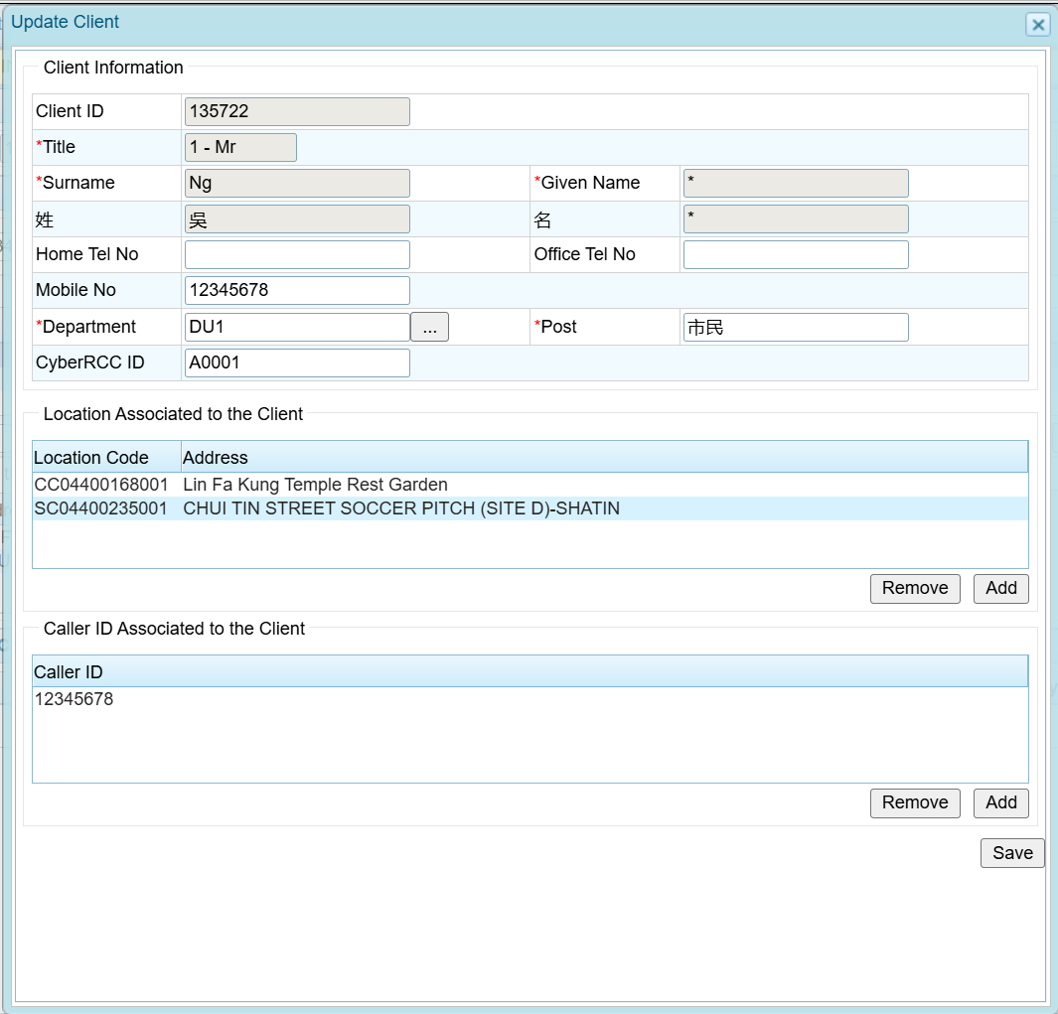

        - UF-0035 DA Display CyberRCC Account ID in repair request record
Item | Description
Function ID | UF-0035
Function Name | DA Display CyberRCC account ID in repair request record
Category | Presentation Layer
Related Requirements | Assigning CyberRCC Account in DA Phonebook (WEB-R11)
Function Description | - RCC CSO can search for the CyberRCC account ID on the Draft Repair Page  - RCC CSO can view the CyberRCC account ID on the Draft Repair Page
Metadata
  Field | Type
  CyberRCC Account ID | Varchar(5)
Business Rule | For repair requests from CyberRCC, the CyberRCC account ID will be included.  A new column titled “CyberRCC ID” will be added under “Clients under Caller ID” for RCC CSOs to view.
Screen Capture | 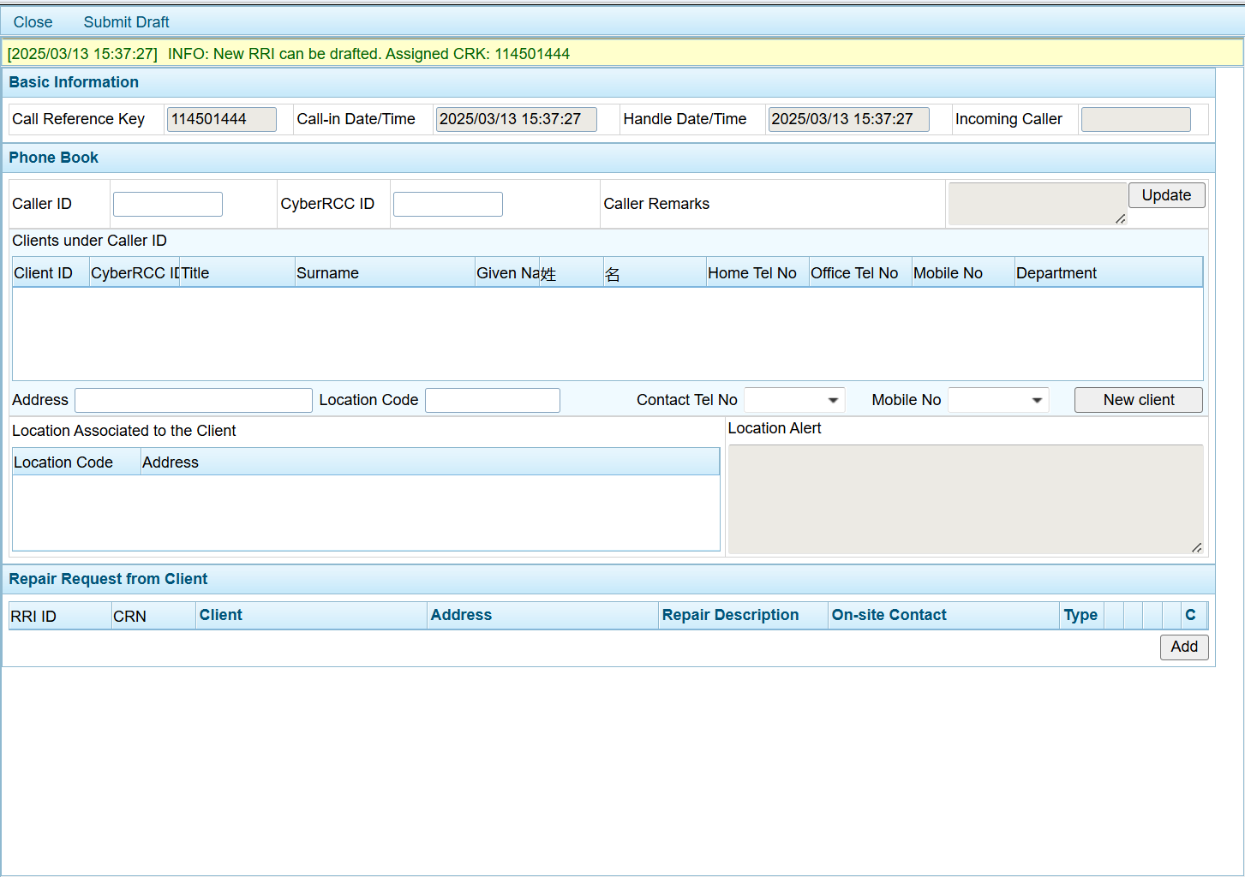

        - UF-0037 DS Login DA
Item | Description
Function ID | UF-0037
Function Name | DS Login DA
Category | Presentation Layer
Related Requirements | NetIQ integration (WEB-R19)
Function Description | - DS users are required to log into the external DA using their ArchSD domain account and password.  - Two-factor authentication via NetIQ is required when DS users access the external DA through the extranet.  - If a DS user's PC is connected to the ArchSD departmental network, they will be automatically logged into the DA.
Metadata
  Field | Type
  ArchSD Domain ID | Varchar(8)
  NetIQ Code | 6 Digits
Business Rule | For logging into DA under public Internet:  - DS users enter their domain login account and password on the DA login page.  - The DA server forwards the entered login credentials to the ArchSD domain server for user authentication.  - Once the user is successfully authenticated, the DA prompts the DS user to enter the NetIQ code.  - The DA server sends the NetIQ code along with the domain login account ID to the NetIQ server for verification.  - After receiving a successful authentication response from the NetIQ server, the DS user is granted access to the DA.  For logging into DA under the ArchSD departmental network:  - DS users access the DA using their desktop PCs via an internet browser.  - The DA retrieves the domain account information and checks whether the DS user is authorized to access it. If authorized, the system will logs the user into the DA.
Screen Capture | 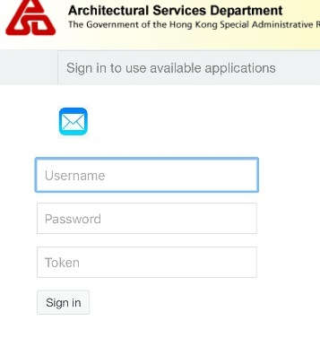  Prompt Box for input NetIQ:  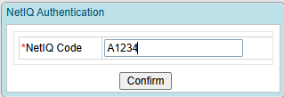

        - UF-0046 DA Alert Button and Display Alert in RRF
Item | Description
Function ID | UF-0046
Function Name | DA Alert Button and Display Alert in RRF
Category | Presentation Layer
Related Requirements | DS functions in CyberRCC (WEB-R20)
Function Description | - DS can view the alert message in RRF in DA.  - RCC can click the alert button of RRF to send an alert message to DS in DA.
Metadata
  Field | Type
  CRN | Varchar(8)
  Alert DS | Button
  Alert Message | NVarchar(255)
Business Rule | RRF Detail  Alert Message Screen  When DS opens the RRF and have not yet read the alert message in either CyberRCC or DA, the alert message will be displayed in the notification bar.  The alert message history will be shown in the 'Request History' tab of the RRF in DA.
  Field | Mode | Description | Business Rule
  Alert DS | Button | - | When RCC clicks the button, an alert message input dialog box will appear.
  Field | Mode | Description | Business Rule
  Alert Message | Free Text | - | -
  Close | Button | - | Click to cancel sending alert message to DS
  Alert | Button | - | Click to send alert message to DS.
Screen Capture | RRF:  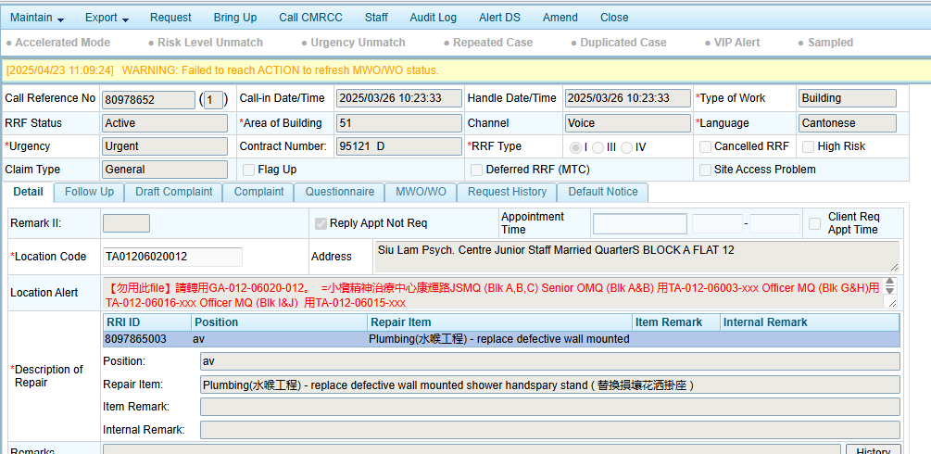  Alert Message Box:  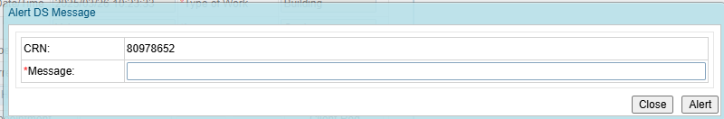  Alert History  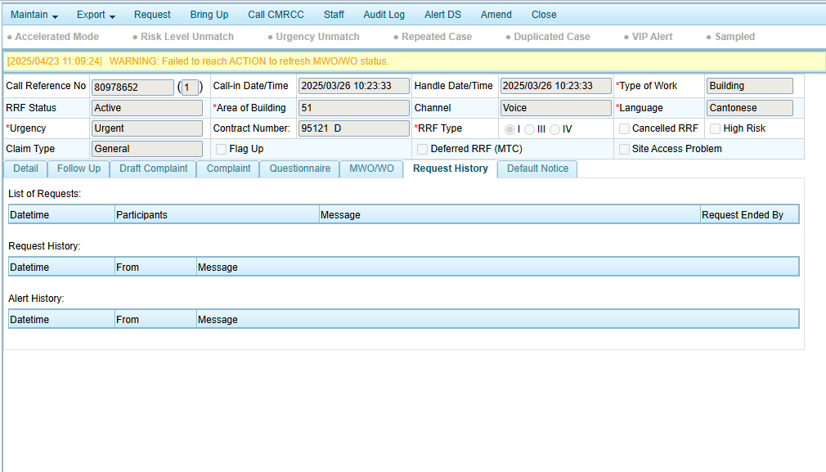

        - UF-0047 Send Monthly RRF Report to B/Ds by Email
Item | Description
Function ID | UF-0047
Function Name | Send monthly RRF report to B/Ds by email
Category | Presentation Layer
Related Requirements | Monthly report to B/Ds (WEB-R22)
Function Description | The system will automatically send the report to each B/D based on the configured settings on the 17th of each month.
Metadata
  Field | Type
  B/D Name | Varchar (50)
  CC list | Varchar (255)
  Static CC list | Varchar (255)
  Exclusion list | Varchar (255)
Email Server
  URL | ArchSDpsbmail.ArchSDrcc.cad.ArchSD.gov
  Sender | TBC ITSupportRCC@archsd.gov.hk
Report | The issued RRF by B/D by month:  - Report title  - Department name  - Location name
  Column | Type
  CRN | String
  Call in date time | String
  Client name | String
  Client post | String
  Client phone | Number
  Repair item description | String
  Attendance date reported by contractor | Date
Email Template
  Sender | To Be Confirmed by ArchSD  (ITSupportRCC@archsd.gov.hk?)
  Subject | To Be Confirmed by ArchSD
  Content | To Be Confirmed by ArchSD
  Attachment | Excel, PDF

        - UF-0048 DA set the configuration of B/Ds monthly report
Item | Description
Function ID | UF-0048
Function Name | DA set the configuration of B/Ds monthly report
Category | Presentation Layer
Related Requirements | Monthly report to B/Ds (WEB-R22)
Function Description | A new page will be available for DA User-Admins and RCC Supervisors to download and upload the monthly report settings in Excel format.
Screen Capture
Metadata
  Field | Type
  Recipient | String
  Location Code | String
  Department | String
  Group | String
  Recipient Email Addresses | List of string
  Report Name | String
Business Rule | DA user-admin and RCC supervisor can export the existing B/Ds Monthly Report Setting in DA.  DA user-admin and RCC supervisor can upload the existing B/Ds Monthly Report Setting excel in DA.
  Field  (* mandatory) | Type | Description
  Recipient* | String | Recipient Name
  Location Code* | String | Identify which location codes are included in the report.
  Department* | String | The target department for the location code RRF
  Group | String | The subgroup under the department, for grouping RRF into one excel file
  Recipient Email Addresses* | List of string | Enter the recipient's email addresses, separated by commas.
  Report Name* | String | Display in report name and email header for list of RRF under the excluded location code.
Screen Capture | 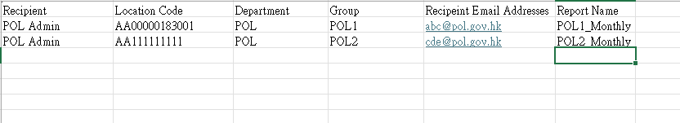  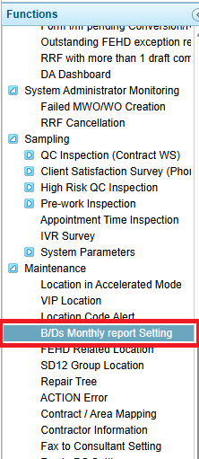  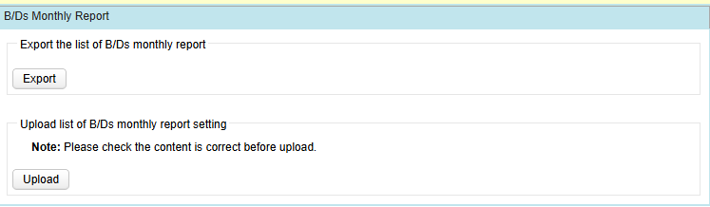

        - UF-0050 Configure Item Remarks of Repair Tree Item in DA
Item | Description
Function ID | UF-0050
Function Name | Configure Item Remarks of Repair Tree Item in DA
Category | Presentation Layer
Related Requirements | Repair tree item configuration (WEB-R21)
Function Description | - RCC Supervisor can update the item remarks and example for each repair tree item in DA.  - RCC Supervisor can update the mandatory setting of item remark 2 for each repair tree item.  - RCC Supervisor can select which items should be synchronize to CyberRCC.
Metadata
  Field | Type
  Item Remark 1 Label | NVarchar(50)
  Item Remark 1 Example | NVarchar(50)
  Item Remark 2 Label | NVarchar(50)
  Item Remark 2 Example | NVarchar(50)
  Item Remark 2 Mandatory | Varchar(1)
  Item sync to CyberRCC | Boolean
Business Rule
  Field  (* mandatory) | Mode | Description | Business Rule
  *Item Remark 1 Label | Text | Item Remark 1 will be displayed in CyberRCC
  *Item Remark 1 Example | Text | Item Remark 1 Example will be displayed in CyberRCC
  Item Remark 2 Label | Text | Item Remark 2 will be displayed in CyberRCC | Mandatory if item remark 2 mandatory is checked
  Item Remark 2 Example | Text | Item Remark 2 Example will be displayed in CyberRCC | Mandatory if item remark 2 mandatory is checked
  Item Remark 2 Mandatory | Checkbox | Mark Item Remark 2 Mandatory in CyberRCC if it is checked in DA | -
  Item synchronize to CyberRCC | Checkbox | The identity object enables synchronization with CyberRCC. | -
Screen Capture | 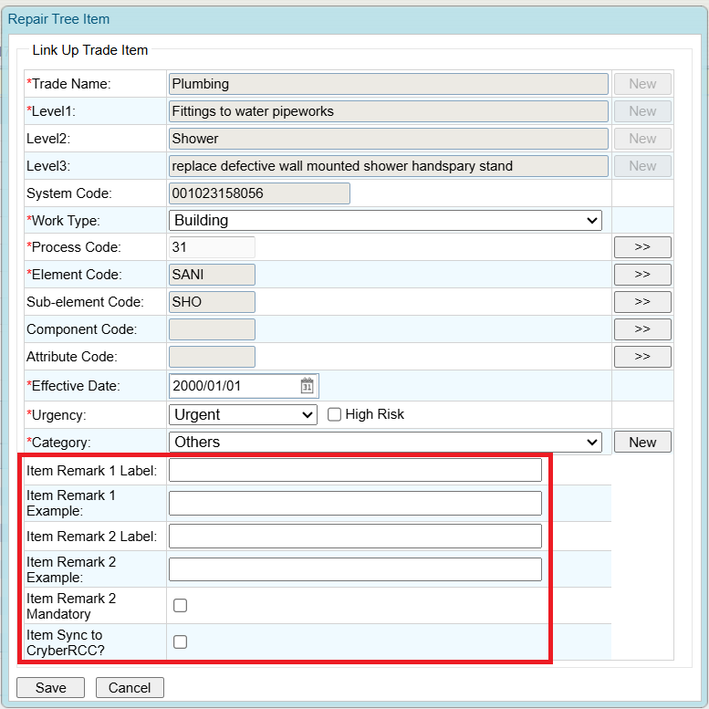

        - UF-0051 DA Link RRI with CyberRCC Account ID
Item | Description
Function ID | UF-0051
Function Name | DA Link RRI with CyberRCC Account ID
Category | Presentation Layer
Related Requirements | Assigning CyberRCC Account in DA Phonebook (WEB-R11)
Function Description | RCC users can update RRI to link it with CyberRCC Account ID in the DA.
Metadata
  Field | Type
  RRI ID | Varchar(10)
  CyberRCC Account ID | Varchar(10)
  Link CyberRCC | Button
  Confirm | Button
  Cancel | Button
Business Rule | RRI Detail:  Link CyberRCC pop up:
  Field | Mode | Description | Business Rule
  Link CyberRCC | Button | - | Display the Link CyberRCC dialog box
  CyberRCC Account | Display | - | Display the linked CyberRCC Account ID
  Field | Mode | Description | Business Rule
  CyberRCC Account ID | Text | - | Should be exist in CyberRCC System
  Confirm | Button | - | Confirm linking the RRI with the CyberRCC Account ID
  Cancel | Button | - | Cancel and back to the RRI Detail Page
Screen Capture | RRI Detail:  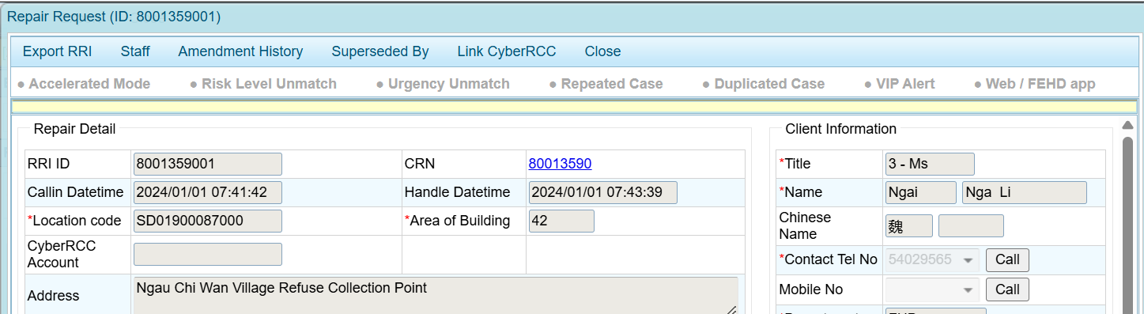  Link CyberRCC Pop Up:  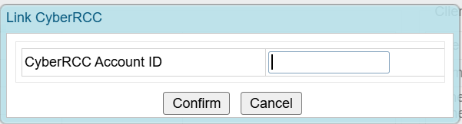

        - UF-0067 New DA Role for Extranet DA Access
Item | Description
Function ID | UF-0067
Function Name | New DA Role for Extranet DA Access
Category | Presentation Layer
Related Requirements
Function Description | - A New Role – Extranet DA Login will be created in DA  - RCC Supervisors can assign the Extranet DA Login role to DA Users if necessary.  - RCC Users with this role can log in to Extranet DA via the public internet.  - RCC Users need to configure the email for 2FA to login external DA.
Business Rule | A New Permission – “Login DA Extranet” will be created in DA.  A New Role – “Extranet DA Login” will be created in DA.  RCC Supervisor can assign the Extranet DA Login role to RCC Users if they need to log in to DA from the public internet.
Screen Capture | 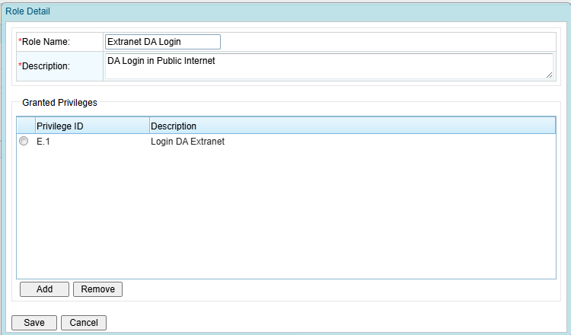
        - UF-0075 Bring up message for new batched for audit to DS
Item | Description
Function ID | UF-0075
Function Name | Bring up message for new batched for audit to DS
Category | Presentation Layer
Related Requirements
Function Description | - A bring up message will be created to DS when new batched for audit arrives.  - Default show the audit batch in pass 3 months when DS click “Search Batch”.
Business Rule | If IC submitted the batch for audit, a bring up message with the batch ID will be created for DS automatically.  Records from the past three months will be displayed automatically when the 'Search Batch' menu is clicked.

      - Reports and Dashboard
        - UF-0064 New Report – Monthly RRF Report
Item | Description
Function ID | UF-0064
Function Name | New Report – Monthly RRF Report
Category | Presentation Layer
Related Requirements | New Report – Monthly RRF Report (WEB-R26)
Function Description | - A new report can be exported in DA, with a layout similar to the existing FEHD monthly report but featuring additional formulas.  - Updating the raw data page will automatically update the summary statistic.
Business Rule | DA new page to export the report:  Worksheet in report:
  Column | Type
  Period | Drop down list
  Export | Button
  Name | Description
  All data | Raw data worksheet
  Summary | Summary with formula
  Area11 | Data of Area 11
  Area12 | Data of Area 12
  Area21 | Data of Area 21
  Area22 | Data of Area 22
  Area31 | Data of Area 31
  Area32 | Data of Area 32
  Area41 | Data of Area 41
  Area42 | Data of Area 42
Screen Capture | All data and other area layout:  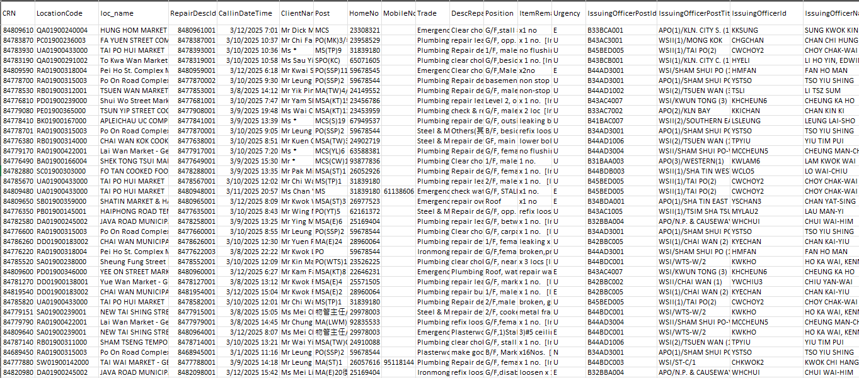  Summary layout:  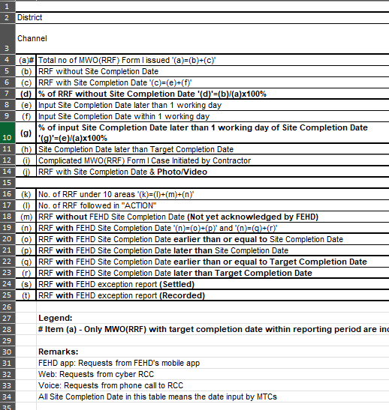  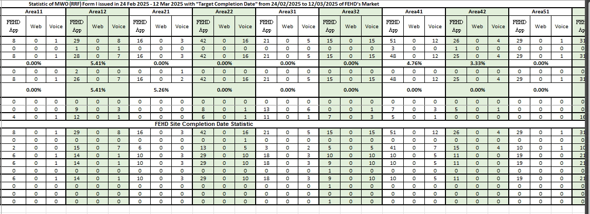

        - UF-0074 General RRF I & III Waiting for Acknowledge in Decision Manager
Item | Description
Function ID | UF-0074
Function Name | General RRF I & III Waiting for Acknowledge in Decision Manager
Category | Presentation Layer
Related Requirements | -
Function Description | Allow generation of an Excel file for RRF I and Form III cases waiting for acknowledge in decision manager. The exported column will match those in the DA monitoring screen.
Business Rule | Criteria for general the report:  Column in report:
  Field | Type
  Callin datetime | Datetime
  Column
  CRN
  Callin Datetime
  Location Code
  Address
  VIP
  HR
  Urgency
  From
  Issuing Officer Post
  Complicated Repair Description
  Handing Officer Po
  Priority
  MWO/WO
  Other MWO/WO

        - UF-0065 RCC Dashboard Update
Item | Description
Function ID | UF-0065
Function Name | DA Dashboard Update
Category | Presentation Layer
Related Requirements | RCC & CCE Dashboard Update (WEB-R27)
Function Description | Add a new RCC Dashboard to show more statistical information from DA
Business Rule | For Chart 1:  It shows the current RRI waiting for MTC Input Appointment Time. At the left bottom corner, it will show the longest waiting time for MTC Input Appointment Time for both emergency and non-emergency RRI.  For Confirming Appointment Time:  For Created RRF III for review:  For Outstanding Draft Complaint:  For Repeated Case for review:
  Chart Type | Bar Chart
  X Axis | Contract Area
  Y Axis | Number of RRI that are waiting for MTC Input Appointment Time
  Bar Option | - Emergency RRI  - Non-Emergency RRI
  Column | Description
  Y | Total RRI with non-appointment required are waiting for confirming appointment time
  Non-Y | Total RRI with appointment required are waiting for confirming appointment time
  Total | Total RRI are waiting for confirming appointment time
  Longest Time | Longest Waiting Time for confirming appointment time in (mm:ss)
  Column | Description
  Created RRF III for review | No. of Created RRF III for review
  Longest Time | Longest time for RRI III be reviewed in (mm:ss)
  Column | Description
  Outstanding Draft Complaint | No. of Outstanding Draft Complaint
  Longest Time | Longest time for Outstanding Draft Complaint be handled in (mm:ss)
  Column | Description
  Repeated Case for review | Number of repeated cases for review
Screen Capture | 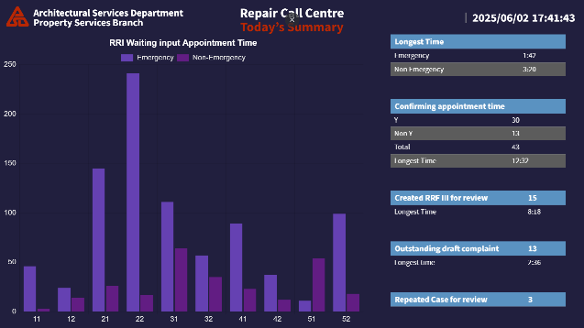  1

        - UF-0066 CCE Dashboard Update
Item | Description
Function ID | UF-0066
Function Name | CCE Dashboard Update
Category | Presentation Layer
Related Requirements | RCC & CCE Dashboard Update (WEB-R27)
Function Description | Update the existing CCE Dashboard to include more statistical information from Enghouse CCE.
Business Rule | For Real Time in Queue Figure:  For Inbound Call:  For Voicemail:  For Web/FEHD App:  For Today’s Summary:  For Inbound Call:  For Voicemail:  For Web/FEHD App:
  Column | Description
  Total Calls in Queue | Total Inbound Calls in Queue
  Waiting Time > 15 minutes | No of Calls that waiting time is more than 15 minutes
  General Longest Waiting | The longest waiting time for general inbound call queue in (mm:ss).
  Emergency Longest Waiting | The longest waiting time for emergency inbound call queue in (mm:ss).
  Column | Description
  Total Voicemail in Queue | Total Voicemail in Queue
  General | Total General Voicemail in Queue
  Emergency | Total Emergency Voicemail in Queue
  General Longest Waiting | The longest waiting time for general Voicemail queue in (mm:ss).
  Emergency Longest Waiting | The longest waiting time for emergency Voicemail queue in (mm:ss).
  Column | Description
  Web | Total Web Request in Queue.
  FEHD | Total FEHD App Request in Queue.
  General | Total General Web Request in Queue.
  Emergency | Total Emergency Web Request in Queue.
  General Longest Waiting | The longest waiting time for general web request queue in (mm:ss).
  Emergency Longest Waiting | The longest waiting time for emergency web request queue in (mm:ss).
  Column | Description
  Handled | Total Handled Inbound Call
  Received | Total Received Inbound Call
  Longest Talk Time | The longest talk time in Inbound Call in (hh:mm:ss)
  Average Talk Time | The average talk time in Inbound Call in (hh:mm:ss)
  Column | Description
  Handled | Total Handled Voicemail
  Received | Total Received Voicemail
  Longest Talk Time | The longest talk time in Voicemail in (hh:mm:ss)
  Average Talk Time | The average talk time in Voicemail in (hh:mm:ss)
  Column | Description
  Handled Web | Total Handled Web Request
  Received Web | Total Received Web Request
  Handled FEHD App | Total Handled FEHD App
  Received FEHD App | Total Received FEHD App
  Longest Talk Time | The longest talk time in Voicemail in (hh:mm:ss)
  Average Talk Time | The average talk time in Voicemail in (hh:mm:ss)
Screen Capture | 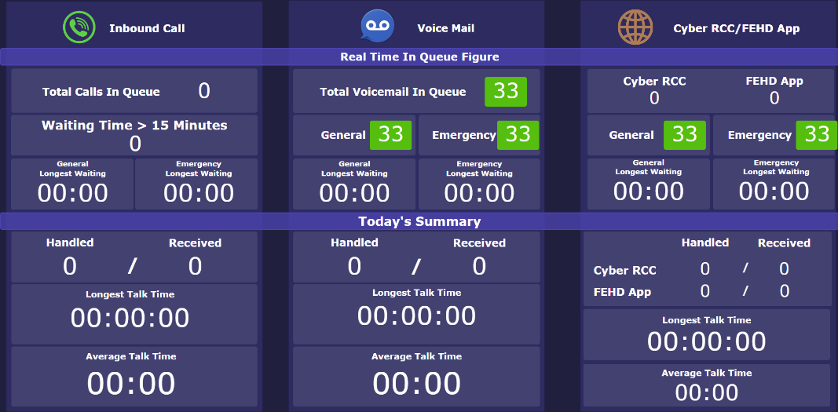

  - SYSYEM DESIGN
    - System Architecture
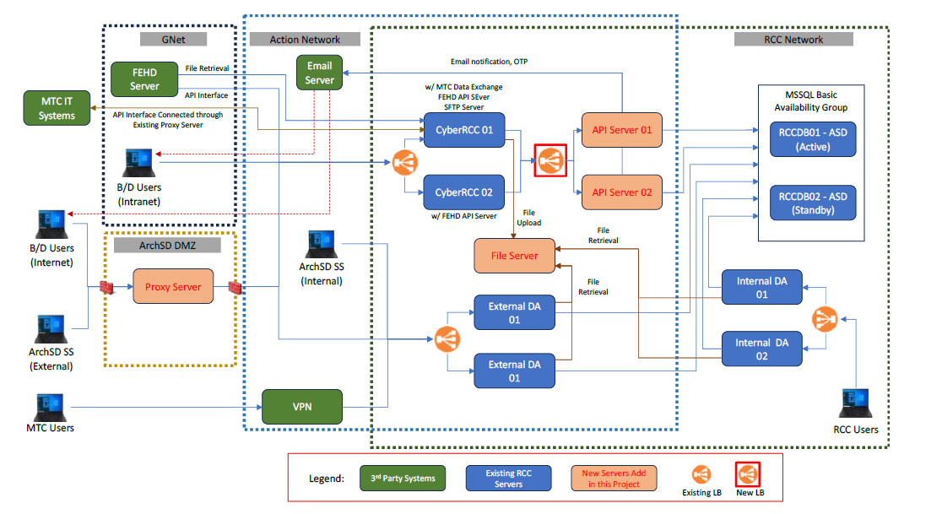

      - Development Tools and Software
Tool/ Software | Description | Finalized Tool/Software | Version
Microsoft Window | OS for file server, CyberRCC API Server | Microsoft Windows Server | Version 2022 (Downgrade from 2025)
Red Hat Linux | OS for Proxy and Reverse Proxy | Red Hat Enterprise Linux | To Be Confirmed
Nginx | Proxy and Reverse Proxy in Linux Proxy Server | Nginx | Version 1.26
Microsoft SQL Server Database | Connect to Database Server | Microsoft SQL Server | Version 2019
Node.js | Development Software for CyberRCC API and Web Server | Node.js | To Be Confirmed
Vue.js | Development Software for CyberRCC Web server | Vue.js | To Be Confirmed
Java | Runtime and JDK | Java | Version 8
Tomcat | Web Server:(FEHD API Server, DA System) | Tomcat | Version 9

      - System Script
- RCCFILE01
Script | Purpose | Remarks
Housekeep.bat | For Housekeeping the document of RRF

    - Data Specification
      - Data Source
Data Source | Description | Type of Data | Frequency of access
Database | MS SQL Server Database to store the information which will be used in CyberRCC, DA, FEHD API and Data Exchange Program with MTC IT Platform | Repair Request Data, RRF Data, Call data, web request data | High

      - Logical Data Model
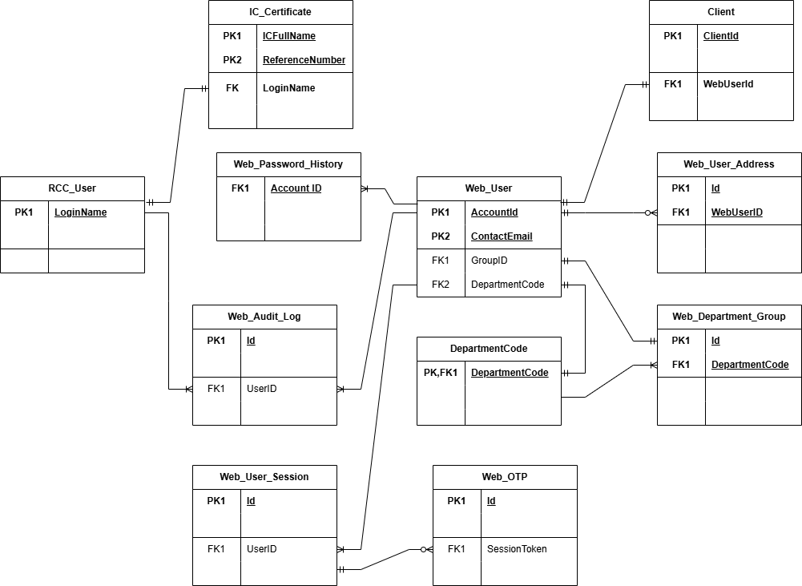

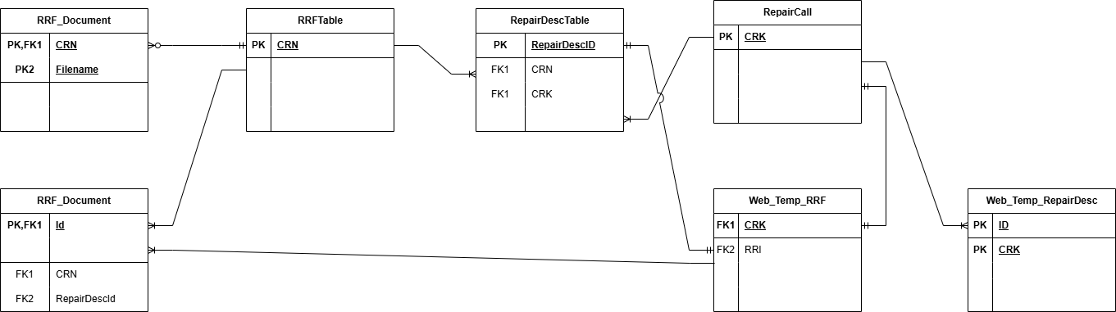

Core Data Entities:
Entity | New Entity | Entity Description
RRF_Document | Y | Related Document of RRF submitted by IC from MTC IT Platform
IC_Certificate | Y | Public Key of IC for verify e-signature
RRFTable |  | Information of RRF
Web_User | Y | CyberRCC User Account
Web_User_Address | Y | CyberRCC User’s Saved Address
Web_Department_Group | Y | B/Ds admin defined Department group
DepartmentCode |  | Government Department Table
Web_Password_History | Y | CyberRCC User Password History
Web_Audit_Log | Y | CyberRCC Audit Log
Web_User_Session | Y | CyberRCC Session Table
Web_OTP | Y | CyberRCC One Time Passcode Table
RepairCall |  | Repair Call Table for DA
Web_Temp_RRF |  | Web Repair Request Table
Web_Temp_RepairDesc |  | Web Repair Request Item Description
Client |  | Client Table in DA
RepairDescTable |  | Repair Request Item Description in DA
WebExceptionMedia | Y | Exception Report Photo

      - Physical Data Model
New Physical Data Entry Description:
Table | Field Name | Type | Description | Mandatory | Primary Key | Foreign Key
RRF_Document | CRN | Varchar(8) | CRN of the RRF | Y | Y | Y
RRF_Document | FileName | Varchar(100) | Document Name | Y | Y
RRF_Document | FileLocation | Varchar(200) | Document Location in file server | Y
IC_Certificate | ContractID | Varchar(8) | Contract Id of IC | Y
IC_Certificate | ICFullName | NVarchar(80) | IC Full Name | Y | Y
IC_Certificate | ReferenceNumber | Varchar(100) | e-Cert Reference Number | Y | Y
IC_Certificate | PublicKey | Varchar(500) | Public Key of IC e-Cert | Y
IC_Certificate | LoginName | Varchar(100) | Login Name of IC in DA | Y
Web_User | AccountId | Varchar(10) | 5 Digit Account Id | Y | Y
Web_User | LoginEmail | Varchar(100) | Login Email for CyberRCC | Y
Web_User | ContactEmail | Varchar(100) | Contact Email for CyberRCC
Web_User | Password | Varchar(14) | Password for CyberRCC Account | Y
Web_User | Title | Varchar(3) | Title of CyberRCC User
Web_User | LastNameEng | Varchar(20) | English Last Name | Y
Web_User | FirstNameEng | Varchar(20) | English First Name
Web_User | LastNameChi | NVarchar(20) | Chinese Last Name
Web_User | FirstNameChi | NVarchar(20) | Chinese First Name
Web_User | PrimaryContact | Integer | Primary Contact No. | Y
Web_User | SecondaryContact | Integer | Secondary Contact No.
Web_User | DepartmentCode | Varchar(3) | Department of CyberRCC User | Y
Web_User | GroupId | Integer | Group of CyberRCC User under Department
Web_User | Post | NVarchar(25) | Post of CyberRCC User
Web_User | PreferedLanaguage | Varchar(50) | Prefered Language:  Eng: English  Chi: Chinese
Web_User | GnetUID | Varchar(50) | Related Government Departmental User Id
Web_User | Status | Varchar(50) | Account Status
Web_User | LastPasswordUpdateDateTime | DateTime | Last Password Update Date Time
Web_User | LastLoginAttemptDateTime | DateTime | Last Login Attempt Date Time
Web_User | FailLoginCount | Integer | Fail Login Count: 0 -5
Web_User | AccountLockDateTime | DateTime | Account Lock Start Date Time
Web_User | iAMSmartToken | Varchar(100) | iAM Smart Token for the account
Web_User | isGovernmentEmail | Varchar(1) | Login Email is government email
Web_User | IsQuarterUser | Varchar(1) | Account is Quarter User
Web_User_Address | AccountId | Varchar(10) | CyberRCC User Account | Y | Y | Y
Web_User_Address | Id | Integer | Record Id |  | Y
Web_User_Address | Address | NVarchar(200) | Full Address | Y
Web_User_Address | Block | NVarchar(100) | Block/Building
Web_User_Address | Floor | Integer | Floor
Web_User_Address | Flat | Varchar(10) | Flat
Web_User_Address | IsQuarter | Varchar(1) | Address Is Quarter
Web_Password_History | AccountId | Varchar(10) | CyberRCC User Account | Y |  | Y
Web_Password_History | Password | Varchar(14) | Password Record | Y
Web_Password_History | CreateDateTime | DateTime | Create Password Date Time | Y
Web_Audit_Log | Id | Integer | Record Id | Y | Y
Web_Audit_Log | LogTime | DateTime | Log Create Date Time | Y
Web_Audit_Log | LogType | Varchar(6) | Log Type | Y
Web_Audit_Log | Message | NVarchar(4000) | Log Message | Y
Web_Audit_Log | UserId | Varchar(100) | Action User Id | Y |  | Y
Web_Department_Group | id | Integer | Record Id | Y | Y
Web_Department_Group | DepartmentCode | Varchar(3) | Department Code | Y |  | Y
Web_Department_Group | GroupNameEng | Varchar(50) | English Group Name | Y
Web_Department_Group | GroupNameChi | NVarchar(50) | Chinese Group Name | Y
Web_Department_Group | UpdateBy | Varchar(10) | Update Person | Y
Web_Department_Group | UpdateDateTime | DateTime | Update Date Time | Y
Web_User_Session | id | Integer | Record Id | Y | Y
Web_User_Session | AccountId | Varchar(100) | Login Account Id | Y |  | Y
Web_User_Session | Token | Varchar(100) | Session Token | Y
Web_User_Session | LoginDateTime | DateTime | Login Date Time | Y
Web_User_Session | LogoutDateTime | DateTime | Logout Date Time
Web_User_Session | LogoutReason | Varchar(100) | Logout Reason
Web_User_Session | LoginType | Varchar(1000) | Login Type
Web_User_Session | IsTwoFactorAuth | Varchar(1) | Has Two Factor Auth
Web_User_Session | IP | Varchar(100) | IP Address of login PC
Web_OTP | id | Integer | Record Id | Y | Y
Web_OTP | SessionToken | Varchar(100) | Related Session Token | Y |  | Y
Web_OTP | OTP | Varchar(6) | One Time Passcode | Y
Web_OTP | CreateDateTime | DateTime | Create Date Time | Y
RepairCall | CyberRCCAccountId | Varchar(10) | Related CyberRCC account Id |  |  | Y
RepairCall | IsEmergency | Varchar(1) | If Repair Call (web) is Emergency
RepairCall | IsDraft | Varchar(1) | If repair call (web) is draft
Web_Temp_RRF | IsCancelled | Varchar(1) | Is Cancelled Web RRF
Web_Temp_RRF | RRI | Varchar(10) | Related RRI ID |  |  | Y
Web_Temp_RRF | RequestType | Varchar(50) | Request Type of Web Request
RepairDescTable | CyberRCCAccountId | Varchar(10) | Related CyberRCC Account Id |  |  | Y
RepairDescTable | WebSiteCompDate | Date | Site Completion Date from CyberRCC
RepairDescTable | WebJustificaton | NVarchar(255) | Exception Report Justification from CyberRCC
RepairDescTable | WebExceptionReportCreationDateTime | DateTime | Exception Report Create Datetime from CyberRCC
RepairDescTable | OptOutFehd | Varchar(1) | Is Opted Out for FEHD
Client | WebUserId | Varchar(10) | Related CyberRCC Account Id |  |  | Y
WebExceptionMedia | Id | Integer | Record Id | Y | Y
WebExceptionMedia | Filename | NVarchar(100) | Filename of the media | Y
WebExceptionMedia | Filetype | NVarchar(10) | Filetype of the media | Y
WebExceptionMedia | Description | NVarchar(250) | Description of the media
WebExceptionMedia | CreationDateTime | DateTime | Create Date Time of the record | Y
WebExceptionMedia | RepairDescId | Varchar(10) | Related RRI ID | Y |  | Y
WebExceptionMedia | Data | Varbinary(max) | Data of the media | Y
WebExceptionMedia | crn | Varchar(8) | Related CRN |  |  | Y
Web_Email_Verification | email | Varchar(100) |  | Y
Web_Email_Verification | verificationCode | Varchar(6) |  | Y
Web_Email_Verification | sendDatetime | DateTime |  | Y

- TECHNICAL SYSTEM OPTION
  - SYSTEM ARCHITECTURE
    - Network Architecture
The proposed network architecture for the enhanced RCC is shown below.
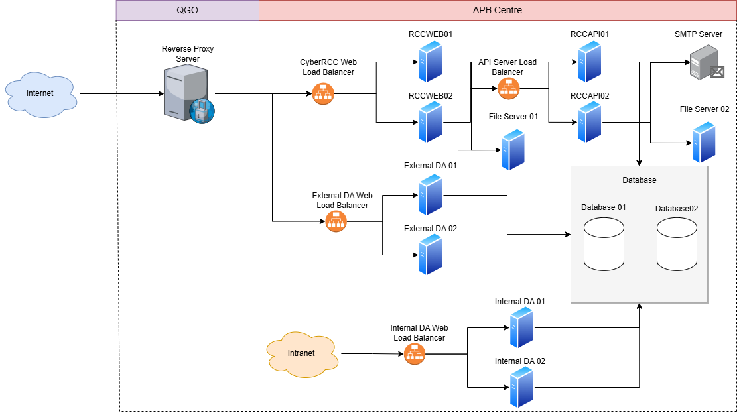
Segment | Description
Internet | Traffic from the public network.
QGO | Routing the traffic from Internet to APB Centre.
APB Centre | Cannot be directly accessed by publics. Allow Internal and QGO traffic only.
Intranet | Traffic from APB Centre only.
The two systems, CyberRCC and External DA, will allow access from the public network and are located within APB Centre’s RCC network.
The new Proxy Server at QGO (DMZ) will function as both a reverse and forward proxy:
- Reverse Proxy: Users on the public network will connect to the system through the proxy server.
- Forward Proxy: If certain functions in CyberRCC (API server) or External DA require communication with services outside the RCC network, the proxy server will facilitate those connections.

    - Storage Architecture
All data is stored on the local hard disks of the servers. A full backup will be performed daily. All RESTRICTED data is strongly encrypted.
Server Name | Hard Disk Drive | Raid Level | Backup Method
RCCWEB01 | 500 GB SSD | RAID 1 | Existing backup method
RCCWEB02 | 500 GB SSD | RAID 1 | Existing backup method
RCCAPI01 | 500 GB SSD | RAID 1 | Existing backup method
RCCAPI02 | 500 GB SSD | RAID 1 | Existing backup method
RCCAPP01 | 500 GB SSD | RAID 1 | Existing backup method
RCCAPP02 | 500 GB SSD | RAID 1 | Existing backup method
RCCAPPEXT01 | 500 GB SSD | RAID 1 | Existing backup method
RCCAPPEXT02 | 500 GB SSD | RAID 1 | Existing backup method
RCCFILE01 | 60 TB SSD | RAID 1 | Daily backup by Veeam
RCCFILE02 | 20 TB SSD | RAID 1 | Daily backup by Veeam
RCCDB01 | 2TB SSD | RAID 1 | Hourly transaction tog backup to RCCDB-BK01  Resilience with RCCDB02
RCCDB02 | 2TB SSD | RAID 1 | Resilience with RCCDB01
RCCPROXY01 | 5TB SSD | RAID 1 | Daily backup by RedHat Linux backup software

    - Backup Schedule
All RESTRICTED data stored in the backup tapes is strongly encrypted. All backup tapes containing RESTRICTED data are labelled with data classification.
Server Name | Backup Schedule
RCCWEB01 | Existing backup schedule
RCCWEB02 | Existing backup schedule
RCCAPI01 | Existing backup schedule
RCCAPI02 | Existing backup schedule
RCCAPP01 | Existing backup schedule
RCCAPP02 | Existing backup schedule
RCCAPPEXT01 | Existing backup schedule
RCCAPPEXT02 | Existing backup schedule
RCCFILE01 | Daily Backup at 23:30 p.m., two tapes will be used for the backup.
  Day | Tape Label (“YYYY-MM-DD” is the creation date)
  1 | RCCFILE Daily A YYYY-MM-DD
  2 | RCCFILE Daily B YYYY-MM-DD
  3 | RCCFILE Daily A YYYY-MM-DD
  4 | RCCFILE Daily B YYYY-MM-DD
  And so on… | And so on…
RCCFILE02
RCCDB01 | Existing backup schedule
RCCDB02 | Existing backup schedule
RCCPROXY01 | Daily Backup at 03:00 a.m.

  - SIZING MODEL
    - Data Storage
      - Raw Data Storage
Entity Name | Annual Growth Rate (%) |  | Record Length (byte) | No. of Records  23-24 Yr |  | Record Storage (MB)
 |  |  |  |  |  | Yr 0 | Yr 1 | Yr 2 | Yr 3 | Yr 4 | Yr 5
AUDIT_LOG | 6 |  | 131 | 5156644 |  | 645.75 | 684.50 | 725.57 | 769.10 | 815.25 | 864.17
RCC_USER | 10 |  | 146 | 2064 |  | 0.289 | 0.318 | 0.35 | 0.38 | 0.42 | 0.47
RRFTable | 2.2 |  | 1230 | 466076 |  | 547.13 | 558.07 | 570.35 | 582.90 | 595.72 | 608.82
RepairDescTable | 2.2 |  | 960 | 485572 |  | 444.84 | 453.73 | 463.71 | 473.91 | 484.34 | 495.00
Sessions | 2 |  | 99 | 115626 |  | 10.95 | 11.22 | 11.44 | 11.67 | 11.91 | 12.14
WEB_TEMP_RepairDesc | 14 |  | 196.24 | 118669 |  | 22.25 | 25.37 | 28.92 | 32.97 | 37.59 | 42.85
WEB_TEMP_RRF | 20 |  | 349 | 81227 |  | 27.01 | 32.42 | 38.90 | 46.68 | 56.02 | 67.23
Total Usage |  | 2980.24 |  |  | 1269234 | 1052.469 | 1081.13 | 1113.68 | 1148.52 | 1186.00 | 1226.51

      - Index Storage
Entity Name | Annual Growth Rate (%) | Index Length (byte) | No. of Records  23-24 Yr | Number of Keys | Record Storage (MB)
 |  |  |  |  | Yr 0 | Yr 1 | Yr 2 | Yr 3 | Yr 4 | Yr 5
AUDIT_LOG | 6 | 121 | 5156644 | 4 | 595.49 | 631.21 | 669.09 | 709.24 | 751.79 | 796.90
RCC_USER | 0 | 0 | 2064 | 0 | 0 | 0 | 0 | 0.00 | 0.00 | 0.00
RRFTable | 2.2 | 1356 | 466076 | 29 | 602.95 | 615.01 | 627.31 | 641.11 | 655.22 | 669.63
RepairDescTable | 2.2 | 877 | 485572 | 12 | 406.18 | 414.3 | 422.59 | 431.89 | 441.39 | 451.10
Sessions | 0 | 0 | 115626 | 0 | 0 | 0 | 0 | 0.00 | 0.00 | 0.00
WEB_TEMP_RepairDesc | 0 | 0 | 118669 | 0 | 0 | 0 | 0 | 0.00 | 0.00 | 0.00
WEB_TEMP_RRF | 20 | 349 | 81227 | 6 | 27.01 | 27.55 | 28.1 | 33.72 | 40.46 | 48.56
Total Usage | - | 2703 | 6425878 | 51 | 1036.14 | 1056.86 | 1078 | 1815.95 | 1888.86 | 1966.18

    - File Server Sizing
Server: RCCFILE01, RCCFILE02 (File Server)
CPU: At least 8 Core (2.6 GHz or higher)
Memory:
RCCFILE01
Component |  | Description | (GB)
 | Operation System Software |  | 4
 | Other Software | 20% of (1) | 0.8
 | Date Buffer | 50 % of (1) + (2) | 2.4
 | Sub-total |  | 7.2
 | System Buffer Cache | 10% of (4) | 0.7
Total |  |  | 7.9
Recommended Memory (GB) |  |  | 8

RCCFILE02
Component |  | Description | (GB)
 | Operation System Software |  | 4
 | Other Software | 20% of (1) | 0.8
 | Date Buffer | 50 % of (1) + (2) | 2.4
 | Sub-total |  | 7.2
 | System Buffer Cache | 10% of (4) | 0.7
Total |  |  | 7.9
Recommended Memory (GB) |  |  | 8

Internal Disk Storage:
RCCFILE01
Component |  | Description | (GB)
 | Operation System |  | 32
 | Other Application Software |  | 10
 | File Storage Space | 1 Financial Year RRF: 358843  Files Per RRF: 4  Size Per File: 5 MB  Storage Duration: 6 yr  =358843 * 4 *5 * 6 | 42052
 | Sub-total |  | 42094
 | Contingency |  | 1000
Total (GB) |  |  | 43094
Total (TB) |  |  | 42
Recommended Memory (TB) |  |  | 45

RCCFILE02
Component |  | Description | (GB)
 | Operation System |  | 32
 | Other Application Software |  | 10
 | File Storage Space | 1 Year Web Request’s RRI:  65627  Max size Per RRI:  3MB+3MB+25MB=31MB  Storage Duration: 6 yr  Buffer increment: 1.5  =65627 * 31 * 6 *1.5/1024 | 17880.79395
 | Sub-total |  | 17922.79395
 | Contingency |  | 1000
Total (GB) |  |  | 18922.79395
Total (TB) |  |  | 18
Recommended Memory (TB) |  |  | 20
    - Network Sizing
Production Site to Internet
Description | Breakdown | Mbps | Remark
Internet concurrent system users (a) | 200
Bandwidth requirement per system user in Kbps (b) | 300
Bandwidth requirement for all Internet system users (c) |  | 60 | (c) = (a) x (b) / 1000
Subtotal (d) |  | 60
Protocol overhead (e) |  | 12 | (d) x 20%
Contingency (f) |  | 6 | (d) x 10%
Total(Mbps) |  | 78 | (d) + (e) + (f)
Recommended Bandwidth (Mbps) |  | 80

  - IMPACT ANALYSIS
    - EVALUATION OF IMPACTS ON ARCHSD DUE TO LOSS OF IT SERVICES
      - Hong Kong E-Post No Longer Issue E-Certificate
Affected System/Components: Data Exchange Program, DA

Category | Impact
Operation | - The Data Exchange Program cannot verify documents from the MTC IT Platform  - The DA system will not receive or display new document from MTC IT Platform
Data | - New IC Users cannot apply for new E-Certificates via Hong Kong E-Post, existing E-Certificates will expire according to their expiry dates
Costs | - Additional E-Certificates are needed  - Existing Encryption Logic and Verification Logic will need updates for new E-certificate

      - All E-Certificates Expired

Affected System/Components: Data Exchange Program, DA

Category | Impact
Operation | - The Data Exchange Program cannot verify documents from the MTC IT Platform  - The DA system will not receive or display new documents from the MTC IT Platform
Data | - N/A
Costs | - Additional E-Certificates are required

      - Exceed File Server Storage

Affected System/Components: Data Exchange Program, DA

Category | Impact
Operation | - Critical services relying on the file server may become available, disrupting business operations
Data | - Files may become corrupted if the server runs out of space during data writing.
Costs | - Additional costs will be incurred to increase storage

      - Reverse Proxy Server Down

Affected System/Components: CyberRCC, DA

Category | Impact
Operation | - CyberRCC User cannot submit web repair requests via the public Internet  - DS cannot access DA via the public Internet
Data | - Data Loss may occur when CyberRCC Users are submitting web requests via the public Internet
Costs | - Additional human resources will be needed to handle incoming call requests

      - CyberRCC Web Server Down

Affected System/Components: CyberRCC, FEHD API Web Service, Data Exchange Program, Hostgateway Program

Category | Impact
Operation | - CyberRCC Users cannot submit web repair requests  - FEHD cannot submit requests through the API  - Data exchange with the MTC IT Platform cannot occur  - Request to create MWOs or WOs from DA to ACTION cannot be sent
Data | - Data loss may occur when CyberRCC Users are submitting web requests  - Data loss may occur during exchanges with the MTC IT Platform
Costs | - Additional human resource will be needed to handle incoming call requests

      - CyberRCC API Web Server Down

Affected System/Components: CyberRCC

Category | Impact
Operation | - CyberRCC Users cannot submit web repair requests
Data | - Data loss may occur when CyberRCC Users are submitting web requests
Costs | - Additional human resources will be needed to handle incoming call requests

      - External DA Web Server Down

Affected System/Components: DA

Category | Impact
Operation | - DS and MTC cannot login to DA through the public internet and Departmental Network
Data | - NA
Costs | - NA

      - Internal DA Web Server Down

Affected System/Components: DA

Category | Impact
Operation | - RCC cannot login to DA through the RCC Network
Data | - NA
Costs | - NA

      - Database Service Down

Affected System/Components: CyberRCC, FEHD API Web Service, Data Exchange Program, Hostgateway Program, DA

Category | Impact
Operation | - All Systems, including DA, CyberRCC, FEHD API Web Service, Data Exchange Program, Hostgateway Program, will not function properly  - Clients cannot submit requests via call, CyberRCC, or FEHD API  - RCC, DS and MTC cannot login to DA for daily operations
Data | - Data may become corrupted
Costs | - NA

  - IMPLEMENTATION PLAN
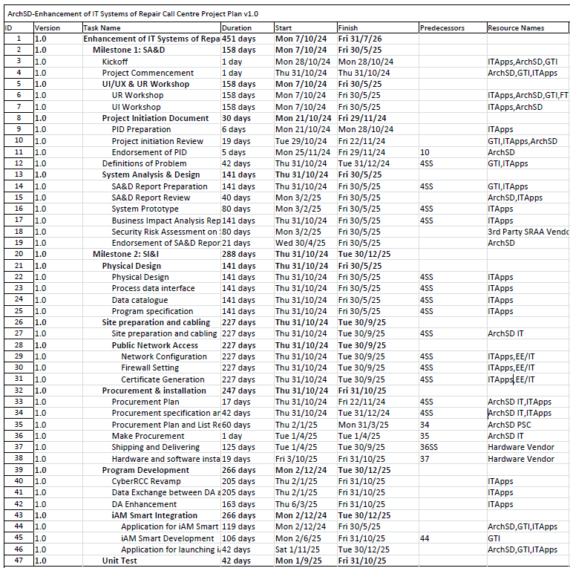
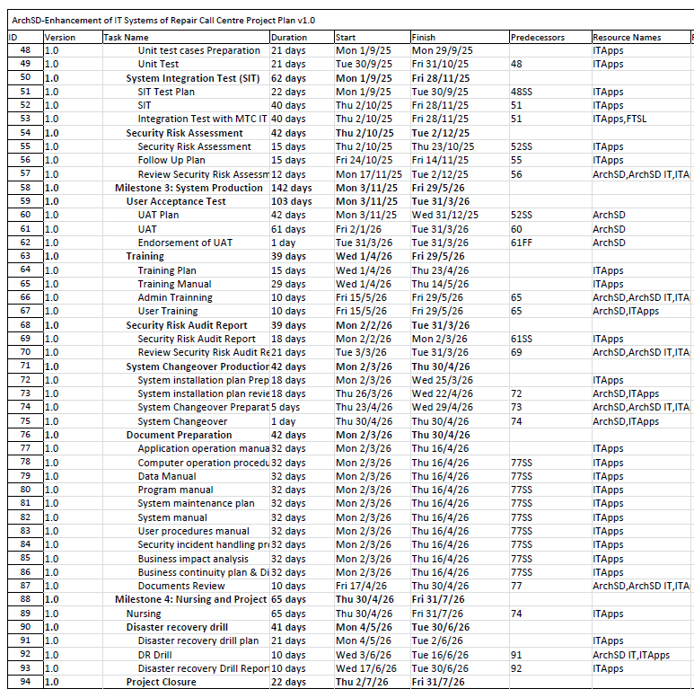
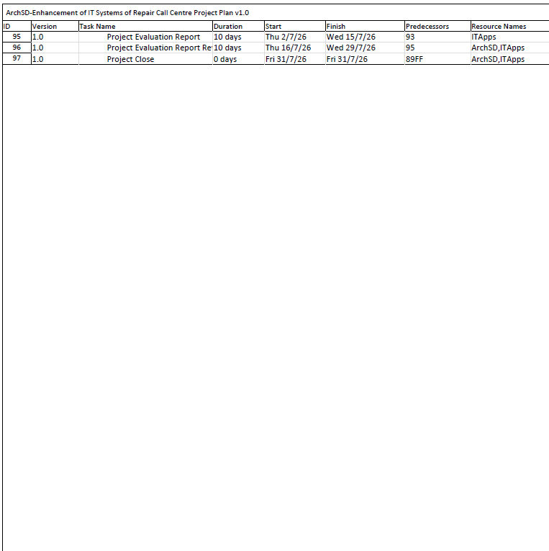

- APPENDIX
- Verified e-Signature Document Screen Capture
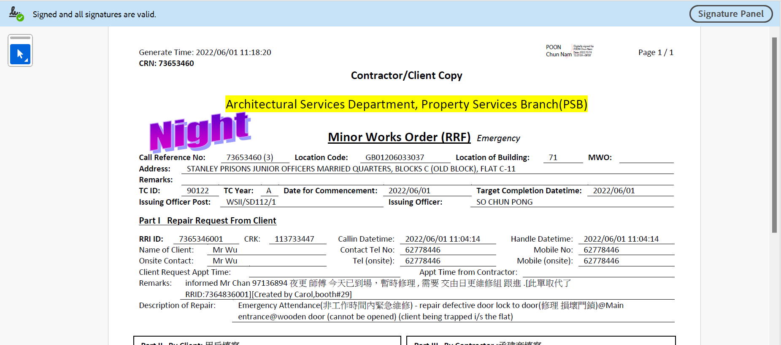

- CyberRCC User Registration Flow
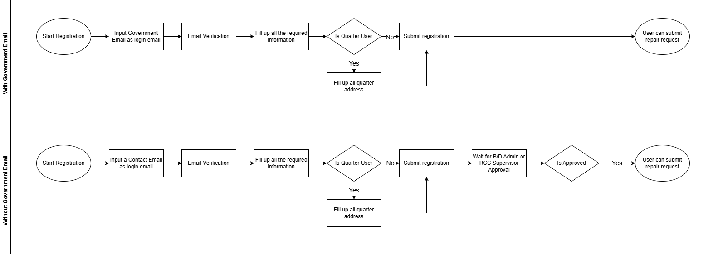

- CyberRCC Session Control Flow
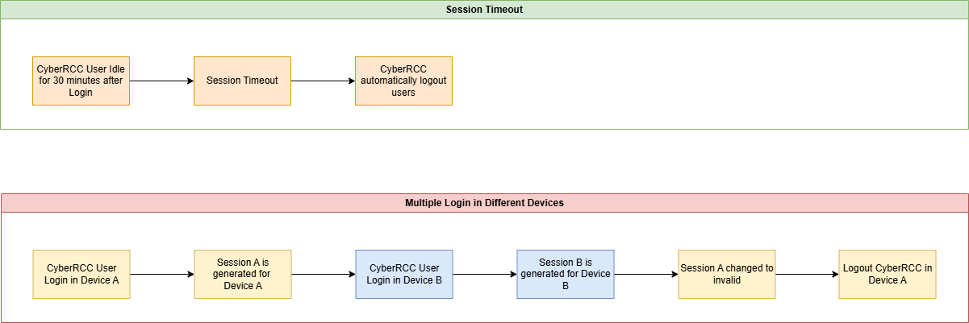

- Cancel in CyberRCC Flow
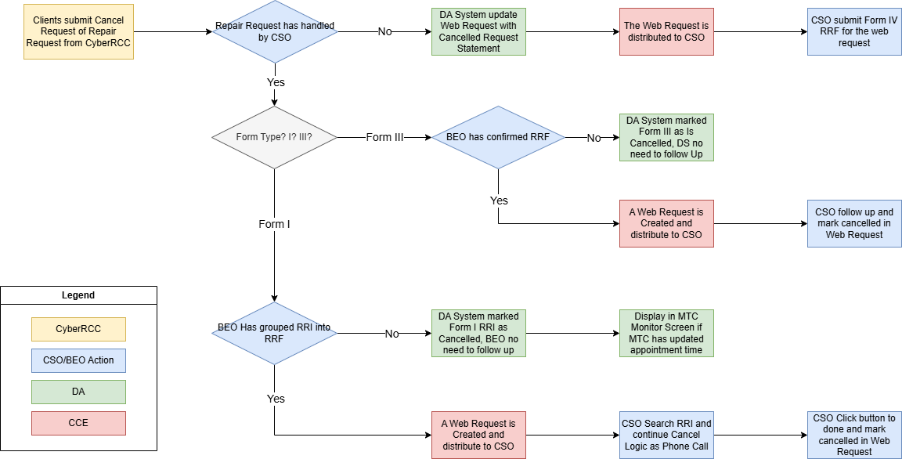

- Enquiry and Follow Up in CyberRCC Flow
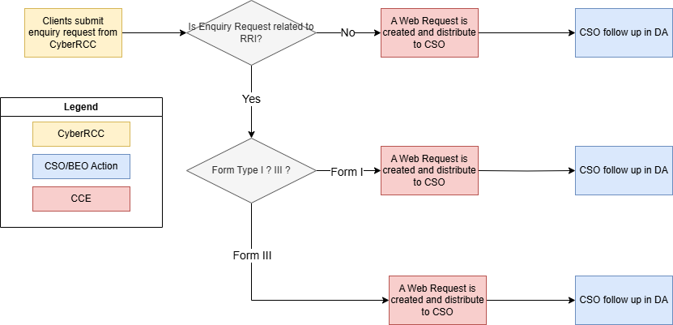

- Plain Text Version Template
